### COVID VACCIENS ANALYSIS

**TEAM MEMBER**

**412621243020: Gokul P**

# Phase-5 Document Submission

**Project: Covid Vaccines Analysis**

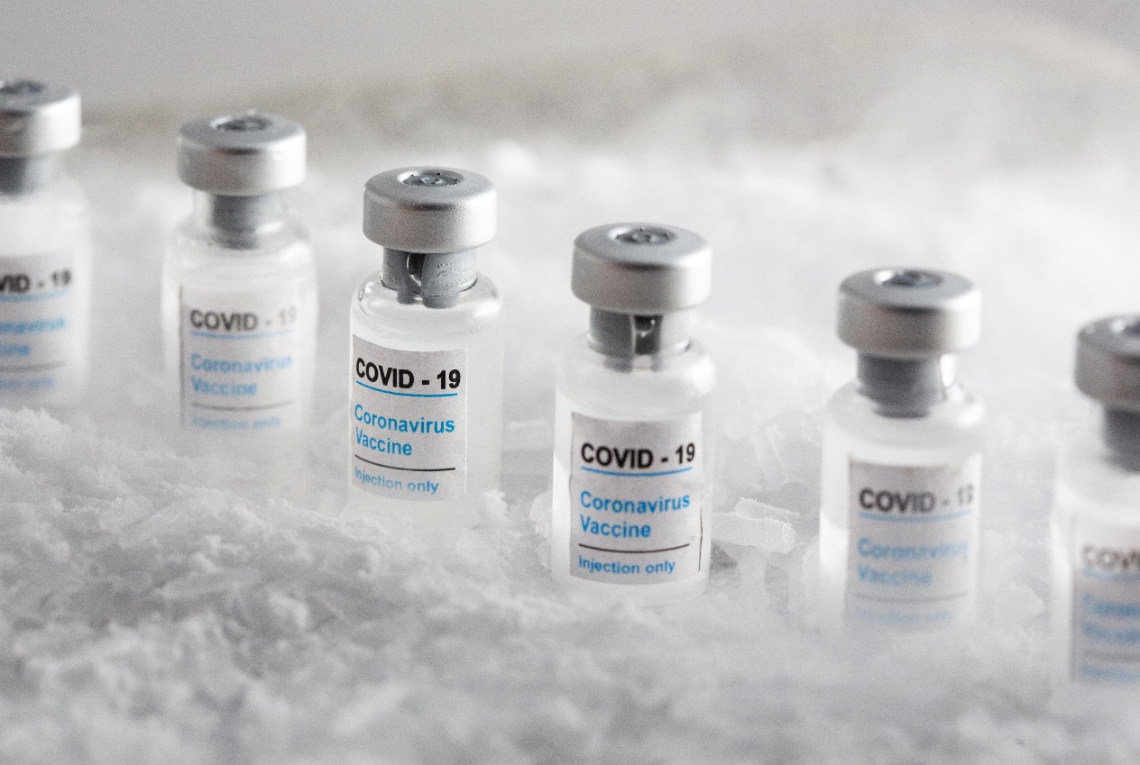

### OBJECTIVE:

The objective of COVID-19 vaccine analysis is to assess the safety, efficacy, and overall performance of COVID-19 vaccines in preventing COVID-19 infections, reducing the severity of the disease, and minimizing its impact on public health. This analysis involves rigorous testing, clinical trials, and ongoing monitoring to ensure that vaccines are effective and safe for widespread use. Additionally, vaccine analysis aims to identify any potential adverse effects and to provide data to guide vaccination strategies and public health policies.

**Phase 5: Project Documentation & Submission:**

***Design Thinking Process:***

***1.*** **Empathize:**

* Understand the needs and concerns of various stakeholders, including healthcare professionals, scientists, policymakers, and the general public.
* Conduct interviews, surveys, and research to gather insights into the current challenges and opportunities in vaccine development and distribution.

***2.* Define:**

* Clearly articulate the problem you are trying to solve, such as improving vaccine effectiveness, addressing distribution challenges, or increasing vaccine acceptance.
* Create a user-centered problem statement to guide your efforts.

***3.*** **Ideate:**

* Brainstorm and generate a wide range of innovative solutions to the defined problem. Encourage cross-disciplinary collaboration to promote diverse perspectives.
* Use techniques like mind mapping, brainstorming sessions, and ideation workshops to generate ideas.

***4.* Prototype:**

* Create tangible representations of your ideas. In the context of vaccine analysis, this might involve developing new vaccine formulations or distribution strategies.
* These prototypes can be physical or digital, depending on the nature of the idea. For example, you could create new vaccine formulations in the lab or design a digital platform to track vaccine distribution.

5. **Implement and Scale:**

* Once you have a tested and refined solution, implement it on a larger scale.
* Collaborate with relevant organizations and agencies to facilitate the implementation of your vaccine-related innovations.
* Continuously monitor and evaluate the impact of your solutions, making adjustments as needed.

**6. Communicate:**

* Effectively communicate the benefits and safety of the improved vaccines to the public. Address any concerns or misconceptions.
* Engage in transparent and informative communication with stakeholders to build trust in the vaccine development and distribution process.

***Development:***

1. **Rapid Development Timeline:** The development of COVID-19 vaccines has been notably fast, taking less than a year from the identification of the virus to the authorization and distribution of vaccines. This rapid timeline was made possible due to advances in vaccine technology, global collaboration, and dedicated resources.
2. **Diverse Vaccine Platforms:** Various vaccine platforms were used to develop COVID-19 vaccines. These include mRNA vaccines (e.g., Pfizer-BioNTech, Moderna), viral vector vaccines (e.g., Johnson & Johnson, AstraZeneca), protein subunit vaccines (e.g., Novavax), and inactivated virus vaccines (e.g., Sinopharm, Sinovac). This diversity allowed for a broader range of options and increased the chances of success.
3. **Emergency Use Authorizations:** Several countries issued emergency use authorizations (EUAs) to expedite vaccine deployment while monitoring safety and efficacy data. The EUAs allowed for early distribution of vaccines to high-risk groups..
4. **Global Cooperation:** International collaboration played a crucial role in vaccine development. Organizations like the World Health Organization (WHO) and COVAX facilitated equitable access to vaccines for lower-income countries. COVAX, in particular, aimed to ensure fair distribution of vaccines worldwide.
5. **Vaccine Hesitancy:** Vaccine hesitancy and misinformation have been challenges in the vaccine rollout. Public health campaigns, education, and community engagement have been critical in addressing these issues.
6. **Variants and Boosters:** The emergence of COVID-19 variants led to the development and distribution of booster shots to enhance vaccine effectiveness. Continuous monitoring and adaptation are necessary to combat new variants.
7. **Safety Monitoring:** Ongoing safety monitoring and post-market surveillance have been crucial to identify and address any potential adverse effects and to build public trust.

***Data Preprocessing Steps:***

**1.Data Collection:**

* + Gather relevant data from trusted sources, such as government health agencies, research institutions, or publicly available datasets.

**2.Data Cleaning:**

* + Handle missing data: Identify and address missing values by imputing, removing, or using appropriate techniques.
  + Remove duplicates: Check for and eliminate duplicate records.
  + Correct errors: Identify and correct data entry errors or inconsistencies.

**3.Data Integration:**

* + Merge data from multiple sources if needed to create a comprehensive dataset.

**4.Data Transformation:**

* + Data normalization: Scale the data if necessary to ensure that variables are on a consistent scale.
  + Encoding categorical variables: Convert categorical data into numerical format (e.g., one-hot encoding).
  + Feature engineering: Create new features or derive meaningful variables to improve analysis, such as vaccination coverage rates or time-based features.
  + Date and time formatting: Standardize date and time formats for consistency.
  + Log transformation: Apply log transformations to skewed data if appropriate.

**5.Data Reduction:**

* + Feature selection: Choose the most relevant features for the analysis to reduce dimensionality and improve model performance.
  + Dimensionality reduction: Apply techniques like Principal Component Analysis (PCA) if needed to reduce the number of variables.

**6.Data Filtering:**

* + Apply filters to focus the analysis on specific subsets of the data, such as a particular time period, location, or vaccine type.

**7.Data Aggregation:**

* + Aggregate data by relevant dimensions, such as region, age group, or vaccine manufacturer, to analyze trends and patterns.

**8.Handling Outliers:**

* + Identify and deal with outliers that can distort the analysis results. You can choose to remove outliers or use robust statistical techniques to minimize their impact.

**9.Data Splitting:**

* + Split the data into training, validation, and testing sets for machine learning or statistical modeling.

**10.Data Standardization:**

* + Standardize data for machine learning algorithms by scaling features to have zero mean and unit variance.

**11.Data Visualization:**

* + Create data visualizations to explore the dataset and identify patterns, trends, and relationships.

**12.Time Series Analysis (if applicable):**

* + If your data includes time series information, perform time series-specific preprocessing steps, such as differencing, smoothing, and seasonality removal.

**13.Quality Assurance:**

* + Continuously check for data quality and consistency throughout the analysis process.

***Analysis Techniques Applied:***

**1.Preclinical Testing:**

* **In Vitro Studies** This involves testing the vaccine's effects on cell cultures to assess its ability to generate an immune response.
* **Animal Studies** Animal models, such as mice or non-human primates, are used to evaluate vaccine safety and efficacy before human trials.

**2.Clinical Trials:**

* **Phase I Trials** Small-scale trials involving a few dozen participants to assess safety, dosage, and immune response.
* **Phase II Trials** A larger group of hundreds of participants is tested to gather more data on safety and efficacy.
* **Phase III Trials** Large-scale trials with thousands of participants to assess vaccine efficacy and monitor for adverse events.
* **Randomized Controlled Trials (RCTs)** Gold standard in vaccine evaluation, where participants are randomly assigned to receive the vaccine or a placebo to measure effectiveness.

**3.Immunogenicity Assessment:**

* **Serological Assays :**These measure the levels of antibodies in the blood to determine the vaccine's ability to generate an immune response.
* **T-cell Assays**: Assess cellular immune responses, including the activation of T-cells.

**4.Safety Evaluation:**

* **Surveillance Systems**: Monitoring for adverse events through reporting systems like the Vaccine Adverse Event Reporting System (VAERS).
* **Safety Biomarkers**: Identifying specific biomarkers that may indicate adverse reactions.

**5.Post-Marketing Surveillance:**

* **Pharmacovigilance**: Continuously monitoring and analyzing vaccine safety in real-world conditions after they are approved and distributed.
* **Epidemiological Studies**: Investigating vaccine safety and efficacy in large populations.

**6.Genomic Analysis:**

* **Genomic Sequencing**: Sequencing the virus and the vaccine strain to ensure a match and monitor for any mutations.
* **Next-Generation Sequencing (NGS)**: Allows for in-depth analysis of the viral genome and identification of new variants.

**7.Manufacturing and Quality Control:**

* **Quality Control Testing**: Ensuring consistent vaccine production quality through various assays and tests.
* **Stability Testing**: Evaluating the vaccine's stability under different storage conditions.

**8.Data Analysis:**

* **Statistical Analysis**: Analyzing clinical trial data to determine vaccine efficacy and safety.
* **Meta-Analysis**: Combining data from multiple studies to draw more comprehensive conclusions.

**9.Economic Analysis:**

* **Cost-Benefit Analysis**: Assessing the economic impact and cost-effectiveness of vaccination programs.

**10.Epidemiological Modeling:**

* Using mathematical models to estimate the potential impact of vaccination on disease spread and public health.

***DataSet Link:***

[**https://www.kaggle.com/datasets/gpreda/covid-world-vaccination-progress**](https://www.kaggle.com/datasets/gpreda/covid-world-vaccination-progress)

***program:***

import pandas as pd

import matplotlib.pyplot as plt

import seaborn as sns

df = pd.read_csv('covid_vaccine_data.csv')

print(df.head())

print(df.describe())

print(df.isnull().sum())

correlation_matrix = df.corr()

print(correlation_matrix)

plt.figure(figsize=(10, 6))

plt.plot(df['Date'], df['Vaccinations'], marker='o', linestyle='-', color='b')

plt.xlabel('Date')

plt.ylabel('Number of Vaccinations')

plt.title('Vaccination Trends Over Time')

plt.xticks(rotation=45)

plt.grid(True)

plt.show()

plt.figure(figsize=(10, 6))

sns.barplot(x='Region', y='VaccinationRate', data=df, palette='viridis')

plt.xlabel('Region')

plt.ylabel('Vaccination Rate (%)')

plt.title('Vaccination Rates by Region')

plt.xticks(rotation=45)

plt.show()

plt.figure(figsize=(8, 6))

sns.boxplot(x='Manufacturer', y='Efficacy', data=df, palette='Set3')

plt.xlabel('Vaccine Manufacturer')

plt.ylabel('Vaccine Efficacy (%)')

plt.title('Vaccine Efficacy by Manufacturer')

plt.show()

***OutPut :***



