**Environmental monitoring-phase 3**

**PROJECT DESIGN:**

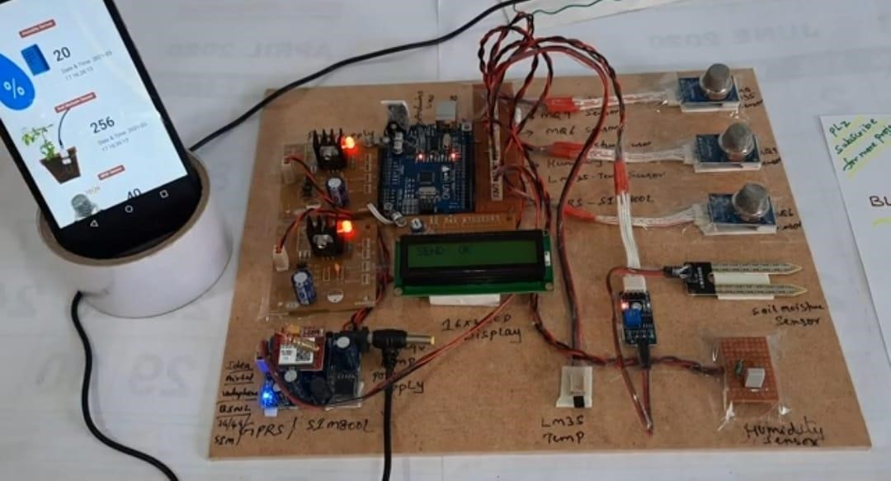

**COMPONENTS :**

**▪︎TEMPARATURE SENSOR :**

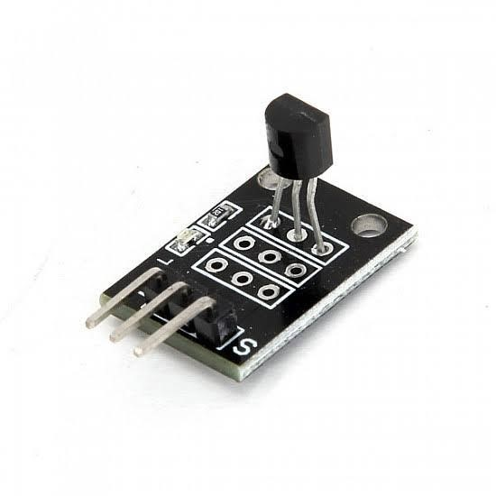

**▪︎CAPACITIVE HUMIDITY SENSORS :**

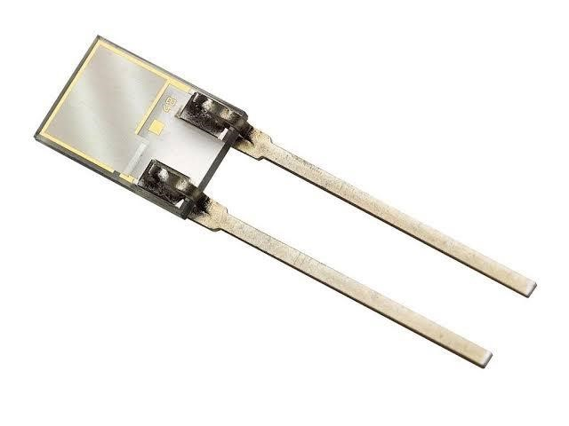

**▪︎MQ 135 SENSOR:**

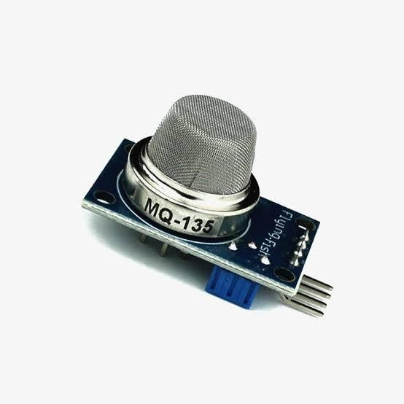

**▪︎MQ 6 GAS SENSOR :**

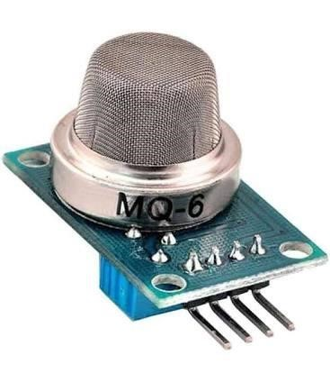

**▪︎MQ 9 GAS SENSOR :**

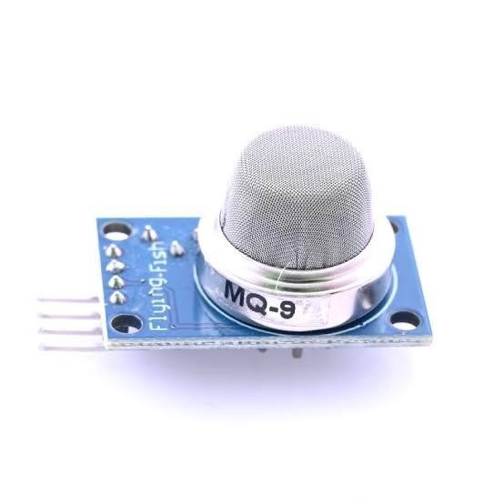

**CODE:**

# Adafruit IO Environmental Monitor for Feather or Raspberry

Pi -

# an internet-enabled environmental monitor

# Import standard python modules import time

# import Adafruit Blinka import board import busio

# import CircuitPython sensor libraries import adafruit_sgp30 import adafruit_veml6070

from adafruit_bme280 import basic as adafruit_bme280

# import Adafruit IO REST client

from Adafruit_IO import Client, Feed, RequestError

# loop timeout, in seconds.

LOOP_DELAY = 10

# Set to your Adafruit IO key.

# Remember, your key is a secret,

# so make sure not to publish it when you publish this code!

ADAFRUIT_IO_KEY = 'YOUR_AIO_KEY'

# Set to your Adafruit IO username.

# (go to https://accounts.adafruit.com to find your username)

ADAFRUIT_IO_USERNAME = 'YOUR_AIO_USERNAME'

# Create an instance of the REST client

aio = Client(ADAFRUIT_IO_USERNAME, ADAFRUIT_IO_KEY)

try: # if we already have the feeds, assign them.

tvoc_feed = aio.feeds('tvoc') eCO2_feed = aio.feeds('eco2') uv_feed = aio.feeds('uv')

temperature_feed = aio.feeds('temperature') humidity_feed = aio.feeds('humidity') pressure_feed = aio.feeds('pressure') altitude_feed = aio.feeds('altitude') except RequestError: # if we don't, create and assign them.

tvoc_feed = aio.create_feed(Feed(name='tvoc')) eCO2_feed = aio.create_feed(Feed(name='eco2')) uv_feed = aio.create_feed(Feed(name='uv')) temperature_feed =

aio.create_feed(Feed(name='temperature'))

humidity_feed = aio.create_feed(Feed(name='humidity')) pressure_feed = aio.create_feed(Feed(name='pressure')) altitude_feed = aio.create_feed(Feed(name='altitude'))

# Create busio I2C

i2c = busio.I2C(board.SCL, board.SDA) # Create VEML6070 object.

uv = adafruit_veml6070.VEML6070(i2c) # Create BME280 object. bme280 = adafruit_bme280.Adafruit_BME280_I2C(i2c) bme280.sea_level_pressure = 1013.25 # Create SGP30 object using I2C.

sgp30 = adafruit_sgp30.Adafruit_SGP30(i2c) sgp30.iaq_init()

sgp30.set_iaq_baseline(0x8973, 0x8aae)

# Sample VEML6070 def sample_VEML(): for _ in range(10): uv_raw = uv.uv_raw return uv_raw

while True:

print('Reading sensors...') # Read SGP30.

eCO2_data = sgp30.eCO2 tvoc_data = sgp30.TVOC

# Read VEML6070.

uv_data = sample_VEML()

# Read BME280.

temp_data = bme280.temperature # convert temperature (C->F) temp_data = int(temp_data) * 1.8 + 32 humid_data = bme280.humidity pressure_data = bme280.pressure alt_data = bme280.altitude

print('sending data to adafruit io...') # Send SGP30 Data to Adafruit IO. print('eCO2:', eCO2_data) aio.send(eCO2_feed.key, eCO2_data) print('tvoc:', tvoc_data) aio.send(tvoc_feed.key, tvoc_data) time.sleep(2)

**# Send VEML6070 Data to Adafruit IO.**

**print('UV Level: ', uv_data) aio.send(uv_feed.key, uv_data) time.sleep(2)**

**# Send BME280 Data to Adafruit IO.**

**print('Temperature: %0.1f C' % temp_data) aio.send(temperature_feed.key, temp_data) print("Humidity: %0.1f %%" % humid_data) aio.send(humidity_feed.key, int(humid_data)) time.sleep(2)**

**print("Pressure: %0.1f hPa" % pressure_data) aio.send(pressure_feed.key, int(pressure_data)) print("Altitude = %0.2f meters" % alt_data) aio.send(altitude_feed.key, int(alt_data)) # avoid timeout from adafruit io time.sleep(LOOP_DELAY * 60)**