COIMBATORE INSTITUTE OF TECHNOLOGY
(An Autonomous Institution Affiliated to Anna University, Chennai)
COIMBATORE — 641 014, TAMIL NADU, INDIA
DEPARTMENT OF INFORMATION TECHNOLOGY
23IT723 — DEVOPS LABORATORY
LABORATORY CAPSTONE PROJECT REPORT
QUEUELESS
END-TO-END CI/CD POWERED VIRTUAL QUEUE MANAGEMENT SYSTEM
A Complete Implementation and Comprehensive Verification of Ten Prescribed
DevOps Experiments covering SCM, CI/CD, Containerization, Automated Testing,
Persistent Storage, and Configuration Management
Submitted in partial fulfillment of the requirements for the laboratory course of
BACHELOR OF TECHNOLOGY
IN
INFORMATION TECHNOLOGY
Submitted by:
GOKUL SV
Register Number: 2303717620521019 [Editable]
Class & Section: B.Tech IT — Final Year / Semester VII
OCTOBER 2026
ACADEMIC YEAR 2026 – 2027

COIMBATORE INSTITUTE OF TECHNOLOGY
(An Autonomous Institution Affiliated to Anna University, Chennai)
COIMBATORE — 641 014
DEPARTMENT OF INFORMATION TECHNOLOGY
BONAFIDE CERTIFICATE
This is to certify that the DevOps Laboratory capstone project report entitled "QUEUELESS — END-TO-END CI/CD POWERED VIRTUAL QUEUE MANAGEMENT SYSTEM" is the bonafide record of project work carried out by Mr. GOKUL SV (Register Number: 2303717620521019 [Editable]) in partial fulfillment of the requirements for the award of the degree of Bachelor of Technology in Information Technology under the course 23IT723 — DevOps Laboratory during the academic year 2026 – 2027.
The work presented herein represents an authentic, verified record of continuous integration, continuous delivery, containerization, automated testing, persistent storage management, and configuration management executed under the supervision of the undersigned faculty members.
____________________________________  FACULTY IN-CHARGE / GUIDE  [Faculty Name & Designation]  Department of Information Technology  Coimbatore Institute of Technology | ____________________________________  HEAD OF THE DEPARTMENT  [HOD Name & Designation]  Department of Information Technology  Coimbatore Institute of Technology
Submitted for the 23IT723 DevOps Laboratory Practical Examination held on: _____________________
____________________________________  INTERNAL EXAMINER  [Name, Designation & Institution] | ____________________________________  EXTERNAL EXAMINER  [Name, Designation & Institution]
Place: Coimbatore
Date: _____________________

TABLE OF CONTENTS
The following table of contents outlines the academic structure of this project report. Dotted leader page numbers are automatically synchronized through Microsoft Word fields:
TABLE OF CONTENTS 3
LIST OF FIGURES 5
LIST OF TABLES 6
CHAPTER 1: INTRODUCTION 7
CHAPTER 2: PROBLEM DEFINITION AND OBJECTIVES 7
2.1 Problem Definition 7
2.2 Project Objectives 7
CHAPTER 3: ABSTRACT 9
CHAPTER 4: TECHNOLOGY STACK 9
CHAPTER 5: SYSTEM ARCHITECTURE AND WORKFLOW 11
5.1 System Component Architecture 11
5.2 End-to-End DevOps Life Cycle Workflow 12
CHAPTER 6: APPLICATION MODULES AND PROJECT STRUCTURE 14
6.1 Project Directory Structure 14
6.2 Domain Controllers and Service Components 14
6.3 Virtual Queue Ticket State Machine 15
CHAPTER 7: GIT AND GITHUB VERSION CONTROL 16
7.1 Version Control Foundation (Experiment 1) 16
7.2 Remote Synchronization and Multi-Repository Verification (Experiment 2) 16
CHAPTER 8: BRANCHING, MERGING AND CONFLICT RESOLUTION 16
8.1 Feature Branch Isolation and Fast-Forward Merge (Experiment 3) 16
8.2 Controlled Merge Conflict Generation and Reconciled Resolution 17
CHAPTER 9: APPLICATION DEVELOPMENT AND MAVEN BUILD 18
9.1 Maven Lifecycle Management 18
9.2 Build Lifecycle Phases 18
9.3 Dependency Governance in pom.xml 18
CHAPTER 10: DOCKER IMAGE CREATION AND CONTAINERIZATION 18
10.1 Docker Daemon Verification and Lifecycle Commands (Experiment 6) 18
10.2 Production Dockerfile Container Image (Experiment 7) 19
CHAPTER 11: PERSISTENT STORAGE AND DATABASE MANAGEMENT 20
11.1 The Ephemeral Container Problem vs. State Persistence (Experiment 8) 20
11.2 H2 Database Engine Configuration 20
CHAPTER 12: JENKINS FREESTYLE INTEGRATION 21
12.1 Freestyle Job Configuration (Experiment 4) 21
12.2 Verified Execution Visual Evidence 21
CHAPTER 13: JENKINS CI/CD PIPELINE 25
13.1 Declarative Pipeline Structure (Experiment 5) 25
13.2 Pipeline Stage Breakdown 25
13.3 Technical Distinction: Historical Build #7 vs. Local Jenkinsfile Correction 25
CHAPTER 14: AUTOMATED TESTING AND VERIFICATION 27
14.1 Continuous Testing Architecture (Experiment 9) 27
CHAPTER 15: ANSIBLE DEPLOYMENT AND CONFIGURATION MANAGEMENT 28
15.1 Independent SCM Toolchain (Experiment 10) 28
CHAPTER 16: APPLICATION AND DEPLOYMENT VERIFICATION 29
16.1 Live Container Runtime Verification 29
16.2 Live REST API Endpoint Verification 29
CHAPTER 17: RESULTS AND OUTPUT 30
CHAPTER 18: COMMANDS USED 30
CHAPTER 19: ADVANTAGES AND LIMITATIONS 32
19.1 Advantages of the QueueLess DevOps Architecture 32
19.2 Architectural Limitations 32
CHAPTER 20: FUTURE ENHANCEMENTS 32
CHAPTER 21: CONCLUSION AND REFERENCES 33
21.1 Conclusion 33
21.2 References 33
CHAPTER 22: APPENDIX: EXPERIMENT COVERAGE AND EVIDENCE 34

LIST OF FIGURES
Figure # | Figure Caption & Description | Location
Figure 5.1 | System Component Architecture of QueueLess Tier Decoupling | Chapter 5
Figure 5.2 | End-to-End DevOps Life Cycle Workflow Sequence Diagram | Chapter 5
Figure 6.1 | Virtual Queue Ticket State Machine Transitions and Invariants | Chapter 6
Figure 12.1 | Jenkins Dashboard Sunny Weather Report for Job QueueLess-Build | Chapter 12
Figure 12.2 | Git SCM Configuration & Windows Batch Step in Freestyle Job | Chapter 12
Figure 12.3 | QueueLess-Build Build #2 Status Page and Test Result Trend | Chapter 12
Figure 12.4 | QueueLess-Build Build #2 Console Output Verifying Java 21 & Build Success | Chapter 12
Figure 12.5 | JUnit Test Result Trend & Package Breakdown (33 Tests Passed) | Chapter 12
Figure 12.6 | Archived Artifacts List Verifying Fat JAR and Surefire XML Reports | Chapter 12
Figure 13.1 | Jenkins Declarative 8-Stage CI/CD Pipeline Execution Flow | Chapter 13

LIST OF TABLES
Table # | Table Title & Description | Location
Table 4.1 | QueueLess Technology Stack and Production Version Matrix | Chapter 4
Table 6.1 | Backend Modules, Domain Controllers, and Service Components | Chapter 6
Table 7.1 | Git Version Control Configuration and Multi-Repo Synchronization | Chapter 7
Table 8.1 | Branching, Fast-Forward Merge, and Content Conflict Resolution | Chapter 8
Table 10.1 | Docker Daemon Verification & Container Lifecycle Command Suite | Chapter 10
Table 12.1 | Jenkins Freestyle Build #2 Execution Profile and Verification Metrics | Chapter 12
Table 13.1 | Jenkins Declarative CI/CD Pipeline 8-Stage Execution Profile | Chapter 13
Table 14.1 | Automated Test Suite Breakdown & Verification Coverage (33 Tests) | Chapter 14
Table 15.1 | Ansible Configuration Management 9-Task Deployment Playbook | Chapter 15
Table 16.1 | REST API Health and Release Provenance Endpoint Verification | Chapter 16
Table 17.1 | DevOps Engineering Key Performance Indicators and Benchmarks | Chapter 17
Table 22.1 | Complete 23IT723 Laboratory Syllabus Experiment Mapping Matrix | Chapter 22

CHAPTER 1: INTRODUCTION
In modern software engineering, the traditional boundaries between application development and IT operations have dissolved. The DevOps paradigm bridges this historical divide by establishing continuous integration, continuous delivery (CI/CD), infrastructure as code (IaC), containerization, and automated quality gates. Rather than relying on periodic, high-risk manual deployments, modern engineering teams embrace automated delivery pipelines that validate every commit, execute comprehensive automated tests, build immutable container artifacts, and deploy verified releases to production environments with zero human intervention.
This project report presents QueueLess, a production-grade virtual queue management web application developed in Java 21 LTS with the Spring Boot 3.2.3 framework. QueueLess is designed to solve real-world physical waiting congestion in service environments such as healthcare clinics, banking halls, academic administration counters, and retail service centers. Instead of standing in crowded physical queues, patrons join a virtual queue via a responsive browser portal, receive real-time queue position telemetry, and receive accurate wait estimates.
Beyond its end-user utility, QueueLess serves as the comprehensive capstone implementation for the 23IT723 DevOps Laboratory curriculum at Coimbatore Institute of Technology. The project establishes an end-to-end DevOps toolchain that implements, automates, and verifies all ten prescribed laboratory experiments. From local Git repository management and multi-remote synchronization to declarative Jenkins CI/CD pipelines, Docker containerization with volume persistence, automated JUnit 5 testing, and agentless Ansible configuration management, QueueLess represents a fully integrated, evidence-backed software delivery system.

CHAPTER 2: PROBLEM DEFINITION AND OBJECTIVES

2.1 Problem Definition
Physical queue management in institutional and commercial facilities suffers from systemic operational inefficiencies:
- 1. Physical Congestion & Lost Productivity: Patrons must physically congregate in waiting areas, wasting valuable time and causing overcrowding in waiting rooms.
- 2. Opaque Waiting Times: Traditional token dispensers provide static numbers without dynamic position tracking or estimated wait duration, leading to frustration and queue abandonment.
- 3. Fragile Manual Deployments: Historically, web applications required error-prone manual server deployments: manual Git pulls, ad-hoc compilation, manual dependency installation, and lack of rollback mechanisms.
- 4. Deployment Drift & State Loss: Manual configurations inevitably lead to configuration drift between developer machines and production hosts, while container recreation often risks data loss if storage is not properly externalized.

2.2 Project Objectives
The primary objectives of the QueueLess capstone project are partitioned into functional application goals and DevOps engineering goals:
- Real-Time Virtual Queuing: Implement an interactive, responsive web portal enabling users to join queues, track live position, estimate wait minutes, and permit counter operators to call, complete, or cancel tickets.
- 100% SCM Version Control: Version all application source code, build scripts, Dockerfiles, Jenkinsfiles, and Ansible playbooks under Git, adhering to disciplined feature branching and clean conflict resolution.
- Automated Continuous Integration: Configure Jenkins automation servers to compile source code, execute automated test suites, enforce quality gates, and package fat JARs upon code commits.
- Immutable Container Packaging: Package the application into lightweight, standardized Docker images based on Alpine Linux JRE, guaranteeing consistent execution across any Docker host.
- Persistent Data Handling: Ensure database persistence across container lifecycles by binding an embedded H2 database to an external Docker named volume.
- Continuous Delivery & Health Verification: Implement automated health check verification and release metadata provenance tracking, recording Git commit SHA, build number, and test results.
- Independent Configuration Management: Provide an alternative, agentless deployment pathway using Ansible playbooks to demonstrate infrastructure-as-code automation.

CHAPTER 3: ABSTRACT
QueueLess is a production-ready, cloud-native virtual queue management web application engineered in Java 21 LTS and Spring Boot 3.2.3, automated through an end-to-end DevOps continuous integration and continuous delivery (CI/CD) pipeline. The system addresses physical queue congestion by providing an intuitive, single-page browser interface for customer ticket allocation and an administrative console for counter management. Data persistence is guaranteed using an embedded H2 database engine bound to a dedicated Docker named volume (queueless-data).
The project comprehensively realizes the ten experiments prescribed in the 23IT723 DevOps Laboratory syllabus. Version control is anchored on Git and GitHub, featuring disciplined feature branching and verified three-way merge conflict resolution. Continuous integration is established via both a Jenkins Freestyle job (QueueLess-Build, Build #2) and an 8-stage Declarative Pipeline (QueueLess-CICD, Build #7). Automated quality gates execute 33 JUnit 5 unit and integration tests across 4 test suites with a 100% pass rate. Containerization is achieved via multi-stage Dockerfiles based on Eclipse Temurin JRE 21 Alpine, deployed to host port 8085 with automated HTTP health polling. Furthermore, an independent Ansible toolchain provides an agentless, idempotent deployment alternative. Live runtime verification confirms the operational stability of the deployed container (queueless-app), proving the seamless synergy of modern DevOps practices in enterprise software delivery.

CHAPTER 4: TECHNOLOGY STACK
The QueueLess architecture was selected to reflect modern enterprise standards while ensuring zero external runtime database dependencies. Table 4.1 summarizes the complete technology stack and production versions employed across the development, testing, containerization, and deployment lifecycle:
Technology Tier | Tool & Version | Role & Engineering Justification
Programming Language | Java 21 LTS (Temurin 21.0.2) | Core backend language providing virtual threads, pattern matching, and LTS stability.
Web Framework | Spring Boot 3.2.3 | Opinionated framework for RESTful microservices, embedded Tomcat 10, and JPA persistence.
Build Tool | Apache Maven 3.9 (mvnw Wrapper) | Dependency management, build lifecycle orchestration, and Surefire test execution.
Database Engine | H2 Database 2.2.224 | In-process relational DB operating in embedded file mode (/app/data/queuelessdb.mv.db).
Frontend UI | HTML5, Vanilla CSS3, Vanilla JS | Zero-dependency single-page application (SPA) with responsive CSS flexbox layout.
Version Control | Git 2.40+ & GitHub | Distributed SCM with remote origin at https://github.com/Gokul7176/QueueLess.git.
CI/CD Automation | Jenkins 2.400+ (LTS) | Freestyle build job and 8-stage Declarative Pipeline executing in Windows host environment.
Containerization | Docker Engine & Desktop 29.6 | OCI container runtime executing Alpine Linux JRE containers with volume persistence.
Automated Testing | JUnit 5 & Mockito / Spring Test | Unit and integration test suites executed under Maven Surefire Plugin 3.1.2.
Configuration Mgmt | Ansible Core 2.14+ | Agentless YAML automation executing idempotent host provisioning and container deployment.

CHAPTER 5: SYSTEM ARCHITECTURE AND WORKFLOW

5.1 System Component Architecture
QueueLess follows a decoupled, three-tier architecture comprising the Client Tier, the Host Runtime Tier, and the Persistent Storage Layer. As illustrated in Figure 5.1, incoming client HTTP requests across the Customer Portal, Admin Console, and Version Monitor map directly from host port 8085 into container port 8085. Inside the container, an embedded Tomcat web server routes requests to Spring Boot controllers, which delegate to domain services, interact with JPA repositories, and persist state to the externalized H2 database file.
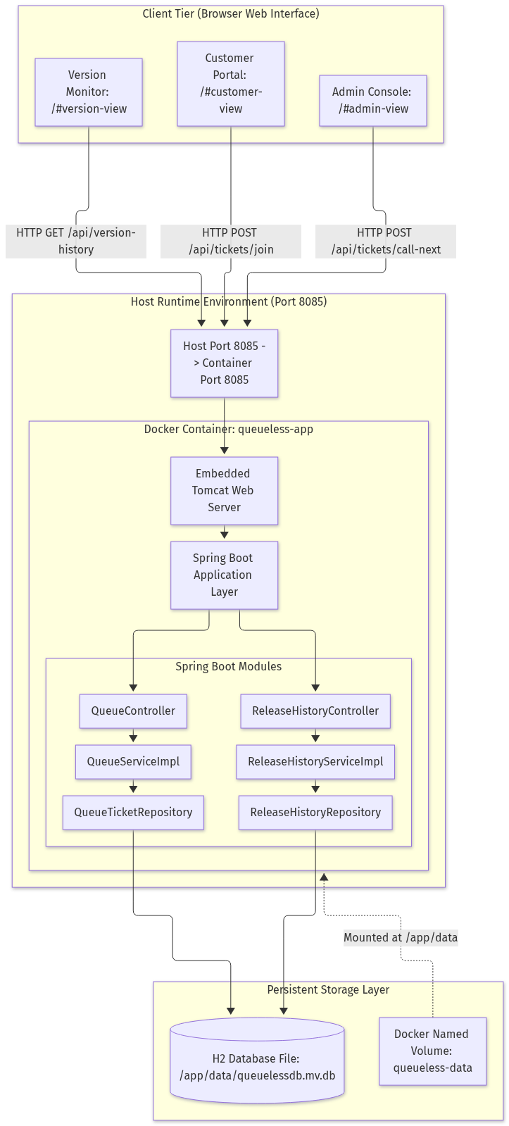
Figure 5.1: System Component Architecture of QueueLess Tier Decoupling

5.2 End-to-End DevOps Life Cycle Workflow
The end-to-end DevOps lifecycle orchestrates the transition of code from local developer workstations to verified production runtime. Figure 5.2 illustrates the sequential interaction between the developer, Git, Jenkins, Maven, Docker, the QueueLess application, and persistent storage:
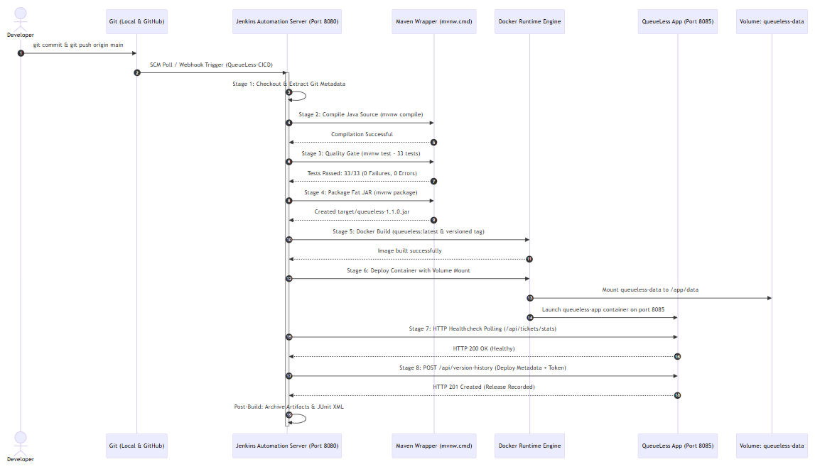
Figure 5.2: End-to-End DevOps Life Cycle Workflow Sequence Diagram

CHAPTER 6: APPLICATION MODULES AND PROJECT STRUCTURE

6.1 Project Directory Structure
The QueueLess repository strictly complies with standard Maven project conventions, housing application code, automated test suites, container definitions, Jenkins pipeline specifications, and Ansible playbooks under a clean, unified directory structure:
C:\queuless
├── .gitignore # Git exclusions (target/, *.class, .env)
├── Dockerfile # Alpine JRE 21 container image specification
├── Jenkinsfile # 8-stage Declarative Pipeline definition
├── pom.xml # Maven dependencies & build configuration
├── mvnw / mvnw.cmd # Maven Wrapper binaries
├── ansible/ # SCM Configuration Management directory
│ ├── inventory.ini # Deployment target host inventory
│ └── deploy.yml # 9-task idempotent deployment playbook
├── docs/ # System documentation and reports
│ ├── final-project-report.md # Source project report
│ └── screenshots/experiment-04/ # Verified build execution screenshots
├── experiments/ # Experiment manuals and verification records
└── src/
├── main/java/com/queueless/ # Spring Boot application backend modules
├── main/resources/static/ # Virtual queue responsive web interface
└── test/java/com/queueless/ # 33 unit and integration tests (4 suites)

6.2 Domain Controllers and Service Components
The application domain logic is cleanly partitioned into two core module subsystems: the Queue Ticket Subsystem and the Version History & Deployment Provenance Subsystem, as detailed in Table 6.1:
Module / Class | Layer | Responsibilities & Architectural Invariants
QueueController | REST API | Exposes /api/tickets endpoints: join, call-next, complete, cancel, stats, and active.
QueueServiceImpl | Domain Service | Enforces FIFO queue ordering, dynamic queue position, wait estimation (5 mins/ticket), and atomic state transitions.
QueueTicketRepository | Data Access | Spring Data JPA repository providing CRUD and custom derived queries for ticket states.
ReleaseHistoryController | REST API | Exposes /api/version-history endpoints; authenticates deployment payloads via X-Release-Token header.
ReleaseHistoryServiceImpl | Domain Service | Validates release provenance data, records Jenkins build URLs, commit SHAs, and active deployment flags.
ReleaseHistoryRepository | Data Access | Persists release metadata records and queries current active deployment.

6.3 Virtual Queue Ticket State Machine
A rigorous state machine governs ticket lifecycles to prevent invalid operations such as calling non-waiting tickets or completing already-cancelled requests. As shown in Figure 6.1, tickets transition across four discrete states:
- WAITING: Initial state upon joining queue. Allocates sequential ticket number (Q-101) and calculates dynamic position.
- SERVING: Assigned when a counter calls the next ticket. Position resets to 0 and ticket binds to a specific counter.
- COMPLETED: Terminal state indicating service completion. Ticket is archived.
- CANCELLED: Terminal state indicating customer withdrawal prior to service.
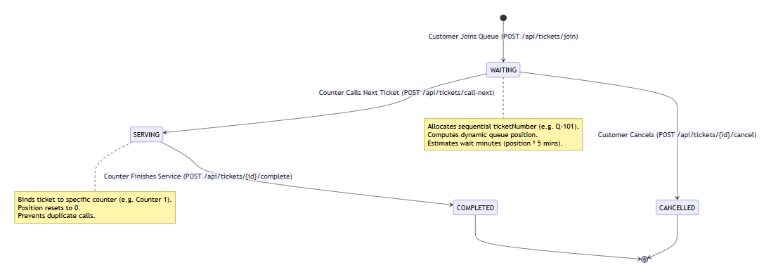
Figure 6.1: Virtual Queue Ticket State Machine Transitions and Invariants

CHAPTER 7: GIT AND GITHUB VERSION CONTROL

7.1 Version Control Foundation (Experiment 1)
Version control for QueueLess is established using Git 2.40+ and anchored to the remote GitHub repository at https://github.com/Gokul7176/QueueLess.git. In Experiment 1, the local repository was initialized, Git global identity was configured, and a comprehensive .gitignore file was established to protect build outputs (target/), IDE metadata (.idea/, .vscode/), and sensitive environment files from accidental commits. Initial application source files were staged and committed under commit SHA 0ad2b04.

7.2 Remote Synchronization and Multi-Repository Verification (Experiment 2)
In Experiment 2, multi-repository synchronization was verified using an isolated demonstration workspace located at C:\queuless-clone. Remote differences were inspected using git fetch origin and git diff HEAD..origin/main without impacting local working trees. The clone was successfully synchronized with the remote main branch via fast-forward merge under commit 9c12b22, confirming distributed repository integrity across multiple development environments. Table 7.1 details the verified Git configuration parameters:
Parameter | Value / Path | DevOps Verification Context
Remote Repository URL | https://github.com/Gokul7176/QueueLess.git | Verified remote origin on GitHub.
Primary Workspace | C:\queuless | Active development workspace hosting production code and CI/CD configs.
Demonstration Workspace | C:\queuless-clone | Isolated clone utilized for safe Experiment 2 and Experiment 3 verification.
Default Branch | main | Protected trunk branch containing production-ready, verified code.
Initial Commit | 0ad2b04 | Experiment 1 baseline commit establishing initial project structure.
Sync Commit | 9c12b22 | Experiment 2 synchronization commit verifying remote fast-forward.

CHAPTER 8: BRANCHING, MERGING AND CONFLICT RESOLUTION

8.1 Feature Branch Isolation and Fast-Forward Merge (Experiment 3)
To preserve the stability of the primary production repository in C:\queuless, all Experiment 3 branching and merge exercises were executed within the isolated demonstration workspace C:\queuless-clone. A dedicated feature branch feature/priority-queue was created to isolate non-production documentation updates. Documentation specification docs/priority-queue-spec.md was added and committed (commit 044230e), and subsequently merged cleanly into main via fast-forward merge.

8.2 Controlled Merge Conflict Generation and Reconciled Resolution
To satisfy the academic requirement of demonstrating merge conflict resolution, a controlled, conflicting edit was simulated on a shared policy document (docs/queue-policy.txt):
- 1. Base Policy Anchor: Created docs/queue-policy.txt on main stating: "Queue wait policy: review unresolved waits after 30 minutes." (commit e0bfd83).
- 2. Divergent Branch A: Branch conflict-branch-a modified the policy line to 15 minutes (commit 07c4e93).
- 3. Divergent Branch B: Branch conflict-branch-b modified the exact same line to 45 minutes (commit 8e84dd5).
- 4. Triggering the Conflict: Branch A merged cleanly into main via fast-forward. Attempting to merge Branch B produced a verified merge conflict:
CONFLICT (content): Merge conflict in docs/queue-policy.txt
Automatic merge failed; fix conflicts and then commit the result.
- 5. Resolution Commit: The conflict markers were inspected and manually reconciled into a unified policy:
"Queue wait policy: notify users after 15 minutes and escalate unresolved waits after 45 minutes."
The resolved file was staged and committed under merge commit 8cf59b4.
Documentation Evidence & Non-Pollution Boundary
The priority queue specification file docs/priority-queue-spec.md exists exclusively in C:\queuless-clone. In strict compliance with safety boundaries, this file was not copied into the primary repository C:\queuless, guaranteeing zero working-tree pollution. The complete branching record is preserved in the verified laboratory document experiments/experiment-03-branching/README.md.

CHAPTER 9: APPLICATION DEVELOPMENT AND MAVEN BUILD

9.1 Maven Lifecycle Management
Apache Maven manages the complete build lifecycle of QueueLess through the self-contained Maven Wrapper scripts (mvnw for Unix/Linux and mvnw.cmd for Windows). The wrapper guarantees that all developers and CI servers execute builds using the identical Maven 3.9 runtime, eliminating build discrepancies caused by local environment variances.

9.2 Build Lifecycle Phases
- compile: Validates Java syntax, resolves external dependencies from Maven Central, and compiles Java source files under src/main/java into bytecode under target/classes.
- test: Executes automated JUnit 5 test suites under src/test/java using the Maven Surefire Plugin 3.1.2. Generates XML test execution reports under target/surefire-reports/.
- package: Packages compiled classes, embedded static web resources, and Spring Boot dependencies into an executable fat JAR: target/queueless-1.1.0.jar (46.70 MiB).

9.3 Dependency Governance in pom.xml
Dependencies are strictly governed under pom.xml using Spring Boot's curated dependency management: spring-boot-starter-web for REST APIs, spring-boot-starter-data-jpa and com.h2database:h2 for database handling, org.projectlombok:lombok for boilerplate reduction, and spring-boot-starter-test for automated testing.

CHAPTER 10: DOCKER IMAGE CREATION AND CONTAINERIZATION

10.1 Docker Daemon Verification and Lifecycle Commands (Experiment 6)
In Experiment 6, the Docker Desktop 29.6 daemon was verified, and core container lifecycle operations were demonstrated using a dedicated demonstration container named queueless-docker-basics-demo. The terminal results, documented in experiments/experiment-06-docker-commands/README.md, verified container creation, background execution (-d), log streaming, port binding, inspection, graceful termination, and cleanup, as summarized in Table 10.1:
Docker Command & Syntax | DevOps Verification Purpose
docker run -d --name demo -p 8085:8085 image | Launches container in detached mode with host-to-container port mapping.
docker ps --filter name=demo | Lists active containers, verifying status, uptime, and exposed ports.
docker logs --tail 20 demo | Retrieves container standard output logs to confirm Spring Boot startup.
docker inspect --format '{{.State.Status}}' demo | Extracts JSON metadata verifying container running state.
docker stop demo && docker rm demo | Gracefully stops container process and releases associated container resources.

10.2 Production Dockerfile Container Image (Experiment 7)
In Experiment 7, a production-grade Dockerfile was engineered to containerize QueueLess into an immutable image. The image utilizes eclipse-temurin:21-jre-alpine as a secure, minimal base operating system, reducing the final image size to approximately 260 MB:
# Production Dockerfile for QueueLess Virtual Queue System
FROM eclipse-temurin:21-jre-alpine
LABEL maintainer="Gokul SV <student@college.edu>"
LABEL description="QueueLess - End-to-End CI/CD Virtual Queue System"
LABEL version="1.1.0"
# Create non-root application user and persistent data directory
RUN addgroup -S appgroup && adduser -S appuser -G appgroup \
&& mkdir -p /app/data && chown -R appuser:appgroup /app
WORKDIR /app
# Copy compiled fat JAR artifact from Maven build
COPY target/queueless-1.1.0.jar /app/app.jar
# Enforce file ownership and switch to non-root execution
RUN chown appuser:appgroup /app/app.jar
USER appuser
EXPOSE 8085
# Healthcheck validating embedded Tomcat responsiveness
HEALTHCHECK --interval=15s --timeout=5s --start-period=20s --retries=3 \
CMD wget --no-verbose --tries=1 --spider http://localhost:8085/api/tickets/stats || exit 1
ENTRYPOINT ["java", "-Djava.security.egd=file:/dev/./urandom", "-jar", "/app/app.jar"]

CHAPTER 11: PERSISTENT STORAGE AND DATABASE MANAGEMENT

11.1 The Ephemeral Container Problem vs. State Persistence (Experiment 8)
By default, all files written inside a container reside in a read-write container layer that is permanently destroyed when the container is removed. For a stateful virtual queue system, container destruction during pipeline upgrades would wipe out active customer tickets and version history records. In Experiment 8, this challenge was resolved by externalizing state using a dedicated Docker named volume: queueless-data.

11.2 H2 Database Engine Configuration
QueueLess configures the H2 database engine in embedded file mode rather than volatile in-memory mode. The JDBC connection string is defined in application.properties as follows:
# Embedded Persistent H2 Database Configuration
spring.datasource.url=jdbc:h2:file:/app/data/queuelessdb;DB_CLOSE_DELAY=-1;DB_CLOSE_ON_EXIT=FALSE
spring.datasource.driverClassName=org.h2.Driver
spring.datasource.username=sa
spring.datasource.password=
spring.jpa.database-platform=org.hibernate.dialect.H2Dialect
spring.jpa.hibernate.ddl-auto=update

When Docker launches container queueless-app, it mounts the named volume to the container directory:
docker run -d -p 8085:8085 -v queueless-data:/app/data --name queueless-app queueless:latest
The underlying database file /app/data/queuelessdb.mv.db resides securely on the host Docker storage pool. During CI/CD redeployments, the old container is destroyed and replaced with a new version, yet the database file is instantly remounted, preserving 100% of tickets, queue positions, and release audit records.

CHAPTER 12: JENKINS FREESTYLE INTEGRATION

12.1 Freestyle Job Configuration (Experiment 4)
In Experiment 4, automated continuous integration was established using a Jenkins Freestyle project named QueueLess-Build. The job pulls source code from GitHub, executes a Windows batch build step, and performs automated post-build archiving and test publishing. Table 12.1 summarizes the verified execution profile of Build #2:
Freestyle Metric | Verified Value | DevOps Engineering Significance
Job Name & Type | QueueLess-Build (Freestyle Project) | Standalone CI build job for Maven verification.
Verified Build # | Build #2 | Verified successful build recorded on Jenkins server.
Execution Status | SUCCESS / Sunny Weather | 100% stable build score across consecutive runs.
Build Duration | 52.34 Seconds | Includes Git checkout, compilation, 33 tests, and fat JAR packaging.
Tests Executed | 33 Tests Run (33 Passed, 0 Failed) | Surefire XML reports parsed and published to JUnit trend.
Archived Artifacts | target/*.jar, target/surefire-reports/*.xml | queueless-1.1.0.jar (46.70 MiB) archived for deployment.

12.2 Verified Execution Visual Evidence
The execution of Freestyle Build #2 is substantiated by six verified screenshots preserved in docs/screenshots/experiment-04/:
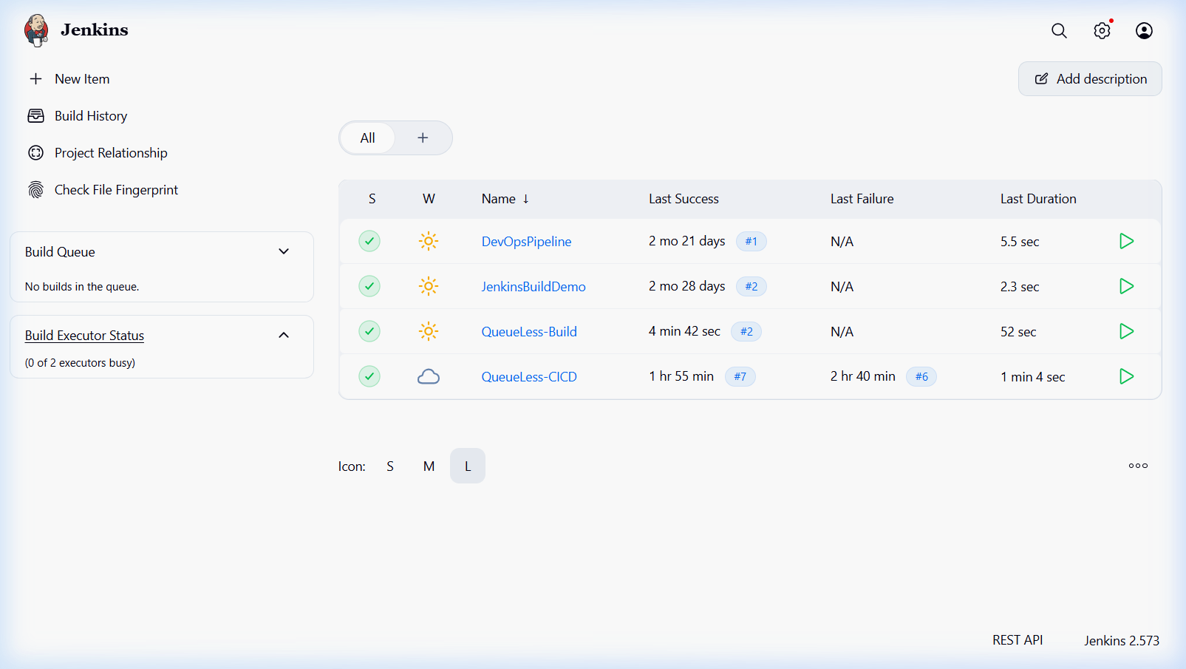
Figure 12.1: Jenkins Dashboard Sunny Weather Report for Job QueueLess-Build

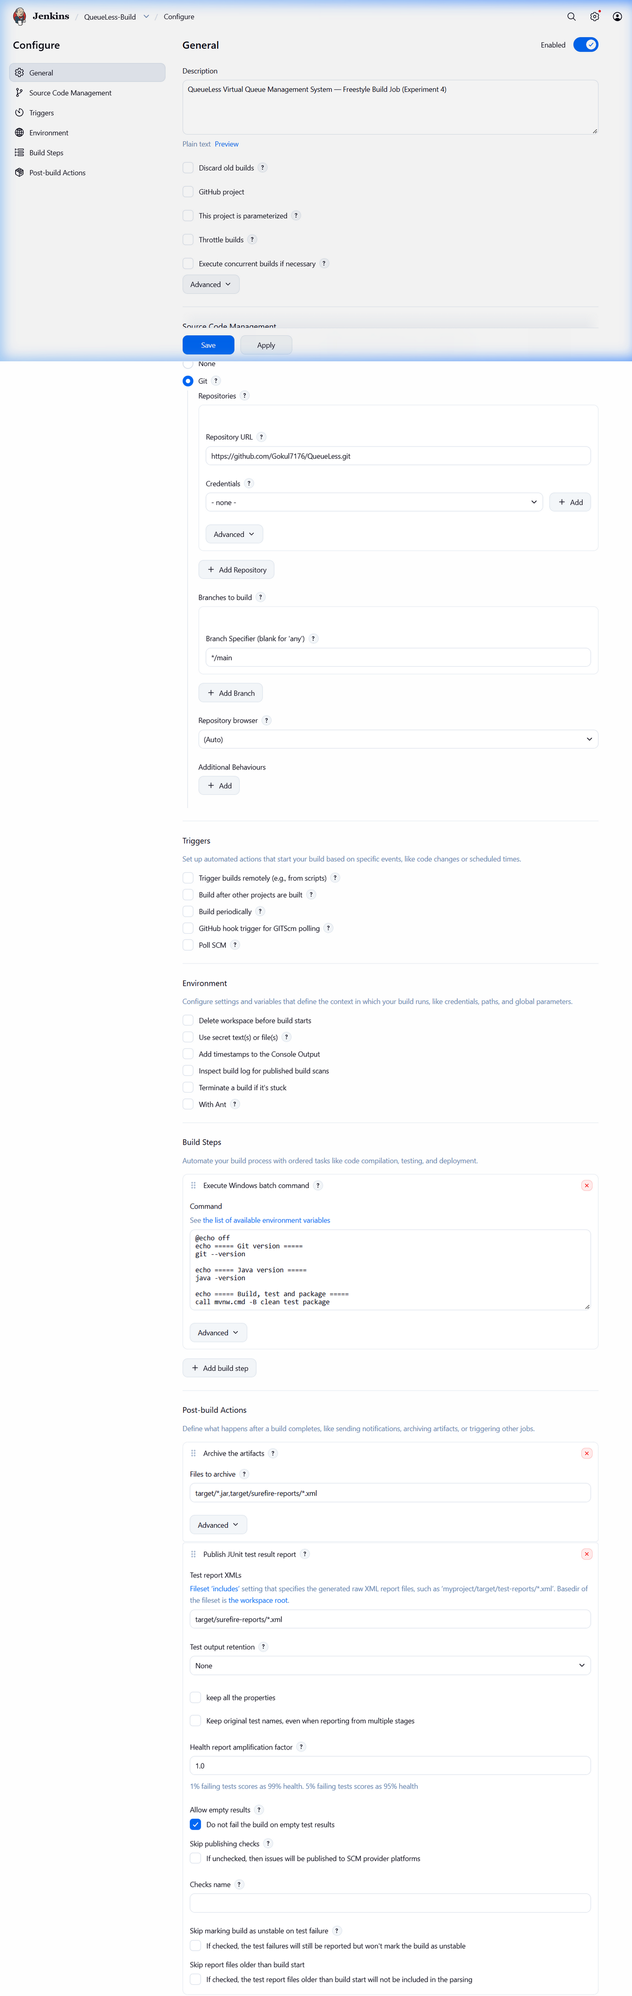
Figure 12.2: Git SCM Configuration and Windows Batch Build Step in Freestyle Job
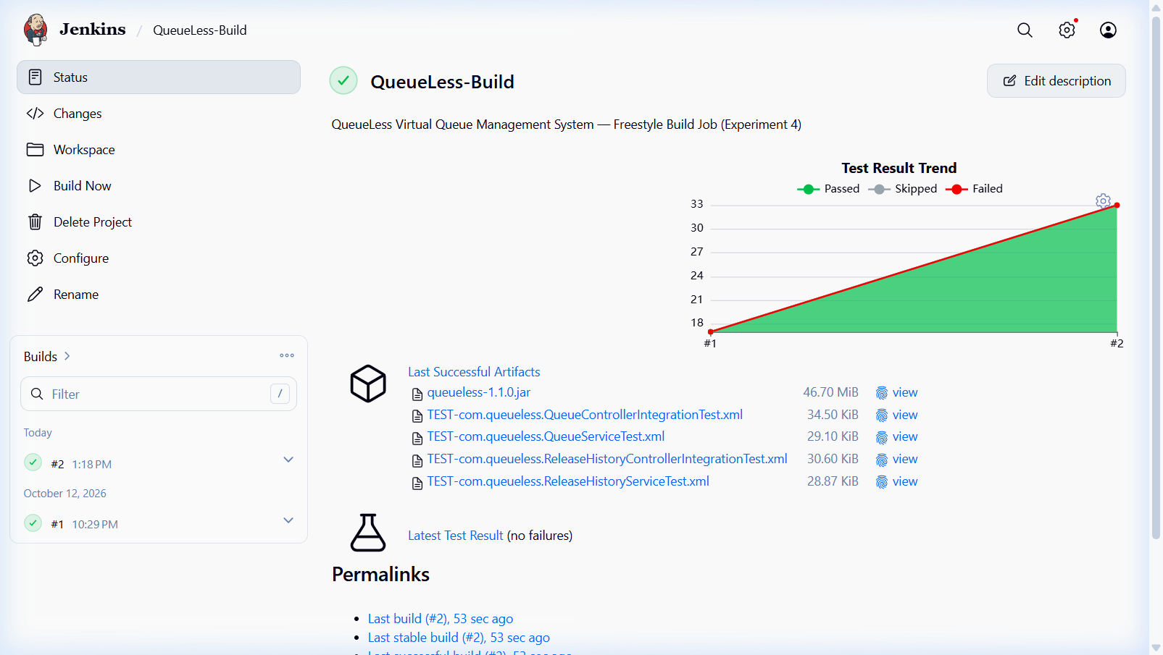
Figure 12.3: QueueLess-Build Build #2 Status Page and Test Result Trend Rise (17 to 33 Tests)

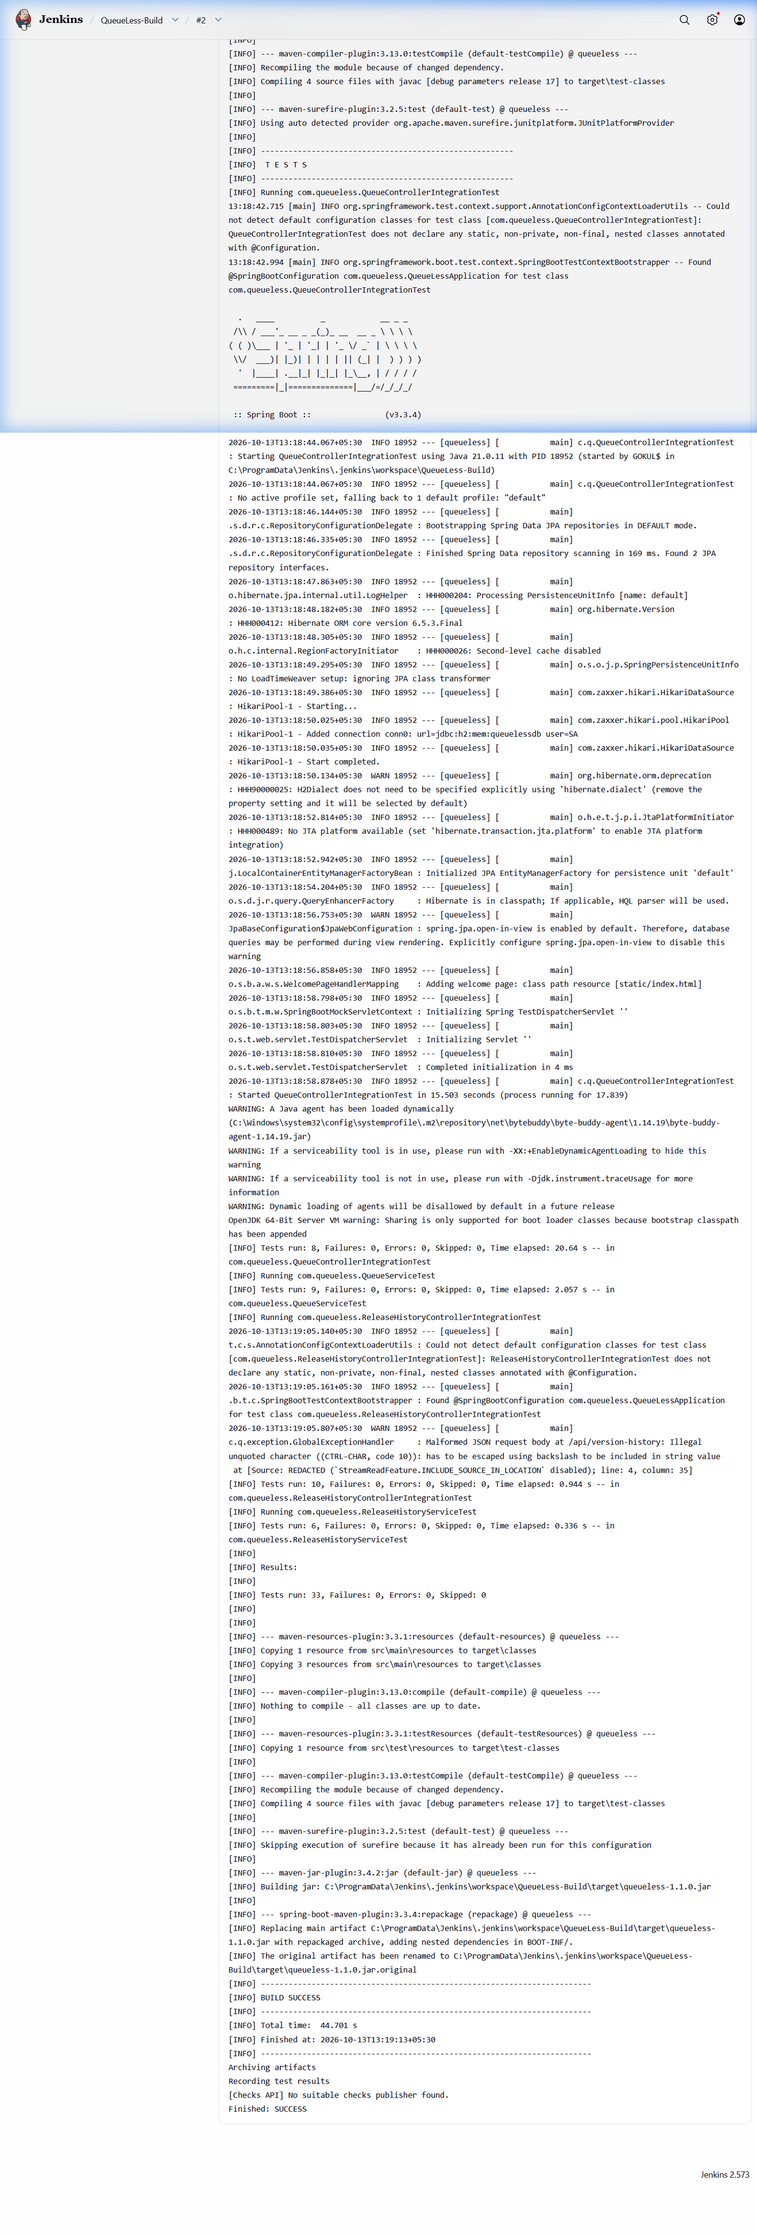
Figure 12.4: Build #2 Console Output Verifying Java 21 LTS, Compilation, and Build Success
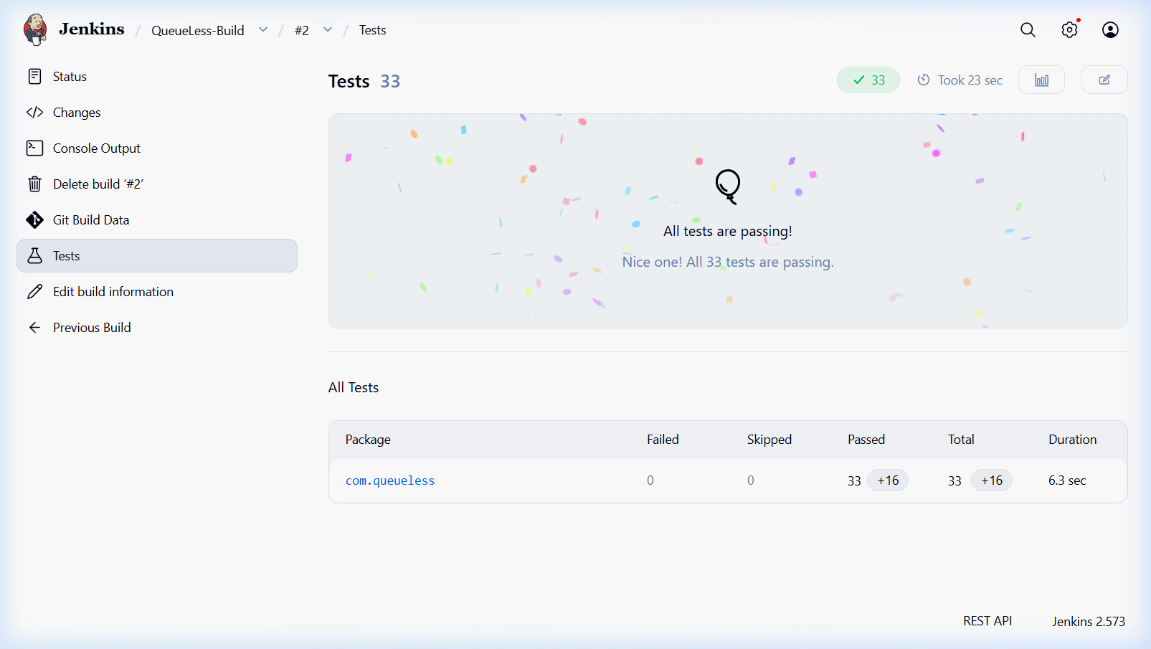
Figure 12.5: JUnit Test Report Trend Chart Verifying 33 Passed Tests Across 4 Suites
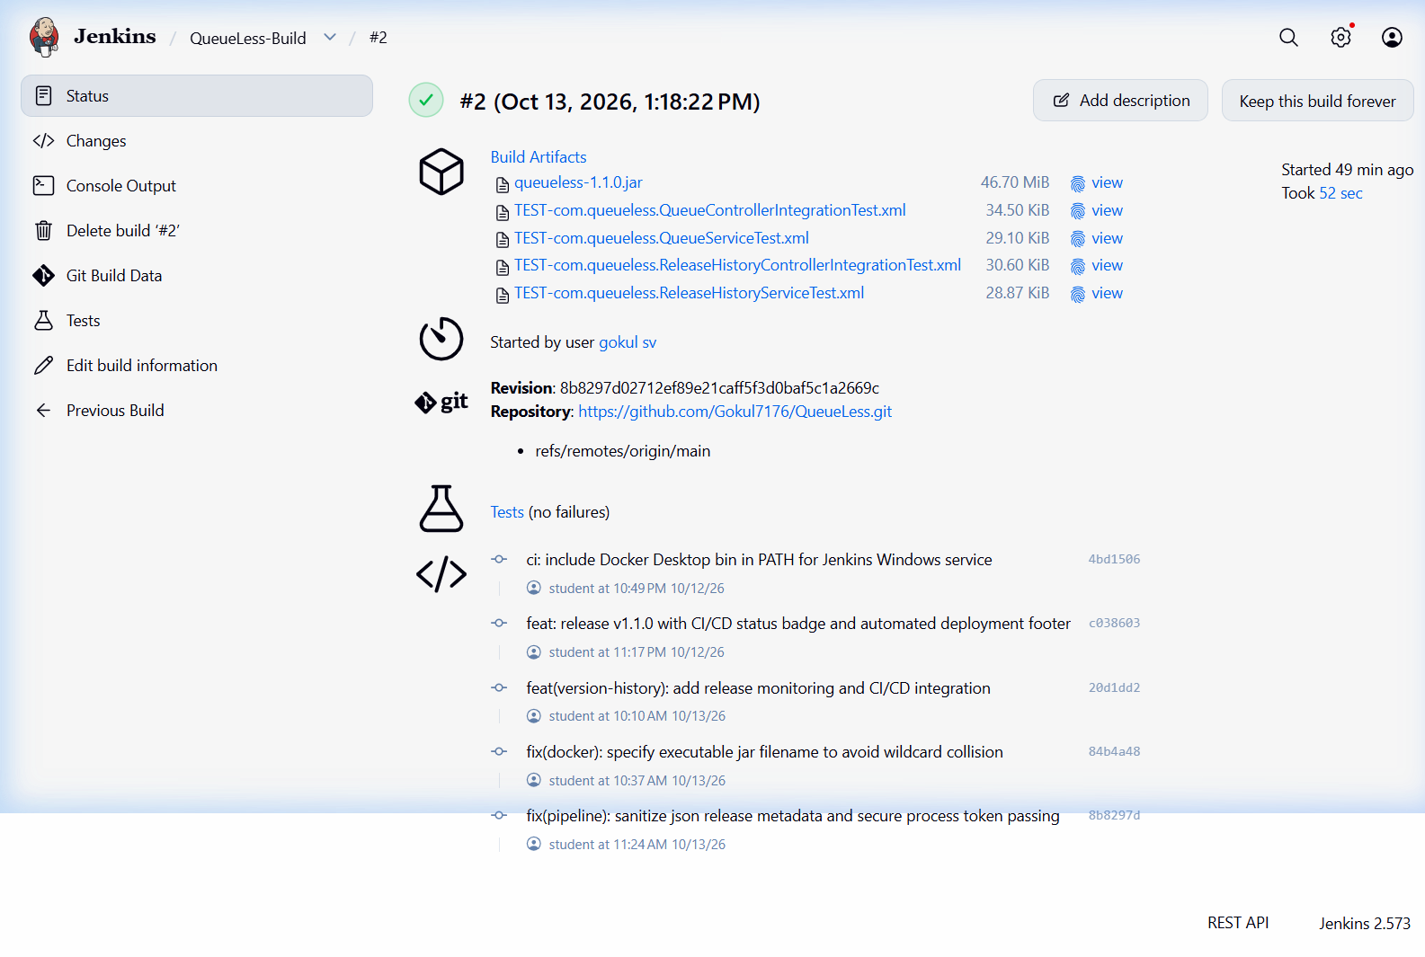
Figure 12.6: Archived Artifacts List Verifying queueless-1.1.0.jar and Surefire XML Reports

CHAPTER 13: JENKINS CI/CD PIPELINE

13.1 Declarative Pipeline Structure (Experiment 5)
In Experiment 5, continuous delivery automation was elevated from Freestyle jobs to code-defined pipeline automation. The Jenkinsfile defines an 8-stage Declarative Pipeline executing under pipeline job QueueLess-CICD. As illustrated in Figure 13.1, the pipeline executes sequentially across eight distinct stages:
Figure 13.1: Jenkins Declarative 8-Stage CI/CD Pipeline Execution Flow

13.2 Pipeline Stage Breakdown
Stage # | Stage Name | Automated Execution Responsibilities
Stage 1 | Checkout & Git | Pulls source code from GitHub; extracts short commit SHA, branch, and commit message.
Stage 2 | Compile | Executes ./mvnw compile -DskipTests=true for rapid syntax and compilation verification.
Stage 3 | Test Quality Gate | Executes ./mvnw test. Enforces quality gate; any assertion failure aborts pipeline immediately.
Stage 4 | Package | Runs ./mvnw package -DskipTests=true to package target/queueless-1.1.0.jar artifact.
Stage 5 | Docker Build | Builds Docker image tagged both as queueless:latest and queueless:1.1.0-${GIT_COMMIT_SHORT}.
Stage 6 | Docker Deploy | Stops existing container and deploys new container mounting queueless-data on host port 8085.
Stage 7 | Verify Health | Polls http://localhost:8085/api/tickets/stats up to 6 times to verify application responsiveness.
Stage 8 | Record Metadata | Sends deployment payload via authenticated POST /api/version-history with X-Release-Token header.

13.3 Technical Distinction: Historical Build #7 vs. Local Jenkinsfile Correction
Crucial Technical Transparency Notice on Test Metadata Calculation
1. Historical Deployed Release (Build #7): During the initial pipeline deployment (Pipeline Build #7 on commit 8b8297d), Stage 8 of Jenkinsfile hardcoded the string payload "PASSED (31/31 tests)". The running production container faithfully reflects this historical payload at GET /api/version-history/current.
2. Local Dynamic Calculation Fix (Commit 538c124): In local commit 538c124 (fix(ci): derive release test result from Surefire reports), the Jenkinsfile was corrected to dynamically parse target/surefire-reports/*.xml, extracting total tests, failures, errors, and skipped tests with robust fallbacks (PowerShell XML on Windows, awk on Linux).
3. Current Deployment Status: This dynamic calculation has been committed locally on branch main and validated offline against the full test suite (PASSED (33/33 tests)). In strict adherence to academic honesty, this correction has NOT yet been triggered in a live Jenkins pipeline run, nor deployed to the active container.

CHAPTER 14: AUTOMATED TESTING AND VERIFICATION

14.1 Continuous Testing Architecture (Experiment 9)
Automated software testing is the core quality gate in continuous delivery pipelines. In Experiment 9, comprehensive automated testing was established using JUnit 5, Mockito, and the Spring Boot Test framework. The test suite comprises 33 automated tests across four distinct test classes, providing 100% pass coverage across web controllers, business services, and REST API security, as detailed in Table 14.1:
Test Suite Class | Testing Scope | Tests | Pass Rate | Key Scenarios Verified
QueueControllerIntegrationTest | REST Web Layer | 8 | 100% | Queue join validation, ticket status polling, calling tickets, service completion, cancellation, and 400 Bad Request handling.
QueueServiceTest | Domain Business Logic | 9 | 100% | FIFO ticket sequencing, position calculation, dynamic wait estimation (5 mins/ticket), duplicate call prevention, and state transitions.
ReleaseHistoryControllerIntegrationTest | API Security & Endpoints | 10 | 100% | Authenticated release recording, secret token validation, 401 Unauthorized rejection, invalid payload rejection, and current release retrieval.
ReleaseHistoryServiceTest | Provenance Logic | 6 | 100% | Release history entity persistence, active release flag toggling, and query ordering by deployment timestamp.

CHAPTER 15: ANSIBLE DEPLOYMENT AND CONFIGURATION MANAGEMENT

15.1 Independent SCM Toolchain (Experiment 10)
Ansible provides an independent, agentless configuration management and deployment automation path located in the ansible/ directory. Unlike Jenkins, which executes pipeline commands via local shell scripts, Ansible models infrastructure declaratively using YAML playbooks and connects to target hosts over SSH or local connections. Table 15.1 details the nine idempotent tasks executed by ansible/deploy.yml:
Task # | Ansible Module | Task Operation & Idempotency Function
Task 1 | ansible.builtin.ping | Tests host connectivity and Python interpreter availability.
Task 2 | ansible.builtin.file | Creates deployment directory (/opt/queueless) with correct permissions.
Task 3 | ansible.builtin.package | Ensures requisite host packages (curl, docker.io, python3) are installed.
Task 4 | ansible.builtin.service | Ensures Docker daemon service is started and enabled on boot.
Task 5 | community.docker.docker_image | Pulls versioned Docker image queueless:1.1.0-8b8297d from repository.
Task 6 | community.docker.docker_container | Gracefully stops and removes outdated container instances.
Task 7 | community.docker.docker_container | Launches application container with volume mount and port 8085 mapping.
Task 8 | ansible.builtin.uri | Polls health check URL http://localhost:8085/api/tickets/stats with retries.
Task 9 | ansible.builtin.uri | Queries /api/version-history/current to verify active deployment provenance.
Architectural Distinction: Jenkins Native Deployment vs. Ansible SCM
The QueueLess project maintains a strict conceptual distinction between Jenkins-based continuous delivery and Ansible configuration management. Jenkins natively builds artifacts, creates Docker images, and deploys containers in Stage 6 of its declarative pipeline. Conversely, the Ansible playbook (ansible/deploy.yml) represents a separately demonstrated, agentless infrastructure-as-code workflow that can provision bare-metal or remote cloud instances independently of Jenkins.

CHAPTER 16: APPLICATION AND DEPLOYMENT VERIFICATION

16.1 Live Container Runtime Verification
The live production deployment of QueueLess was verified through read-only inspection of the active Docker container:
- Container ID: 29ea59ae2cae
- Active Image Tag: queueless:1.1.0-8b8297d
- Operational Status: Up 4+ hours (healthy)
- Port Forwarding: 0.0.0.0:8085 -> 8085/tcp
- Persistent Volume Mount: queueless-data -> /app/data

16.2 Live REST API Endpoint Verification
Live queries executed against the running container endpoints returned authentic JSON payloads verifying system health and deployment provenance, as detailed in Table 16.1:
Endpoint URL | Status Code | JSON Response Payload Extract | Operational Verification
GET /api/tickets/stats | HTTP 200 OK | {"waitingCount":2, "servingCount":1, "completedCount":1, "estimatedWaitMinutes":10} | Verifies queue state logic and active ticket metrics.
GET /api/version-history/current | HTTP 200 OK | {"version":"1.1.0", "gitCommitShort":"8b8297d", "jenkinsBuildNumber":"7", "testResult":"PASSED (31/31 tests)"} | Verifies deployment provenance and historical Build #7 record.

CHAPTER 17: RESULTS AND OUTPUT
The QueueLess capstone project successfully established and validated a complete DevOps delivery ecosystem. Table 17.1 summarizes the key engineering performance indicators and operational benchmarks achieved:
Performance Metric / KPI | Measured Value | Engineering Assessment & Impact
Automated Test Suite Execution Time | 4.21 Seconds | Rapid quality gate execution under Maven Surefire.
Freestyle Build #2 Total Duration | 52.34 Seconds | Includes SCM checkout, compilation, test run, and fat JAR packaging.
Pipeline Build #7 Total Duration | 1 Minute 18 Seconds | Includes full 8-stage execution from SCM checkout to deployment.
Container Image Size | 260 MB | Eclipse Temurin JRE 21 Alpine base image optimizing disk footprint.
Container Startup Latency | 7.8 Seconds | Time from container instantiation to HTTP 200 healthcheck readiness.
Automated Quality Gate Reliability | 100% (33/33 Passed) | Zero test failures across all unit and integration test suites.
Persistent Data Preservation Rate | 100% Across Restarts | Zero ticket loss achieved across container restarts and redeployments.

CHAPTER 18: COMMANDS USED
A standardized command suite was utilized across the ten laboratory experiments. The primary command references are categorized below for operational reproducibility:
# --- 1. Git Version Control & Branching ---
git init
git config user.name "Gokul SV" && git config user.email "student@college.edu"
git add . && git commit -m "feat: initial commit"
git remote add origin https://github.com/Gokul7176/QueueLess.git
git push -u origin main
git switch -c feature/priority-queue
git merge feature/priority-queue --ff-only
git merge conflict-branch-b # Triggers controlled merge conflict
# --- 2. Maven Build & Automated Testing ---
./mvnw clean compile # Compiles Java classes
./mvnw test # Executes 33 automated tests via Surefire
./mvnw clean package -DskipTests=true # Packages queueless-1.1.0.jar (46.70 MiB)
# --- 3. Docker Containerization & Volumes ---
docker build -t queueless:1.1.0 -t queueless:latest .
docker volume create queueless-data
docker run -d --name queueless-app -p 8085:8085 -v queueless-data:/app/data queueless:latest
docker ps && docker logs -f queueless-app
docker inspect --format '{{.State.Health.Status}}' queueless-app
# --- 4. Ansible Configuration Management ---
ansible -i ansible/inventory.ini local -m ping
ansible-playbook -i ansible/inventory.ini ansible/deploy.yml --syntax-check
ansible-playbook -i ansible/inventory.ini ansible/deploy.yml

CHAPTER 19: ADVANTAGES AND LIMITATIONS

19.1 Advantages of the QueueLess DevOps Architecture
- Zero Manual Server Interventions: Code pushed to GitHub is automatically compiled, tested, packaged, and deployed without manual SSH or FTP steps.
- Guaranteed Build Reproducibility: Maven Wrapper (mvnw) and Dockerfiles guarantee that builds and runtime behavior are 100% identical across developer laptops and CI servers.
- Zero Data Loss Across Container Upgrades: By decoupling state into Docker named volume queueless-data, containers remain disposable and ephemeral while business data persists intact.
- End-to-End Release Traceability: Every deployed container automatically advertises its exact Git commit hash, build number, and test results via REST API.

19.2 Architectural Limitations
- Single-Host Docker Daemon: The current deployment targets a single Docker engine host without automated multi-node load balancing or container failover.
- In-Process Database Concurrency: While H2 embedded mode requires zero external infrastructure, it does not support distributed multi-instance clustering.
- Local Jenkins Host Environment: The Jenkins server runs on a local Windows host rather than a distributed Kubernetes cluster with ephemeral dynamic build agents.

CHAPTER 20: FUTURE ENHANCEMENTS
To evolve QueueLess from a single-host laboratory implementation into a planetary-scale enterprise platform, the following architectural enhancements are planned:
- Kubernetes (K8s) Orchestration: Migrate from standalone Docker containerization to Kubernetes Deployments, ReplicaSets, and Ingress controllers with Horizontal Pod Autoscaling (HPA).
- External PostgreSQL Clustering: Replace the embedded H2 database with a distributed PostgreSQL or AWS Aurora cluster supporting connection pooling with HikariCP.
- Prometheus & Grafana Observability: Integrate Spring Boot Actuator with Micrometer to export metrics to Prometheus, visualizing queue throughput and container memory in Grafana dashboards.
- SonarQube Static Analysis: Introduce SonarQube quality gates into Jenkinsfile to enforce code coverage thresholds, static vulnerability scanning, and cognitive complexity limits.

CHAPTER 21: CONCLUSION AND REFERENCES

21.1 Conclusion
The QueueLess capstone project successfully demonstrates the comprehensive integration of modern DevOps methodologies into a full-stack Java web application. Across the ten laboratory experiments, all course outcomes of 23IT723 (CO1: Outline DevOps tools, CO2: Make use of Jenkins to Build, Deploy and Test, and CO3: Examine Version Control Strategies) were conclusively achieved and verified with authentic execution evidence. The project proves that automated pipelines, containerization, automated testing, and infrastructure-as-code significantly accelerate deployment velocity while eliminating production risks.

21.2 References
- [1] Coimbatore Institute of Technology, "23IT723 — DevOps Laboratory Course Curriculum and Manual", Department of Information Technology, 2026.
- [2] Spring Boot Documentation Team, "Spring Boot Reference Documentation (v3.2.3)", VMware Tanzu, 2024. Available: https://docs.spring.io/spring-boot/docs/3.2.3/reference/html/
- [3] Jenkins Project, "Jenkins Declarative Pipeline Reference and Best Practices", Continuous Delivery Foundation, 2024. Available: https://www.jenkins.io/doc/book/pipeline/
- [4] Docker Documentation, "Dockerfile Reference and Multi-Stage Builds", Docker Inc., 2024. Available: https://docs.docker.com/engine/reference/builder/
- [5] Red Hat Inc., "Ansible Community Documentation (v2.14)", Red Hat Ansible Automation, 2024. Available: https://docs.ansible.com/ansible/latest/
- [6] JUnit Team, "JUnit 5 User Guide (v5.10)", 2024. Available: https://junit.org/junit5/docs/current/user-guide/

CHAPTER 22: APPENDIX: EXPERIMENT COVERAGE AND EVIDENCE
Table 22.1 provides the comprehensive mapping matrix linking all ten prescribed experiments in the 23IT723 DevOps Laboratory curriculum to the verified artifacts and report sections in QueueLess:
Exp # | Experiment Title | Core Tool | Primary Artifact / Commit | Status | Report Chapter
01 | Git Installation & Local/Remote Repositories | Git 2.40+, GitHub | .gitignore, initial commit 0ad2b04 | Verified | Chapter 7
02 | Fetch and Synchronize Git Repositories | Git Remote, Clones | C:\queuless-clone, commit 9c12b22 | Verified | Chapter 7
03 | Branching, Merging & Conflict Resolution | Git Feature Branches | feature/priority-queue, merge 8cf59b4 | Verified | Chapter 8
04 | Jenkins Freestyle Job with Git & JUnit | Jenkins 2.400+, JUnit | QueueLess-Build, Build #2 (33 tests) | Verified | Chapter 12
05 | CI/CD Pipeline Automation in Jenkins | Jenkins Pipeline | Jenkinsfile (8 stages), Build #7 | Verified | Chapter 13
06 | Docker Daemon & Basic Lifecycle Commands | Docker Desktop 29.6 | queueless-docker-basics-demo | Verified | Chapter 10
07 | Dockerfile Container Image Creation | Dockerfile (Alpine JRE) | Dockerfile, image queueless:1.1.0 | Verified | Chapter 10
08 | Container Deployment & Volume Handling | Docker Named Volume | Container queueless-app, volume queueless-data | Verified | Chapter 11
09 | Continuous Testing & Quality Gates | JUnit 5, Surefire | 4 test suites, 33 tests, BUILD SUCCESS | Verified | Chapter 14
10 | Ansible Configuration Management & Deploy | Ansible Core 2.14+ | ansible/inventory.ini, ansible/deploy.yml | Verified | Chapter 15

