**PHASE 2 Project Title: NOISE POLLUTION MONITORING**

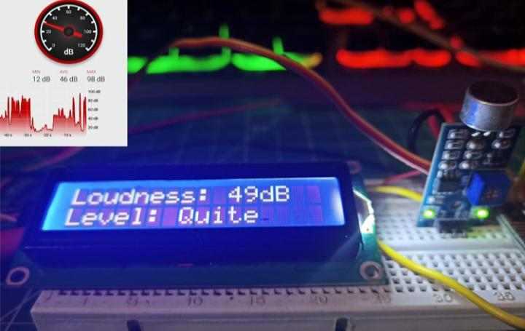**Name : S.GOKUL( 210521205017)**

**Introduction**

The innovation phase may involve collaboration with experts in IOT , data analysis, and environmental science to create an effective and impactful noise pollution monitoring system. The document outlines the comprehensive steps that will be taken to put our design concept into practice.

**Step 1: Refine Problem Definition**

* **Review Problem Statement**: Revisit the problem statement to ensure clarity and relevance.
* **Gather Additional Insights:** Consult with stakeholders, environmental experts, and target communities to gather more insights.

**Step 2: Define Technical Requirements**

* **Sensor Selection:** Determine the types of sensors required for data collection (e.g., sound, air quality, water quality, temperature, humidity, etc.).
* **Sensor Placement**: Position the sensors strategically in the area you want to monitor. Ensure that they are exposed to the noise sources and located at representative points.
* **Data Storage:** Decide on the data storage solutions (local or cloud-based databases) and data management tools.
* **Communication Protocols:** Choose the appropriate communication protocols for data ttransmissio.
* **Data Analysis Tools:** Identify the data analysis tools and algorithms to be used for deriving actionable insights.

**Step 3: Develop Hardware and Software**

* **Hardware Development:**
  + Identify IoT hardware components (sensors, microcontrollers, communication modules).
  + Create a detailed hardware architecture diagram.
  + Source the required hardware components.
  + Assemble and test the hardware components.
* **Software Development:**
  + Develop firmware for microcontrollers to collect and transmit data.
  + Develop server-side software for data reception, storage, and analysis.
  + Create a user interface (UI) for data visualization and user interaction.
  + Ensure data security and privacy measures are implemented.

**Step 4: Prototyping**

* **Create Prototypes**:
  + Build a prototype system with a limited set of sensors.
  + Test the prototype in controlled environments.
  + Refine the hardware and software based on initial testing.

**Step 5: Real-world Testing**

* **Deploy Prototypes in Real Environments:**
  + Install prototypes in target environmental monitoring locations.
  + Monitor and collect real-time data over an extended period.
  + Address technical issues and refine the system based on field testing results.

**Step 6: User Feedback**

* **Gather User Feedback:**
  + Engage with stakeholders and user groups for feedback.
  + Identify areas for improvement and additional features.
  + Iteratively refine the system based on feedback.

**Step 7: Data Analysis and Insights**

* **Data Analysis:**
  + Use collected data to analyze environmental conditions and trends.
  + Apply machine learning and AI algorithms for predictive analysis.
  + Generate actionable insights and reports for decision-makers.

**Step 8: Sustainability and Community Engagement**

* **Community Involvement**:
  + Engage with the community to raise awareness of noise pollution issues and involve residents in the monitoring process.
  + Implement community engagement programs, educational initiatives, and awareness campaigns.
  + Enable community members to access and interpret environmental data.
  + Promote sustainable practices based on insights.

**Step 9: Regulatory Compliance**

* **Ensure Regulatory Compliance**:
  + Ensure that your noise monitoring system complies with local noise regulations and standards.
  + This may involve periodic calibration and validation of your sensors.

**Step 10: Documentation and Reporting**

* **Document the Entire Process**:
  + Create detailed documentation for hardware and software components.
  + Prepare reports on field testing, user feedback, and data analysis.
  + Share findings and progress with stakeholders and project sponsors.

**Conclusion**

The Innovation phase is a crucial step in turning our design thinking concept into a practical solution for IOT based Noise pollution Monitoring. By following these steps, we aim to address the noise pollution Monitoringl challenges effectively and make a positive impact on sustainability efforts.