NLP ASSIGNMENT 1
CODE:
pip install nltk
import nltk
import string
import re
import spacy
from nltk.tokenize import word_tokenize
from nltk.corpus import stopwords
from nltk.stem import PorterStemmer, WordNetLemmatizer
from nltk import pos_tag
# Download required datasets
resources = [
'punkt',
'punkt_tab',
'stopwords',
'wordnet',
'omw-1.4',
'averaged_perceptron_tagger',
'averaged_perceptron_tagger_eng',
'maxent_ne_chunker',
'maxent_ne_chunker_tab',
'words'
]

for r in resources:
nltk.download(r)

nlp = spacy.load("en_core_web_sm")
text = """
My name is Gokul, and I am from Malayattoor.
I completed my schooling at Sree Sarada Vidyalaya, Mattoor,
Kerala, and I am currently pursuing a Bachelor of Technology
(B.Tech) degree in Artificial Intelligence and Data Science.
I come from a family of four that has always supported me
in achieving my goals.
I am currently a sixth-semester student.
Some of my achievements include internships at InfineCode
and Genzee Technology (Robotics), along with attending a
hackathon at SCMS.
My hobbies include traveling, listening to music, watching
movies, and playing football.
I am interested in artificial intelligence, machine learning,
and robotics-related projects.
My strengths are that I like to build and figure things out
on my own, and I enjoy hands-on learning.
My weaknesses are that I have a bit of stage fear.

"""

print(text)

- lower_text = text.lower()
print(lower_text)

- no_punctuation = lower_text.translate(str.maketrans('', '', string.punctuation))
print(no_punctuation)

- no_numbers = re.sub(r'\d+', '', no_punctuation)
print(no_numbers)

- tokens = word_tokenize(no_numbers)
print(tokens)

- stop_words = set(stopwords.words("english"))
filtered_words = [word for word in tokens if word not in stop_words]
print(filtered_words)

- stemmer = PorterStemmer()
stemmed_words = [stemmer.stem(word) for word in filtered_words]
print(stemmed_words)

- lemmatizer = WordNetLemmatizer()
lemmatized_words = [lemmatizer.lemmatize(word) for word in filtered_words]
print(lemmatized_words)

- pos_tags = pos_tag(filtered_words)
print(pos_tags)

- doc = nlp(text)
print("Named Entities:\n")
for entity in doc.ents:
print(entity.text, "-->", entity.label_)

- final_text = " ".join(lemmatized_words)
- print(final_text)

SCREENSHOT:
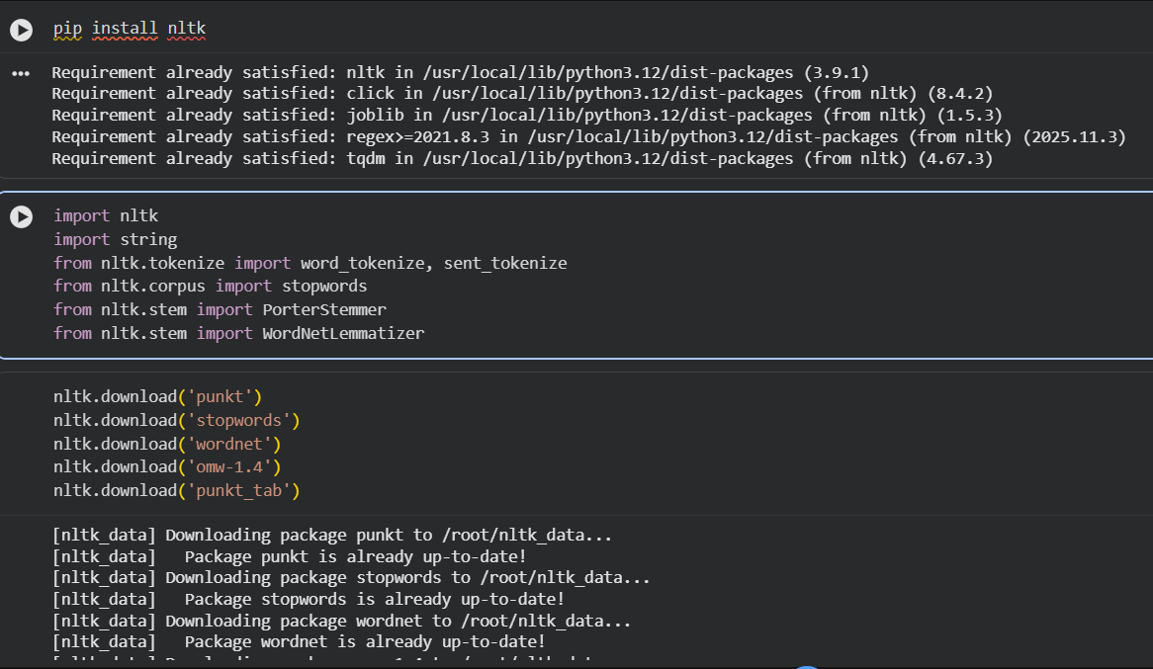

Original Text:
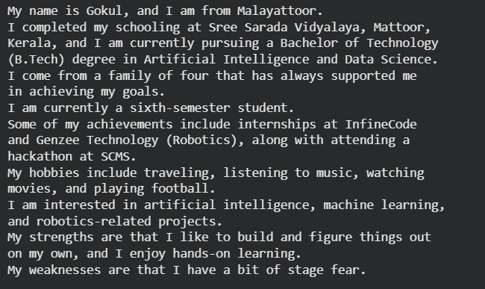
Lower case:
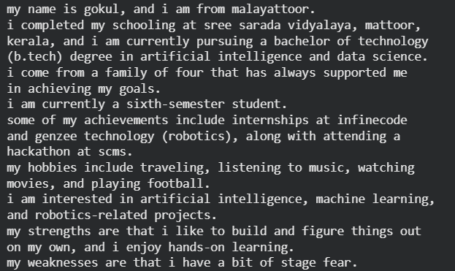
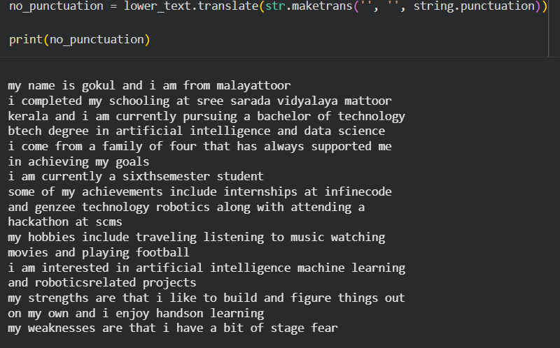
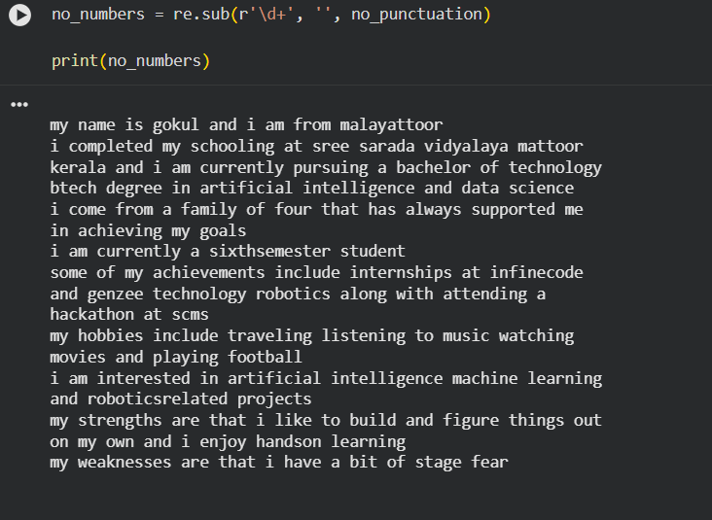
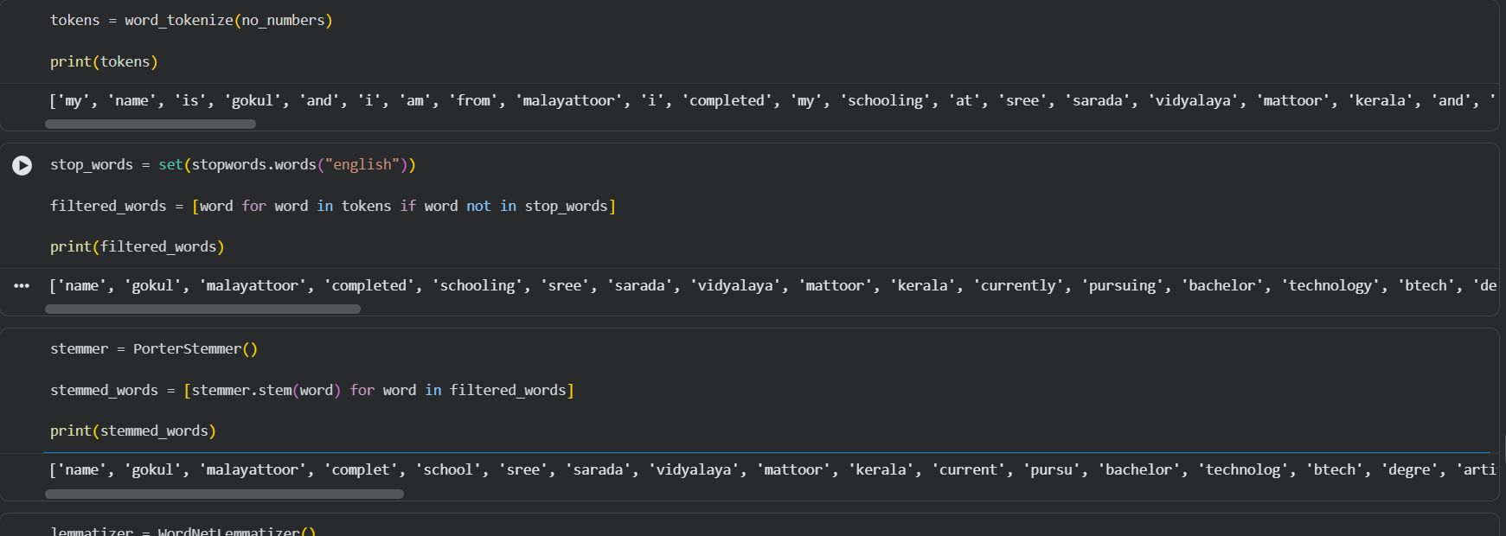
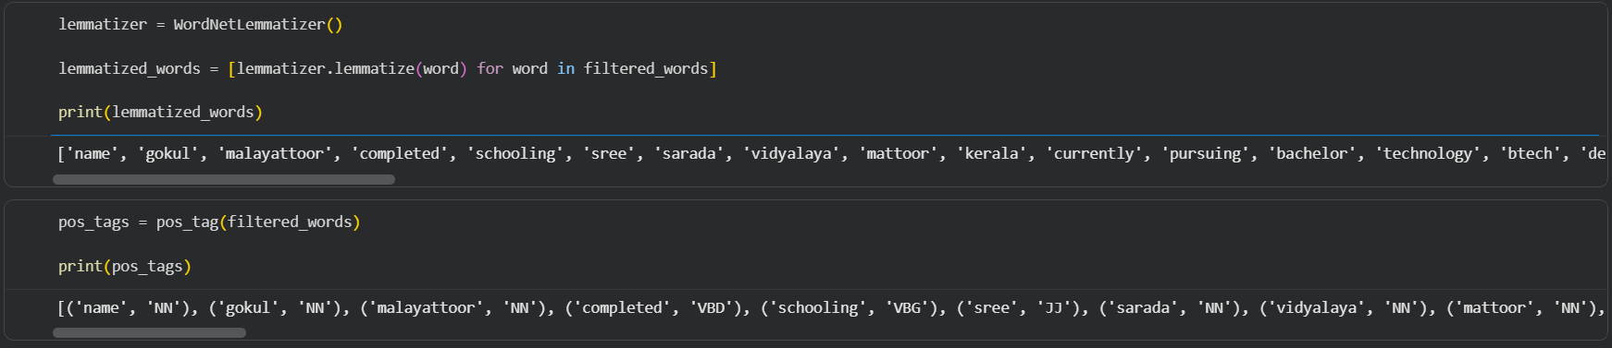
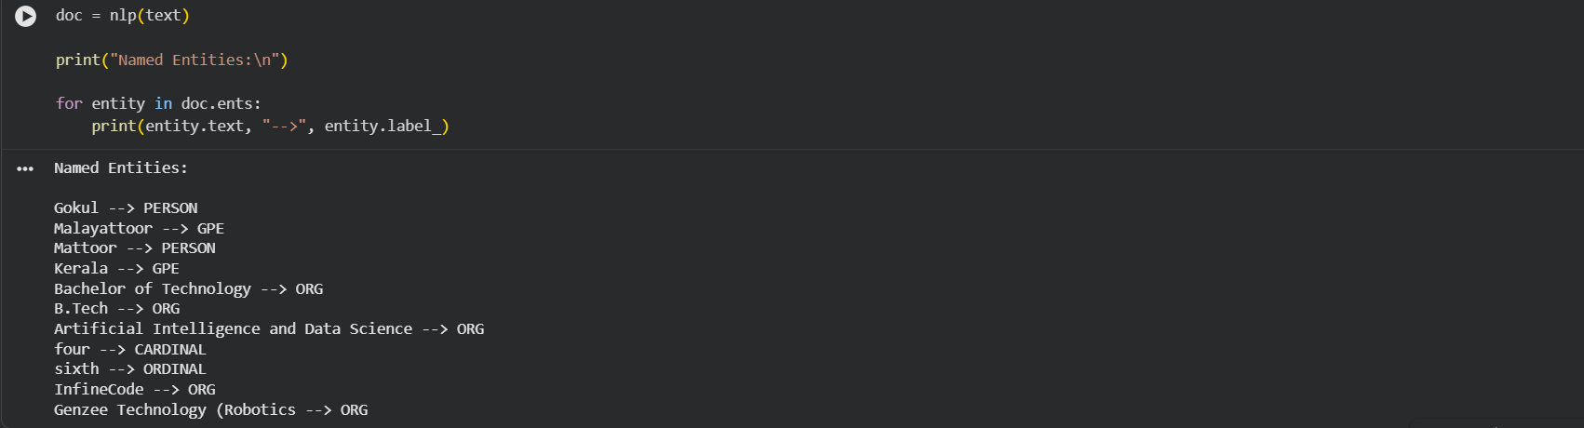

Repo link:https://github.com/GokulGNa1r/NLP

