**Week 2 – PL/SQL**

**Exercise 2: Error Handling**

**Scenario 1:** Handle exceptions during fund transfers between accounts.

**Question:** Write a stored procedure SafeTransferFunds that transfers funds between two accounts. Ensure that if any error occurs (e.g., insufficient funds), an appropriate error message is logged and the transaction is rolled back.

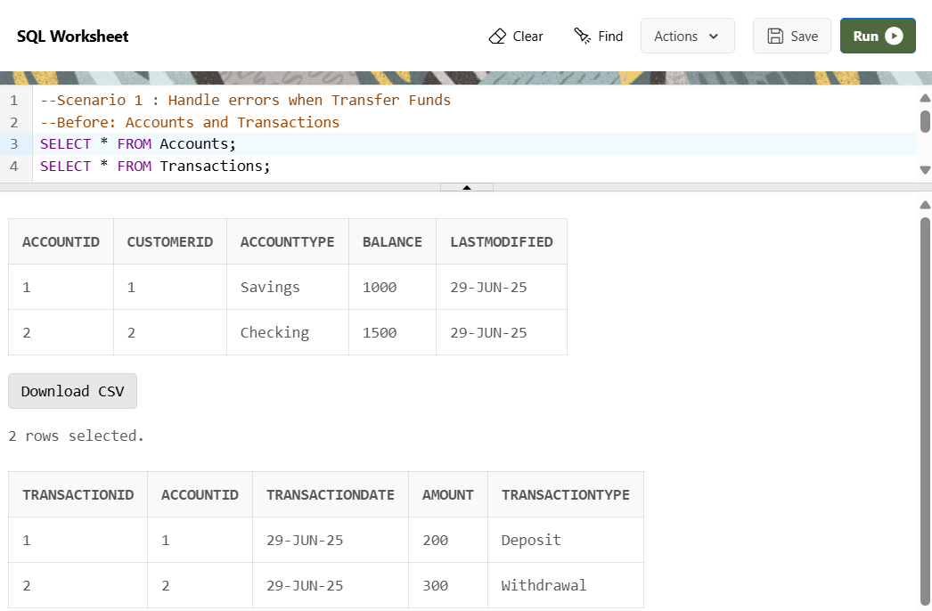

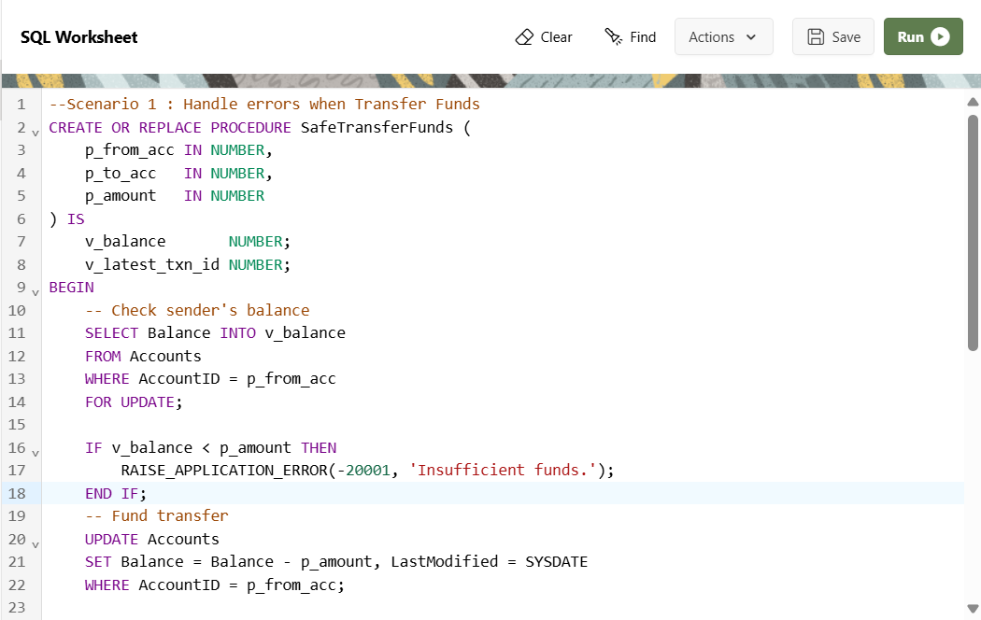

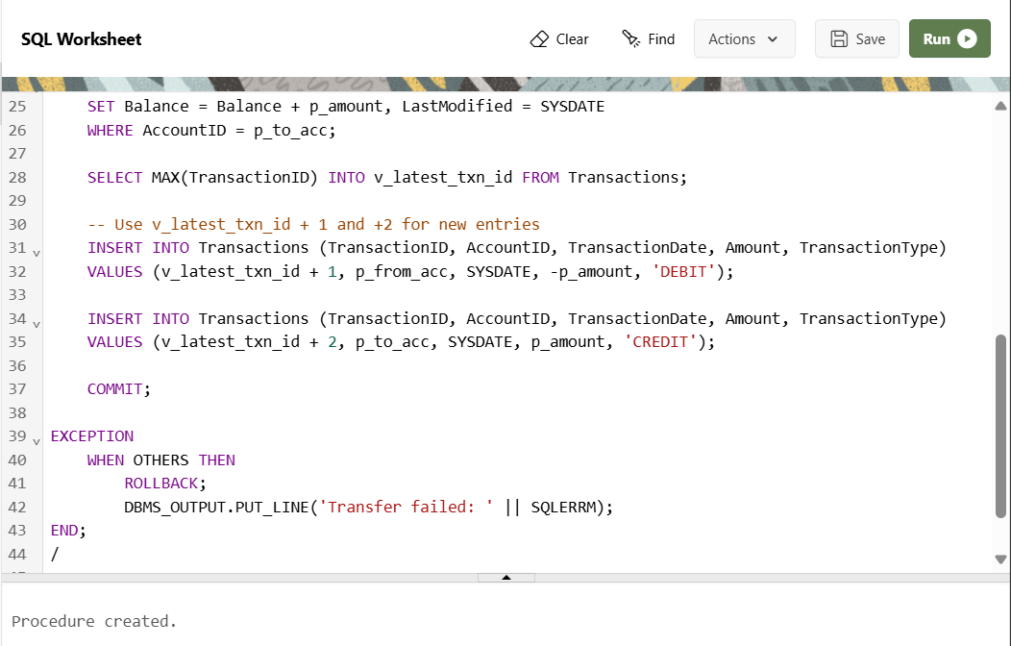

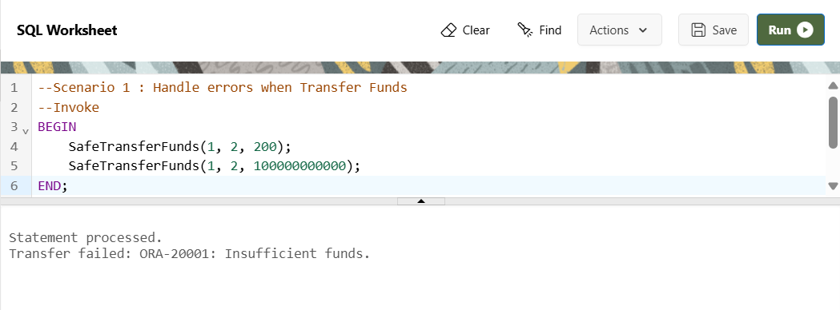

**OUTPUT**



**Scenario 2**: Manage errors when updating employee salaries.

**Question:** Write a stored procedure UpdateSalary that increases the salary of an employee by a given percentage. If the employee ID does not exist, handle the exception and log an error message.

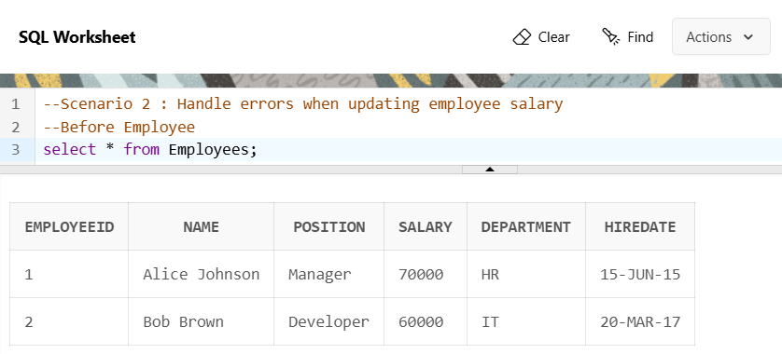

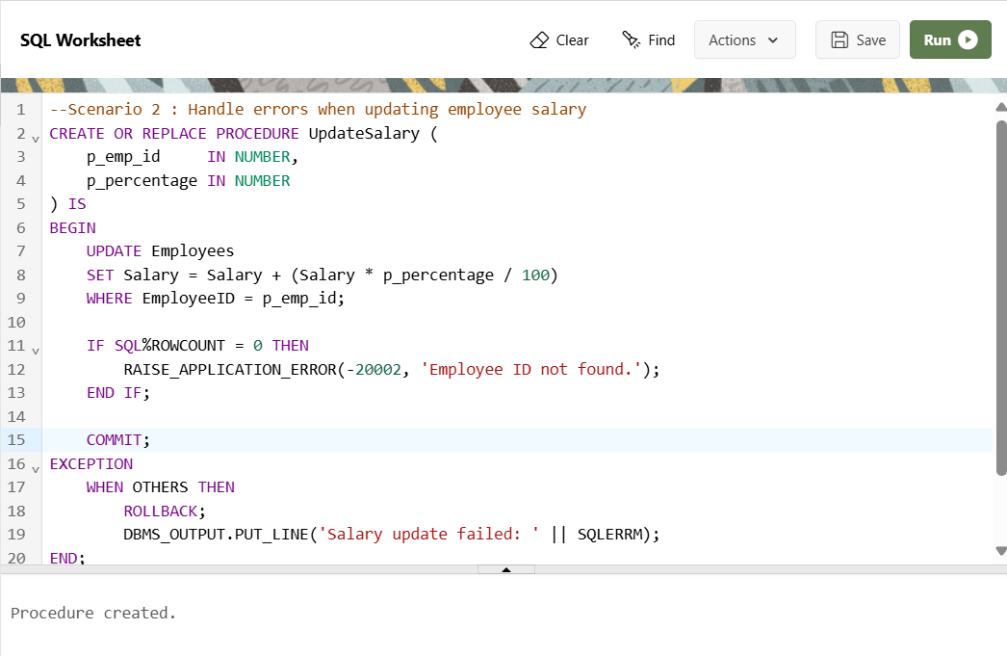

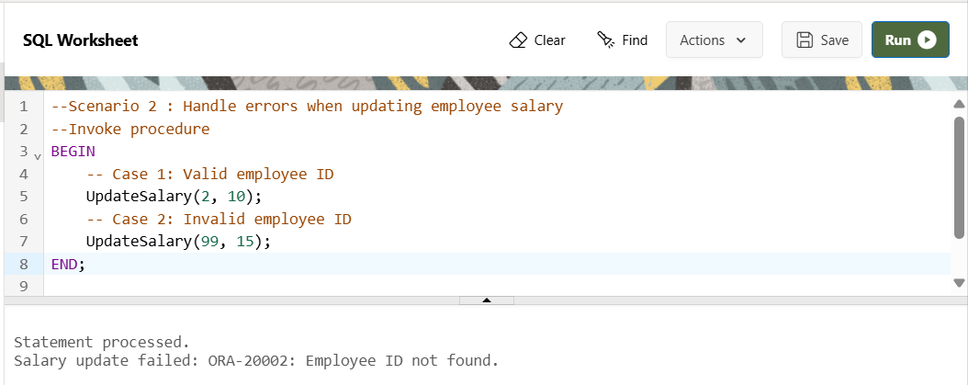

**OUTPUT**

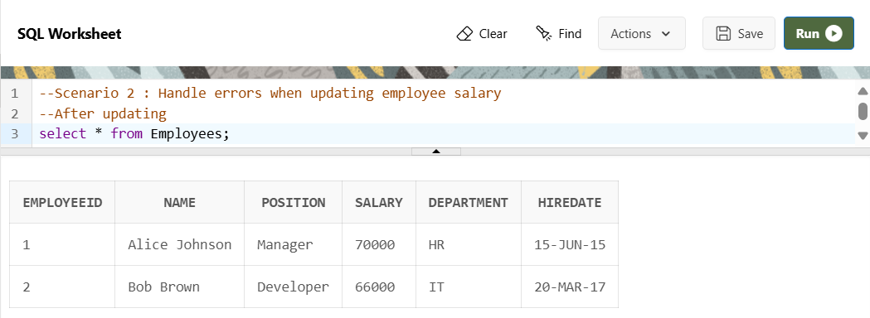

**Scenario 3:** Ensure data integrity when adding a new customer.

**Question**: Write a stored procedure AddNewCustomer that inserts a new customer into the Customers table. If a customer with the same ID already exists, handle the exception by logging an error and preventing the insertion.

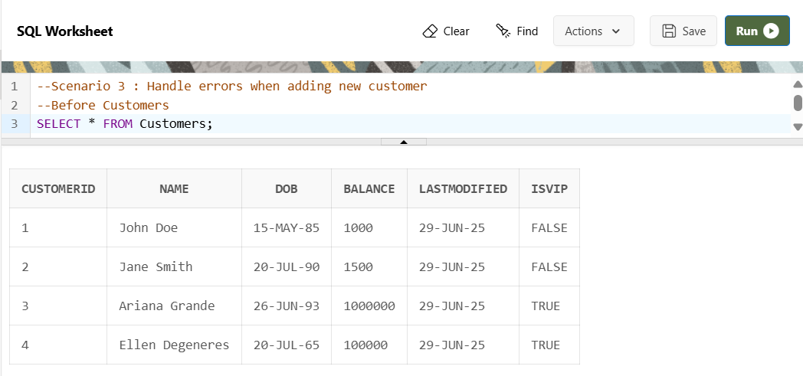

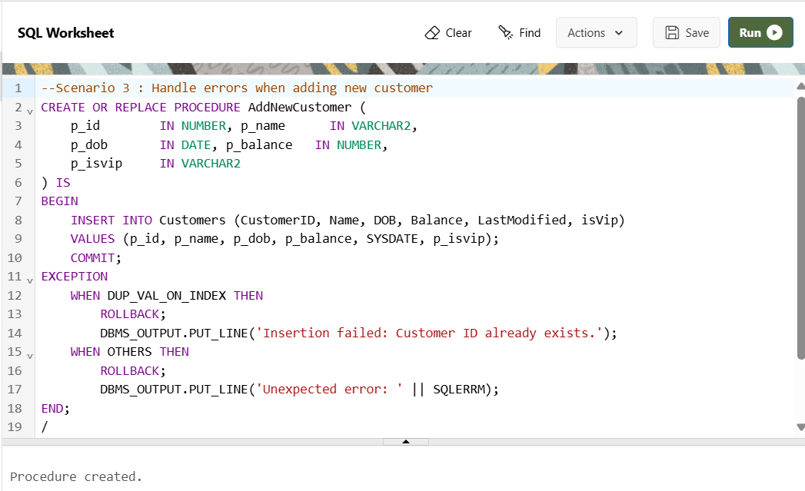

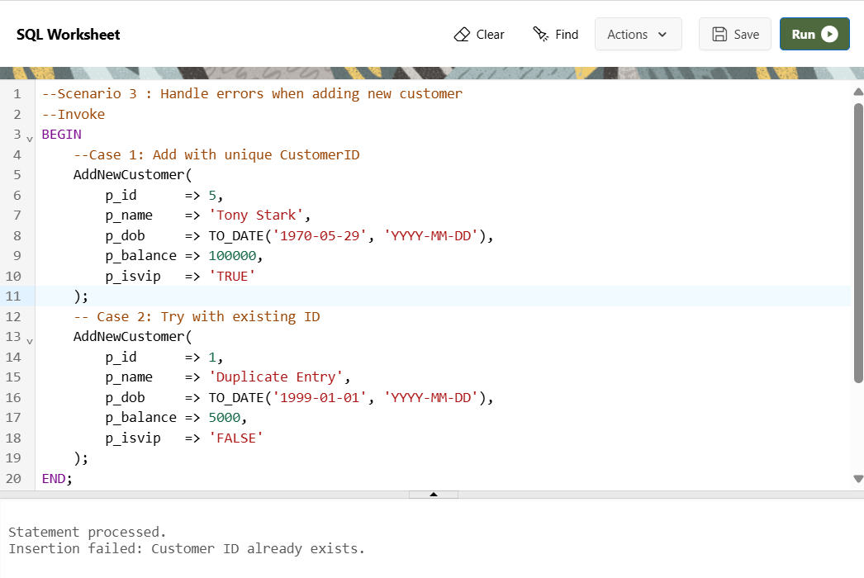

**OUTPUT**

