**IOT Based Smart Parking System**

A Project report submitted in partial fulfillment of the requirements for the degree of B.E in

Electronics And Communication Engineering

By

**R.Gokul (513221106310)**

Under the supervision of the Hod & Professor department of

Electronics And Communication Engineering

**Phase 5: Project Documentation & Submission**

In this section you will document the complete project and prepare it for submission.

**Introduction**

In recent years, the Internet of Things has been applied in many ways. The smart parking system is one part of the technology of the Internet of Things [1]. The concept of the Internet of Things starts from a device that can be traced, controlled, or monitored over the internet [2]. One of the systems of smart parking is to know the condition of parking lot via the internet. This is related to parking problems which one of them is the difficulty of knowing the condition of vacant space in the wide parking lot so that the driver spends his time just to find a parking place and tend to more difficult along with the increasing number of vehicle ownership [2-4]. Problems related to parking can be solved if the driver can be informed beforehand about the availability of parking space around the desired destination [2]. As the result, the concept of the Internet of Things applies to the smart parking system. Various approaches and research have been done to overcome parking problems. Since the early 1970s, smart parking has been implemented throughout Europe, the UK, and Japan. The initial system is displayed in the driver's parking information such as availability status and/or the amount of space available [5]. More complex smart parking incorporates more advanced technology to serve customers with different needs [6]. A recent survey conducted by the International Parking Institute [6] reflects an increasing number of innovative ideas related to parking systems. Currently, there are certain parking systems that are able to provide real-time information about available parking spaces. Such systems require efficient sensors to be placed in parking lots to monitor parking spaces and rapid data processing units to gain practical insights of data collected from various sources [2].

* **Problem statement**
* **Design thinking approach**

**Problem statement**

Once a car enters a parking garage followed by a parking space, a ping ultrasonic sensor will then be able to determine if a car is parked in the space or not.

In recent research in metropolitan cities the parking management problem can be viewed from various angles such as high vehicle density on roads.

The drivers usually waste time and effort in finding parking space and end up parking their vehicles finding a space on the street which further leads to space congestion. In worst case, people fail to find any parking space especially during peak hours and festive season.

This results in annoying issues for the drivers to park their vehicles.

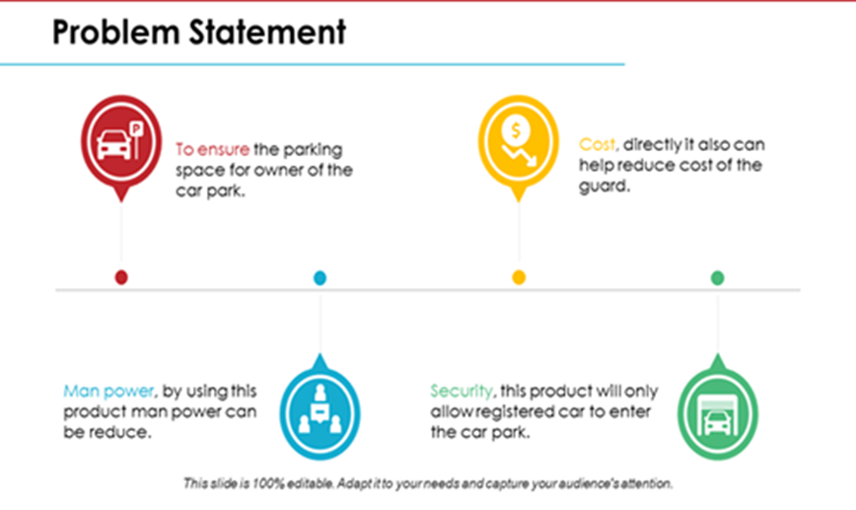

**Design thinking approach**

This model has the capacity of containing two cars. There are two sensors at the entrance to detect the presence of a car before going inside or outside of the parking lot. The other two sensors are plotted inside the parking lot to detect the car individually for each parking slot.

A DC Servo motor has been used at the entrance to open and close the gate according to the signals sent by the sensors through Arduino. The projection on the screen corresponds to the system model parking slots. This is a real time display regarding the status of the parking lot. As this is a web-based representation, anyone will be able to get the status of the parking lot by visiting the website on the URL through their cell phones, laptops, desktops and other internet supporting devices.

The model of the parking lot has two parking slots. Thus, we can park a maximum number of two cars through the system. We have used two IR sensors which when vehicle parked will show appropriate message to the user and when all the parking slots the dc motor would not open gate for the vehicle to be parked.

Displaying of appropriate message for any action which takes place in the parking zone is done effectively and efficiently.

This results in annoying issues for the drivers to park their vehicles as it is very difficult to find a parking slot.

The drivers usually waste time and effort in finding parking space and end up parking their vehicles finding a space on the street which further leads to space congestion. In worst case, people fail to find any parking space especially during peak hours and festive season**.**

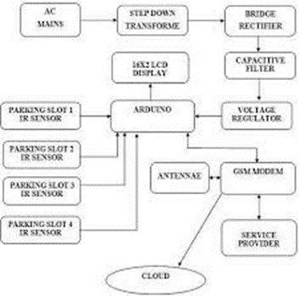

**Innovative ideas for smart parking system**

Finding a parking spot in the city is the one driving maneuver that causes drivers the most stress. However, the application of smart parking technology, according to [Libelium](https://www.libelium.com/iot-solutions/smart-parking/), a provider of technology solutions based on the Internet of Things (IoT), reduces traffic volume by 8%, gas emissions by 40%, the distance driven by a car topark by 30%, and the amount of time needed to park by 43%.

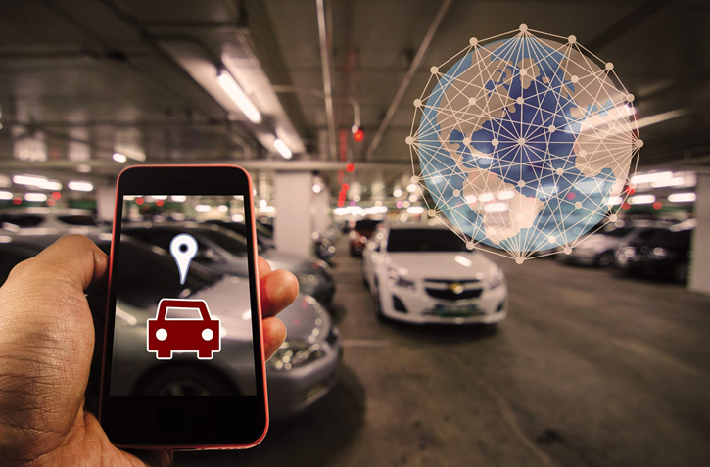

Smart parking systems are beginning to provide answers for urban transportation as a result of digitization. This system enables the acquisition of real-time data about parking availability and information about traffic and road conditions.

This is made possible through the Internet of Things and sensor technologies.The structure of smart parking is made up of several tools and procedures that serve as parking space detectors. On the one hand, the installation of cameras and/or sensors that capture, analyze, and present data and images to deliver real-time traffic occupancy statistics for the location we are going. On the other hand, an IoT cloud-based system enables the connection of various devices and the centralization of the data. The availability of parking spaces is then determined using big data analysis of the data.

In this article, you will learn about 5 hidden gems boosting corporate innovation in the smart parking industry. The +2 million companies’ [Novable](https://novable.com/startup-scouting-for-corporate-innovation/) database never disappoints.

**5 Innovative solutions in the smart parking industry**

* Voice park
* Yazamtec
* Nwave
* Smart City System
* Parquery

1. **VoicePark**

Being a key player in the parking sector has always been a priority for [VoicePark](https://www.voicepark.org/). The first step was developing an innovative smartphone app that improves and sustains urban mobility. VoicePark was the first to direct vehicles turn-by-turn to open on-street parking spaces in real-time during the test with the San Francisco Municipal Transportation Agency (SFMTA). The team managed to cut down the time it took for cars to find a parking space in San Francisco from 12.5 minutes to 45 seconds using proprietary algorithms**.**



1. **Yazamtec**

[Parking Hero Matrix](https://www.yazamtec.com/) is a blockchain-based solution for parking management, monetization, and enforcement. The technology makes it possible to incorporate any parking space – on-street, off-street, private, commercial, or individual – into a global distributed ledger.

The irreversible and unchangeable nature of the ledger enables all parties involved to transact in a highly transparent, secure, and reliable manner. They have immediate access to the settlement information, thus there is no need for expensive processing or financial reconciliations**.**

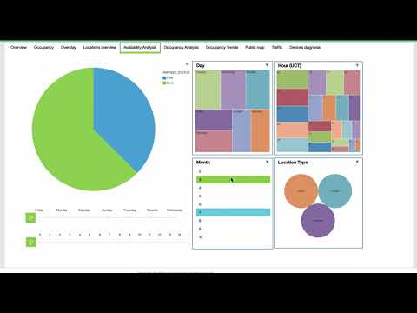

1. **Nwave**

One of the market-leading wireless parking management solutions was created by [Nwave.](https://www.nwave.io/) It assists operators of parking assets and providers of smart parking solutions in streamlining their operations.

Nwave meets and exceeds the needs of end users and parking system integrators in terms of technical accuracy, reliability, and functionality. Additionally, it eases solution installation and data/API integration.



1. **Smart City System**

[Smart city system](https://smart-city-system.com/en/home/) produces smart parking sensors that wirelessly transmit the current occupancy status of your parking spot. Their user-friendly software allows you to view the parking information, and it can also be easily linked to your current system. Parking sensors from smart city systems are entirely wireless, simple to install, and immediately operational.



1. **Parquery**

Any type of parking space, whether indoors or outside, permanent or temporary, continually or irregularly, in good or bad weather, can be searched in real-time using [Parquery](https://parquery.com/).

Parquery is a tried-and-true partner for end users seeking a smart parking solution to manage their spaces. Moreover, it serves distributors, system integrators, and parking industry manufacturers seeking a technology partner to expand their portfolio.

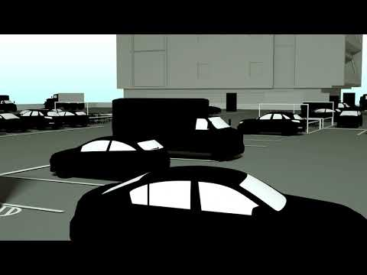

**Smart parking has many benefits:**

* Maps. Access to real-time traffic information and parking availability.
* Signage. Road-sign systems are also utilizing smart technologies in an effort to improve safety and effectively manage traffic flow. Examples include pedestrian crossings and traffic lights that alter their color or brightness in response to actual or projected traffic loads, such as peak periods.
* Detectors for vehicles. The foundation of smart parking is knowing precisely how many vehicles are present in a parking lot at any one moment. The sensor system used in this vehicle presence detection feature includes dual channel loop detectors, ultrasonic presence sensors, and LiDAR vehicle sensors. They offer accurate vehicle locations, determine whether a parking garage is full, and detect whether a parking space is free or occupied. Parking spot occupancy. In this instance, these sensors identify open parking spaces, making it easier for vehicles to find open parking places in closed areas. Drivers can see how many parking spaces are available thanks to the addition of LED indicators.

**DEVELOPMENT**

**1. Sensor Deployment**

Install IoT sensors (e.g., ultrasonic, magnetic, or infrared sensors) in each parking space to detect occupancy. These sensors should be able to communicate data wirelessly.

**2. Data Communication**

Set up a reliable communication network to transmit data from the sensors to a central server. This could be Wi-Fi, LoRa, cellular, or a combination of technologies.

**3. Central Server**

Develop a central server or cloud platform to collect and process data from the sensors. This server should be capable of handling a large volume of real-time data.

**4. User Interface**

Create a user-friendly interface for both parking lot operators and users. This interface should show real-time parking space availability and may include mobile apps and websites.

**5. Data Processing and Analysis**

Use data analytics to process the information received from sensors. This can help in identifying trends, predicting peak usage times, and optimizing parking space allocation.

**6. Mobile Apps**

Develop mobile apps for users to check parking space availability, reserve spots, and receive navigation directions to available spaces.

**7. Payment Integration**

If required, integrate payment processing into the app to allow users to pay for parking through the system.

**8. Security**

Implement robust security measures to protect user data and the system from cyber threats.

**9. Remote Monitoring and Maintenance**

Implement remote monitoring and maintenance capabilities to ensure the system operates smoothly and address any issues promptly.

**10. Scalability**

Ensure the system can scale to accommodate additional sensors or parking lots as needed.

**11. Sustainability**

Consider the environmental impact and energy efficiency of the system, as well as the use of renewable energy sources where applicable.

**12. Regulatory Compliance**

Be aware of and comply with local regulations and privacy laws that may apply to your system.

**Program**

# Import necessary libraries

from flask import Flask, request, jsonify

app = Flask(__name)

# Create a dictionary to simulate parking space occupancy status

parking_spaces = {

    'A1': False,

    'A2': False,

    'B1': False,

    'B2': False,

}

# Route to get parking space status

@app.route('/parking', methods=['GET'])

def get_parking_status():

return jsonify(parking_spaces)

# Route to update parking space status

@app.route('/parking/update', methods=['POST'])

def update_parking_status():

data = request.get_json()

space_id = data.get('space_id')

status = data.get('status')

if space_id in parking_spaces:

parking_spaces[space_id] = status

return "Parking status updated for space " + space_id

else:

return "Invalid space ID"

if _name_ == '_main_':

app.run(debug=True)

In this example, we've created a simple Flask server that allows you to:

1. Get the status of parking spaces.

2. Update the status of parking spaces using a POST request.

You would need to deploy this server on a cloud platform or a local server.

For the IoT part, you would need to integrate sensor data to send POST requests to update parking space statuses. This code doesn't cover the hardware and sensor integration, which may involve various IoT platforms and technologies.

As for the web interface, you can create HTML templates and use JavaScript to display the parking space status in a user-friendly manner. This part involves front-end development, which is beyond the scope of this code example.

**Output**

1. When you access the route `'/parking'` with a GET request, the server will return a JSON response showing the simulated parking space occupancy status. For example:

{

"A1": false,

"A2": false,

"B1": false,

"B2": false

}

This indicates that all parking spaces are currently unoccupied (False).

2. When you access the route `'/parking/update'` with a POST request and provide valid data, it will update the parking space status accordingly. For example, if you send a POST request with JSON data:

json

{

"space_id": "A1",

"status": true

}

The server will respond with:

Parking status updated for space A1

This means that parking space A1 is now marked as occupied (True).