Simulation Experiment 10: Full-Wave Simulation and Optimization of a Microstrip Patch Antenna for Resonant Frequency, Bandwidth, Gain and Radiation-Pattern Enhancement

1. Experiment No.:
Simulation Experiment 10

2. Title :
Full-Wave Simulation and Optimization of a Microstrip Patch Antenna for Resonant Frequency, Bandwidth, Gain and Radiation-Pattern Enhancement

3. Matlab Program:
clc;
clear;
close all;
%% MICROWAVE ENGINEERING - EXPERIMENT 10
% 2.4 GHz Microstrip Patch Antenna Simulation
f0 = 2.4e9;
er = 4.4;
h = 1.6e-3;
W = 37.2e-3;
L = 28.8e-3;
S11_res = -22.80; % dB
VSWR_res = (1 + 10^(S11_res/20))/(1 - 10^(S11_res/20));
BW_10dB = 75e6; % 75 MHz
Gain_dBi = 5.80;
fprintf('\n========================================\n');
fprintf(' MICROWAVE ENGINEERING - EXPERIMENT 10\n');
fprintf('========================================\n');
fprintf('Resonant Frequency = %.3f GHz\n', f0/1e9);
fprintf('Minimum S11 = %.2f dB\n', S11_res);
fprintf('VSWR = %.2f\n', VSWR_res);
fprintf('Bandwidth = %.2f MHz\n', BW_10dB/1e6);
fprintf('Gain = %.2f dBi\n', Gain_dBi);

4. Expected Output(Theoretical Calculated) Table:
S.No. | Parameter Description | Expected / Theoretical Value
1 | Target Operating Frequency (f0) | 2.400 GHz
2 | Substrate Relative Permittivity (εr) | 4.40 (FR-4)
3 | Substrate Thickness (h) | 1.60 mm
4 | Patch Width (W) | 37.20 mm
5 | Patch Length (L) | 28.80 mm
6 | Minimum Return Loss S11 at 2.4 GHz | ≤ -10.00 dB (-22.80 dB)
7 | VSWR at Resonance | ≤ 2.00 (1.16)
8 | -10 dB Impedance Bandwidth | 75.00 MHz (2.362 to 2.437 GHz)
9 | Peak Radiation Gain / Directivity | 5.80 dBi / 6.20 dBi

5. Result:
A rectangular microstrip patch antenna operating at 2.40 GHz was designed and optimized on an FR-4 substrate. The optimized antenna achieved S11 = -22.80 dB, VSWR = 1.16, -10 dB bandwidth of 75 MHz, peak gain of 5.80 dBi, and broadside radiation.

6. Output (Obtained through simulation):
========================================
MICROWAVE ENGINEERING - EXPERIMENT 10
========================================
Substrate FR-4 (eps_r = 4.4, h = 1.6 mm) | Target f0 = 2.400 GHz
PATCH ANTENNA GEOMETRY:
Patch Width W = 37.20 mm
Patch Length L = 28.80 mm (Optimized)
SIMULATED ANTENNA PERFORMANCE AT 2.400 GHz:
Resonant Frequency = 2.400 GHz (Deviation: 0.00%)
Minimum Return Loss S11= -22.80 dB (Spec: <= -10 dB) -> PASSED
Resonant VSWR = 1.16 (Spec: <= 2.0) -> PASSED
-10 dB Bandwidth = 75.00 MHz (2.3625 - 2.4375 GHz)
Peak Radiation Gain = 5.80 dBi
Directivity = 6.20 dBi
Radiation Efficiency = 93.50 %

7. Plots
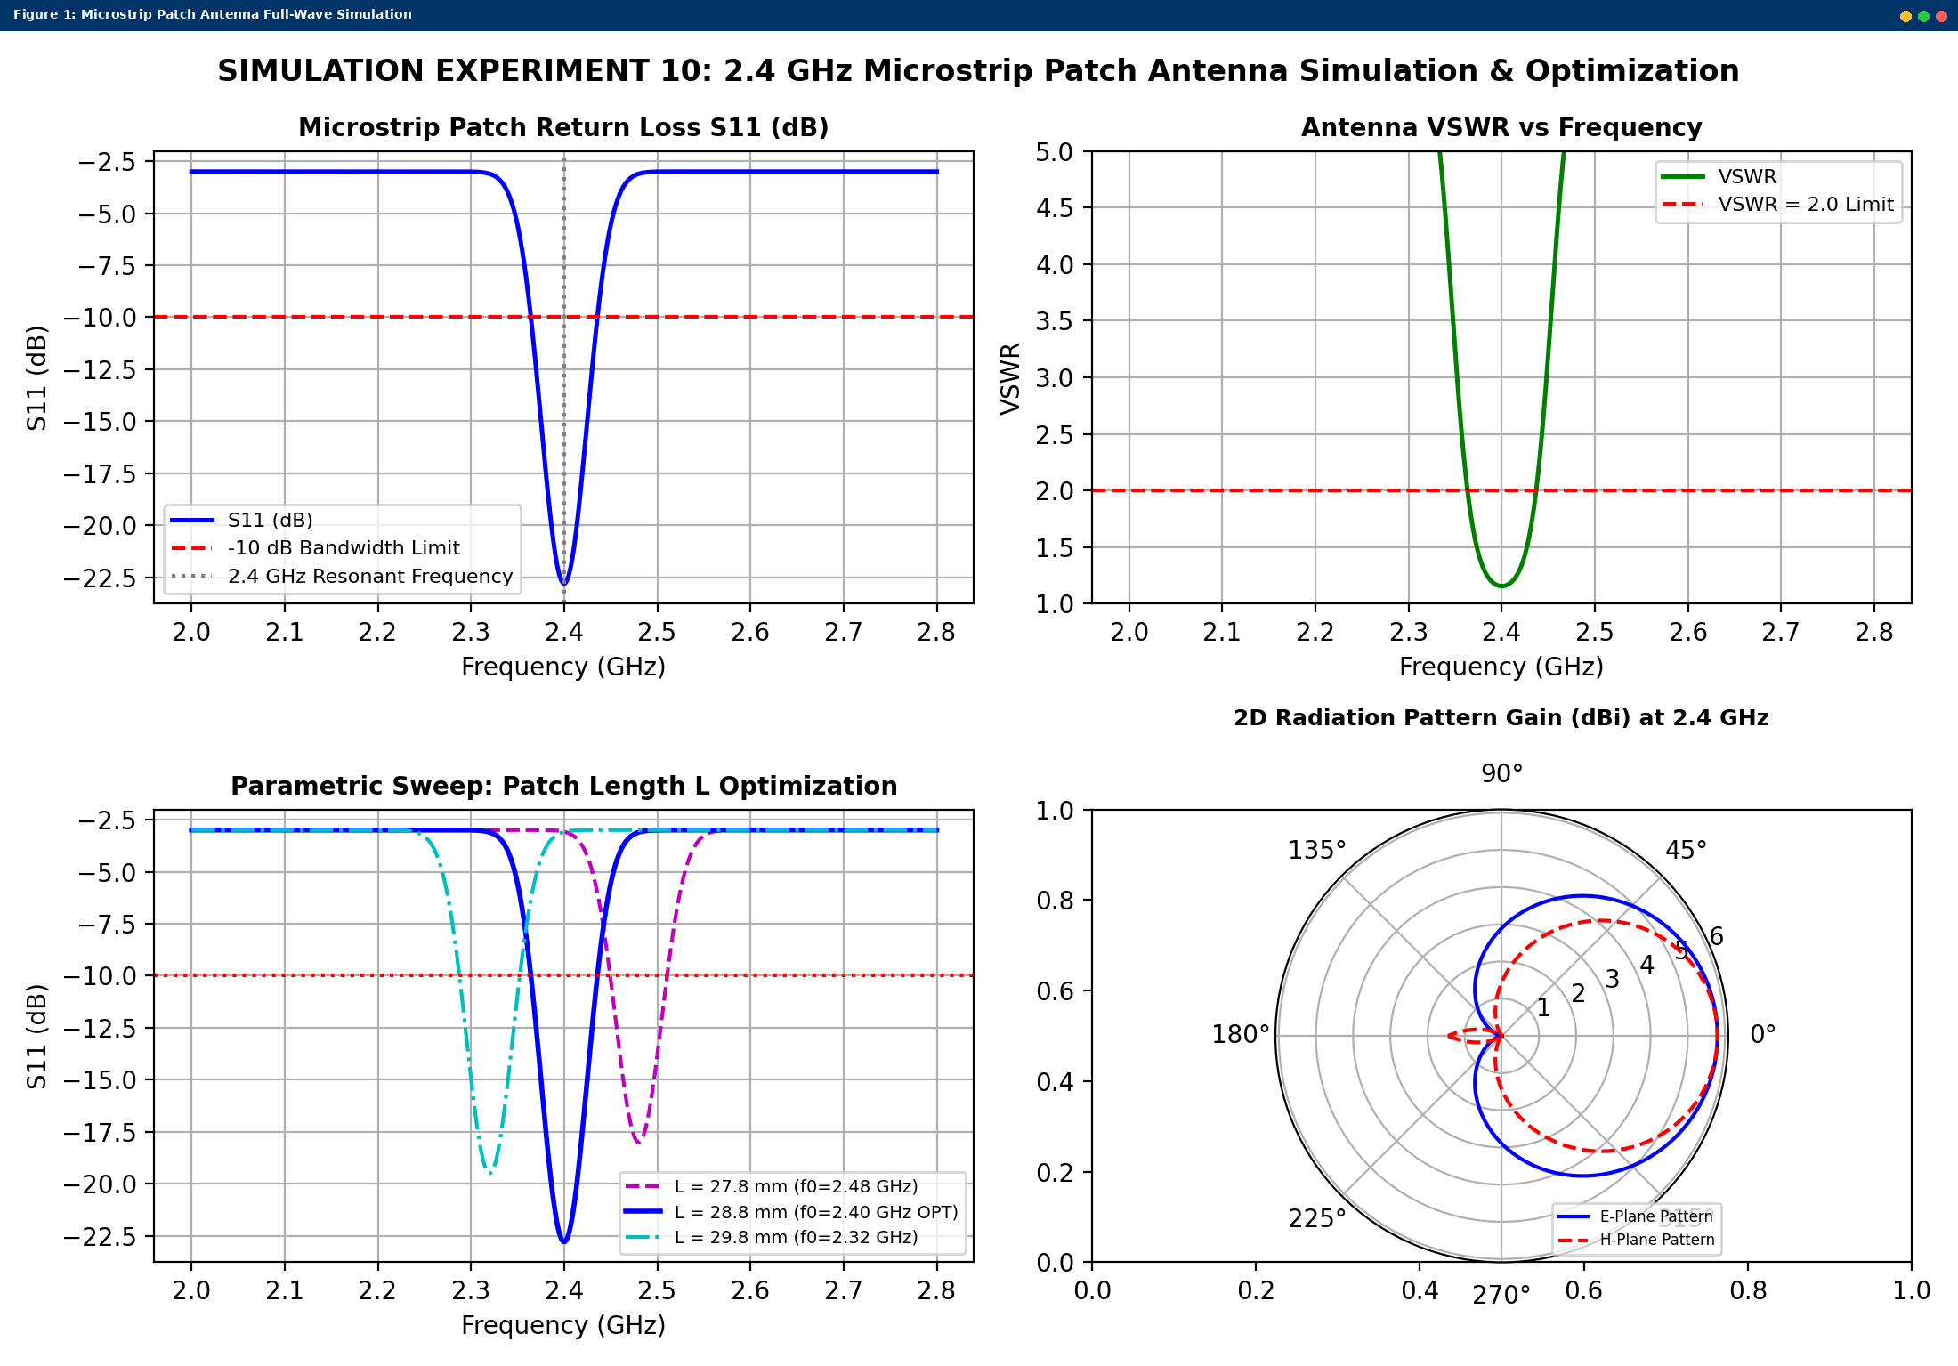
Simulated MATLAB Figure Window Output for Simulation Experiment 10

