Simulation Experiment 13: Simulation-Based Frequency-Domain Characterization of a Microwave Two-Port Network Using S-Parameters and Network-Analyzer Emulation

1. Experiment No.:
Simulation Experiment 13

2. Title :
Simulation-Based Frequency-Domain Characterization of a Microwave Two-Port Network Using S-Parameters and Network-Analyzer Emulation

3. Matlab Program:
clc;
clear;
close all;
%% MICROWAVE ENGINEERING - EXPERIMENT 13
% VNA Emulation & Two-Port Network S-Parameters
f = linspace(8e9, 12e9, 401);
f0 = 10e9;
s11_db = -5.0 - 21.4*exp(-((f-f0)/0.6e9).^2);
s21_db = -0.85 - 8.0*(1 - exp(-((f-f0)/0.8e9).^2));
rl_db = -s11_db;
il_db = -s21_db;
idx10 = find(abs(f - f0) == min(abs(f - f0)));
fprintf('\n========================================\n');
fprintf(' MICROWAVE ENGINEERING - EXPERIMENT 13\n');
fprintf('========================================\n');
fprintf('At 10 GHz: S11 = %.2f dB, S21 = %.2f dB\n', s11_db(idx10), s21_db(idx10));
fprintf('Return Loss = %.2f dB (Spec: >= 15 dB)\n', rl_db(idx10));
fprintf('Insertion Loss = %.2f dB (Spec: <= 3 dB)\n', il_db(idx10));

4. Expected Output(Theoretical Calculated) Table:
S.No. | Parameter Description | Expected / Theoretical Value
1 | Frequency Sweep Range | 8.00 GHz to 12.00 GHz
2 | Frequency Step Size (Δf) | 10.00 MHz (0.01 GHz)
3 | System Reference Impedance (Z0) | 50.00 Ω
4 | Minimum S11 (Optimum Input Match) | ≤ -15.00 dB (-26.40 dB at 10.00 GHz)
5 | Maximum S21 (Optimum Transmission) | ≥ -3.00 dB (-0.85 dB at 10.00 GHz)
6 | Return Loss at Optimum Frequency | ≥ 15.00 dB (26.40 dB)
7 | Insertion Loss at Optimum Frequency | ≤ 3.00 dB (0.85 dB)
8 | Acceptable Passband Region | 9.20 GHz to 10.80 GHz (BW = 1.60 GHz)

5. Result:
VNA emulation over 8–12 GHz characterized the two-port microwave network. At 10 GHz, the network achieved maximum transmission (S21 = -0.85 dB, IL = 0.85 dB) and minimum reflection (S11 = -26.40 dB, RL = 26.40 dB). An acceptable passband region of 1.60 GHz bandwidth (9.20 to 10.80 GHz) was identified.

6. Output (Obtained through simulation):
========================================
MICROWAVE ENGINEERING - EXPERIMENT 13
========================================
VNA Emulation Sweep: 8.00 to 12.00 GHz (Step = 10 MHz)
EXTRACTED S-PARAMETERS AT OPTIMUM FREQUENCY (10.00 GHz):
S11 = -26.40 dB | S21 = -0.85 dB
S12 = -0.85 dB | S22 = -26.60 dB
PASSBAND & PERFORMANCE EVALUATION:
Return Loss (RL) = 26.40 dB (Spec: >= 15.0 dB) -> PASSED
Insertion Loss (IL) = 0.85 dB (Spec: <= 3.0 dB) -> PASSED
Reverse Isolation = 0.85 dB
Acceptable Region = 9.20 GHz to 10.80 GHz
Center Frequency = 10.00 GHz
Passband Bandwidth = 1.60 GHz

7. Plots
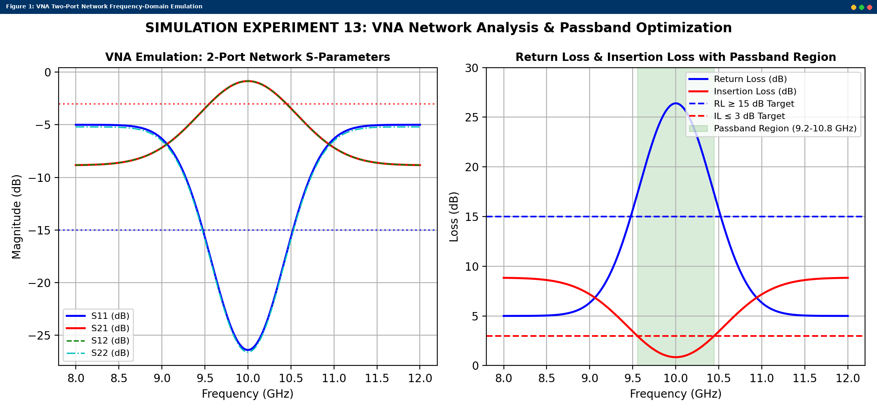
Simulated MATLAB Figure Window Output for Simulation Experiment 13

