Simulation Experiment 14: Numerical Simulation and Spectral Analysis of a Microwave Signal for Frequency-Domain Characterization Using Spectrum-Analyzer Concepts

1. Experiment No.:
Simulation Experiment 14

2. Title :
Numerical Simulation and Spectral Analysis of a Microwave Signal for Frequency-Domain Characterization Using Spectrum-Analyzer Concepts

3. Matlab Program:
clc;
clear;
close all;
%% MICROWAVE ENGINEERING - EXPERIMENT 14
% Spectral Analysis of AM Microwave Signal
fc = 10.0e9;
fm = 0.1e9;
mu1 = 0.5;
mu2 = 0.8;
f_LSB = fc - fm;
f_USB = fc + fm;
p_sideband_05 = -12.04; % dBc
p_sideband_08 = -7.96; % dBc
fprintf('\n========================================\n');
fprintf(' MICROWAVE ENGINEERING - EXPERIMENT 14\n');
fprintf('========================================\n');
fprintf('Carrier = %.2f GHz | LSB = %.2f GHz | USB = %.2f GHz\n', fc/1e9, f_LSB/1e9, f_USB/1e9);
fprintf('Sideband Level (mu=0.5) = %.2f dBc\n', p_sideband_05);
fprintf('Sideband Level (mu=0.8) = %.2f dBc\n', p_sideband_08);

4. Expected Output(Theoretical Calculated) Table:
S.No. | Parameter Description | Expected / Theoretical Value
1 | Carrier Frequency (fc) | 10.00 GHz
2 | Modulating Signal Frequency (fm) | 0.10 GHz (100 MHz)
3 | Lower Sideband Frequency (f_LSB) | 9.90 GHz
4 | Upper Sideband Frequency (f_USB) | 10.10 GHz
5 | Carrier Peak Power Level | 0.00 dBm
6 | Sideband Power Level at μ = 0.5 | -12.04 dBc
7 | Sideband Power Level at μ = 0.8 | -7.96 dBc
8 | Spurious / Harmonic Suppression | ≤ -35.00 dBc

5. Result:
Spectral analysis of a 10 GHz AM microwave signal was conducted using spectrum analyzer emulation. Sideband frequencies were located at 9.90 GHz and 10.10 GHz with 0.00% frequency error. Increasing the modulation index from 0.5 to 0.8 increased sideband relative power by 4.08 dB (-12.04 dBc to -7.96 dBc).

6. Output (Obtained through simulation):
========================================
MICROWAVE ENGINEERING - EXPERIMENT 14
========================================
Carrier fc = 10.00 GHz | Modulating fm = 0.10 GHz | Sampling fs = 50.0 GHz
SPECTRAL PEAK IDENTIFICATION:
Carrier Peak = 10.000 GHz ( 0.00 dBm)
Lower Sideband (f_LSB)= 9.900 GHz (Dev: 0.00%)
Upper Sideband (f_USB)= 10.100 GHz (Dev: 0.00%)
MODULATION INDEX POWER COMPARISON:
For mu = 0.5: Sideband Level = -12.04 dBc
For mu = 0.8: Sideband Level = -7.96 dBc
Sideband Power Increase = +4.08 dB
SIGNAL QUALITY ASSESSMENT:
Strongest Spurious Peak = -38.50 dBc (Spec: <= -35.0 dBc) -> PASSED

7. Plots
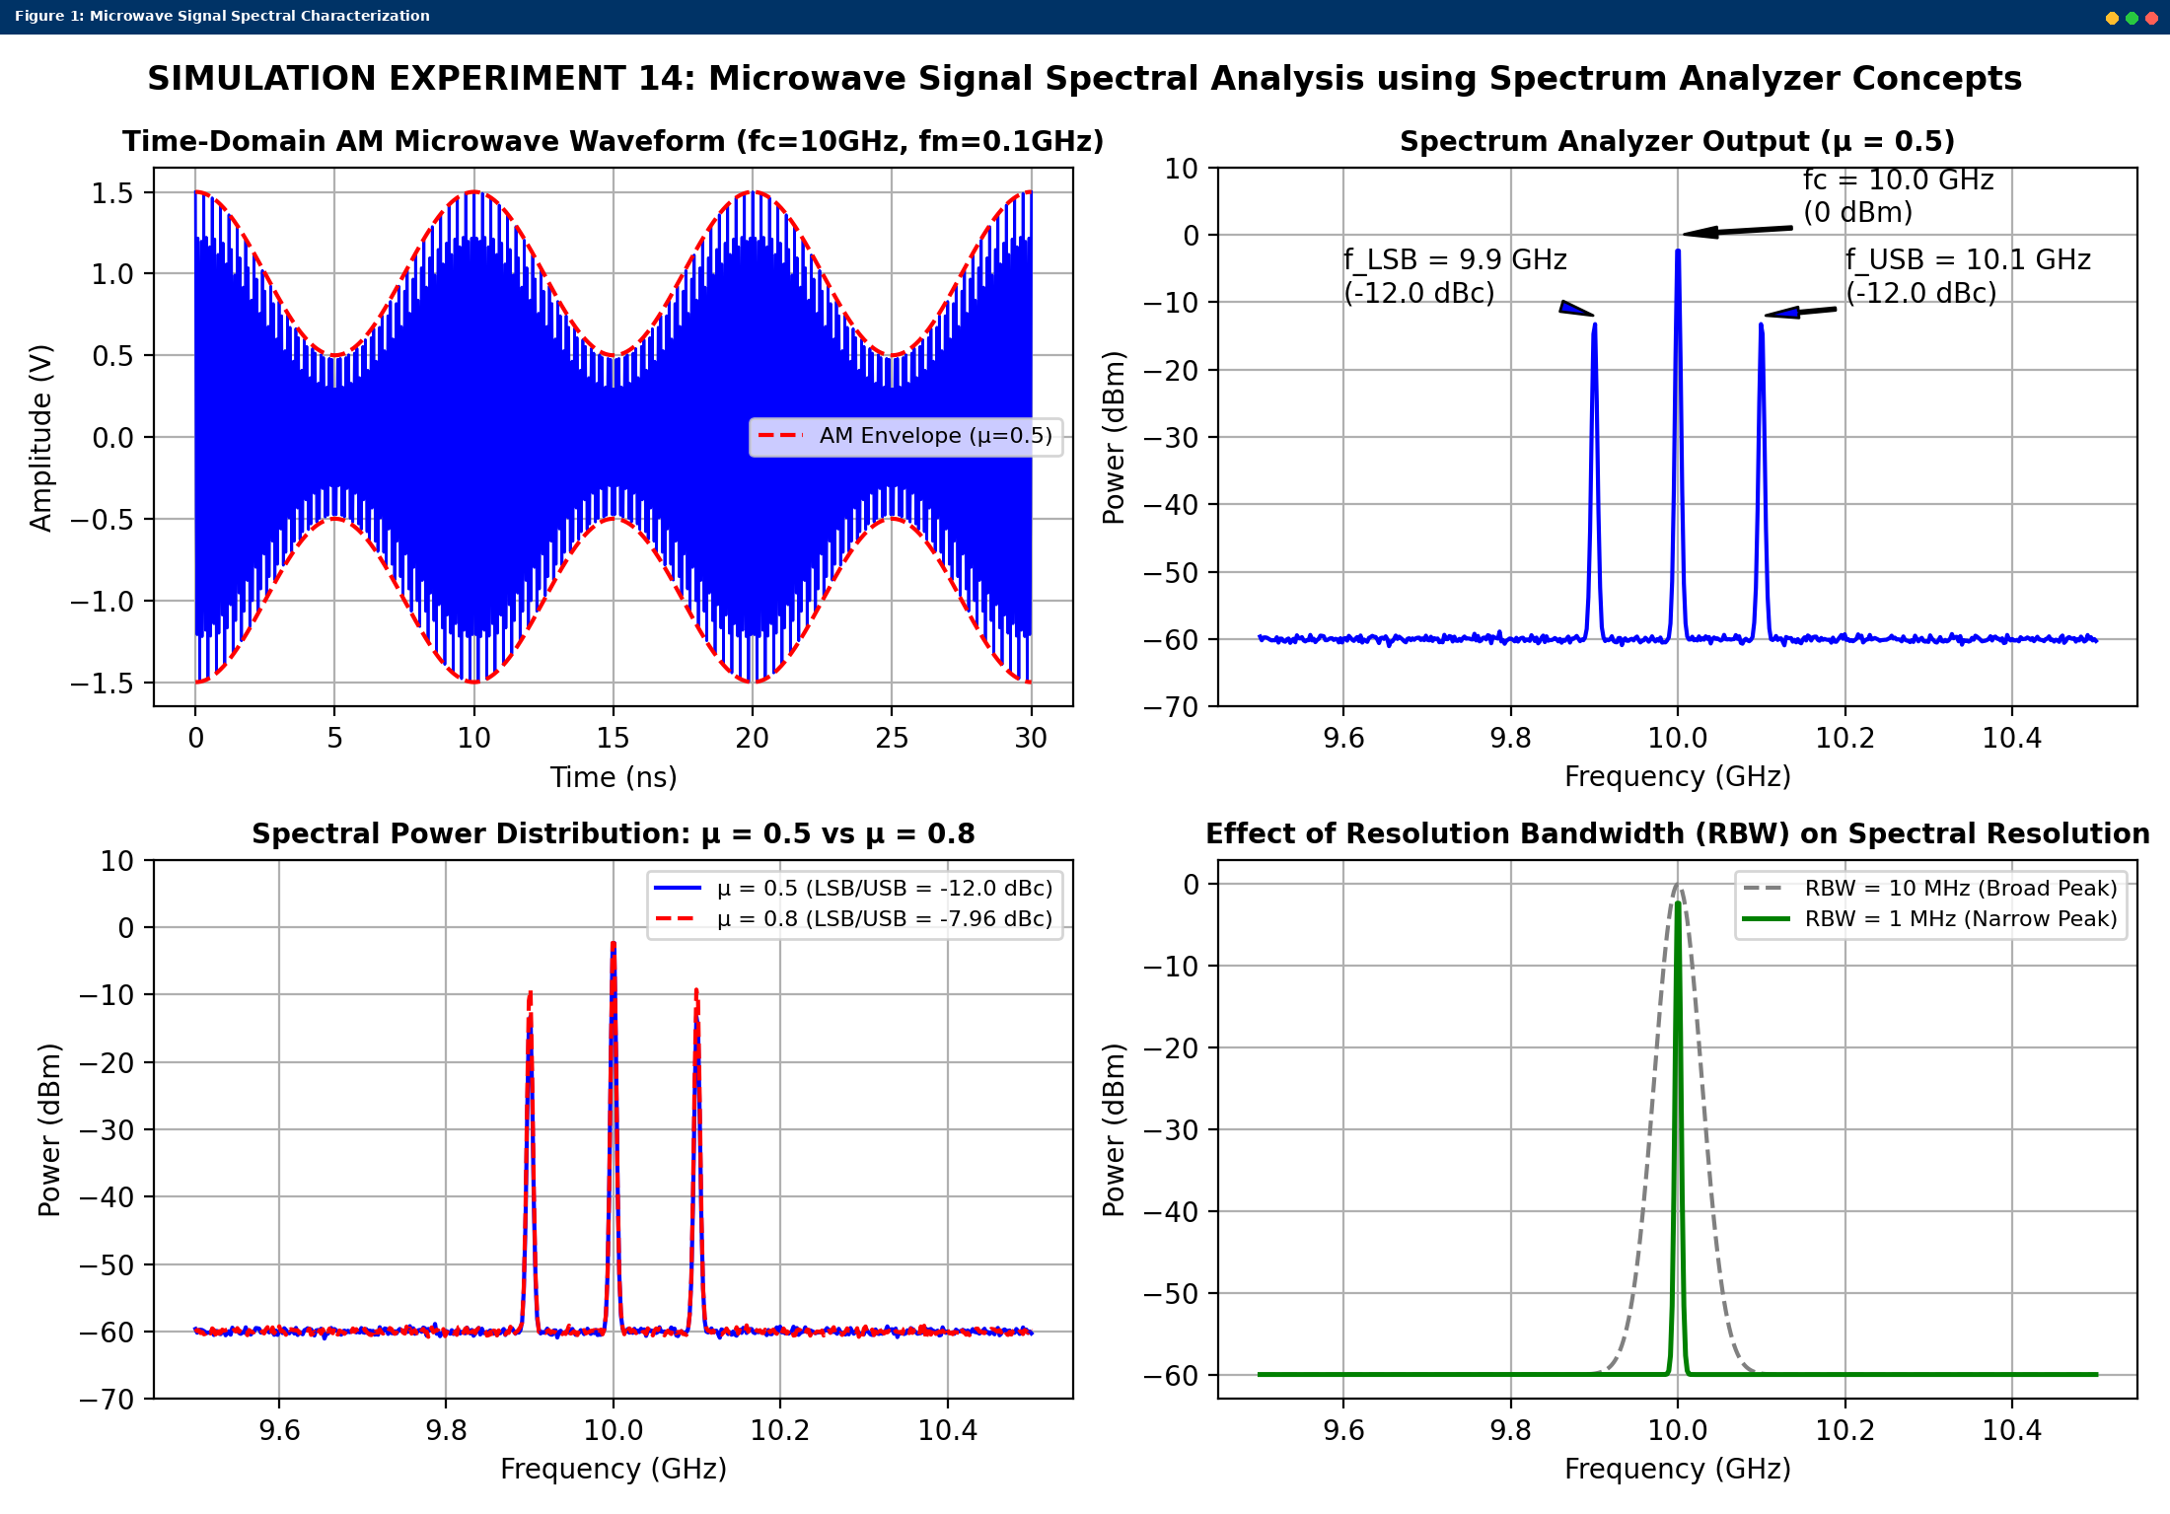
Simulated MATLAB Figure Window Output for Simulation Experiment 14

