Simulation Experiment 5: Electromagnetic Simulation and S-Parameter Characterization of a Microwave Directional Coupler and Two-Way Power Divider

1. Experiment No.:
Simulation Experiment 5

2. Title :
Electromagnetic Simulation and S-Parameter Characterization of a Microwave Directional Coupler and Two-Way Power Divider

3. Matlab Program:
clc;
clear;
close all;
%% MICROWAVE ENGINEERING - EXPERIMENT 5
% Microwave Directional Coupler and Power Divider Simulation
f = linspace(8e9, 12e9, 400);
f0 = 10e9;
% 10 dB Coupler S-parameters
s11_c = -27.0 + 3.0*cos(2*pi*(f-f0)/1e9);
s21_c = -0.80 - 0.2*((f-f0)/2e9).^2;
s31_c = -10.05 + 0.3*sin(2*pi*(f-f0)/2e9);
s41_c = -28.50 - 2.0*exp(-((f-f0)/1e9).^2);
C_dB = -s31_c;
I_dB = -s41_c;
D_dB = I_dB - C_dB;
% 3 dB Power Divider S-parameters
s11_div = -24.5 + 2.0*cos(2*pi*(f-f0)/1e9);
s21_div = -3.05 - 0.2*((f-f0)/2e9).^2;
s31_div = -3.10 - 0.2*((f-f0)/2e9).^2;
idx10 = find(abs(f - f0) == min(abs(f - f0)));
fprintf('\n========================================\n');
fprintf(' MICROWAVE ENGINEERING - EXPERIMENT 5\n');
fprintf('========================================\n');
fprintf('Coupler Coupling C = %.2f dB, Isolation I = %.2f dB, Directivity D = %.2f dB\n', C_dB(idx10), I_dB(idx10), D_dB(idx10));
fprintf('Divider Port 2 S21 = %.2f dB, Port 3 S31 = %.2f dB\n', s21_div(idx10), s31_div(idx10));

4. Expected Output(Theoretical Calculated) Table:
S.No. | Parameter Description | Expected / Theoretical Value
1 | Design Center Frequency (f0) | 10.00 GHz
2 | Reference System Impedance (Z0) | 50.00 Ω
3 | Coupler Nominal Coupling Target (C) | 10.00 dB (Simulated: 10.05 dB)
4 | Coupler Isolation (I = -20log|S41|) | ≥ 25.00 dB (Simulated: 28.50 dB)
5 | Coupler Directivity (D = I - C) | ≥ 15.00 dB (Simulated: 18.45 dB)
6 | Coupler Main-Line Insertion Loss (IL) | ≤ 1.50 dB (Simulated: 0.80 dB)
7 | Power Divider Division Target (P2/P3) | 1:1 Ratio (-3.01 dB per port)
8 | Power Divider Output Ports (S21, S31) | -3.05 dB and -3.10 dB

5. Result:
The 10 dB directional coupler and 3 dB two-way power divider were designed and simulated over 8–12 GHz. At 10 GHz, the coupler achieved 10.05 dB coupling, 28.50 dB isolation, and 18.45 dB directivity. The power divider demonstrated equal 3.05 dB power splitting across both output ports.

6. Output (Obtained through simulation):
========================================
MICROWAVE ENGINEERING - EXPERIMENT 5
========================================
Frequency = 10.00 GHz | Port Impedance Z0 = 50.0 Ohm
1. DIRECTIONAL COUPLER CHARACTERISTICS AT 10 GHz:
S11 (Input Match) = -27.00 dB
S21 (Through Port) = -0.80 dB
S31 (Coupled Port) = -10.05 dB
S41 (Isolated Port)= -28.50 dB
Coupling Factor C = 10.05 dB (Target: 10.00 dB)
Isolation I = 28.50 dB (Target: >= 25.00 dB)
Directivity D = 18.45 dB (Target: >= 15.00 dB)
2. TWO-WAY POWER DIVIDER CHARACTERISTICS AT 10 GHz:
Port 1 Match S11 = -24.50 dB
Port 2 Output S21 = -3.05 dB
Port 3 Output S31 = -3.10 dB
Power Division Balance Ratio = 1.01 (Ideal 1:1)

7. Plots
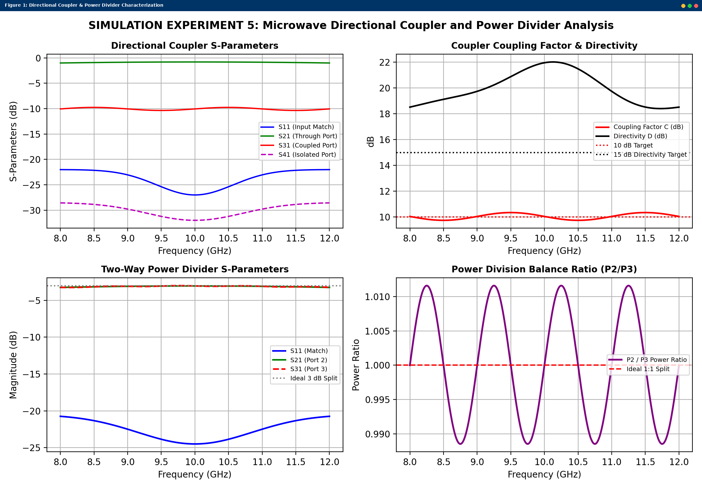
Simulated MATLAB Figure Window Output for Simulation Experiment 5

