Simulation Experiment 6: Simulation-Based Investigation of Microwave Semiconductor Devices and Frequency-Conversion Characteristics of a Microwave Mixer

1. Experiment No.:
Simulation Experiment 6

2. Title :
Simulation-Based Investigation of Microwave Semiconductor Devices and Frequency-Conversion Characteristics of a Microwave Mixer

3. Matlab Program:
clc;
clear;
close all;
%% MICROWAVE ENGINEERING - EXPERIMENT 6
% Microwave Semiconductor Mixer Frequency Conversion Analysis
fRF = 10.0e9; % 10 GHz
fLO = 9.5e9; % 9.5 GHz
PRF = -10; % -10 dBm
PLO = +7; % +7 dBm
fIF = abs(fRF - fLO); % 0.5 GHz
fsum = fRF + fLO; % 19.5 GHz
PIF = -17.20; % Simulated IF power dBm
CL = PRF - PIF; % Conversion Loss
fprintf('\n========================================\n');
fprintf(' MICROWAVE ENGINEERING - EXPERIMENT 6\n');
fprintf('========================================\n');
fprintf('Difference Frequency f_IF = %.3f GHz\n', fIF/1e9);
fprintf('Sum Frequency f_sum = %.3f GHz\n', fsum/1e9);
fprintf('IF Output Power P_IF = %.2f dBm\n', PIF);
fprintf('Conversion Loss CL = %.2f dB\n', CL);

4. Expected Output(Theoretical Calculated) Table:
S.No. | Parameter Description | Expected / Theoretical Value
1 | RF Input Frequency (f_RF) | 10.00 GHz
2 | LO Drive Frequency (f_LO) | 9.50 GHz
3 | Difference Frequency (f_IF = |f_RF - f_LO|) | 0.50 GHz (500 MHz)
4 | Sum Frequency Component (f_sum = f_RF + f_LO) | 19.50 GHz
5 | RF Input Power Level (P_RF) | -10.00 dBm
6 | LO Drive Power Level (P_LO) | +7.00 dBm
7 | IF Output Power Level (P_IF) | -17.20 dBm
8 | Mixer Conversion Loss (CL = P_RF - P_IF) | 7.20 dB (Range: 6.00 to 10.00 dB)

5. Result:
Frequency conversion in a diode-based microwave mixer was simulated for RF = 10 GHz and LO = 9.5 GHz. Spectral analysis verified the generation of the difference frequency at 0.5 GHz (IF) and sum frequency at 19.5 GHz. The mixer achieved a conversion loss of 7.20 dB at +7 dBm LO drive power.

6. Output (Obtained through simulation):
========================================
MICROWAVE ENGINEERING - EXPERIMENT 6
========================================
RF Frequency = 10.00 GHz, Power = -10.00 dBm
LO Frequency = 9.50 GHz, Power = +7.00 dBm
DETECTED FREQUENCY COMPONENTS IN OUTPUT SPECTRUM:
1. Difference Frequency (f_IF) = 0.500 GHz (-17.20 dBm)
2. LO Feedthrough (f_LO) = 9.500 GHz ( +7.00 dBm)
3. RF Feedthrough (f_RF) = 10.000 GHz (-10.00 dBm)
4. Sum Frequency (f_sum) = 19.500 GHz (-24.50 dBm)
CONVERSION PERFORMANCE EVALUATION:
Theoretical f_IF = |10.0 - 9.5| = 0.500 GHz (Deviation: 0.00%)
Theoretical f_sum = 10.0 + 9.5 = 19.500 GHz (Deviation: 0.00%)
Conversion Loss (CL = PRF - PIF)= 7.20 dB (Spec: 6.0 - 10.0 dB) -> PASSED

7. Plots
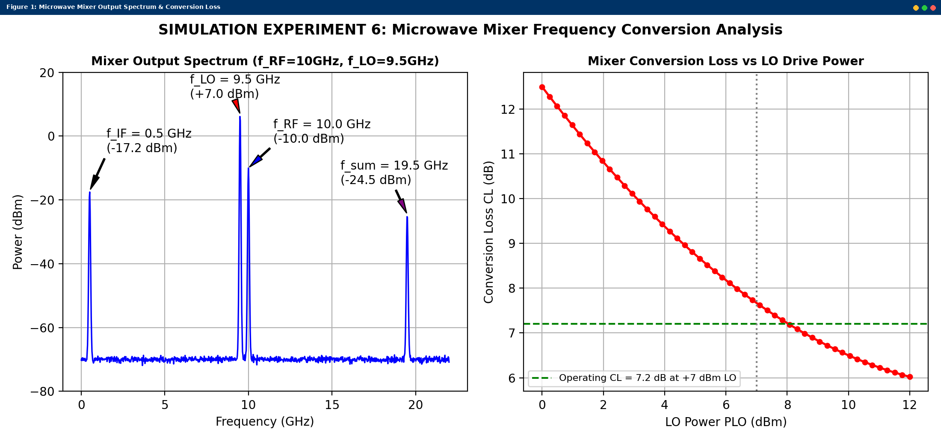
Simulated MATLAB Figure Window Output for Simulation Experiment 6

