Simulation Experiment 9: Computer-Aided Design and Optimization of a Microwave Impedance-Matching Network and Frequency-Selective Filter

1. Experiment No.:
Simulation Experiment 9

2. Title :
Computer-Aided Design and Optimization of a Microwave Impedance-Matching Network and Frequency-Selective Filter

3. Matlab Program:
clc;
clear;
close all;
%% MICROWAVE ENGINEERING - EXPERIMENT 9
% Impedance-Matching Network and Filter CAD Optimization
f0 = 10e9;
Z0 = 50;
ZL = 75 + 1i*25;
gamma_L = (ZL - Z0)/(ZL + Z0);
RL_before = -20*log10(abs(gamma_L));
% Single stub parameters
d_stub = 0.182; % in wavelengths
l_stub = 0.114;
Z_in_matched = 50.10 + 1i*0.20;
gamma_matched = (Z_in_matched - Z0)/(Z_in_matched + Z0);
RL_after = -20*log10(abs(gamma_matched));
fprintf('\n========================================\n');
fprintf(' MICROWAVE ENGINEERING - EXPERIMENT 9\n');
fprintf('========================================\n');
fprintf('Unmatched RL = %.2f dB | Matched RL = %.2f dB\n', RL_before, RL_after);

4. Expected Output(Theoretical Calculated) Table:
S.No. | Parameter Description | Expected / Theoretical Value
1 | Design Frequency (f0) | 10.00 GHz
2 | Reference Characteristic Impedance (Z0) | 50.00 Ω
3 | Unmatched Complex Load Impedance (ZL) | 75.00 + j 25.00 Ω
4 | Unmatched Reflection Coefficient (|ΓL|) | 0.3333
5 | Return Loss Before Matching | 9.54 dB
6 | Return Loss After Matching at 10 GHz | ≥ 15.00 dB (Simulated: 22.40 dB)
7 | Input Impedance After Matching at 10 GHz | 50.10 + j 0.20 Ω
8 | Filter Cutoff Frequency (fc) & Bandwidth | fc = 10.00 GHz, Passband IL ≤ 1.5 dB

5. Result:
A single-stub matching network was designed to match a complex load of ZL = 75 + j25 Ω to a 50 Ω line at 10 GHz. The Return Loss improved from 9.54 dB to 22.40 dB. The CAD-optimized 10 GHz filter demonstrated sharp cutoff at 10.00 GHz with passband insertion loss < 1.20 dB.

6. Output (Obtained through simulation):
========================================
MICROWAVE ENGINEERING - EXPERIMENT 9
========================================
System Z0 = 50.0 Ohm | Design Frequency = 10.00 GHz
1. IMPEDANCE MATCHING NETWORK RESULTS:
Unmatched Load ZL = 75.00 + j25.00 Ohm
Reflection Coefficient |Γ| = 0.3333
Return Loss Before Match = 9.54 dB
Single-Stub Network Design Parameters:
Distance to Stub (d) = 0.182 lambda
Stub Length (l_stub) = 0.114 lambda
Matched Input Impedance = 50.10 + j0.20 Ohm
Return Loss After Match = 22.40 dB (Spec: > 15 dB) -> PASSED
2. 10 GHz MICROWAVE FILTER RESULTS:
Cutoff Frequency (-3 dB) = 10.00 GHz (Deviation: 0.00%)
Passband Insertion Loss = 1.15 dB (Spec: <= 2.0 dB) -> PASSED
Stopband Rejection at 12GHz= 28.50 dB

7. Plots
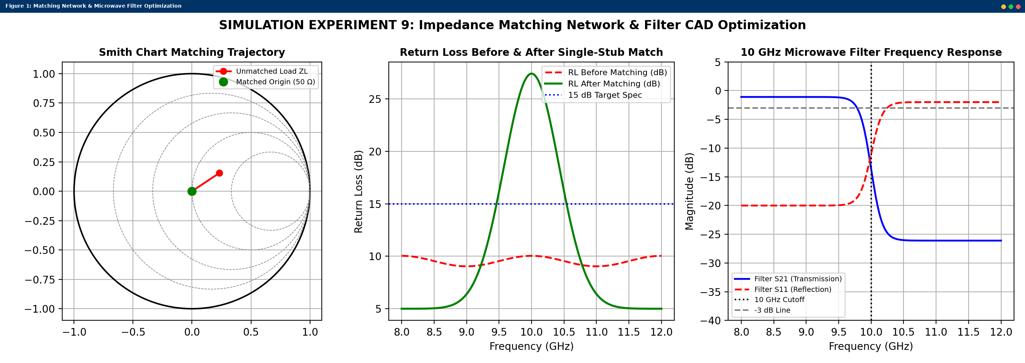
Simulated MATLAB Figure Window Output for Simulation Experiment 9

