Configuration 1: Image-ID = 0; Feature Space = color; K = 10
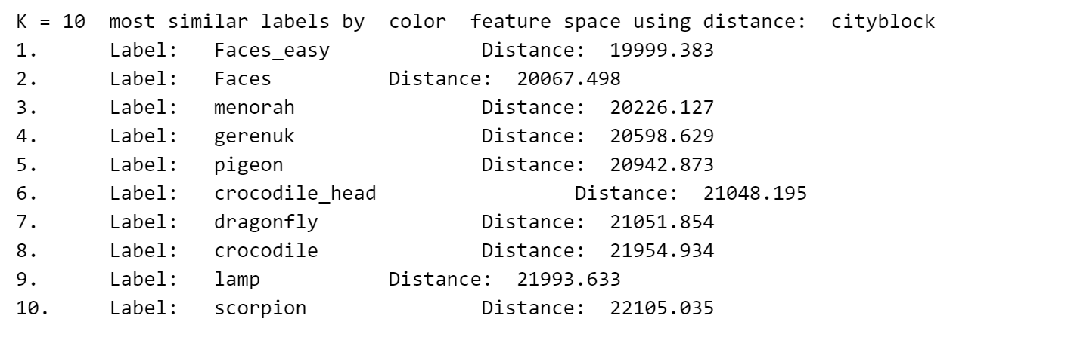
Configuration 2: Image-ID = 0; Feature Space = hog; K = 10
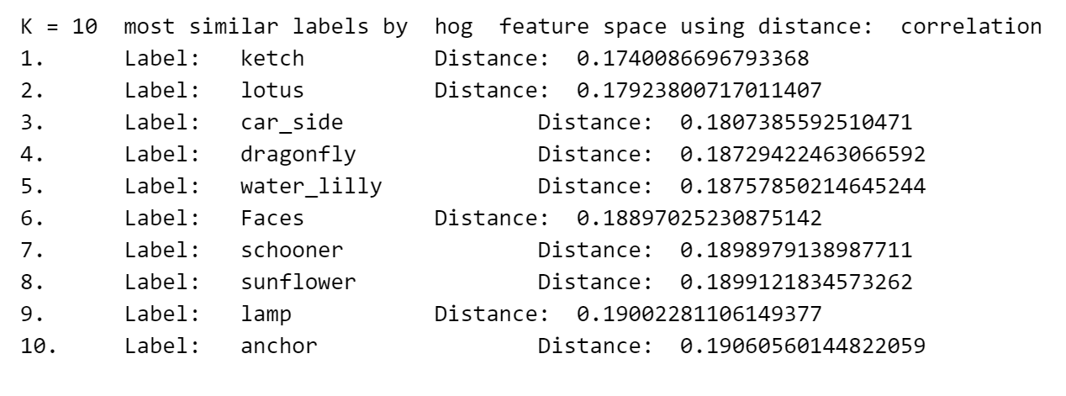

Configuration 3: Image-ID = 0; Feature Space = avgpool; K = 10
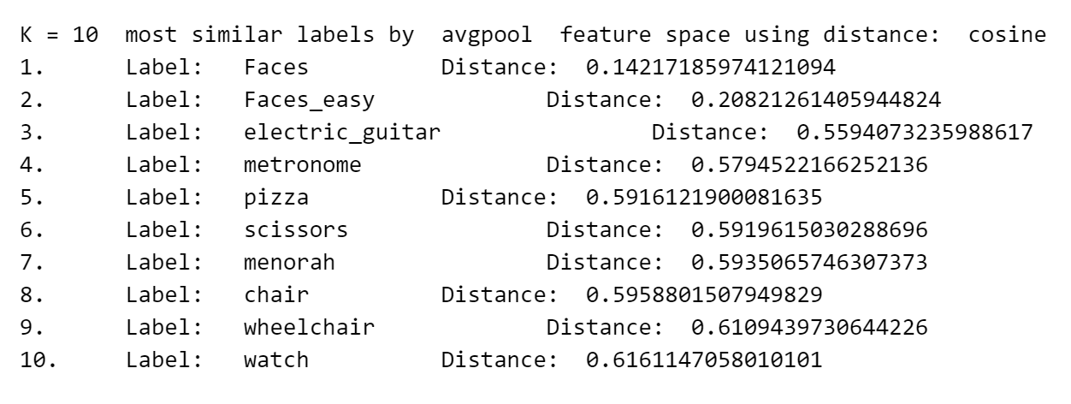

Configuration 4: Image-ID = 0; Feature Space = layer3; K = 10
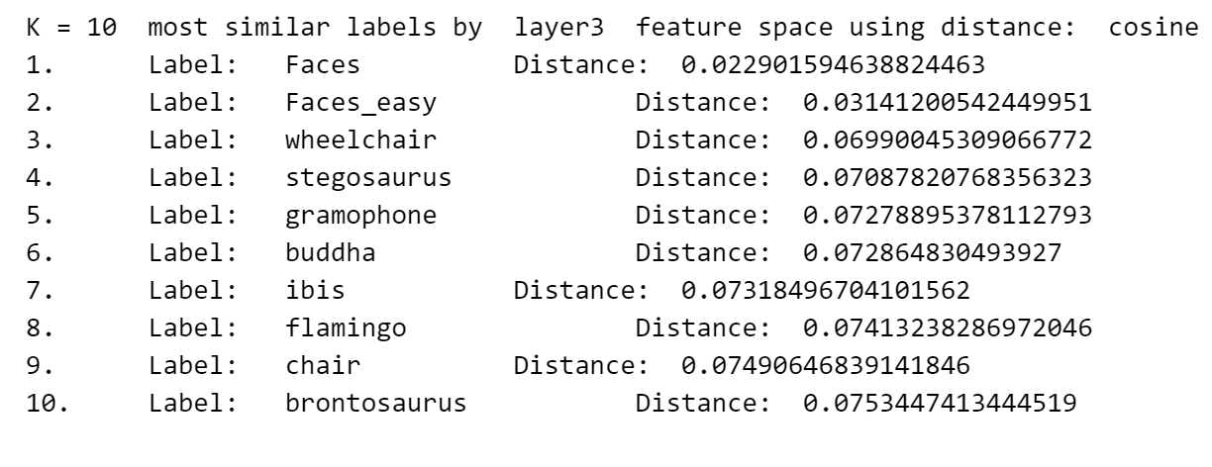
Configuration 5: Image-ID = 0; Feature Space = fc; K = 10
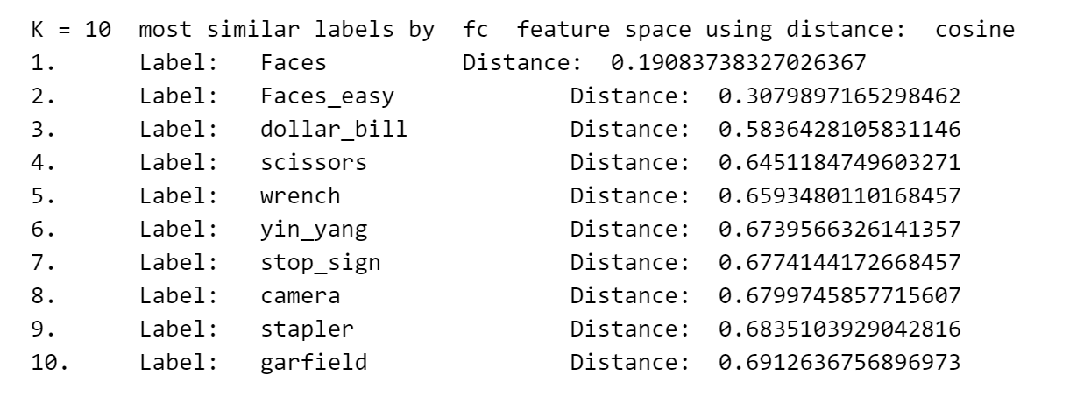

Configuration 6: Image-ID = 880; Feature Space = color; K = 10
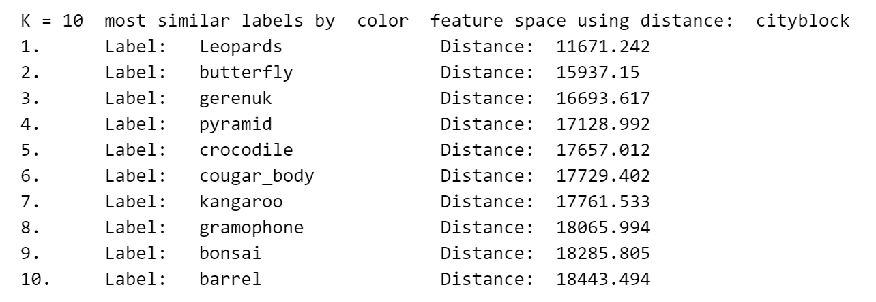

Configuration 7: Image-ID = 880; Feature Space = hog; K = 10
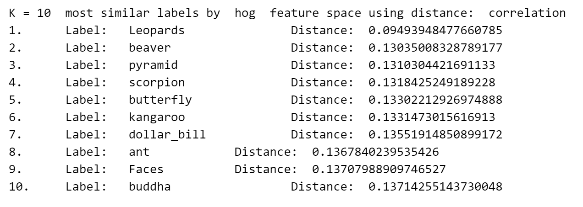
Configuration 8: Image-ID = 880; Feature Space = avgpool; K = 10
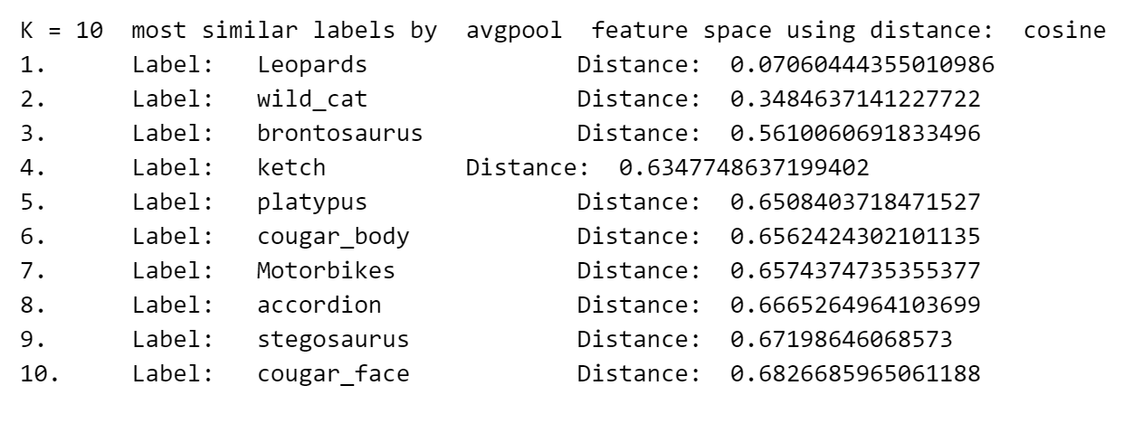

Configuration 9: Image-ID = 880; Feature Space = layer3; K = 10
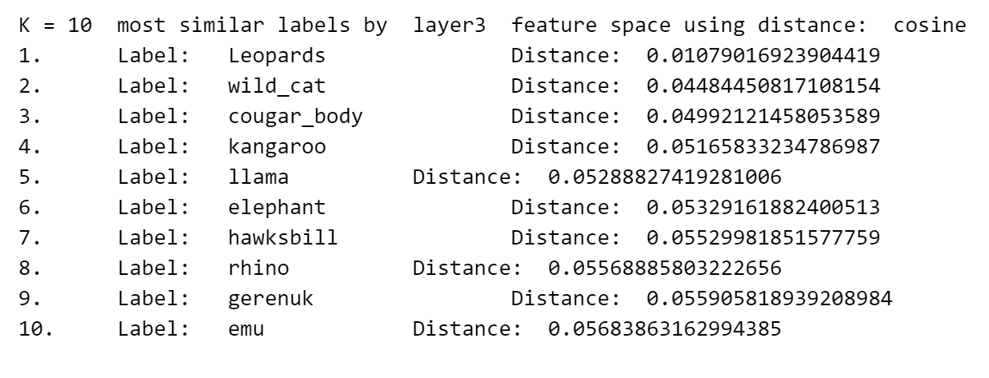
Configuration 10: Image-ID = 880; Feature Space = fc; K = 10
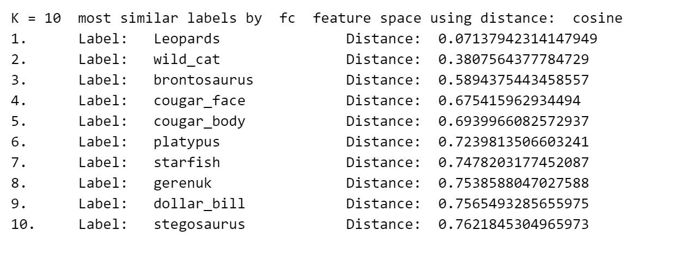

Configuration 11: Image-ID = 2500; Feature Space = color; K = 10
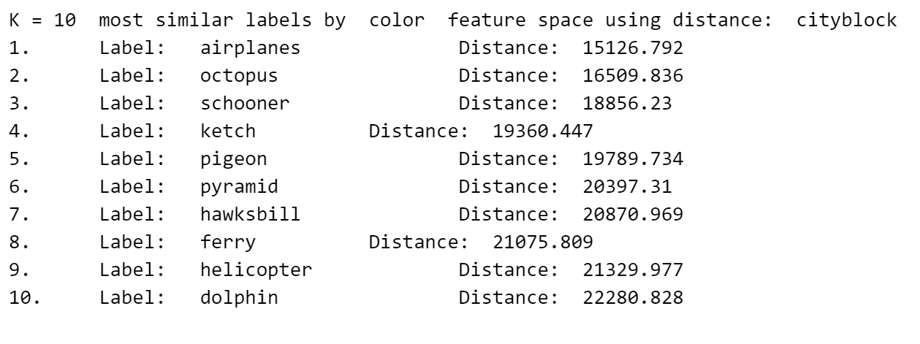
Configuration 12: Image-ID = 2500; Feature Space = hog; K = 10
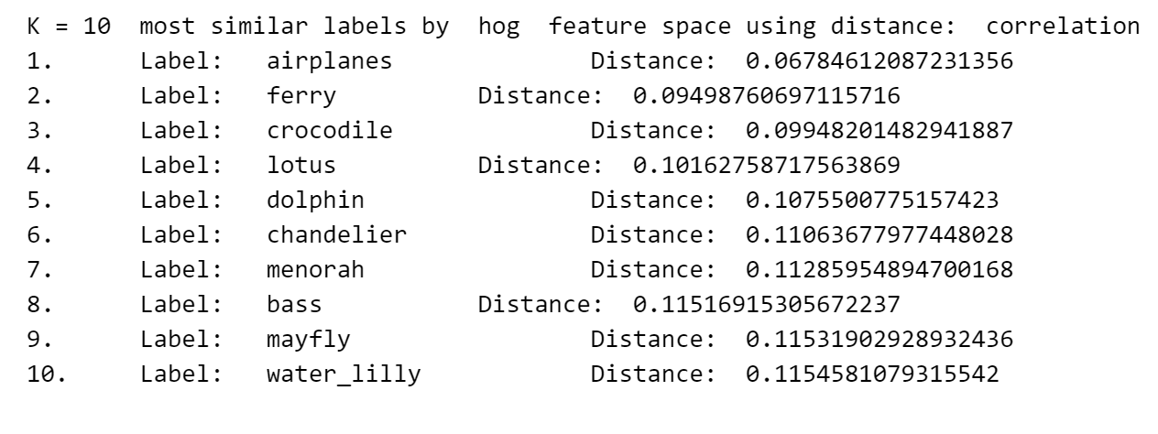
Configuration 13: Image-ID = 2500; Feature Space = avgpool; K = 10
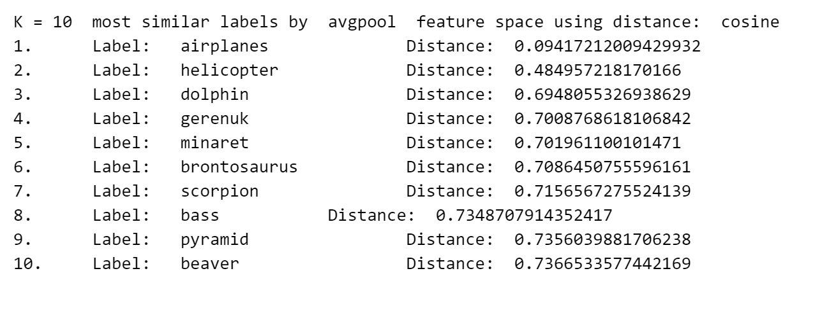

Configuration 14: Image-ID = 2500; Feature Space = layer3; K = 10
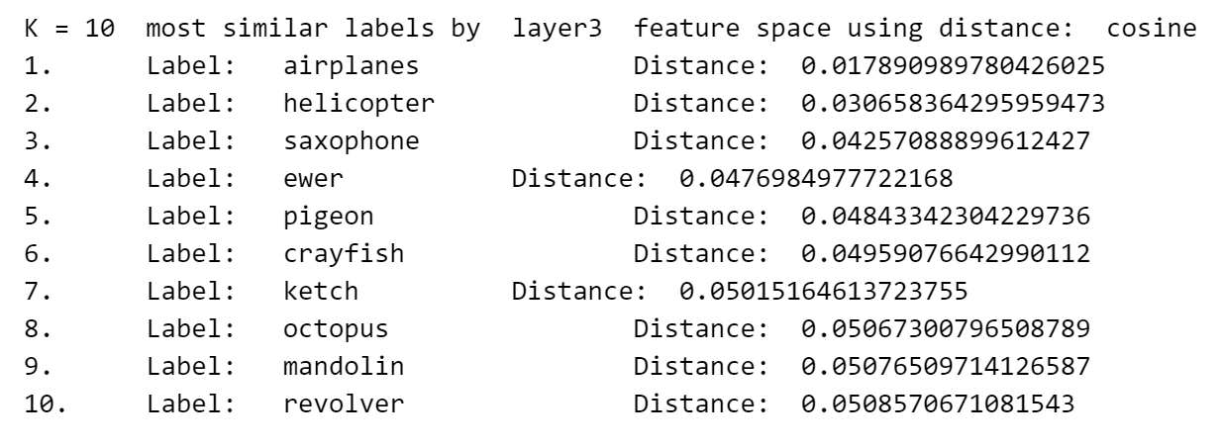
Configuration 15: Image-ID = 2500; Feature Space = fc; K = 10
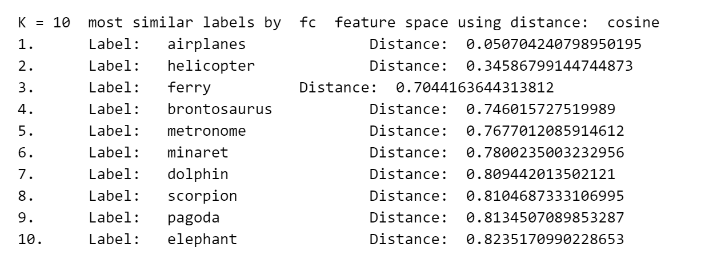

Configuration 16: Image-ID = 5122; Feature Space = color; K = 10
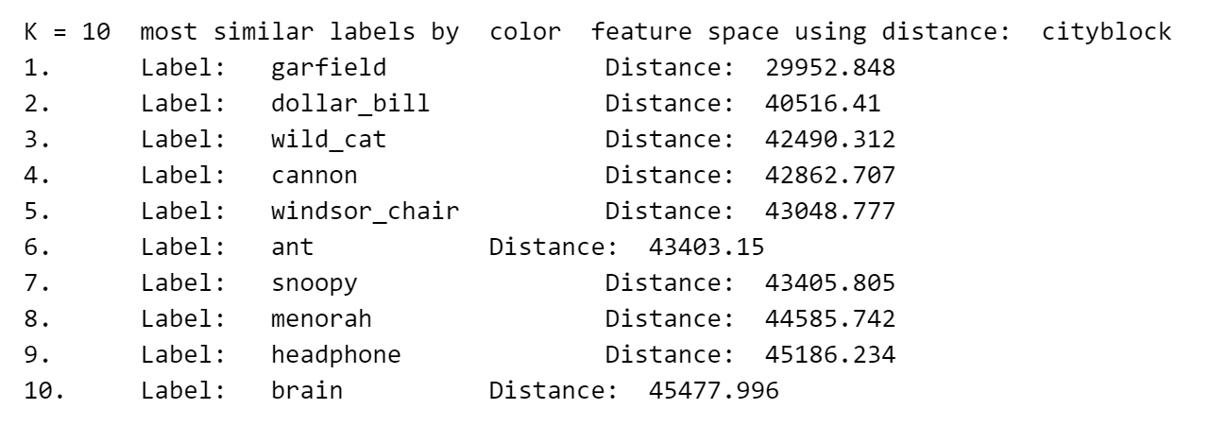
Configuration 17: Image-ID = 5122; Feature Space = hog; K = 10
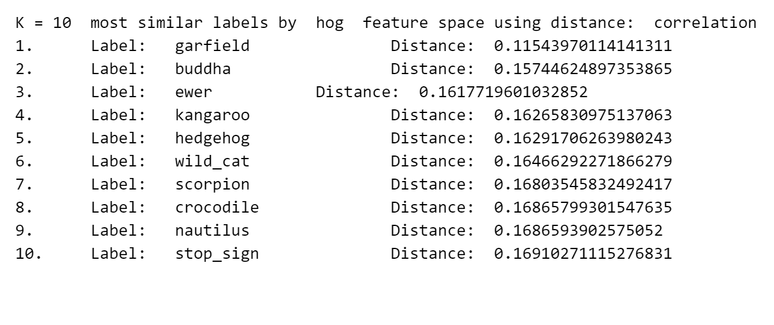
Configuration 18: Image-ID = 5122; Feature Space = avgpool; K = 10
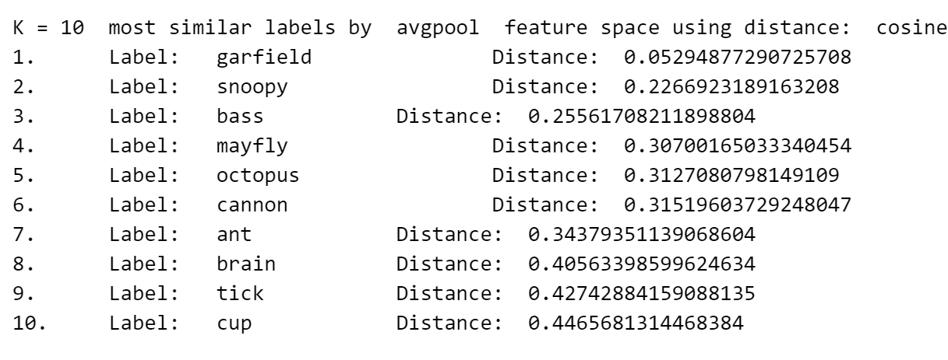
Configuration 19: Image-ID = 5122; Feature Space = layer3; K = 10
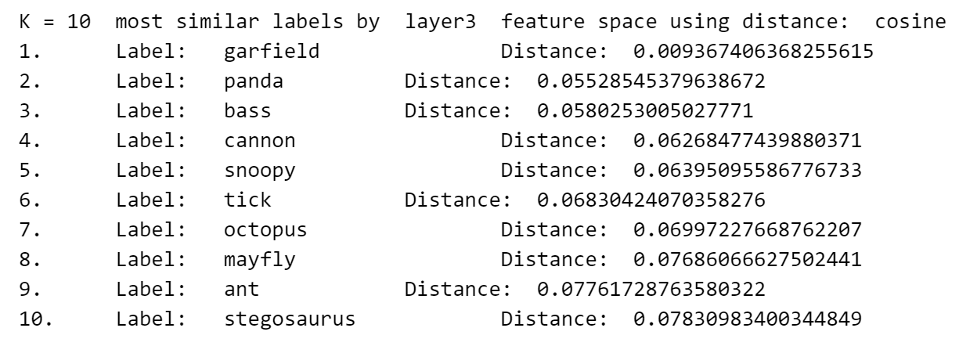
Configuration 20: Image-ID = 5122; Feature Space = fc; K = 10
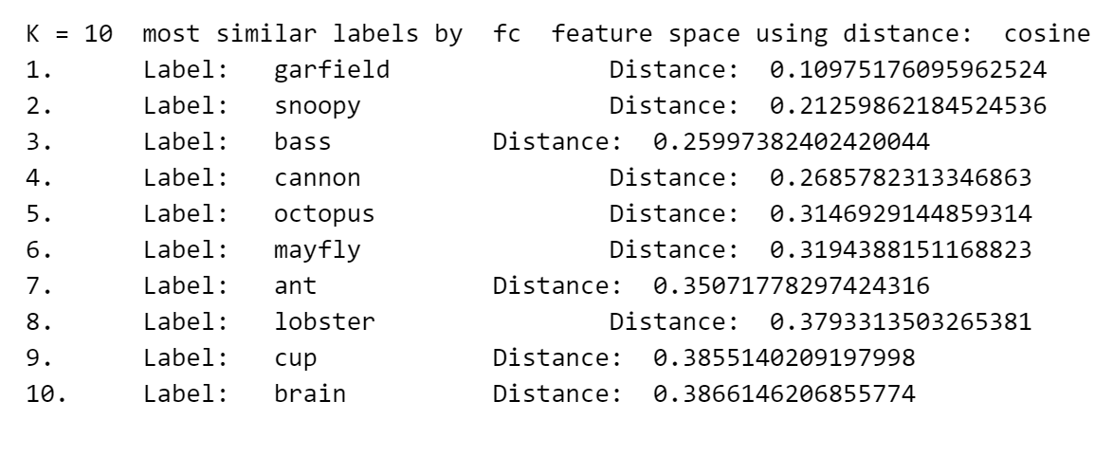

Configuration 21: Image-ID = 8676; Feature Space = color; K = 10
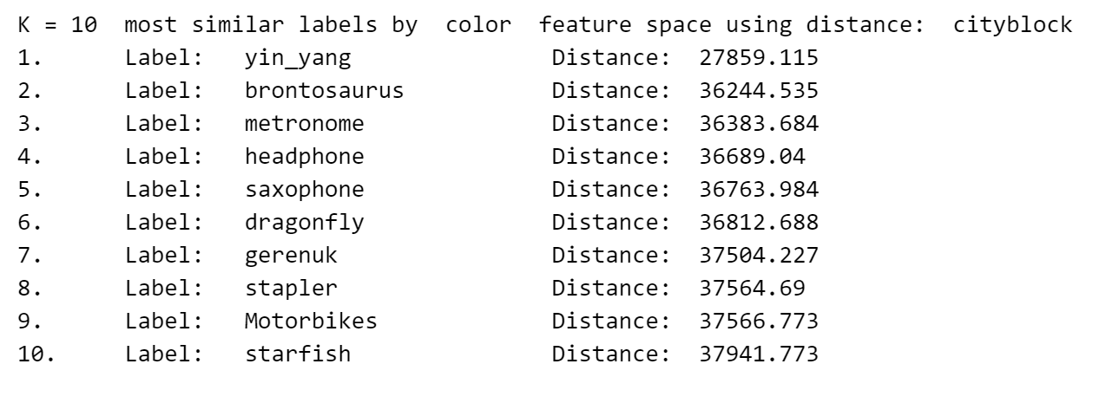
Configuration 22: Image-ID = 8676; Feature Space = hog; K = 10
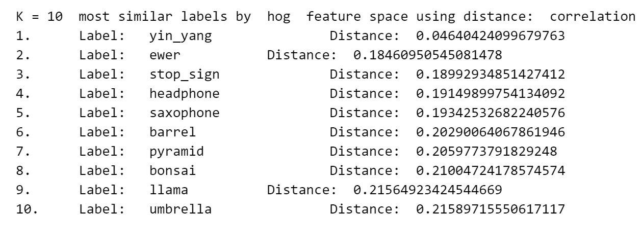
Configuration 23: Image-ID = 8676; Feature Space = avgpool; K = 10
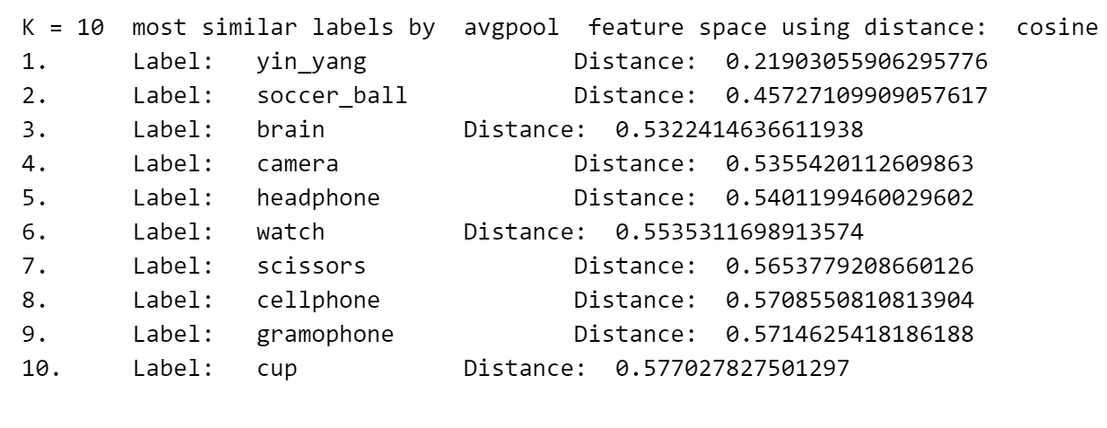
Configuration 24: Image-ID = 8676; Feature Space = layer3; K = 10
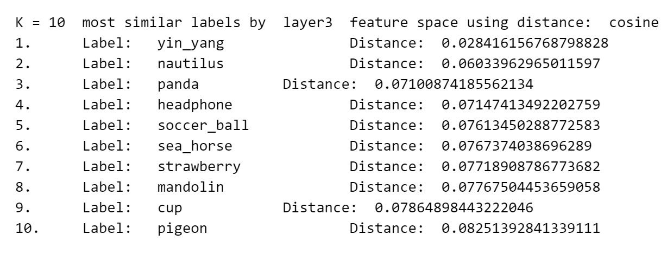
Configuration 25: Image-ID = 8676; Feature Space = fc; K = 10
