Task 6, Config 1: Layer3, SVD, K=5, Latent Semantics:
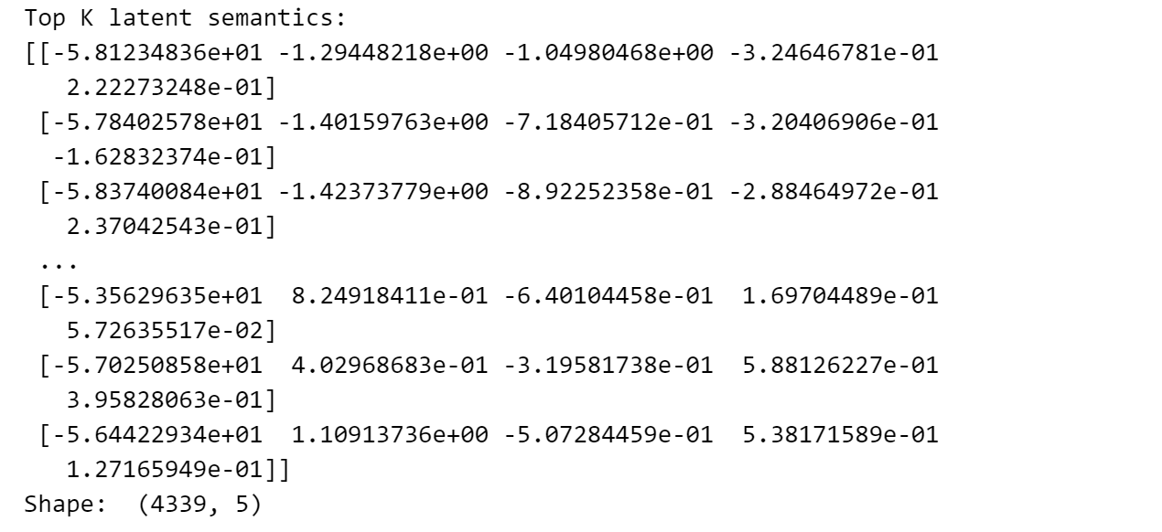

Task 6, Config 1: Layer3, SVD, K=5, Image - Weight pairs:
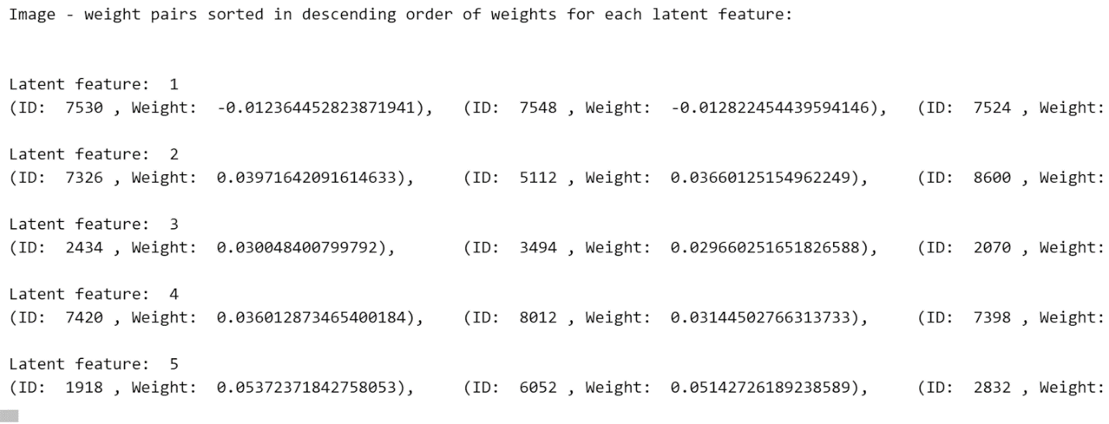

Task 6, Config 2: Layer3, NNMF, K=5, Latent Semantics:
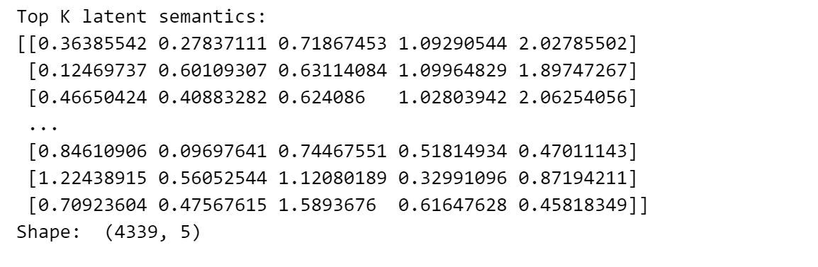

Task 6, Config 2: Layer3, NNMF, K=5, Image - Weight pairs:
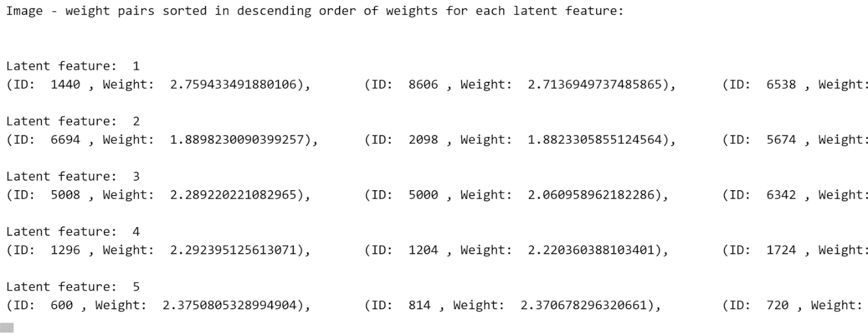

Task 6, Config 3: Layer3, LDA, K=5, Latent Semantics:
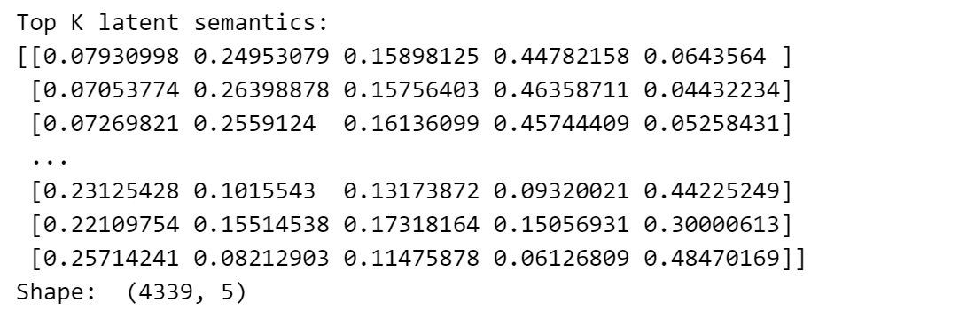

Task 6, Config 3: Layer3, LDA, K=5, Image - Weight pairs:
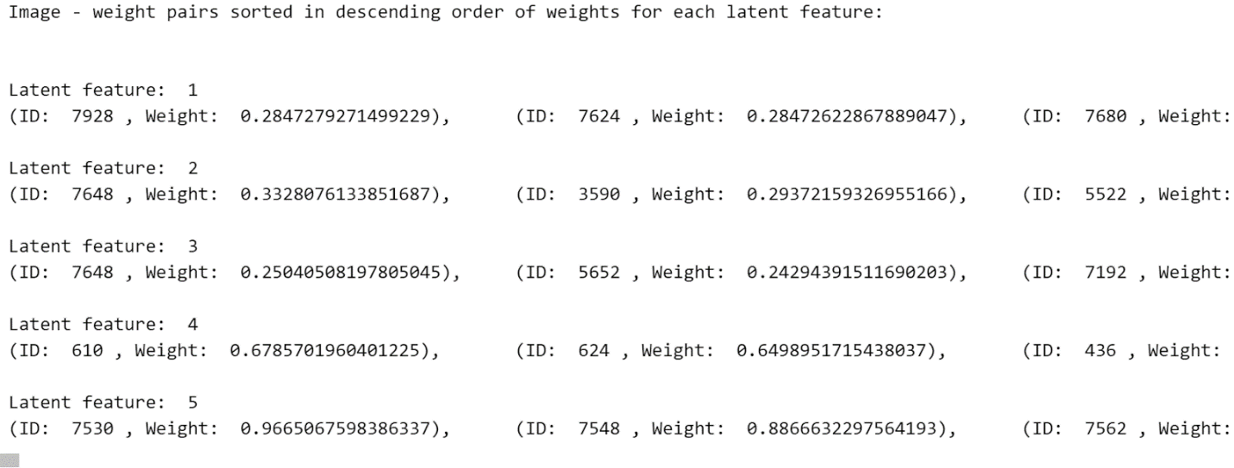

Task 6, Config 4: Layer3, K-Means, K=5, Latent Semantics:
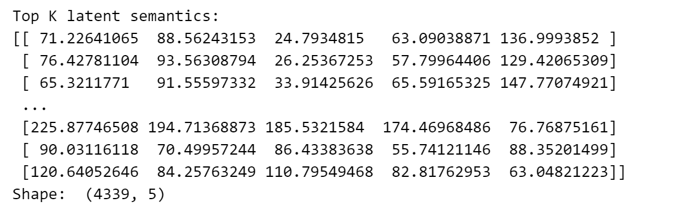

Task 6, Config 4: Layer3, K-Means, K=5, Image - Weight pairs:
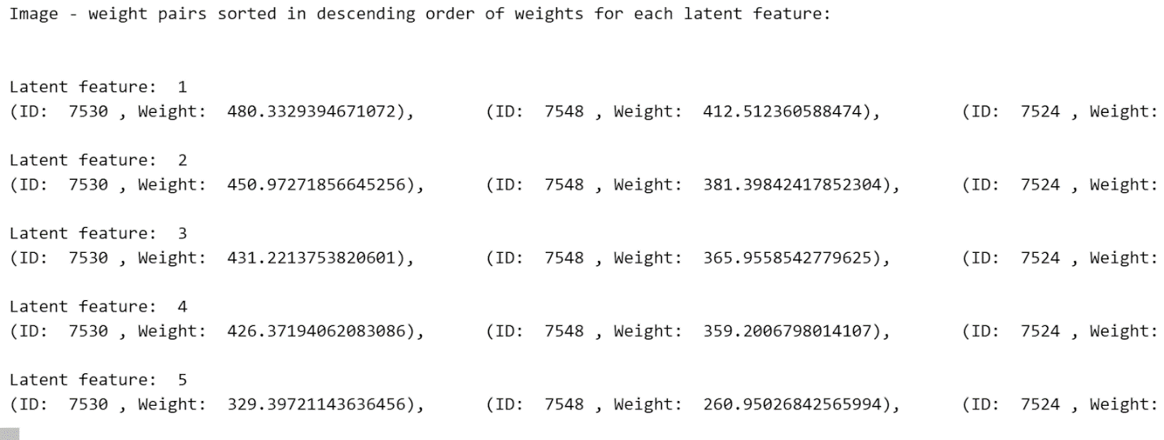

Task 6, Config 5: RESNET, SVD, K=5, Latent Semantics:
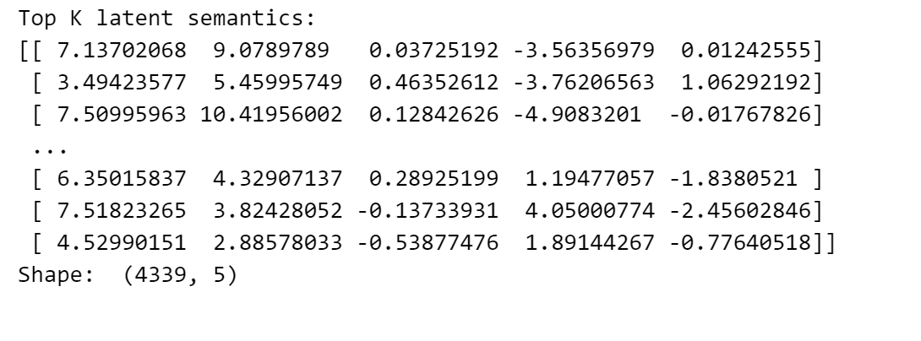

Task 6, Config 5: RESNET, SVD, K=5, Image - Weight pairs:
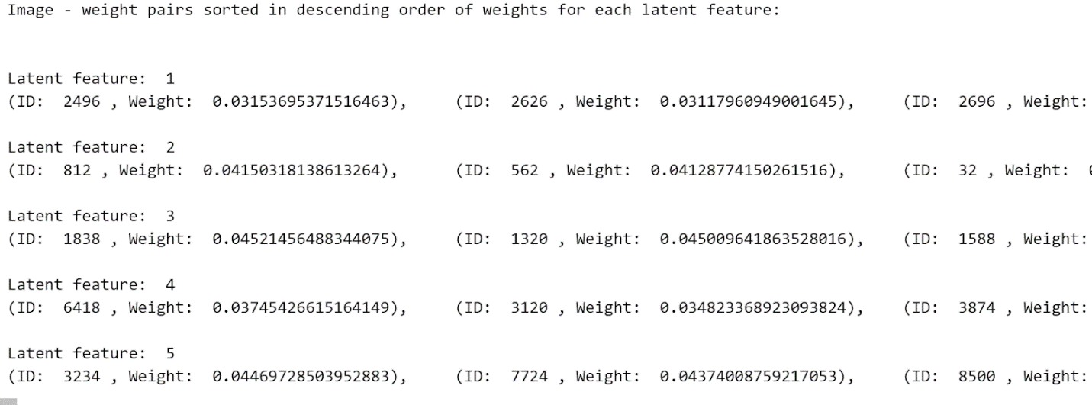

Task 6, Config 6: RESNET, NNMF, K=5, Latent Semantics:
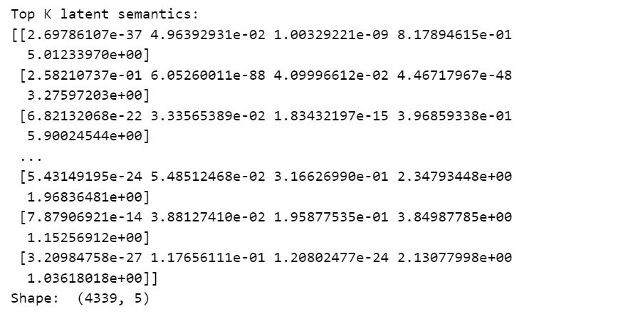

Task 6, Config 6: RESNET, NNMF, K=5, Image - Weight pairs:
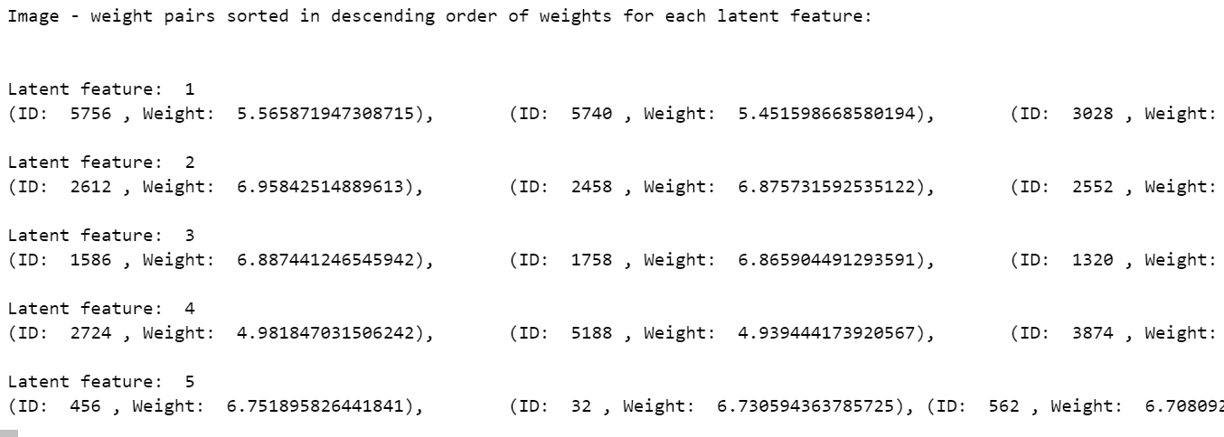

Task 6, Config 7: RESNET, LDA, K=5, Latent Semantics:
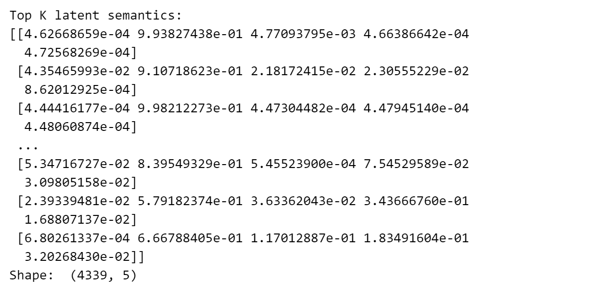

Task 6, Config 7: RESNET, LDA, K=5, Image - Weight pairs:
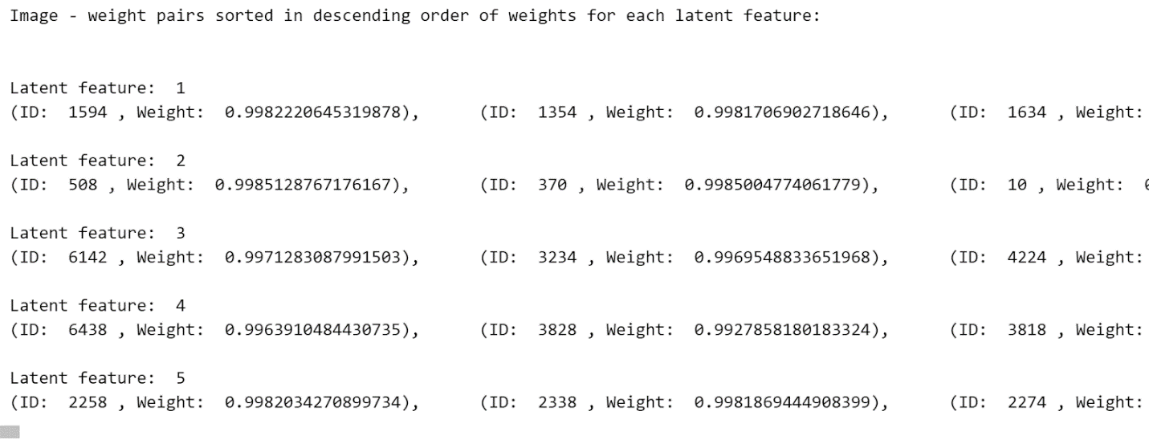

Task 6, Config 8: RESNET, K-Means, K=5, Latent Semantics:
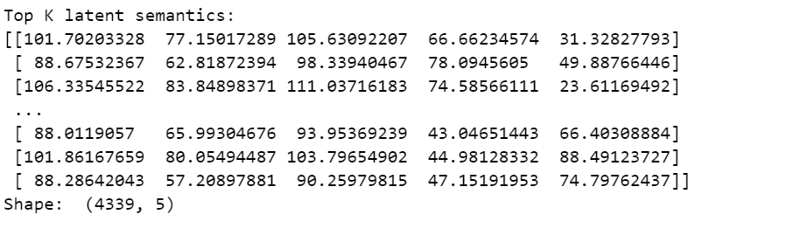

Task 6, Config 8: RESNET, K-Means, K=5, Image - Weight pairs:
