**Sememster Practical Exam**

**U18CSI6203T-Data Warehousing and Data Mining**

NAME : GOKULA KANNAN G NROLL NO:18BCS123

1. **Use apple_and_oranges.csv dataset**

· Import the dataset and divide the dataset in to Training and Testing dataset.

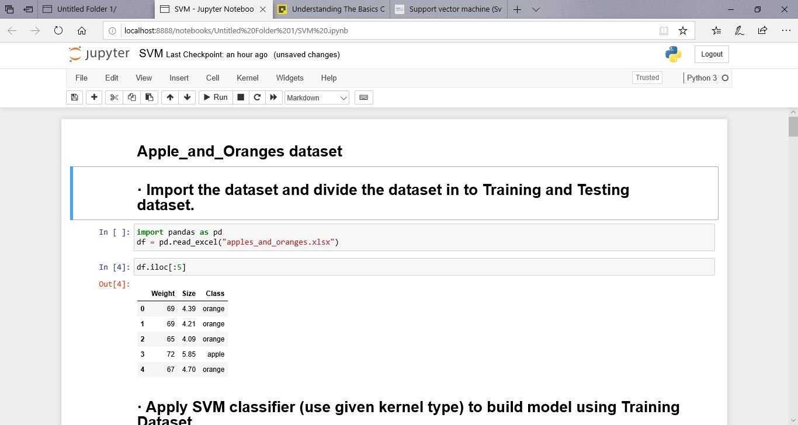

· Apply SVM classifier (use given kernel type) to build model using Training Dataset.

Kernel Type = Radial basis function (RBF), gamma=0.6

Kernel Type = Linear

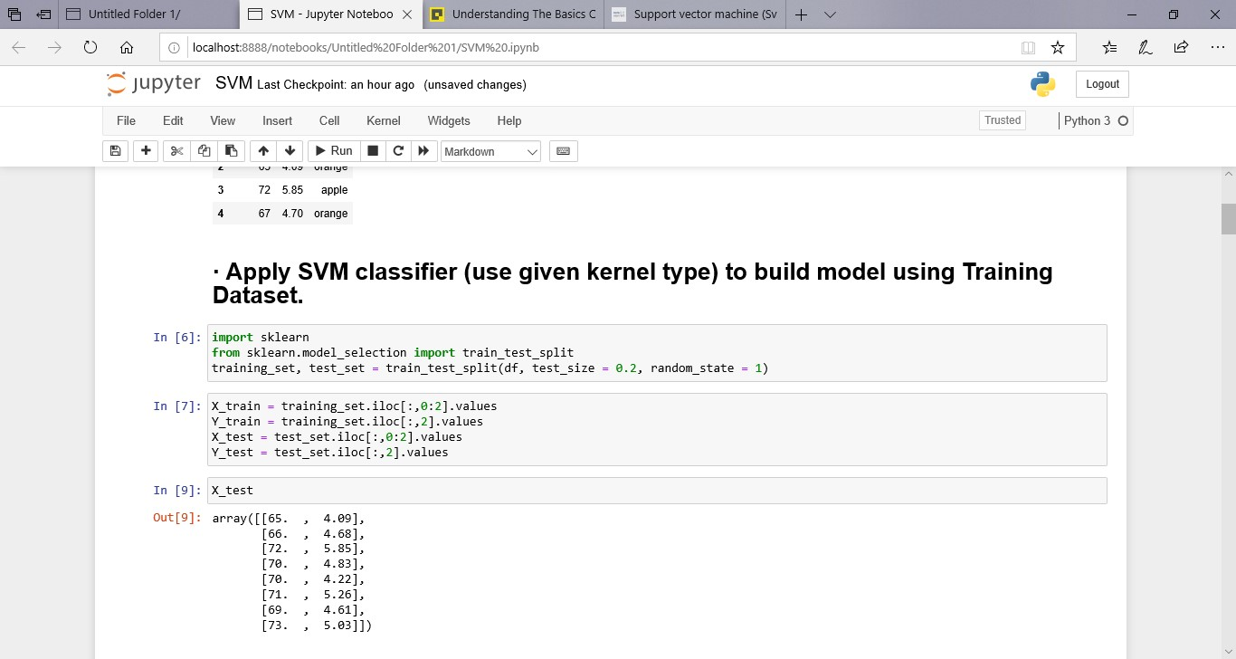

· Predict class label for data items in test Dataset.

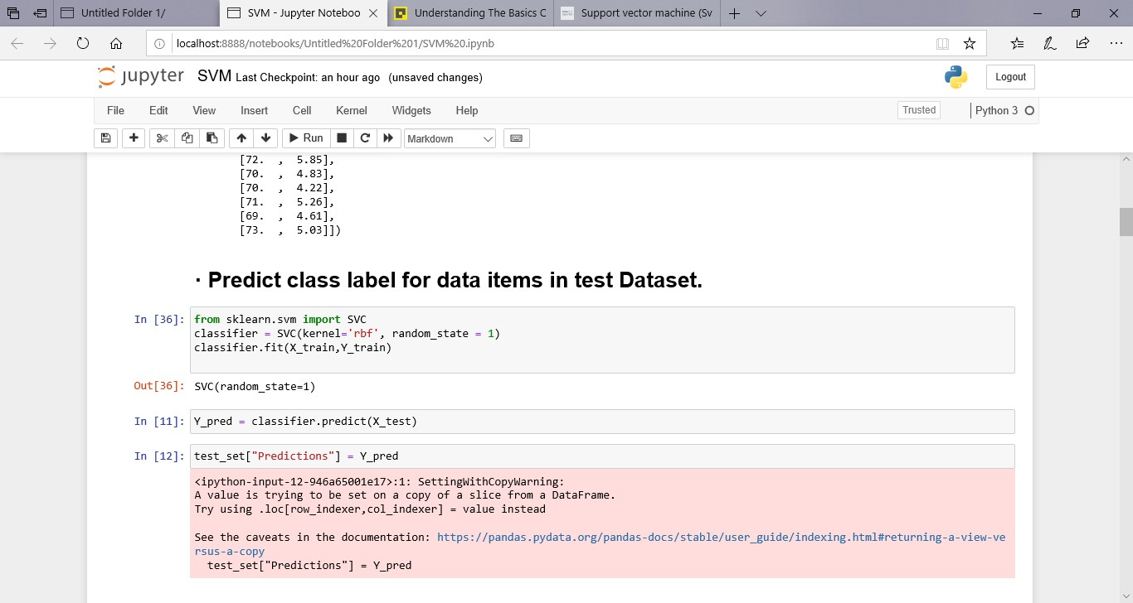

· Print the Confusion Matrix and Calculate the accuracy of the predictions.

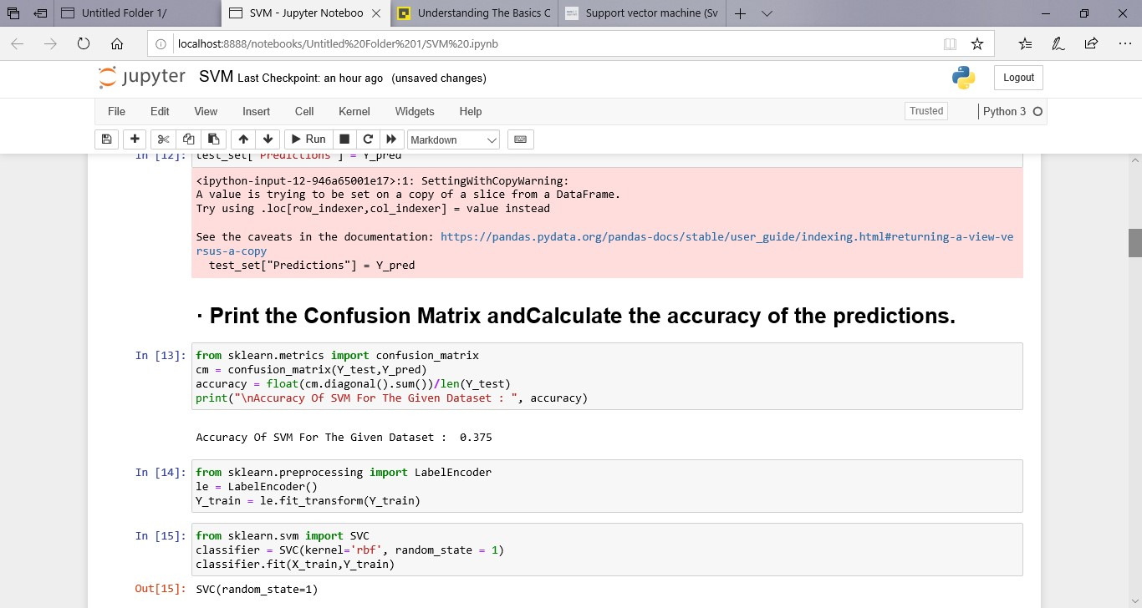

· Visualize the classifier results

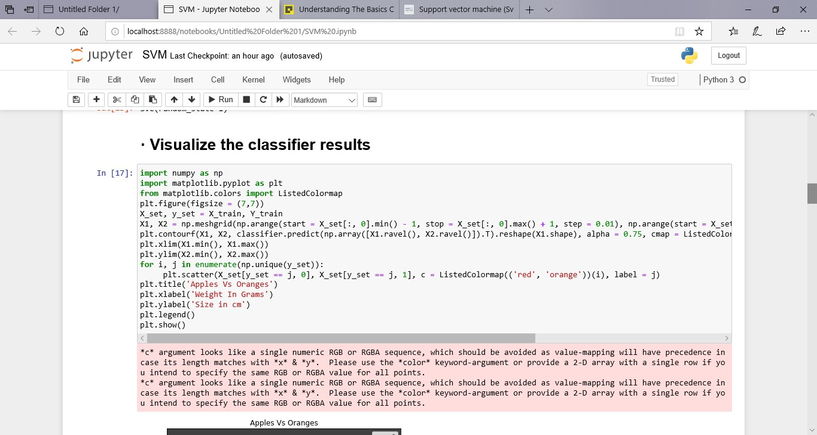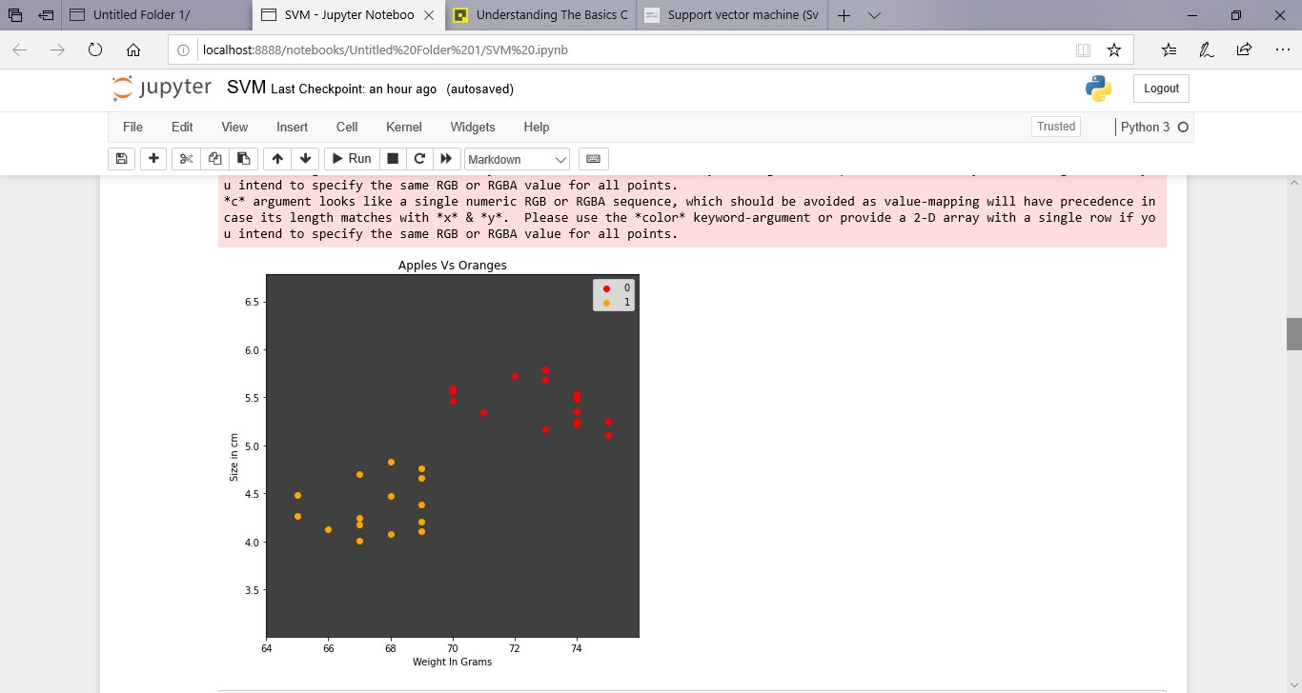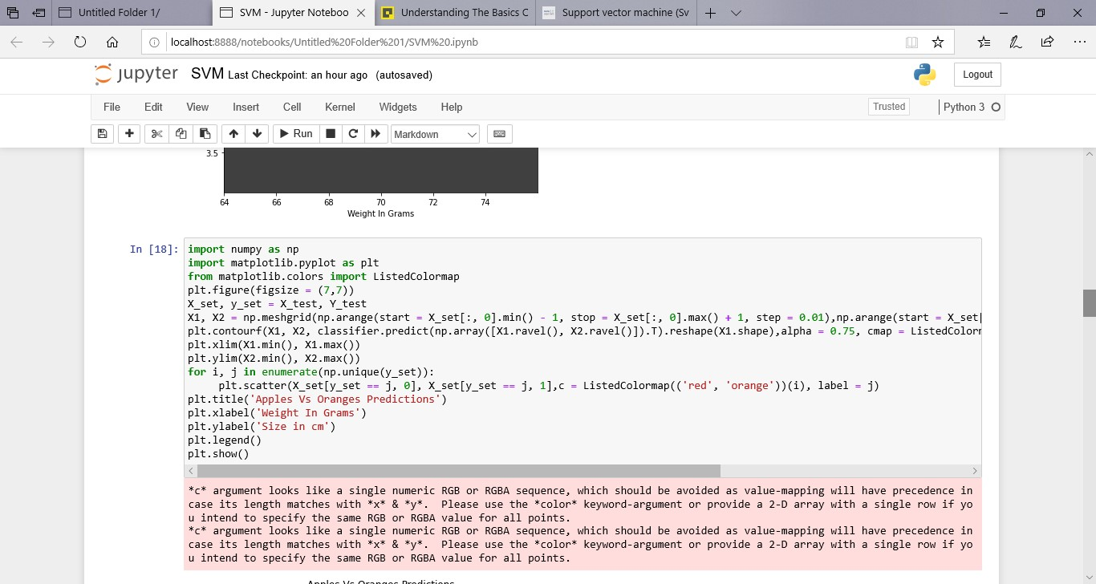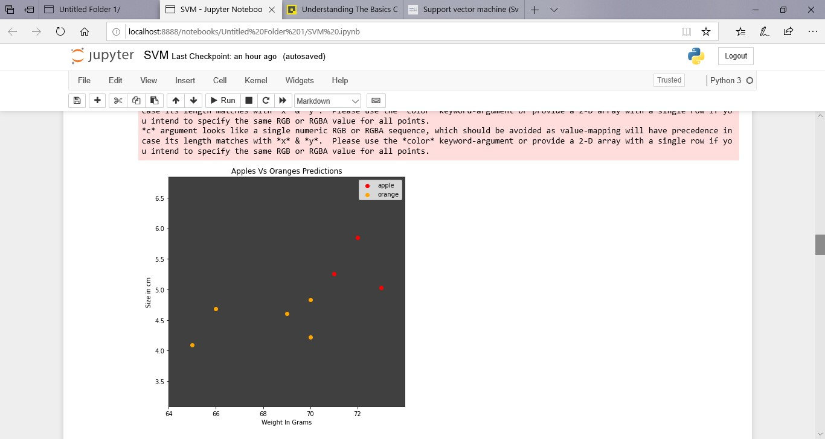

1. **Use “iris.csv” dataset.**

I. Import and

Visualize the dataset.

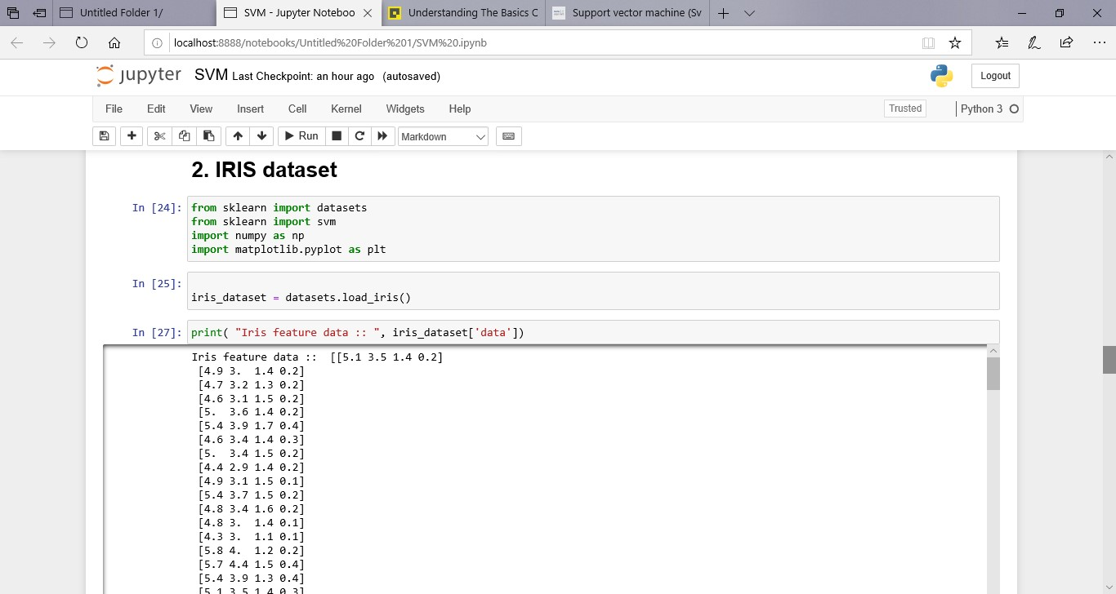

* 1. Visualizing the relationship between sepal width and target classes

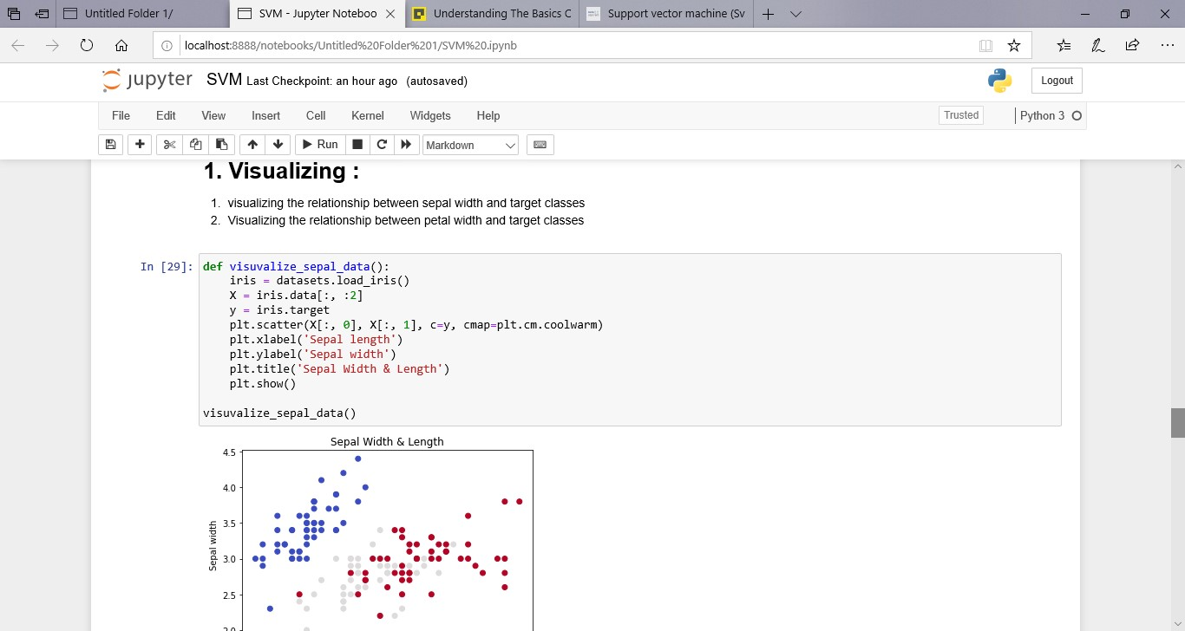

* 1. Visualizing the relationship between petal width and target classes

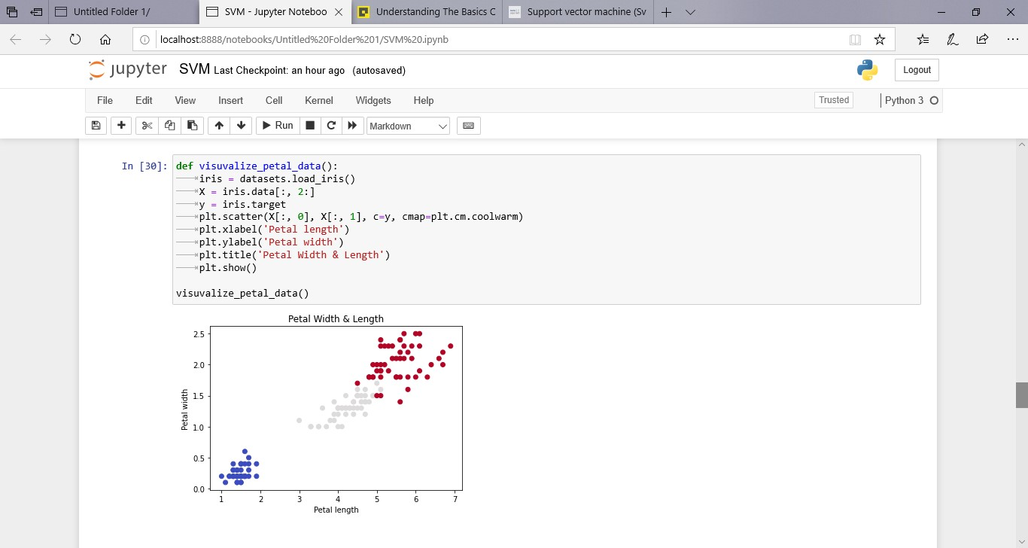

1. Apply SVM (use given kernel type) for prediction.
   1. Model given Kernel SVM classifier using Iris Sepal features and Visualizing the modeled SVM classifiers with Iris Sepal features
   2. Model given Kernel SVM classifier using Iris Sepal features and Visualizing the modeled SVM classifiers with Iris petal features l Kernel Type = Radial basis function (RBF), gamma=0.7 l Kernel Type = Linear l Kernel Type = Polynomial, Degree = 3

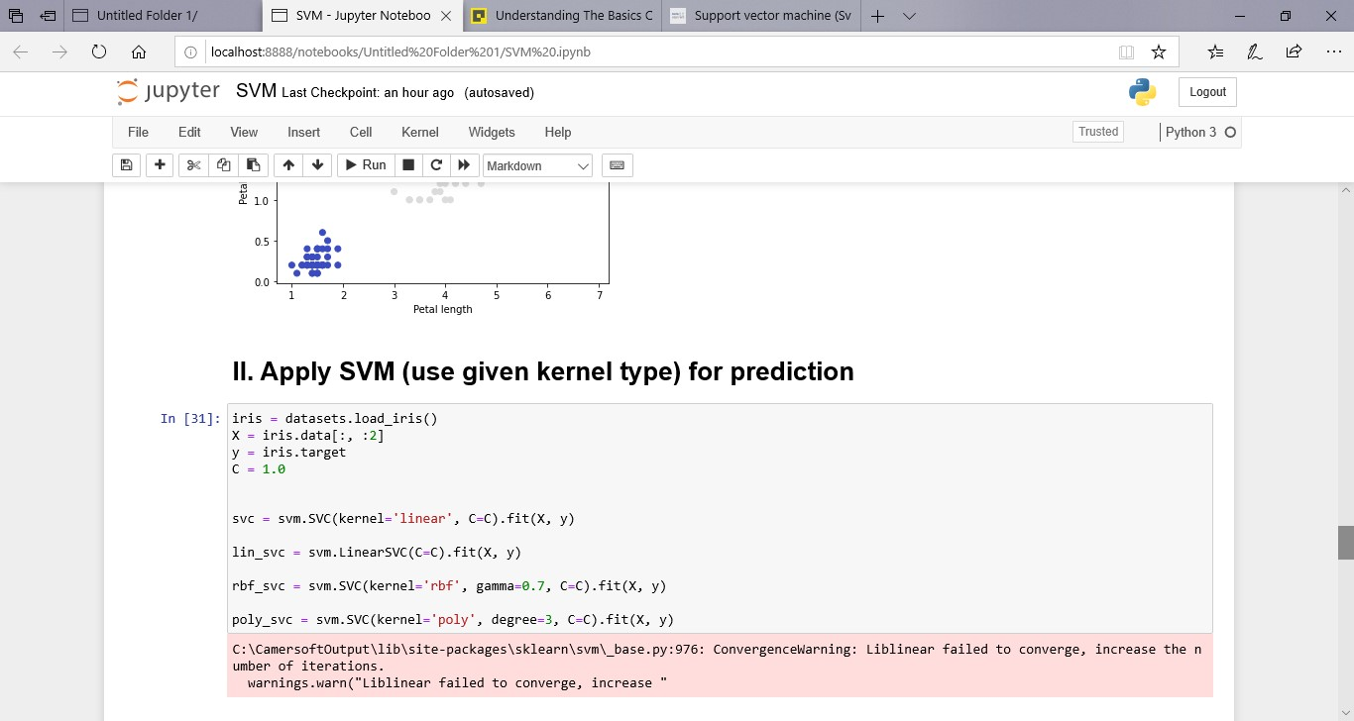

1. Predict iris flower category for new feature inputs - sepal length and width (or) petal length and width, using different kernel model built.

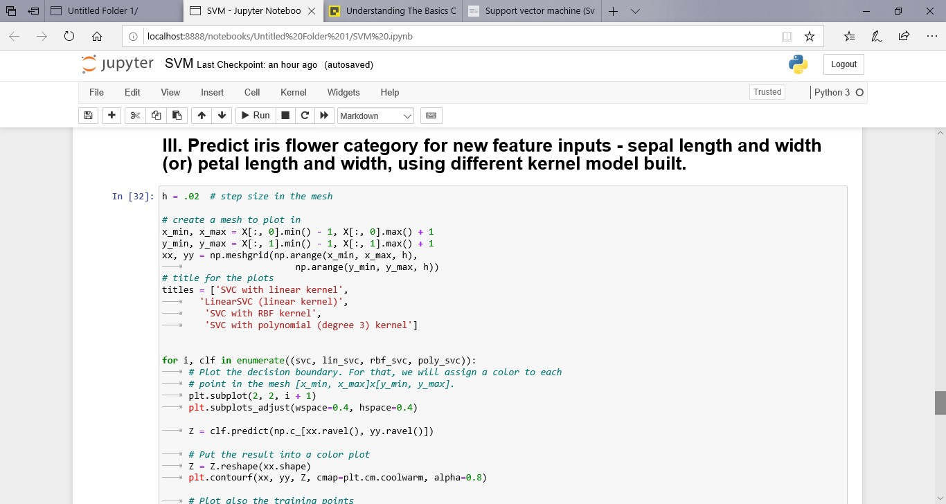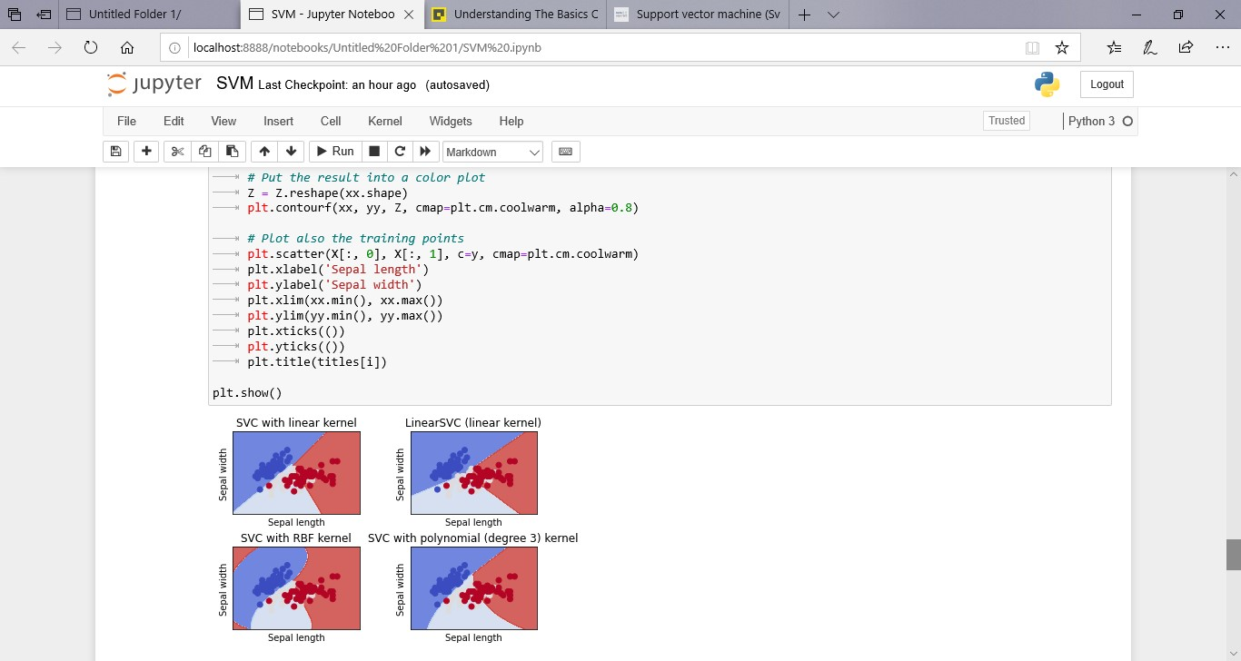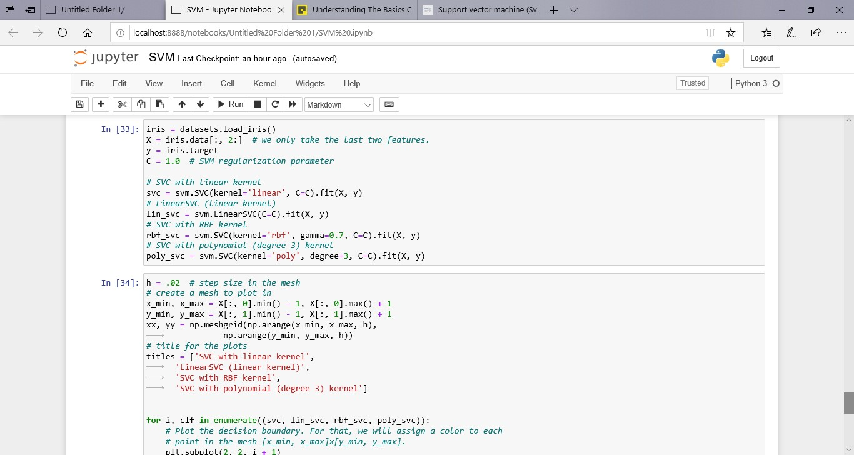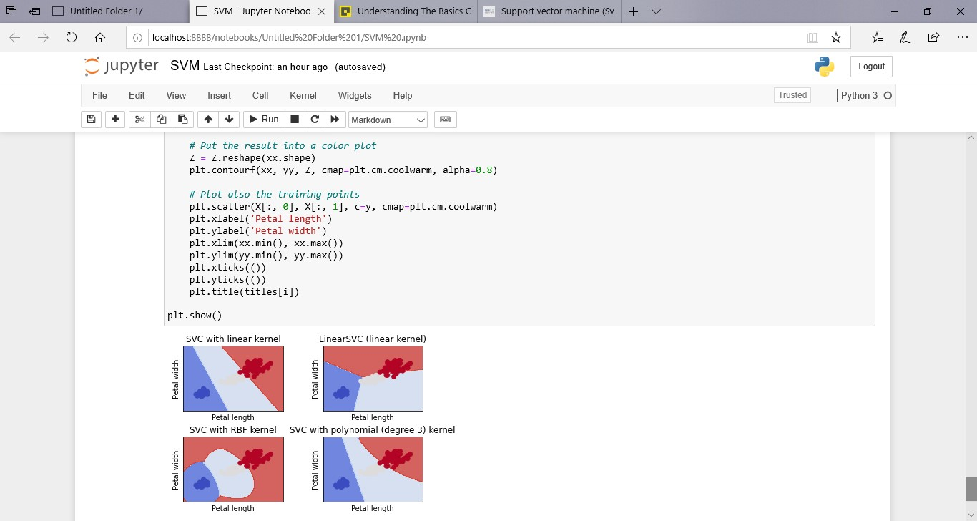

1. GITHUB LINK: