Special Session Title and Acronym:
Special Session on Applied AI/ML for Intelligent Electrical and Electronic Systems (AIML-IEES)

Brief description of the special session (max 500 words):
Artificial Intelligence (AI) and Machine Learning (ML) have become integral to the advancement of modern electrical and electronic engineering, enabling data-driven modelling, intelligent automation, and real-time decision-making. Their adoption has accelerated research and innovation across diverse domains, including sensing and instrumentation, control systems, embedded intelligence, robotics, electric mobility, renewable energy, and smart power networks. The growing convergence of AI/ML with these engineering disciplines is driving the development of more efficient, reliable, and adaptive systems capable of addressing increasingly complex real-world challenges.
This special session aims to provide a common platform for researchers, academicians, and industry professionals to present recent advances in AI/ML methodologies and their practical applications in electrical and electronic systems. The session encourages interdisciplinary contributions that combine intelligent algorithms with hardware design, measurement and instrumentation, sensing technologies, embedded computing, automation, and energy systems. It seeks to promote discussions on both methodological developments and application-oriented solutions that address current industrial and societal needs.
The session welcomes original research in, but is not limited to, AI/ML for control and instrumentation, biomedical and chemical sensors, process control and fabrication, cyber-physical and embedded systems, robotics and mechatronics, signal and image processing, electric vehicle and battery technologies, and intelligent power and renewable energy systems. Contributions demonstrating novel algorithms, experimental validation, hardware implementation, system integration, and practical case studies are particularly encouraged.
The proposed special session complements the existing conference tracks by bringing together AI-driven research that is otherwise distributed across multiple technical areas. Rather than focusing on a single application domain, it emphasizes the application of AI/ML as a common enabling technology across electrical and electronic engineering. By providing a dedicated interdisciplinary forum, the session is expected to encourage collaboration between researchers working in sensing, instrumentation, automation, embedded systems, intelligent transportation, and power and energy technologies, thereby enriching the technical breadth and impact of the conference.

Details of Session Chairs/Organizers: Name, Photo, Brief bio (800 words max), Contact email

Organizer 1: Dr. Asmita Bose, Assistant Professor, NIT Durgapur
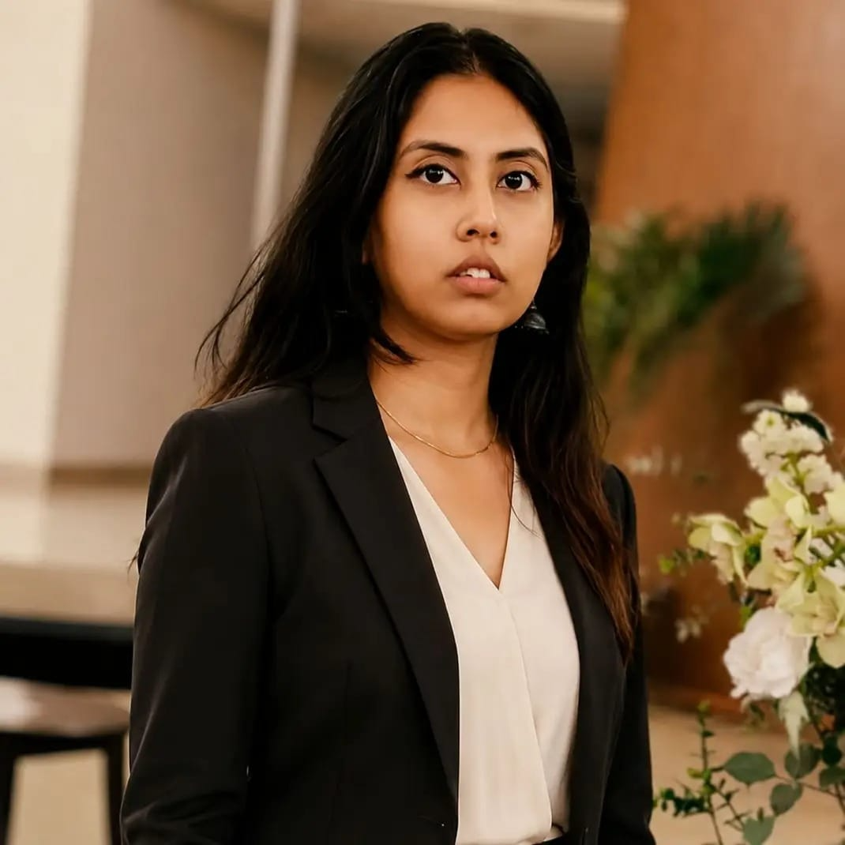
Dr. Asmita Bose is an Assistant Professor in the Department of Electrical Engineering at NIT Durgapur since 2026 and Member of IEEE. Dr. Bose earned his B.Tech. in Electrical Engineering from BESUS (now IIEST Shibpur) in 2010. She has completed her M. Tech and PhD from IIT Kharagpur in 2013 and 2023, respectively. She has also served as Ad-hoc faculty in NIT Raipur from 2023 to 2025 and as Visheshsaraya Post-Doctoral Fellow in 2025-26 in IIT Bhilai.
Her research area includes applied biomedical instrumentations and biosensors, sensor electronics, sensor data analytics, device fabrication and POCT design. Dr Bose has till date 12 publications and 1 patent. She has taught more than 15 different subjects on Sensor and Control in NIT Raipur, NIT Durgapur and IIT Bhilai. Besides, she has served various key academic and leadership roles her institutions.
Dr Bose is recipient of Awards of Appreciation in the Final Round of International IEEE Instrumentation and Measurement Student Contest, Huston, USA in 2019, and Recipient of the prestigious Best Pitch award in Sensorprunership competetion in APSCON 2026, Delhi, India for her idea in POCT device for Chronic Kidney Disease patient for rural healthcare system.
Contact: +91 7430033888 (phone and WhatsApp)
abose.ee@nitdgp.ac.in

Organizer 2: Dr. Avishek Adhikary, Associate Professor, IIT Bhilai
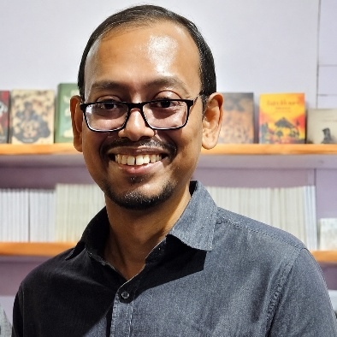
Dr. Avishek Adhikary is an Associate Professor in the Department of Electrical Engineering at IIT Bhilai since 2018 and a Senior Member of IEEE. Dr. Adhikary earned his B.E. in Electrical Engineering from Jadavpur University in 2007. He has completed his joint M. Tech-PhD from IIT Kharagpur in 2018. His research area includes applied sensing systems, biosensors, fractional-order electronics, sensor data analytics, UAV-based sensing, and precision agriculture. He has secured several sponsored research projects from MeitY, SERB, DST-IBITF, and IIT Bhilai.
Dr Adhikary has till date 54 publications including 22 high quality journal articles, 29 conference papers and 3 book chapters along with 3 patents. His Google Scholar record reads an h-index of 14, i10-index of 18, and 846 citations. He also has a wide teaching experience which includes teaching 40 courses spread across different domains of Electrical Engineering with an average teaching feedback of 4.37 out of 5. He developed Applied Sensing and Control Lab for Intelligent India (ASCII Lab) at IIT Bhilai which includes 1 post-doc, 6 PhD students, 11 MTech and 5 project members across interdisciplinary domains. The lab members have been awarded with several prestigious awards such as Young Scientist Award, best paper award, etc. Dr Adhikary is PI of various research projects funded by MeitY, ANRF and DST on UAV Control and Navigation, Fruit Ripening Detector Design and Precision Agriculture.
At IIT Bhilai, he has served various key academic and leadership roles including Head of the EE Department, Senate Member, and Joint Faculty in Mechatronics. He has also been a keynote speaker and season chair in several prestigious conferences. His laboratory works extensively on developing next-generation sensing devices and data-driven models for biosensing, food-quality analysis, smart agriculture, image processing and underwater autonomous systems.
Contact: +91 9836312018 (phone and WhatsApp)
avisheka@iitbhilai.ac.in

Organizer 3: Prof. Shubhojit Ghosh, Professor, NIT Raipur
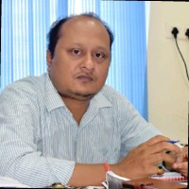
Subhojit Ghosh received the Ph.D degree from IIT Kharagpur in 2010. He has more than 20 years of teaching experience at BIT Mesra, NIT Rourkela and NIT Raipur. Presently he is working as Professor in Electrical Engineering Department, NIT Raipur. He has published more than 85 papers in different SCI journals from reputed publishers like IEEE, Elsevier, Taylor and Francis, Wiley and Springer. An Indian Patent titled “System and Method for Detecting, Classifying and Communication Faults in Power Transmission Lines” has been granted to him. He has handled research projects worth more than 1.5 crore from different funding agencies like DST, CCOST, C3i IIT Kanpur, SERB, DRDO and North Carolina State University. Twelve students have completed PhD under his guidance. He was awarded the best faculty award of NIT Raipur for the year 2020 and 2021. Listed among the top 2% cited researchers worldwide by Standford University. At NIT Raipur, he had held different administrative posts like Controller of Examination, Head of the department, Associate Dean (Academic Affairs), Coordinator IPR Cell, Chairman Continuing Education Cell, Chairman International Collaboration Cell. His research interests include optimization techniques, control systems, renewable energy and cyber physical systems.
Contact: +91 8225817389 (phone and WhatsApp)
sghosh.ele@nitrr.ac.in

Technical Outline of the Session and Topics:
The session welcomes theoretical, experimental, and application-oriented research in the following areas:
- AI/ML for Control and Instrumentation
- AI/ML for Biomedical and Chemical Sensors
- AI/ML for Process Control and Fabrication
- Cyber-Physical and Intelligent Embedded Systems
- Deep Learning for Signal and Image Processing
- AI/ML for Robotics and Mechatronics
- AI for Electric Vehicle Technologies (EVT) and Battery Technologies
- AI in Power Systems, Renewable Energy, and Smart Grids

Potential Contributing Authors (names, affiliations and emails), if available:
The list of invited contributors is currently being finalized. The organizers will invite researchers from academia, research laboratories, and industry with expertise in AI/ML applications in sensing, instrumentation, embedded systems, control engineering, robotics, electric vehicles, battery technologies, renewable energy, and power systems. The finalized list of contributors and tentative paper titles will be communicated to the conference organizers upon confirmation.

Potential Reviewers (names, affiliations and emails, at least 20):
S/N | Name | Designation | Affiliation | Email ID
1 | Prof. Siddhartha Sen | Professor (Retired) | IIT Kharagpur | ssen@ee.iitkgp.ac.in
2 | Prof. Santosh Biswas | Professor | IIT Bhilai | santosh@iitbhilai.ac.in
3 | Prof. Chiranjib Koley | Professor | NIT Durgapur | ckoley.ee@nitdgp.ac.in
4 | Prof. Ebha Koley | Professor | NIT Raipur | ekoley.ele@nitrr.ac.in
5 | Prof. Sachin Jain | Professor | NIT Raipur | sjain.ee@nitrr.ac.in
6 | Prof. Madhab C Tripathy | Professor | OUTR Bhubaneswar | mctripathy@outr.ac.in
7 | Dr. Ashis Maity | Associate Professor | IIT Kharagpur | ashis@ee.iitkgp.ac.in
8 | Dr. Pratim Kundu | Associate Professor | IIT Mandi | pratim@iitmandi.ac.in
9 | Dr. Nitin Khanna | Associate Professor | IIT Bhilai | nitin@iitbhilai.ac.in
10 | Dr. Kaushik Bandyopadhyay | Associate Professor | IIT Bhilai | kaushik@iitbhilai.ac.in
11 | Dr. Sougata Kr Kar | Associate Professor | NIT Rourkela | kars@nitrkl.ac.in
12 | Dr. Arnab De | Assistant Professor | IIT Roorkee | Arnab.dey@ee.iitr.ac.in
13 | Dr. Debanjan Das | Assistant Professor | IIT Kharagpur | debanjandas@iitkgp.ac.in
14 | Dr. Banibarata Mukherjee | Assistant Professor | IIT Kharagpur | banibaratam@atdc.iitkgp.ac.in
15 | Dr. Subhajit Siddhanta | Assistant Professor | IIT Kharagpur | subhajit@iem.iitkgp.ac.in
16 | Dr. Parijat Bhowmick | Assistant Professor | IIT Guwahati | parijat.bhowmick@iitg.ac.in
17 | Dr. Kapil Jainwal | Assistant Professor | IIT Hyderabad | kapiljainwal@ee.iith.ac.in
18 | Dr. Soumajit Pramanik | Assistant Professor | IIT Bhilai | soumajit@iitbhilai.ac.in
19 | Dr. Saikat Sahoo | Assistant Professor | IIT Bhilai | saikat@iitbhilai.ac.in
20 | Dr. Sandeep Soni | Assistant Professor | IIT Bhilai | sandeepsoni@iitbhilai.ac.in
21 | Dr. Snehanjan Achharya | Assistant Professor | IIT Bhilai | snehanjana@iitbhilai.ac.in
22 | Dr. Shailendra Kumar | Assistant Professor | IIT Bhilai | shailendra@iitbhilai.ac.in
23 | Dr. Siddharth Kedarshetti | Assistant Professor | IIT Bhilai | shailendra@iitbhilai.ac.in
24 | Dr. Arijit Guha | Assistant Professor | NIT Rourkela | guhaa@nitrkl.ac.in
25 | Dr. Soumya Chatterjee | Assistant Professor | NIT Durgapur | schatterjee.ee@nitdgp.ac.in
26 | Dr. Ravita Saraswat | Assistant Professor | NIT Durgapur | rsaraswat.ee@nitdgp.ac.in
27 | Dr. B Kiran Babu | Assistant Professor | NIT Durgapur | bkbabu.ee@nitdgp.ac.in
28 | Dr. Tanmay Pal | Assistant Professor | IIEST Shibpur | tanmay@mechatronics.iiests.ac.in
29 | Dr. Debasmita Mondal | Assistant Professor | TIET, Patiyala | debasmita.mondal@thapar.edu
30 | Dr. Chiranjib Ghosh | Post-Doctoral Fellow | IIT Bhilai | chiranjibg@iitbhilai.ac.in
31 | Dr. Dibakar Roy | Post-Doctoral Fellow | IIT Bhilai | dibakar@iitbhilai.ac.in

Other Details (if any):
Not Available.

