**11 - Exceptions**



**Dept of Artificial Intelligence and Machine Learning** | **Rajalakshmi Engineering College**

. 138

**Ex. No.**

**:**

**11.1**

**Date:** 1/6/24

**Register No.: 231501054**

**Name: S Gokulakrishnan**



**Out of Range Numbers**

Problem Description:

Write a Python script that asks the user to enter a number within a specified range (e.g., 1 to 100). Handle exceptions for invalid inputs and out-of-range numbers.

Input Format:

User inputs a number.

Output Format:

Confirm the input or print an error message if it's invalid or out of range.

**For example:**

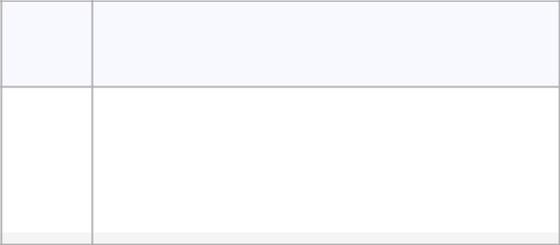

**Input Result**

|  |  |  |  |
| --- | --- | --- | --- |
|  | 1 |  | Valid input. |
|  |  |  |  |
|  | 101 |  | Error: Number out of allowed range |
|  |  |  |  |
|  | rec |  | Error: invalid literal for int() |
|  |  |  |  |

**PROGRAM**

try:

num = int(input())

if 1 <= num <= 100:

print("Valid input.")

else:

print("Error: Number out of allowed range")

except ValueError:

print("Error: invalid literal for int()")



|  |  |  |
| --- | --- | --- |
| **Dept of Artificial Intelligence and Machine Learning** | **Rajalakshmi Engineering College** | . 139 |  |
|  |  |  |
|  |  |  |

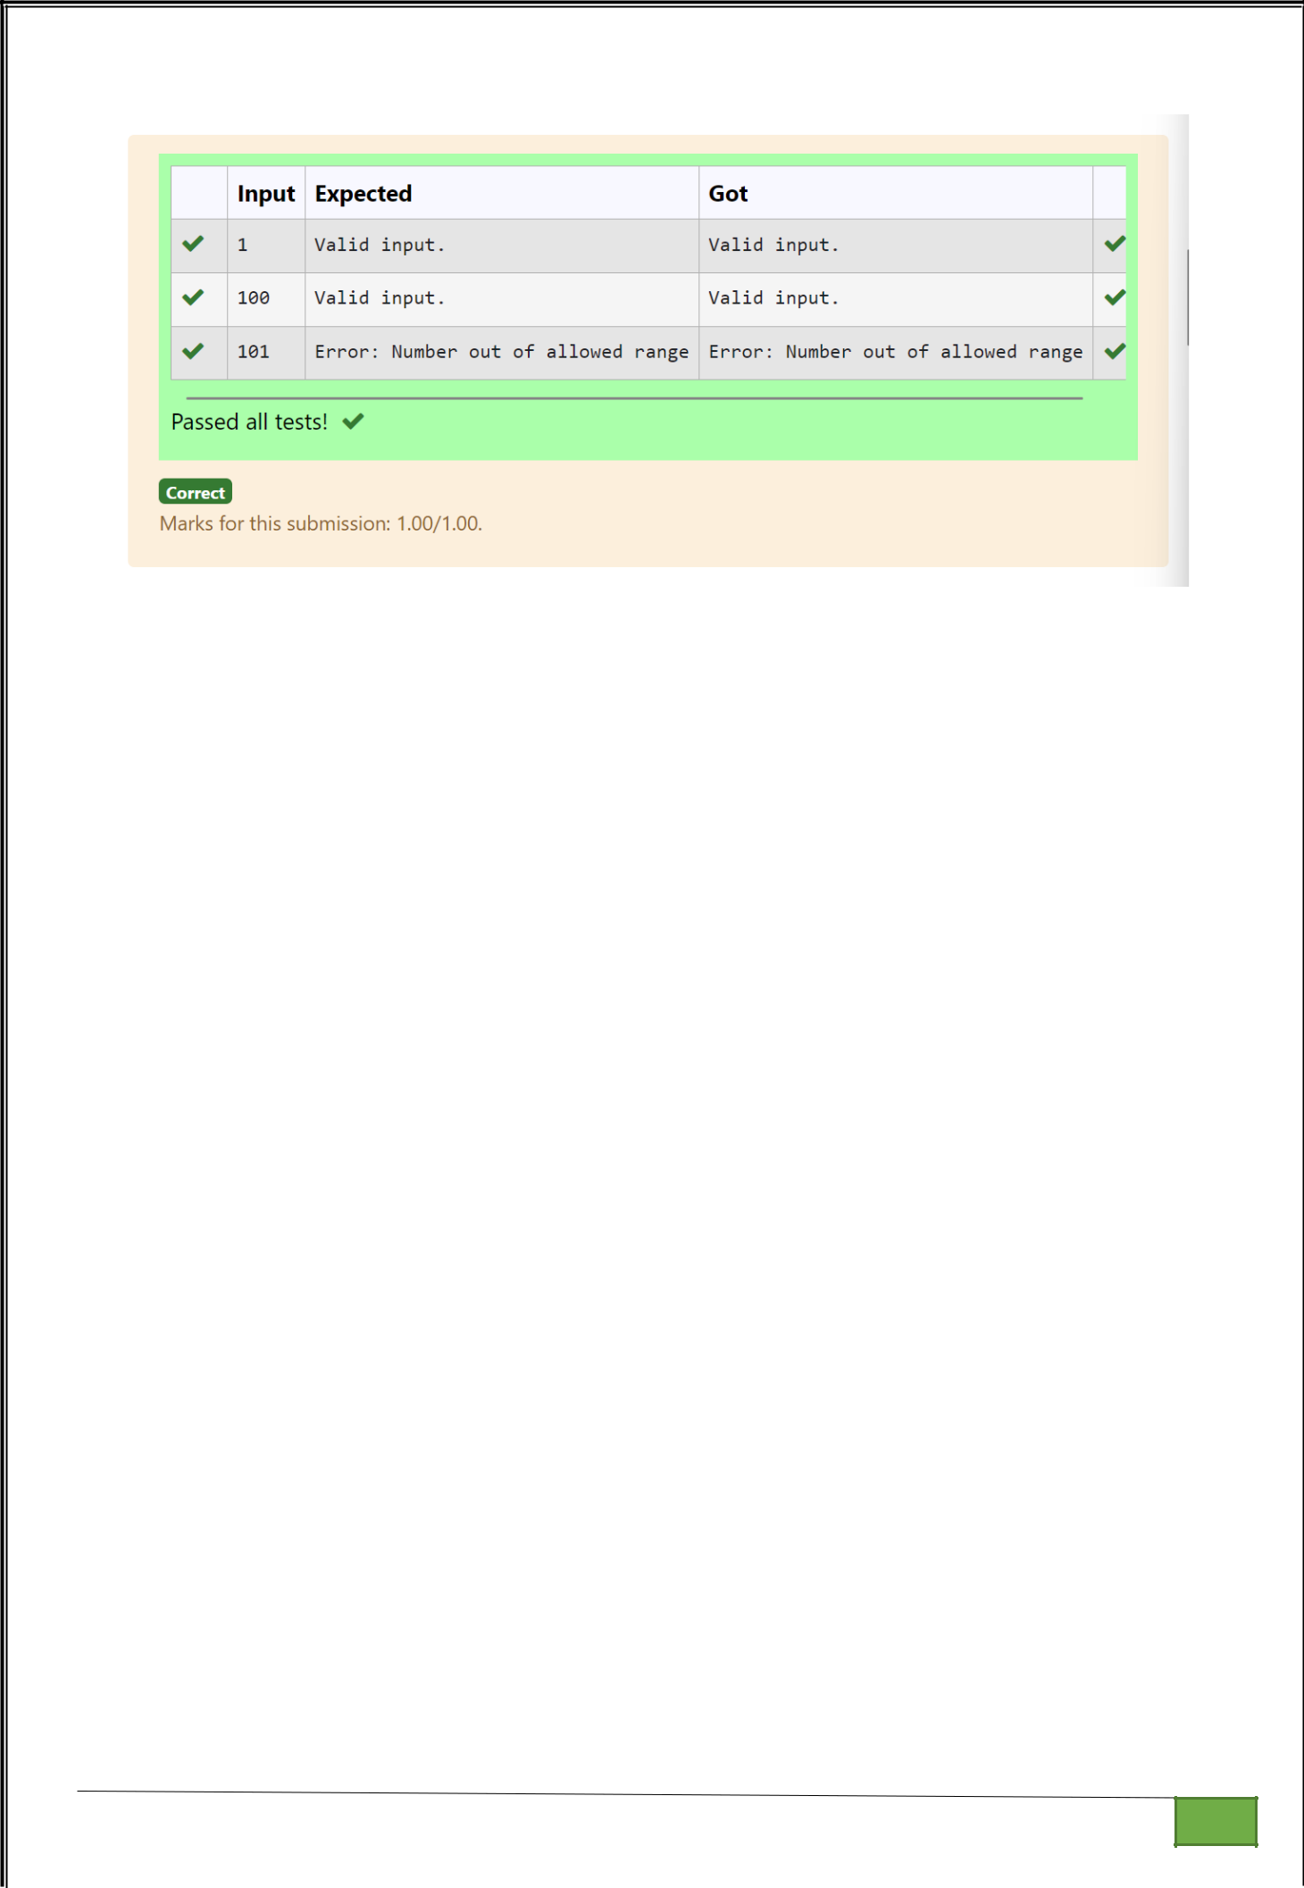

**Dept of Artificial Intelligence and Machine Learning** | **Rajalakshmi Engineering College**

. 140

**Ex. No.** **:** **11.2** **Date:** 1/6/24

**Register No.: 231501054** **Name: S Gokulakrishnan**



**Divide by Zero**

Develop a Python program that safely performs division between two numbers provided by the user. Handle exceptions like division by zero and non-numeric inputs.

**Input Format:** Two lines of input, each containing a number.

**Output Format:** Print the result of the division or an error message if an exception occurs.

**For example:**

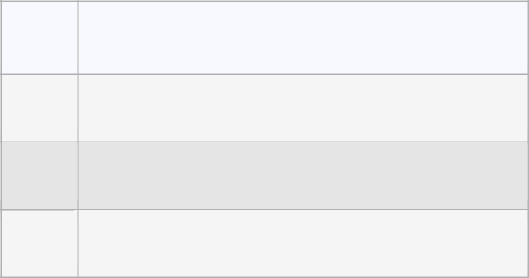

**Input Result**

1. 5.0
2. Error: Cannot divide or modulo by zero.

|  |  |
| --- | --- |
| ten | Error: Non-numeric input provided. |
| 5 |  |

**PROGRAM**

try:

a=int(input())

b=int(input())

print(a/b)

except ValueError:

print("Error: Non-numeric input provided.")

except ZeroDivisionError:

print("Error: Cannot divide or modulo by zero.")



**Dept of Artificial Intelligence and Machine Learning** | **Rajalakshmi Engineering College**

. 141

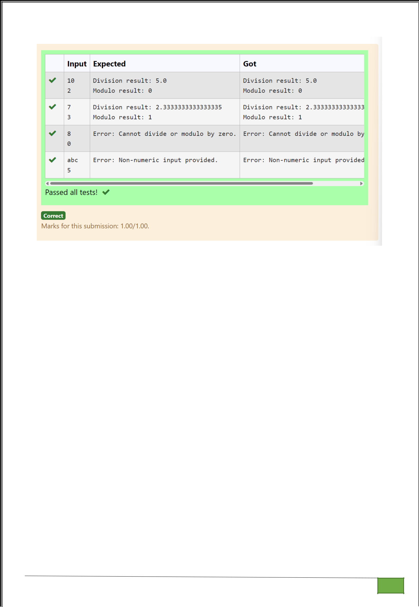

**Dept of Artificial Intelligence and Machine Learning** | **Rajalakshmi Engineering College**

. 142

**Ex. No.**

**:**

**11.3**

**Date:** 1/6/24

**Register No.: 231501054**

**Name: S Gokulakrishnan**



**Valid Age**

Problem Description:

Write a Python script that asks the user to enter a number within a specified range (e.g., 1 to 100). Handle exceptions for invalid inputs and out-of-range numbers.

Input Format:

User inputs a number.

Output Format:

Confirm the input or print an error message if it's invalid or out of range.

**For example:**

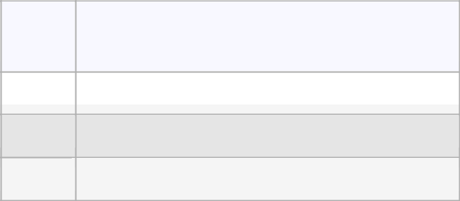

**Input Result**

|  |  |  |
| --- | --- | --- |
| 1 |  | Valid input. |
|  |  |  |

|  |  |  |
| --- | --- | --- |
| 101 | Error: | Number out of allowed range |
| rec | Error: | invalid literal for int() |

**PROGRAM**

try:

num = int(input())

if 1 <= num <= 100:

print("Valid input.")

else:

print("Error: Number out of allowed range")

except ValueError:

print("Error: invalid literal for int()")



|  |  |  |
| --- | --- | --- |
| **Dept of Artificial Intelligence and Machine Learning** | **Rajalakshmi Engineering College** | . 143 |  |
|  |  |  |
|  |  |  |



**Dept of Artificial Intelligence and Machine Learning** | **Rajalakshmi Engineering College**

. 144

**Ex. No.** **:** **11.4** **Date:** 1/6/24

**Register No.: 231501054** **Name: S Gokulakrishnan**



**Safe Square Root**

Problem Description:

Develop a Python program that safely calculates the square root of a number provided by the user. Handle exceptions for negative inputs and non-numeric inputs.

Input Format:

User inputs a number.

Output Format:

Print the square root of the number or an error message if an exception occurs.

**For example:**

|  |  |  |  |
| --- | --- | --- | --- |
| **Input** | **Result** |  |  |
|  |  |  |  |
|  |  |  |  |
| 16 | The square root of 16.0 | is 4.00 |  |
|  |  |  |  |
| -4 | Error: Cannot calculate | the square root of a negative number. | |
|  |  |  |  |
| rec | Error: could not convert string | | to float |
|  |  |  |  |

**PROGRAM**

try:

a=int(input())

if a>=0:

print("The square root of %.1f is %.2f"%(float(a),float(a**0.5)))

else:

print("Error: Cannot calculate the square root of a negative number.")

except:

print("Error could not convert string to float")



**Dept of Artificial Intelligence and Machine Learning** | **Rajalakshmi Engineering College**

. 145

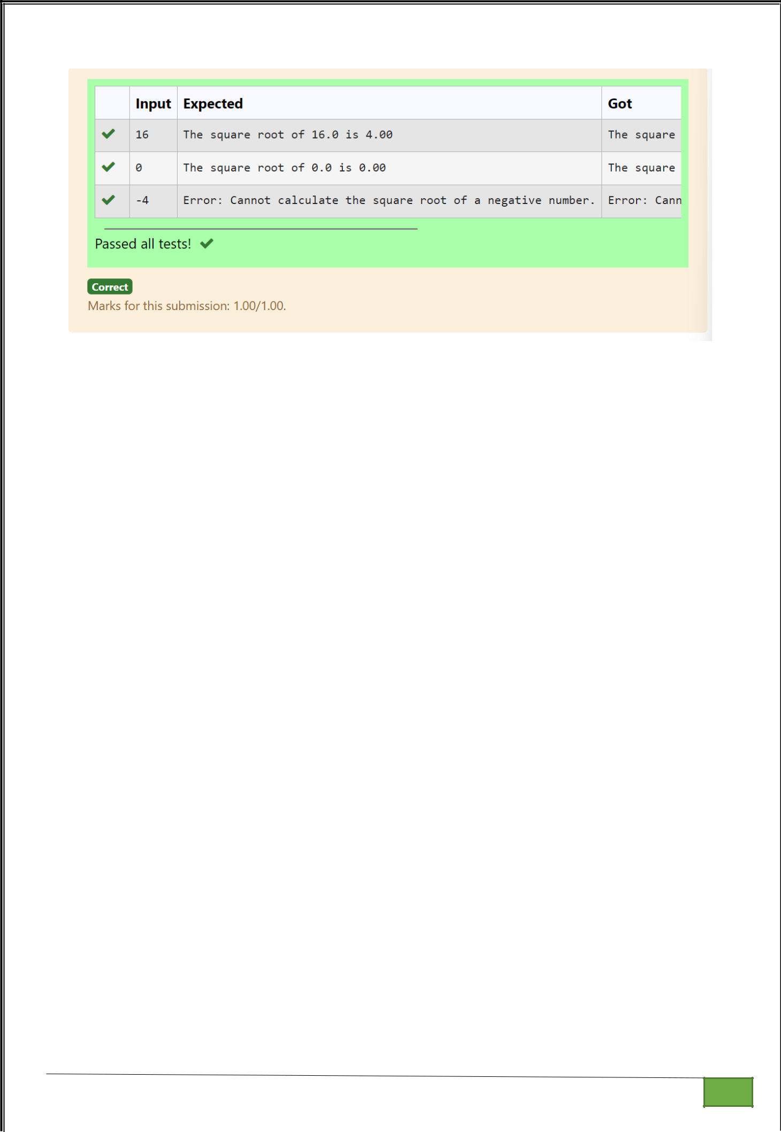

**Dept of Artificial Intelligence and Machine Learning** | **Rajalakshmi Engineering College**

. 146

**Ex. No.**

**:**

**11.5**

**Date:** 1/6/24

**Register No.: 231501054**

**Name: S Gokulakrishnan**



**Valid Integer**

Problem Description:

Write a Python program that asks the user for their age and prints a message based on the age. Ensure that the program handles cases where the input is not a valid integer.

Input Format:

A single line input representing the user's age.

Output Format:

Print a message based on the age or an error if the input is invalid.

**For example:**

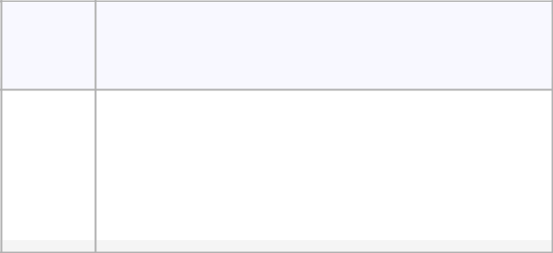

**Input Result**

|  |  |  |  |
| --- | --- | --- | --- |
|  | 25 |  | You are 25 years old. |
|  |  |  |  |
|  | rec |  | Error: Please enter a valid age. |
|  |  |  |  |
|  | -5 |  | Error: Please enter a valid age. |
|  |  |  |  |

**PROGRAM**

try:

n=int(input())

if n>=1:

print("You are",n,"years old.")

else:

print("Error: Please enter a valid age.")

except:

print("Error: Please enter a valid age.")



|  |  |  |
| --- | --- | --- |
| **Dept of Artificial Intelligence and Machine Learning** | **Rajalakshmi Engineering College** | . 147 |  |
|  |  |  |
|  |  |  |

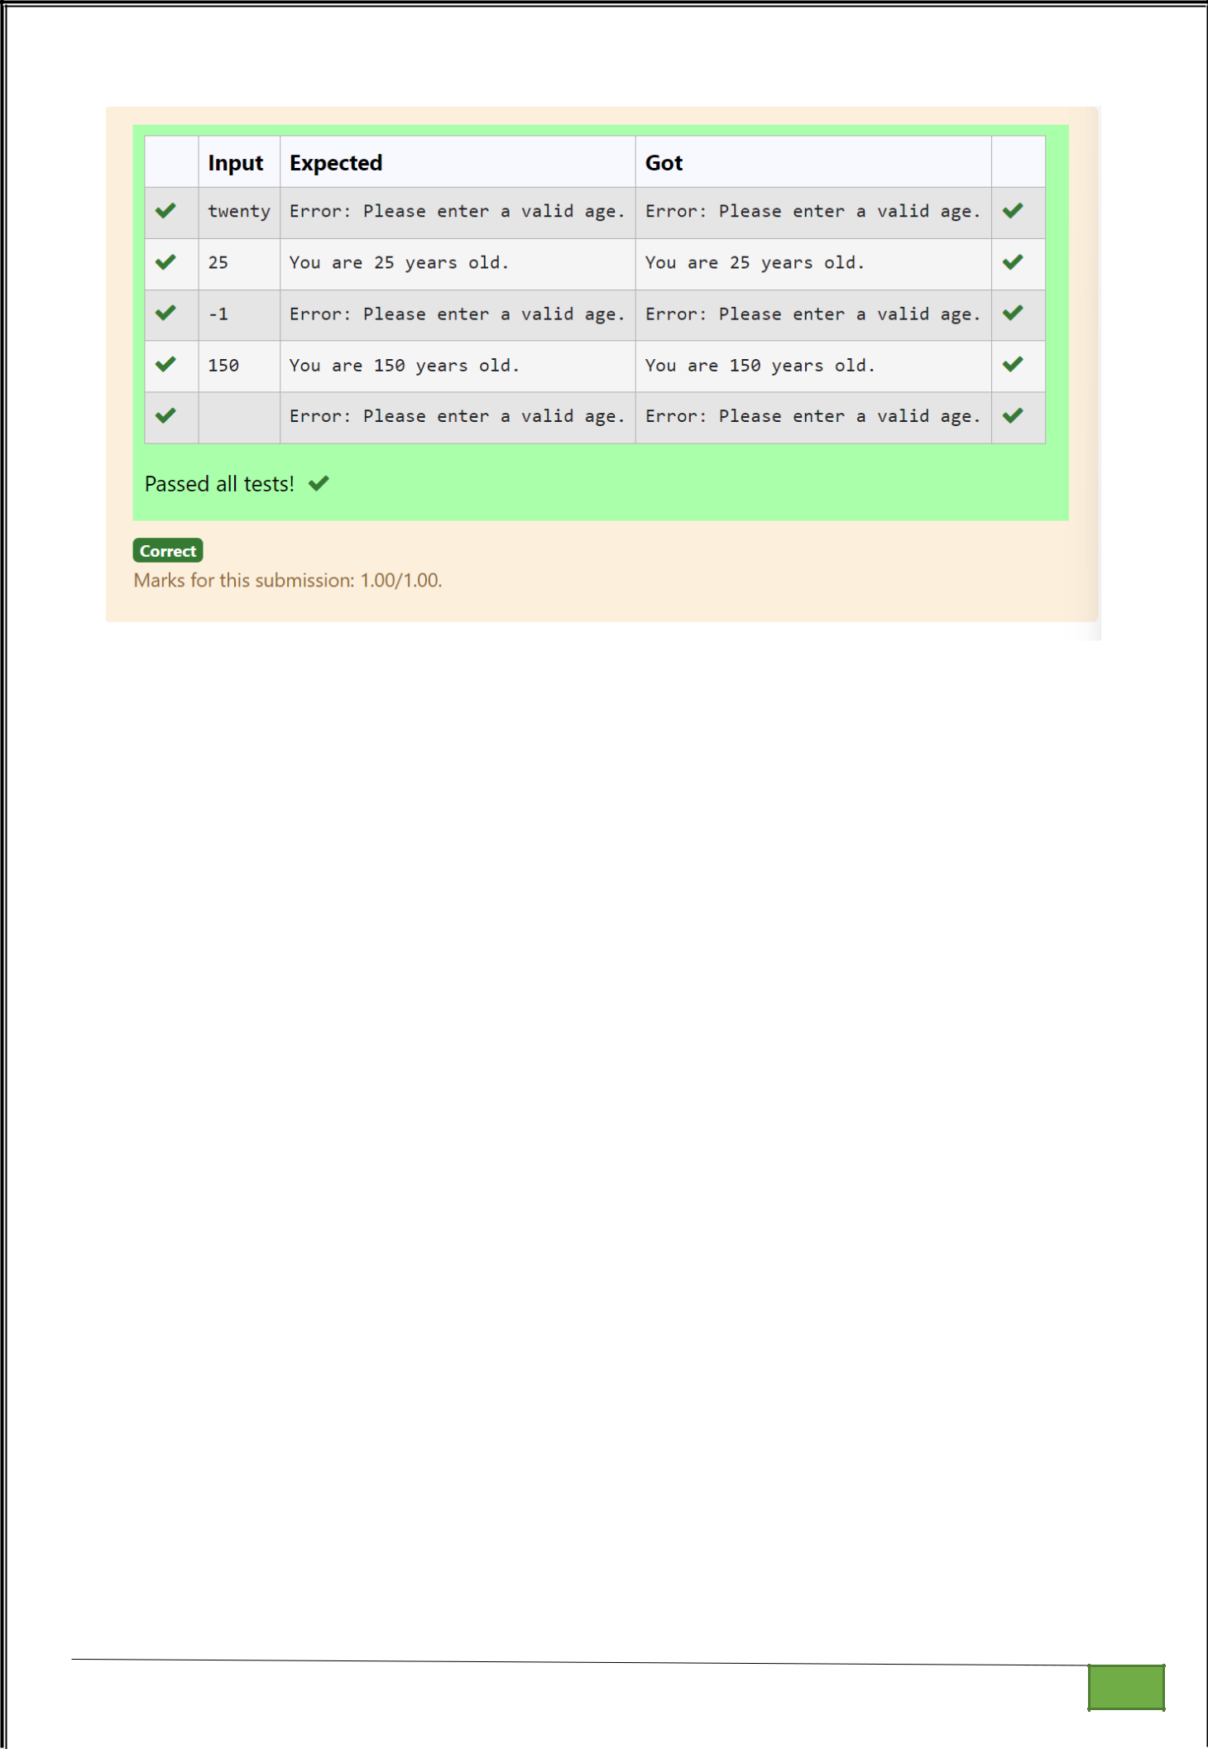

**Dept of Artificial Intelligence and Machine Learning** | **Rajalakshmi Engineering College**

. 148