**Data Management**

**Data Description**

This database consists of

* Admin: Admin information is added to database with Unique ID
* Customer: Customer information is added to database with Unique ID
* Product: Complete products information is stored in this table.
* Cart: All Customer Cart information can be stored in this table with Unique Id.
* Buyed_Product: Customer buyed products can be stored in this table

**Data Objects**

* Admin: name, password
* Customer: cus_id, name, phone_no, password, address
* Product: item_id, item_name, price, specification, quantity
* Cart: cus_id, item_id
* buyed_product: cus_id, item_id, quantity, address, ordered_date, delivery_date, status

**Database Table Diagram**

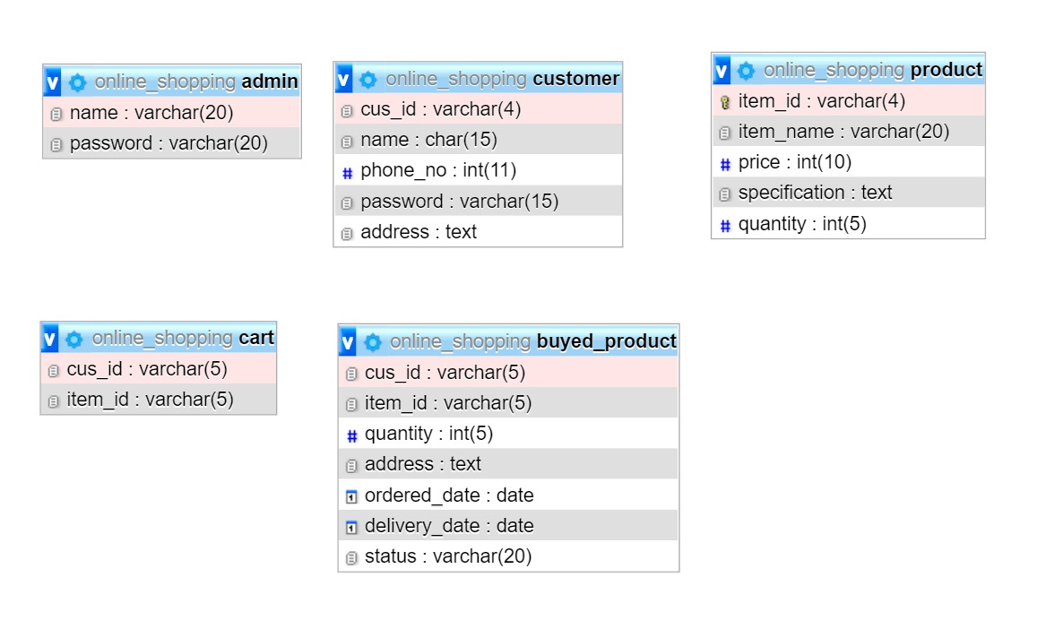

**Class Diagram**

