***INDEX***

|  |  |  |
| --- | --- | --- |
| **S No** | **Title** | **Page No** |
| **1.** | Virtual machine | 2 |
| **2.** | Deploying in azure VM using cmd | 3 |
| **3.** | Creating storage using blob | 5 |
| **4.** | Deploying directly with github | 7 |

**Virtual Machine**

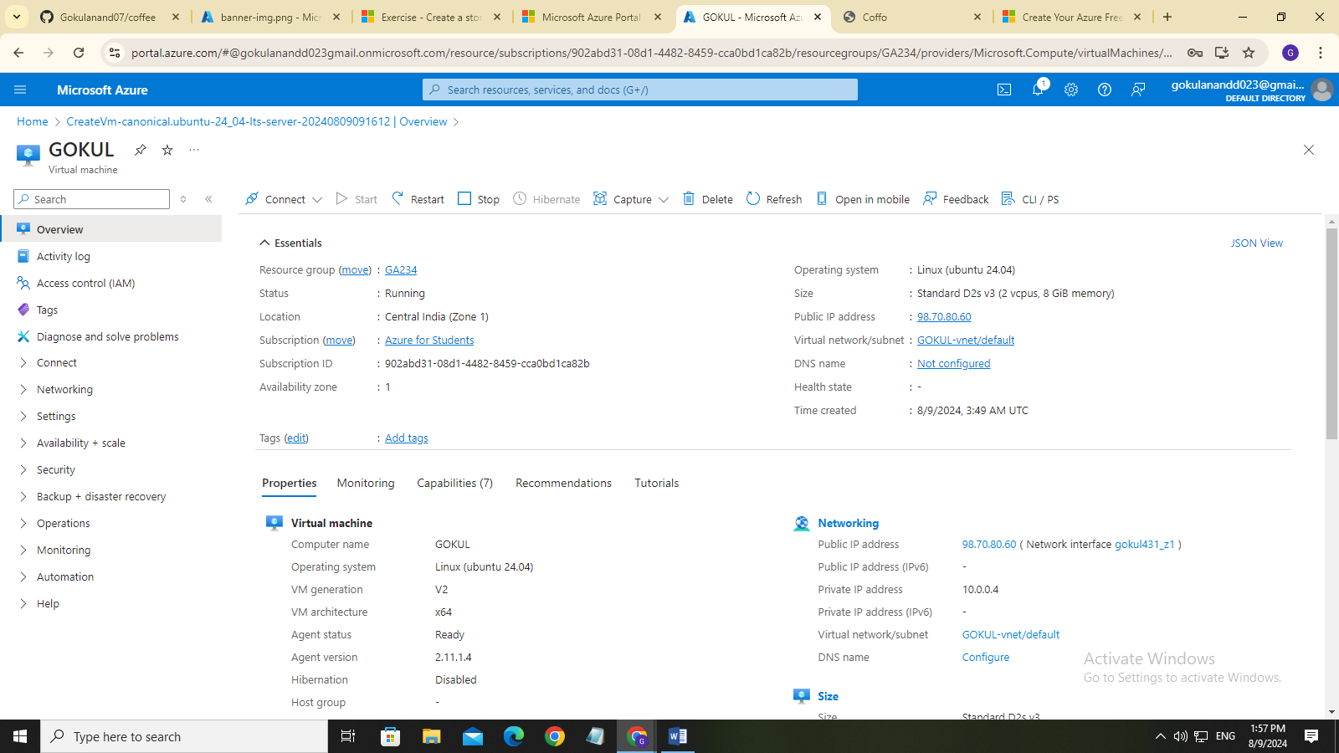

**Deploying in Azure VM using cmd**

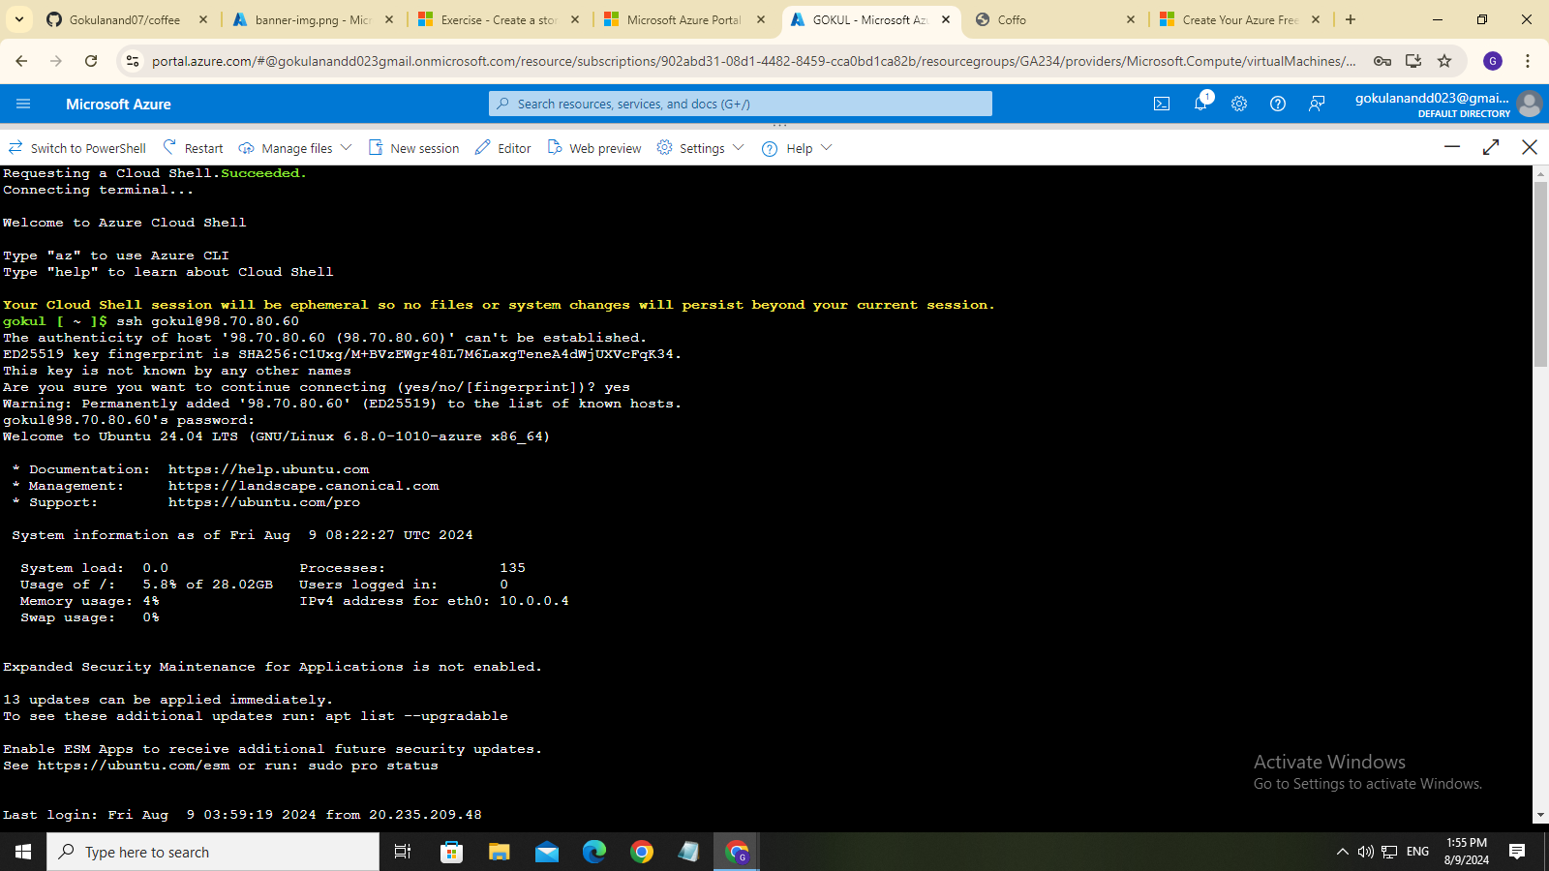

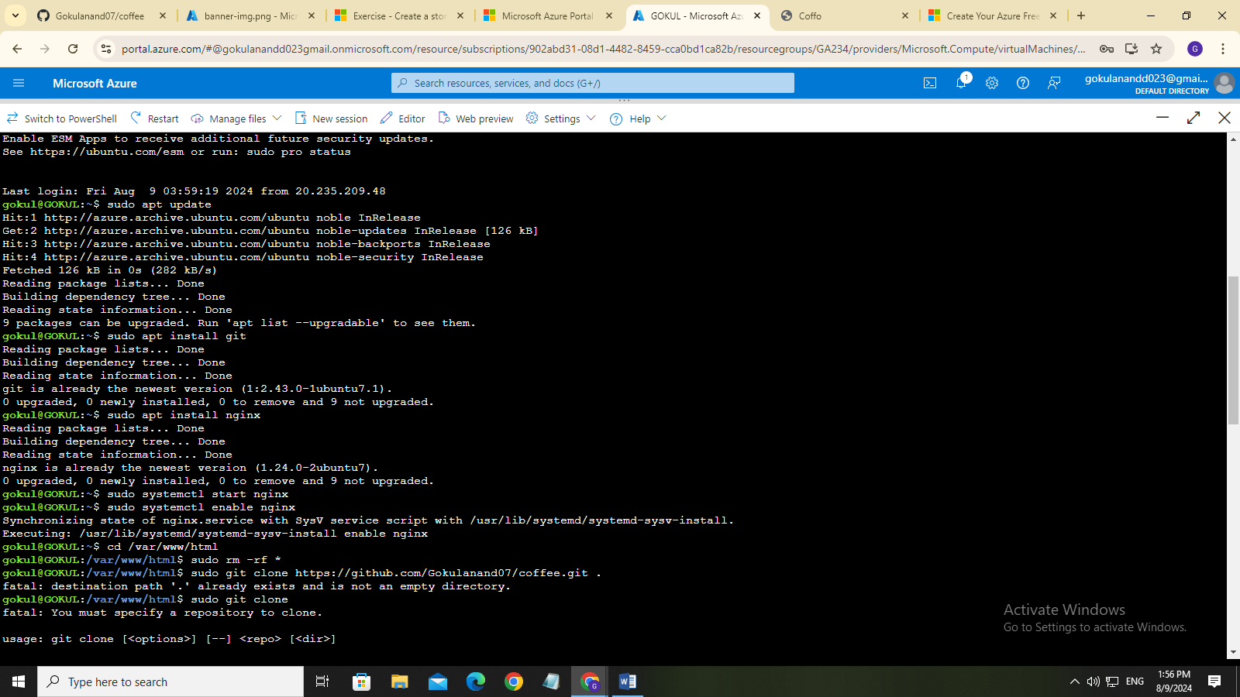

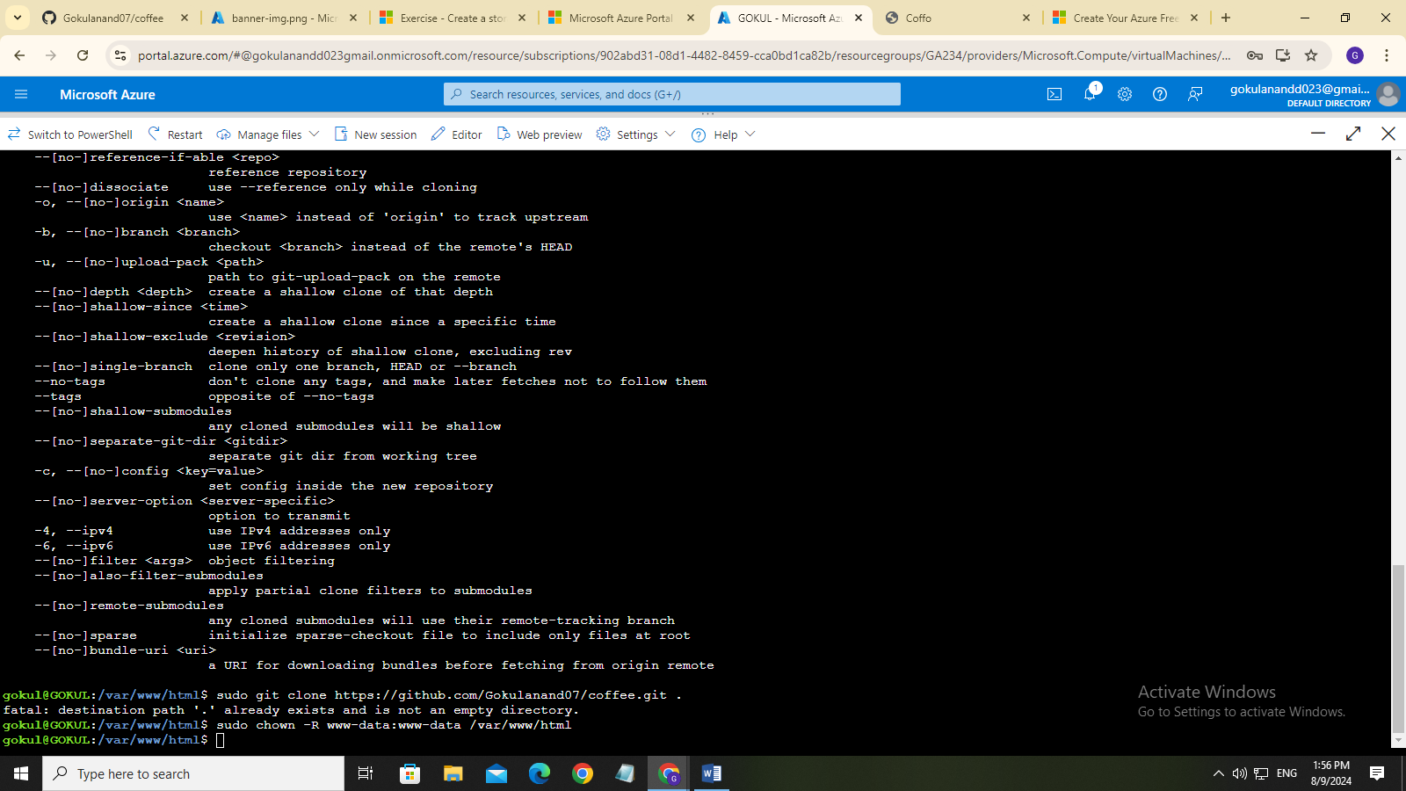

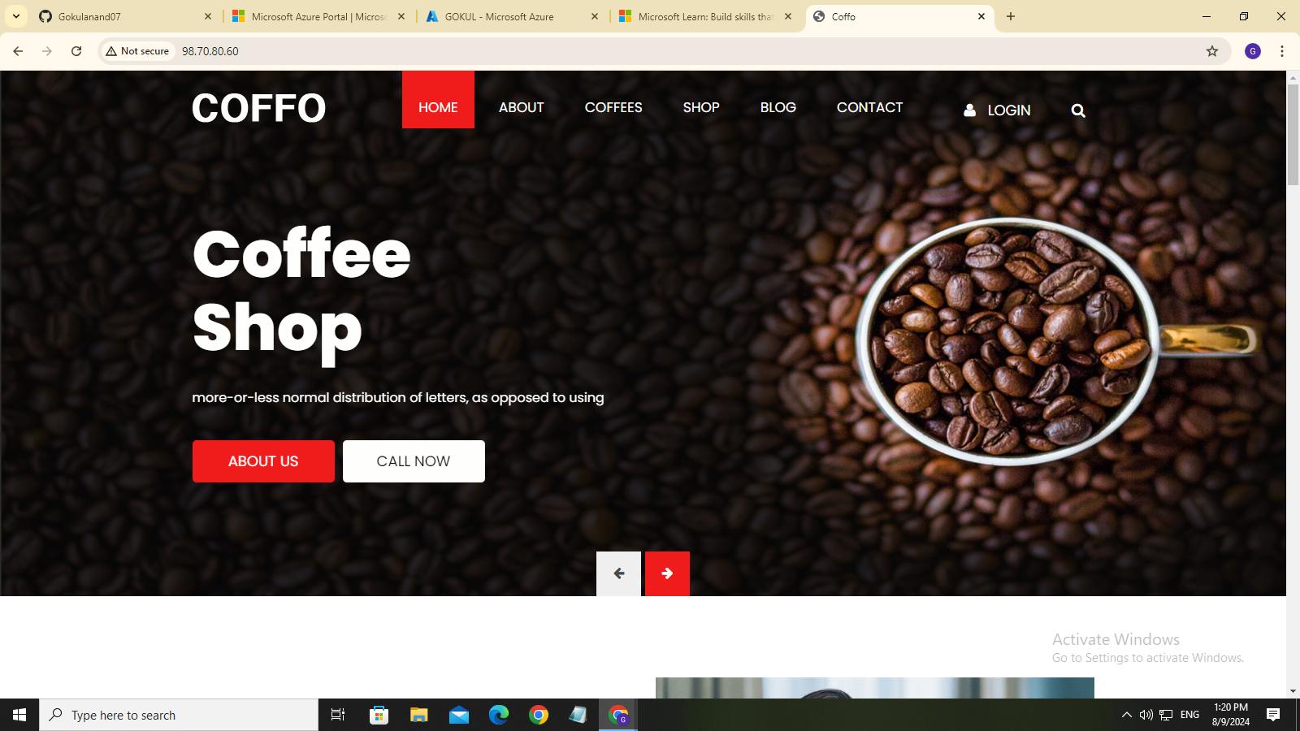

**Creating Storage using blob**

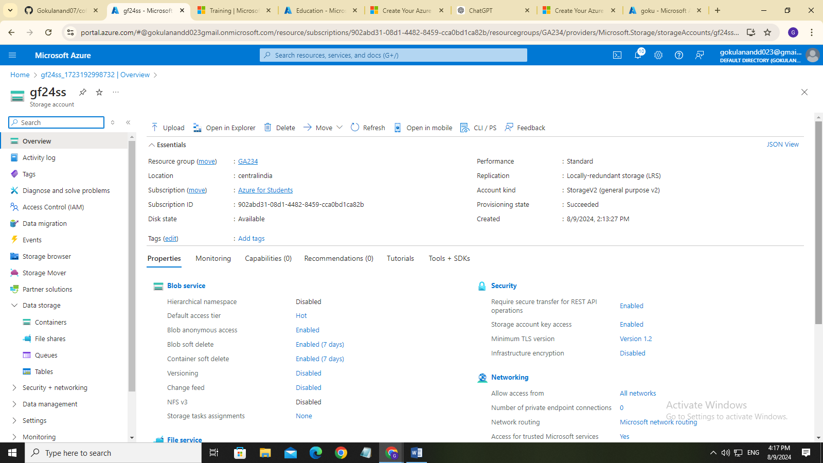

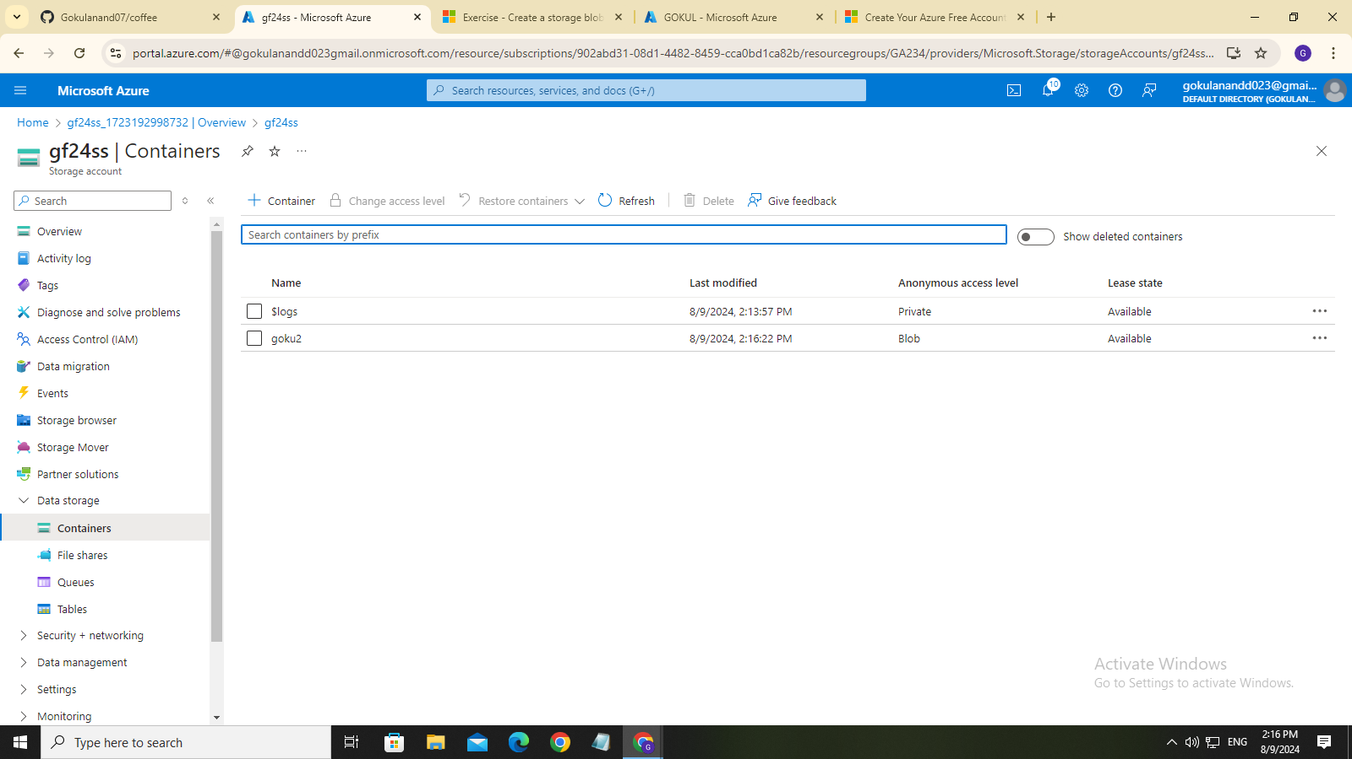

**Output**

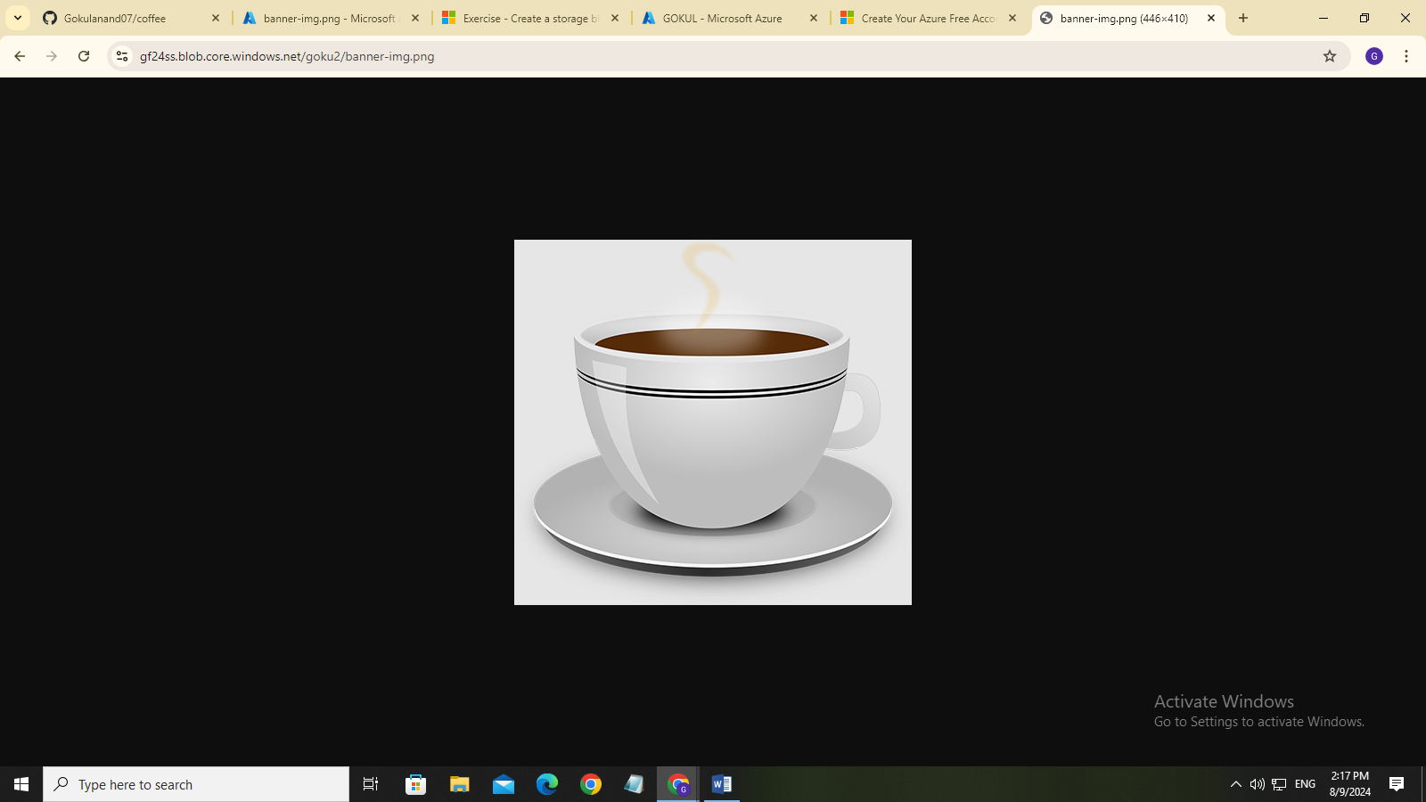

Url:https://gf24ss.blob.core.windows.net/goku2/banner-img.png

**Deploying Directly with Github**

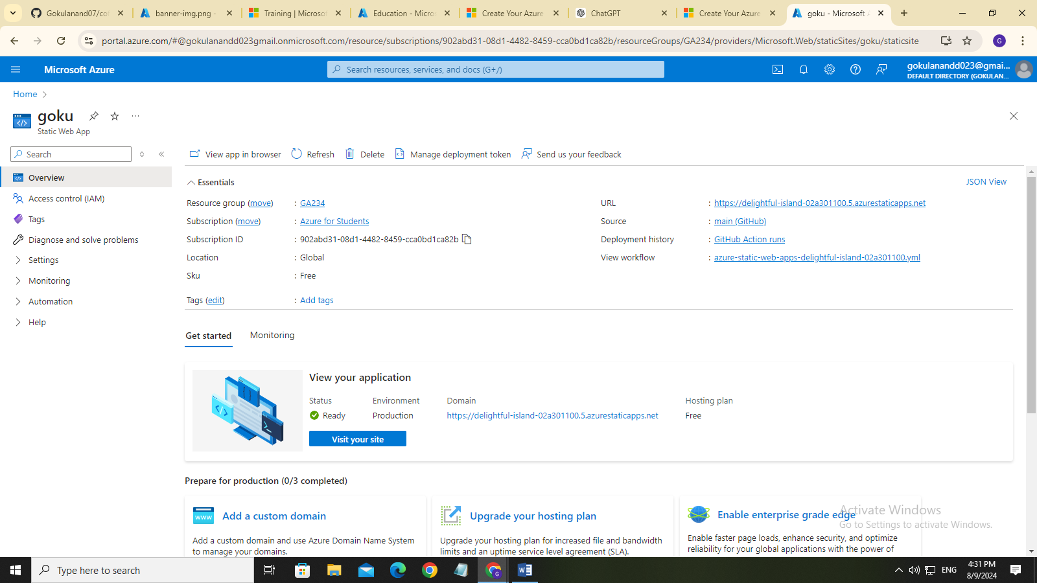

Url:https://delightful-island-02a301100.5.azurestaticapps.net/