‘Collective Intelligence’

Project Details:
The Problem Statement:
To create a bridge between service providers to service seeker.
To provide fast, free, reliable and comprehensive service to the consumers.
Description:
We suppose to build a website where we attempt to reduce the gap between the Service Provider and Service Seeker where service provider registers with his details and the seeker searches for the particular service required and accordingly the information about the service is provided.
The service providers who give service to the customers register their services with the website and provide all the necessary information required for the consumer.
Now when the consumer visits the website, he enters his requirements and fetches all the available service providers and their contact information and when the customer requests the services by adding a calendar entry then the particular service provider provides his service in given date and time.
"The world is full of people seeking solutions and people who have solutions or who ARE problem solvers, and now we make an attempt to put these people together."
The experience that people are having in private and consumer lives is influencing the expectations they now have for how they can behave in the Corporate World.
This includes new ways to share information and collaborate more freely.

From the Business Point of view, Business Intelligence is one of those functions which are primed for being able to leverage these best practices into their routines.
Collective intelligence can be implied on many levels within the organization. Most people think of Internal Sharing but cut above the rest is External Sharing i.e. sharing with suppliers, sharing with customers, sharing with third party government agents. So the idea which was being within the four walls of your life is pretty much gone away and everybody is striving to figure out to stretch those boundaries and how far they should really go..! So now the TECHNOLOGY should really help them to achieve this.
On the other hand, there are people who are prejudiced against the very notion of collectiveness and decentralization. Very recently for instance, there have been a number of people who have looked at the success of Wikipedia and pointed out ways in which is not Perfect. And then based on that they have argued that nothing central control can ever be successful.
About the System:

Objective:
- To create a bridge between service providers and service seekers.
- To provide fast, free, reliable and comprehensive service to the consumers.

Introduction to System:

We are the middleware between the Service seeker and Service provider. We are going to provide the service to the service provider as service provider gets benefited by the service as they gets the service seeker to consume services provided by the service provider.

Our System plays the part of intelligence as it gives the benefits to both the parties by providing collective intelligence as the service provider and the seeker are collectively getting the work to be done using this System.

The system will be providing different categories of services and the services will be selected by the provider or seeker as per their need. The service category for example can be “Shopping Malls”, “Food and lifestyle”, “Educational”, etc.

The Seeker will be selecting a particular category of his need and will be getting a list of service providers in that category. According to his area or living place for efficiency the seeker will be selecting the provider and getting an appointment generated by this system and a time slot will be allotted to the seeker and will be engaged.

Functioning of the system:

- Registration for the Service Provider:
The Service provider have to register into the system to give the detail of services been provided by the him and select a particular category in which the service will be displayed.

- Registration for service Seeker:
The seeker will register into the system and provide the details like the residence/office address, email, and phone. The Seeker will be selecting a particular category of his need and will be getting a list of service providers in that category. According to his area or living place for efficiency the seeker will be selecting the provider and getting an appointment generated by this system and a time slot will be allotted to the seeker and will be engaged.

- Calendar entries:
The calendar entries are for the Service provider and seeker. The provider will be updating the calendar to allot the appointment to the seeker to be selected. The seeker will select the non-reserved time slot and get appointment from the provider.

- Acknowledgement:
The service provider will acknowledge on the website about the work being done. The service consumer will rate the provider according to satisfaction of work. According to the review provided by the seeker the provider will be classified with priority. And the name of the provider will be listed accordingly.

Analysis Model:

- Use Case:
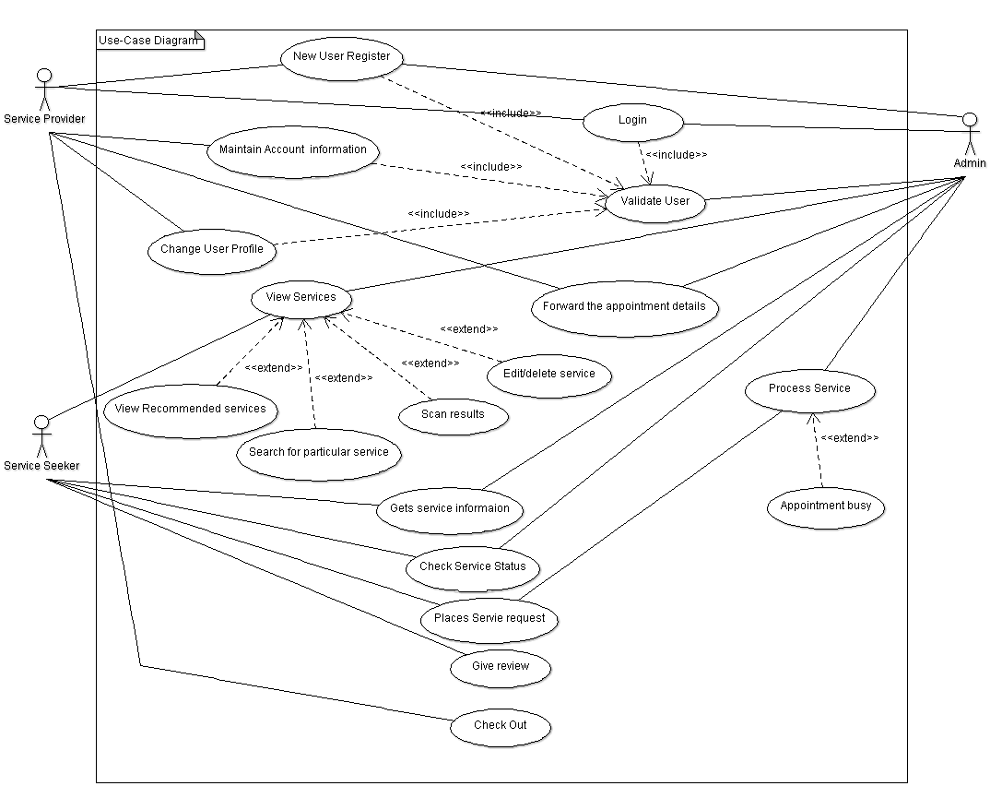

- Class Diagram:

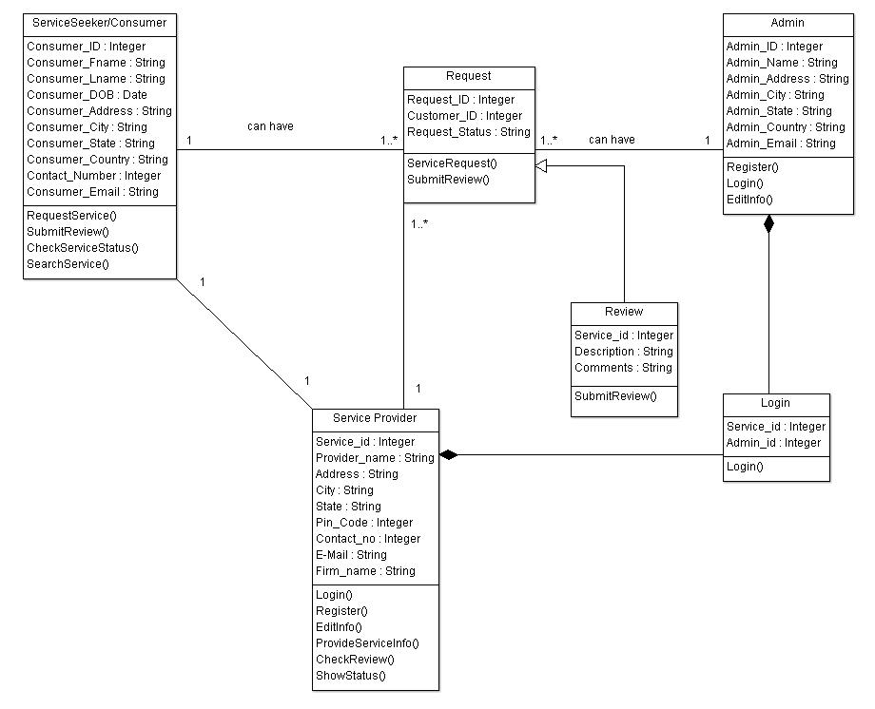

- Sequence Diagram:

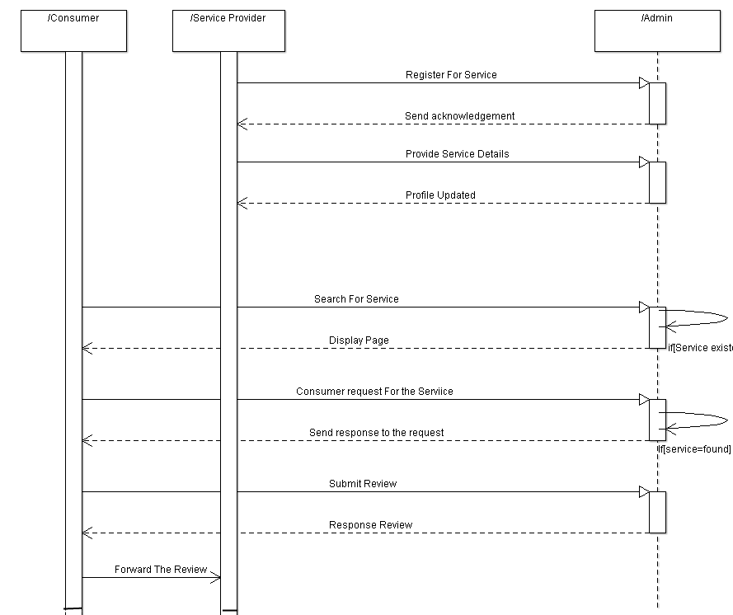

- Activity Diagram :

  - Service Provider:

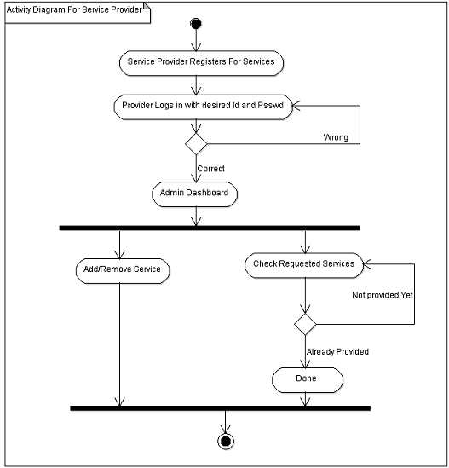

  - Seeker:
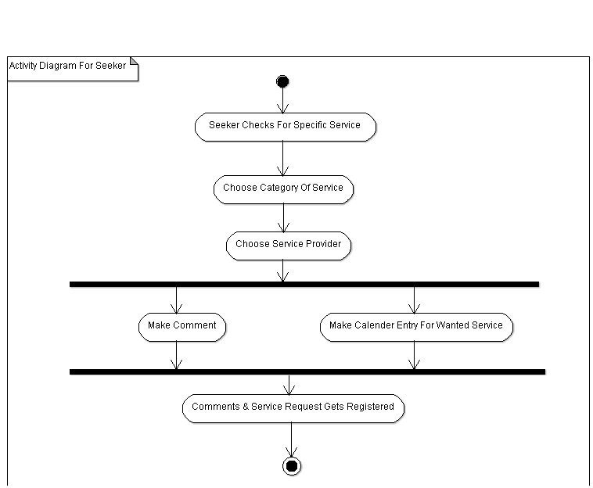

- ER-Diagram:

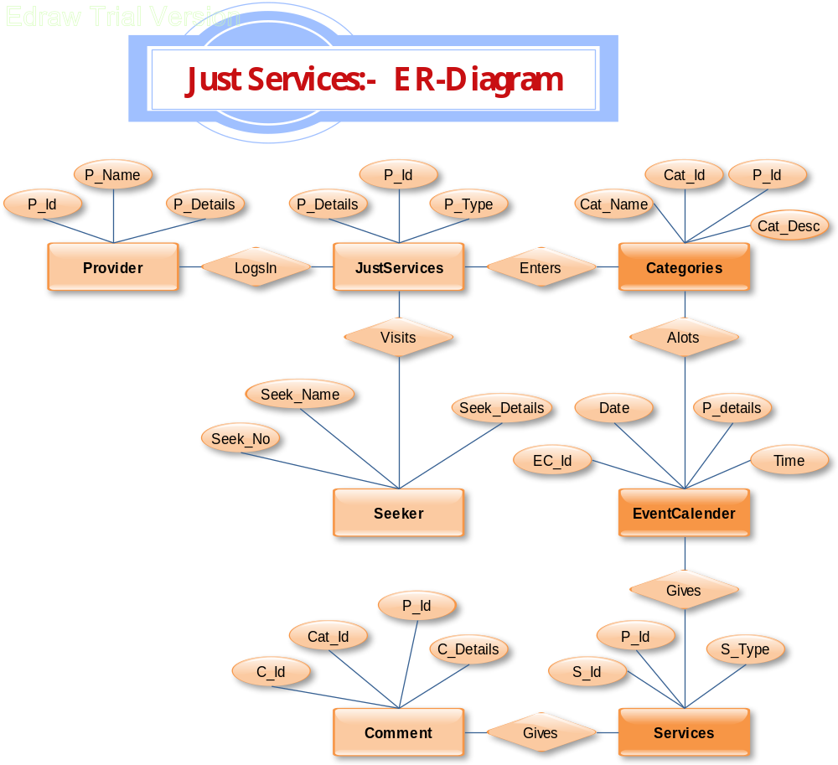

- Context Level- DFD:

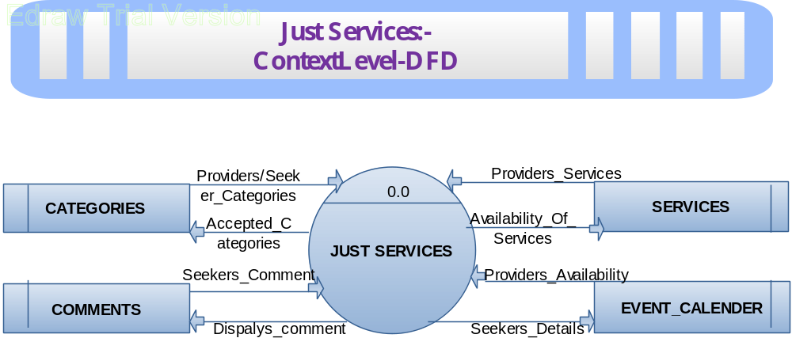

- First Level- DFD:

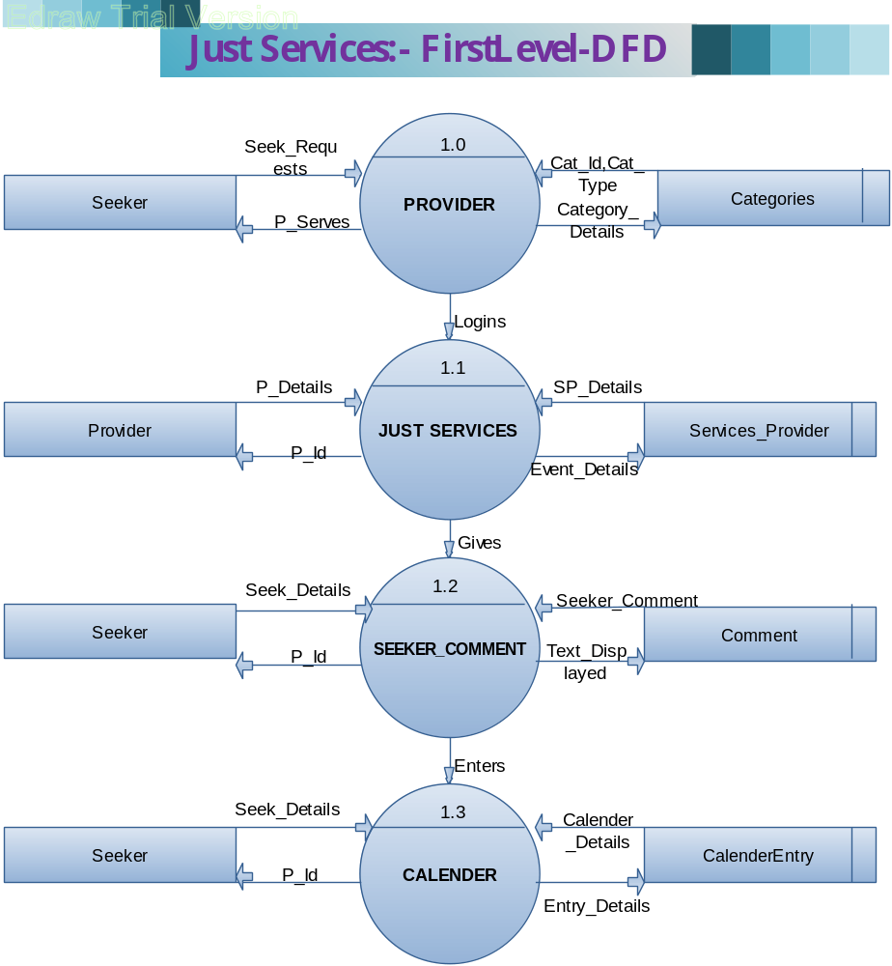

Technical Feasibility:
- Language: PHP, JavaScript, JQuery, HTML.
- Server: Apache.
- Database: MySQL.

“Now i think both of these extremes are equally wrong. Sometimes collective intelligence is good and sometimes it isn't.”

References:
- MIT center for Collective Intelligence
- MIT slogan
- Computing for Nation Development, Bharathi Vidhyapeeth's Institute of Computer Application and management, New Delhi.
- All things Web2.0.http://www.allthingsweb2.com/component/option, com mtree/Itemid,26/
- McGovern, Gerry. Collective intelligence: is your website tapping it? April 2006, New Thinking, http://www.gerrymcgovern.com/nt/2006/ nt-2006-04-17-collective- intelligence.htm
- Weiss, A. (2005). The Power of Collective Intelligence.-MIT http://cci.mit.edu/people/index.html
- Computational Collective Intelligence from IEEE.

