Steps:
1.Create a windows console / form application
2.Add Dependencies Beckhoff XAE Base 3.3 Type Library
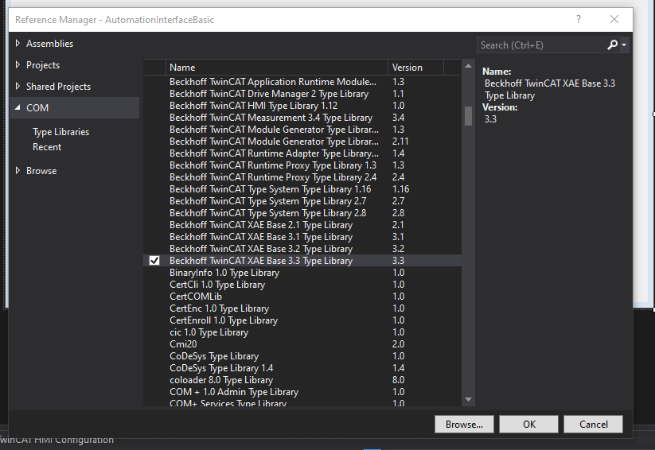
3.Search in nugget package envdte nugget Package -> then install envdte & envdte80
