1.For PC Com Port Communication Check Com Port Number for PC using Hercules Software & Check Same for Salve Device Communication

2.First Install TF6255 in Target & XAE system

3.Confirm the com port number (must be Com 1,2,3,4) others are not supported

4.Add serial port in I/O

5.Port should be same as step 1

6.Com Port Mode setting for pc, make sure receiver & Device manager com setting are same as setting in twincat

7.Add Reference Library TC2_ModbusRTU

8.Create an Main Program & add FB Depending upon the physical hardware the FB has to be selected

9.Created FB has may actions, depending upon requirement use . after the fb instance to access the functions

10.After programming as per requirement build the solution

11.Link I/O Variable to Hardware after building the solution

12.Go to com device click on input, select data1 to 64 Right click change multilink & link

Similar to output also

14. Go to Instance, Task Inputs servStatus to com input device, similar for output

15.Also add serStatus & SerCtrl

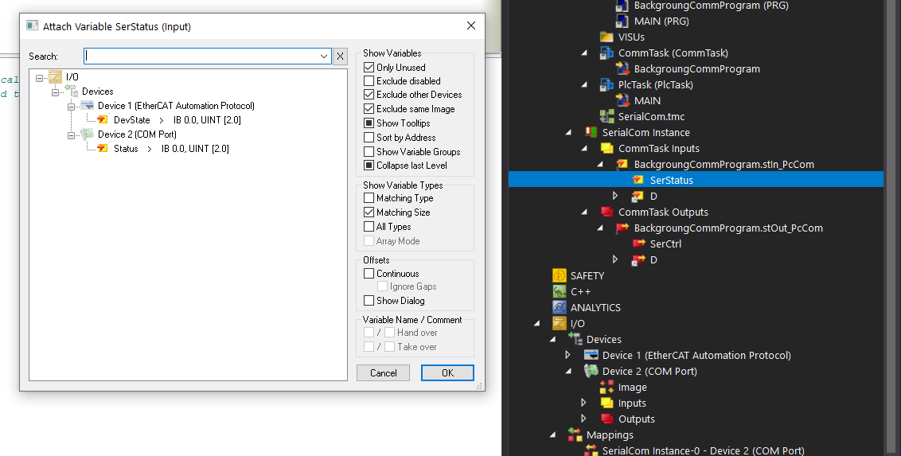

16.In Main Program

Variable

MbMaster: ModbusRtuMaster_PcCOM;

MB_ID: BYTE;

MB_Quantity: WORD;

MB_Address: WORD;

aReadRegister : ARRAY[1..10] OF INT;

bReadRegister: BOOL;

bWriteRegister: BOOL;

aWriteRegister : ARRAY[1..10] OF INT;

tTimeOut : TIME := T#2S;

(* Read Register *)

MbMaster.ReadRegs(

UnitID:= MB_ID,

Quantity:= MB_Quantity,

MBAddr:=MB_Address ,

cbLength:= SIZEOF(aReadRegister),

pMemoryAddr:= ADR(aReadRegister),

Execute:=bReadRegister ,

Timeout:= tTimeOut,

BUSY=> ,

Error=> ,

ErrorId=> ,

cbRead=> );

(* Write Register *)

MbMaster.WriteRegs(

UnitID:= MB_ID,

Quantity:= MB_Quantity,

MBAddr:=MB_Address ,

cbLength:= SIZEOF(aWriteRegister),

pMemoryAddr:= ADR(aWriteRegister),

Execute:=bWriteRegister ,

Timeout:= tTimeOut,

BUSY=> ,

Error=> ,

ErrorId=> ,

cbRead=> );

17.Then in Main enable bRead/Write Register for Read & Write Register

18. Note :

If Address in Modscan is 100 then in MBAdd the address should be 99 (-1)

19.Refer Infosys for further information

20. Github Link https://github.com/gokulgbeckhoff/ModbusRTU