**Prometheus**

Prometheus Installation on AWS linux Machine

Go to prometheus Official website.

https://prometheus.io/download/

Based on the OS copy the link address to download.

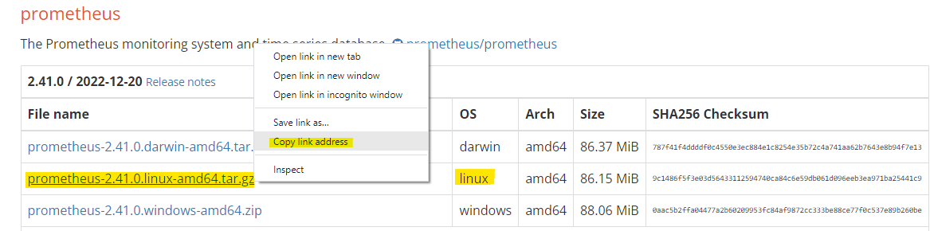

[wget https://github.com/prometheus/prometheus/releases/download/v2.41.0/prometheus-2.41.0.linux-amd64.tar.gz](https://github.com/prometheus/prometheus/releases/download/v2.41.0/prometheus-2.41.0.linux-amd64.tar.gz)

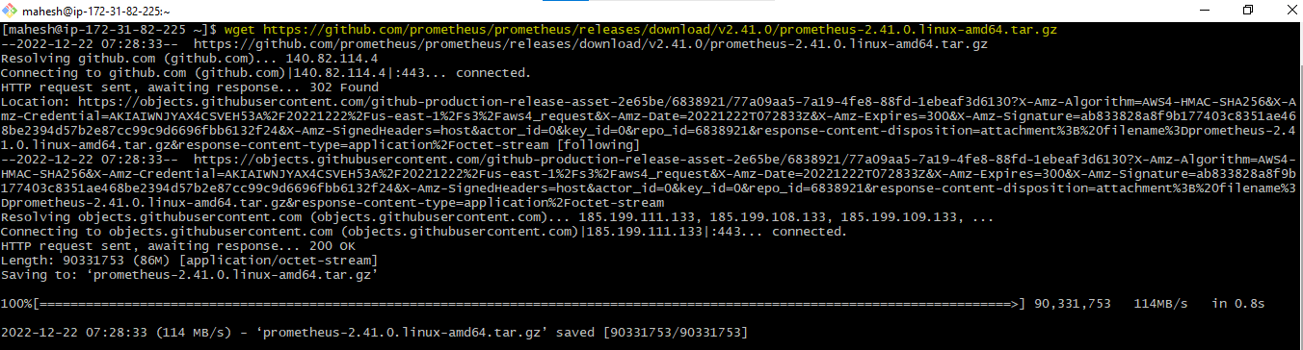



Extract the download file.

**tar xvfz prometheus-2.41.0.linux-amd64.tar.gz**



Change to extracted directory:



Edit the prometheus.yml

vi prometheus.yml

Do the necessary changes: save and exit **Esc[:wq!]**

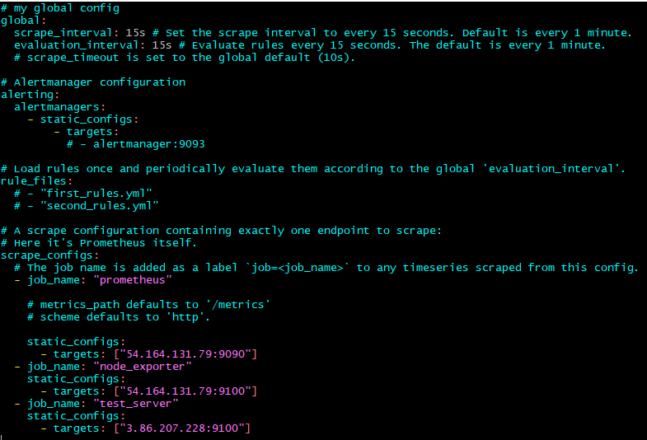

Run the **./prometheus**

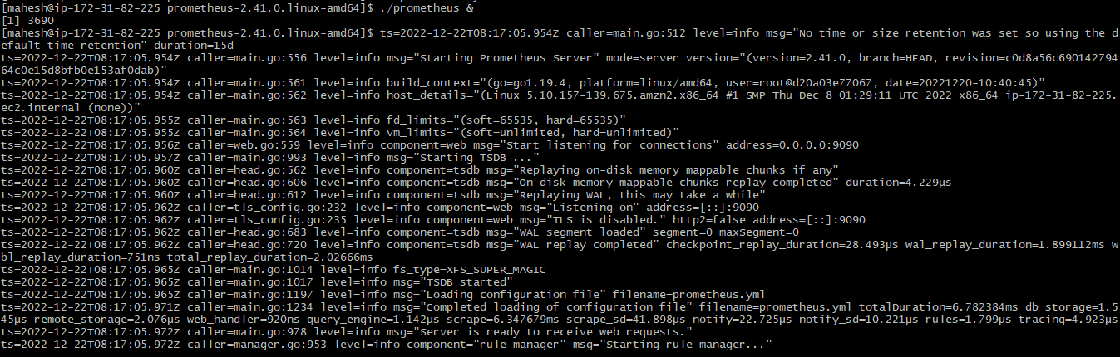

Access the Prometheus dashboard by using public_ip:9090[default port]

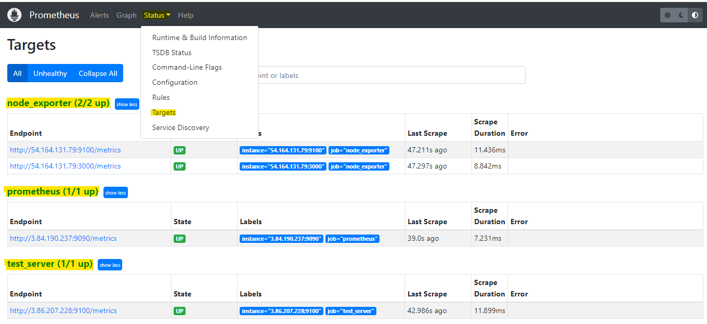

**Node Exporter**

**Installing Node Exporter:**

<https://prometheus.io/download/>

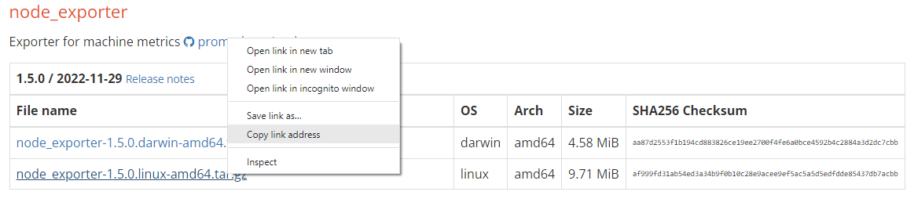

**wget https://github.com/prometheus/node_exporter/releases/download/v1.5.0/node_exporter-1.5.0.linux-amd64.tar.gz**

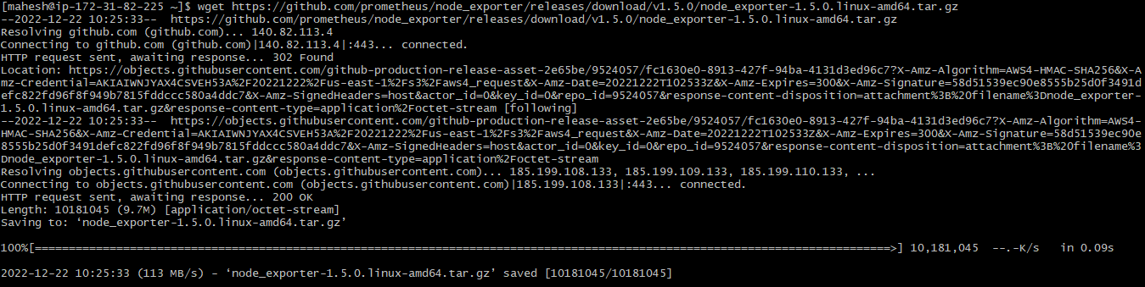

Extract node_exporter:

**tar -xzf node_exporter-1.5.0.linux-amd64.tar.gz**

Change to extracted directory:

**cd node_exporter-1.5.0.linux-amd64/**



Run the following command to start the node_exporter:

**./node_exporter &**

Check the node_exporter by using **public-ip:9100**[default port]

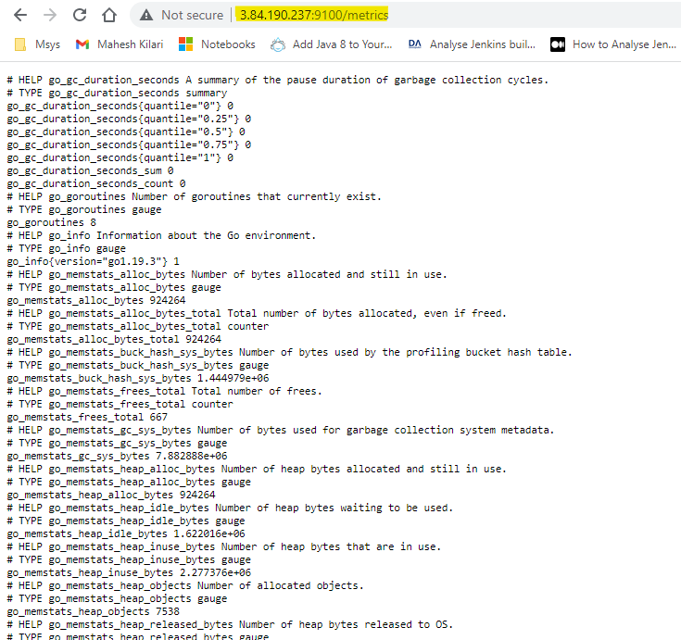

**Grafana**

Installing Grafana on AWS Linux:

<https://grafana.com/grafana/download>

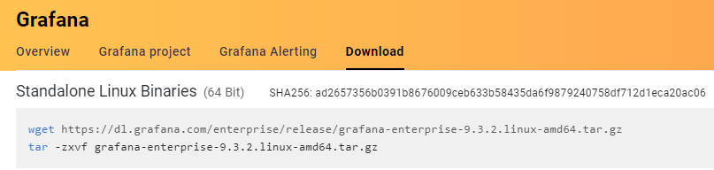

Run below command to download Grafana:

**wget https://dl.grafana.com/enterprise/release/grafana-enterprise-9.3.2.linux-amd64.tar.gz**

Extract the download file:

**tar -zxvf grafana-enterprise-9.3.2.linux-amd64.tar.gz**

