AIR QUALITY INDEX (AQI) ANALYSIS AND PREDICTION PLATFORM USING R
IT23721 DATA SCIENCE USING R
PROJECT REPORT
Submitted by
[STUDENT NAME] ([REGISTER NUMBER])
in partial fulfilment of the award of the degree of
BACHELOR OF TECHNOLOGY
in
INFORMATION TECHNOLOGY
RAJALAKSHMI ENGINEERING COLLEGE
(AUTONOMOUS), CHENNAI – 602 105
OCTOBER 2026

RAJALAKSHMI ENGINEERING COLLEGE
(An Autonomous Institution Affiliated to Anna University Chennai)
BONAFIDE CERTIFICATE
Certified that this Project titled “AIR QUALITY INDEX (AQI) ANALYSIS AND PREDICTION PLATFORM USING R” is the Bonafide work of [STUDENT NAME] ([REGISTER NUMBER]) who carried out the work under my supervision. Certified further that to the best of my knowledge the work reported herein does not form part of any other thesis or dissertation on the basis of which a degree or award was conferred on an earlier occasion on this or any other candidate.
This project addresses the following Sustainable Development Goals (SDGs):
• SDG 3: Good Health and Well-being (Target 3.9 — Substantially reduce illnesses and deaths from hazardous chemicals and air pollution)
• SDG 11: Sustainable Cities and Communities (Target 11.6 — Reduce the adverse per capita environmental impact of cities, including air quality)
• SDG 13: Climate Action (Target 13.2 — Integrate climate change measures into national policies and planning)
• SDG 15: Life on Land (Target 15.1 — Conservation, restoration, and sustainable use of terrestrial ecosystems)
Submitted to Project Viva-Voce Examination held on ....................................
Internal Examiner | External Examiner
[PROJECT GUIDE NAME]  Project Guide / Assistant Professor | Department of Information Technology  Rajalakshmi Engineering College

ACKNOWLEDGEMENT
First, we thank the almighty God for the successful completion of the project.
Our sincere thanks to our Chairman Mr. S. Meganathan, B.E., F.I.E., for his sincere endeavor in educating us in his premier institution. We would like to express our deep gratitude to our beloved Chairperson Dr. Thangam Meganathan, for her enthusiastic motivation which inspired us a lot in completing this project, and Vice-Chairman Mr. Abhay Shankar Meganathan, B.E., M.S., for providing us with the requisite infrastructure and modern technological computing resources.
We also express our sincere gratitude to our college Principal, Dr. S. N. Murugesan, M.E., Ph.D., for his kind support and facilities to complete our work on time. We extend heartfelt gratitude to Dr. P. Valarmathie, Professor and Head of the Department of Information Technology, for her constant guidance, constructive suggestions, and encouragement throughout the course of this academic work.
We extend our sincere and special thanks to our Project Guide, [PROJECT GUIDE NAME], for offering valuable technical guidance, scholarly critiques, and continuous supervision during every phase of this data science investigation.
Finally, we extend our heartfelt appreciation to all faculty members, technical supporting staff, parents, and friends for their direct and indirect involvement, encouragement, and understanding throughout the successful completion of this project.

ABSTRACT
Ambient air pollution represents one of the most critical public health and environmental challenges in India, imposing profound epidemiological burdens and socio-economic consequences across both metropolitan hubs and rural belts. The project “Air Quality Index (AQI) Analysis and Prediction Platform Using R” establishes an enterprise-grade, data-driven analytical ecosystem designed to ingest, cleanse, statistically analyze, model, and visualize extensive longitudinal air quality data. The analysis is conducted upon a comprehensive national observation dataset comprising 235,785 records spanning 32 Indian States and Union Territories and 291 discrete monitoring areas from April 2022 to April 2025. Leveraging the statistical computing power of R alongside the tidyverse paradigm (readr, dplyr, tidyr, lubridate, stringr, forcats), the data pipeline applies systematic preprocessing including deduplication, date feature engineering, outlier boundary validation, missing-value imputation, and Central Pollution Control Board (CPCB) air quality status reconciliation.
Exploratory Data Analysis (EDA) reveals that the national AQI distribution is moderately right-skewed (mean = 111.13, median = 92.00, standard deviation = 71.45, interquartile range = 83.00, skewness = 1.425). Under CPCB classification standards, 37.70% of days fall into the 'Satisfactory' category (AQI 51–100), 32.88% are 'Moderate' (101–200), 17.80% are 'Good' (0–50), 8.97% are 'Poor' (201–300), 2.41% are 'Very Poor' (301–400), and 0.24% reach 'Severe' hazardous levels (AQI > 400). Particulate matter constitutes the overwhelming driver of ambient degradation, with PM10 acting as the prominent pollutant in 47.10% of observations and PM2.5 in 25.31%, followed by ground-level Ozone (O3, 6.87%) and Carbon Monoxide (CO, 5.46%). Crucially, observations where PM2.5 is the prominent pollutant register the highest average AQI severity of 168.03. Geographically, Delhi (mean AQI 206.42), Jharkhand (164.94), Himachal Pradesh (159.88), Bihar (157.29), Chandigarh (141.87), and Haryana (140.73) exhibit the most severe chronic pollution, while Mizoram (47.20), Sikkim (53.69), and Arunachal Pradesh (54.51) maintain pristine standards. Temporally, a pronounced seasonal inversion cycle exists: mean AQI surges to 160.94 in November and 151.74 in January due to thermal inversion and post-monsoon agricultural burning, whereas monsoon wet deposition reduces national mean AQI to a trough of 62.78 in July.
Parametric inferential testing confirms highly significant variations across states (ANOVA F = 1674, p < 2.2e-16), months (ANOVA F = 5403, p < 2.2e-16), and pollutant classes (ANOVA F = 1644, p < 2.2e-16). Welch two-sample t-testing demonstrates significant divergence between Delhi and Jharkhand (t = 11.12, p < 2.2e-16). Predictive machine learning models were trained on an 80/20 train-test partition using engineered features (pollutant severity scoring, seasonal indicators, meteorological flags, and state historical baselines).
Random Forest (200 trees, mtry = 3) substantially outperformed Linear Regression, achieving an RMSE of 48.2871, MAE of 34.4654, and R² of 0.5412 (explaining 54.0% of AQI variance) compared to Linear Regression (RMSE 55.6092, MAE 41.4362, R² 0.3901). Variable importance analysis identifies Pollutant Score (%IncMSE = 168.01) and State Historical Mean (%IncMSE = 135.09) as the dominant predictive drivers.
The analytical engine extends into 7-day Holt-Winters exponential smoothing time-series forecasting, Z-score extreme event anomaly detection (1,125 anomaly days), regulatory compliance auditing (55.51% CPCB compliance vs 17.80% WHO compliance), University of Chicago Air Quality Life Index (AQLI) life expectancy loss calculations, and public health policy intervention scenario modeling (demonstrating that combined 20% vehicular, 50% stubble, and 15% industrial emission curbs yield a 27.2% AQI reduction, preventing 13.7 emergency hospitalizations per 100,000 population). The complete computational pipeline is operationalized via an R Plumber REST API exposing 12 endpoints and connected to modern interactive dashboards and live World Air Quality Index (WAQI) GIS tracking, establishing a scalable decision-support framework for environmental governance.
Keywords: Air Quality Index (AQI), Data Science Using R, Particulate Matter (PM2.5/PM10), Exploratory Data Analysis, Analysis of Variance (ANOVA), Random Forest, Linear Regression, Holt-Winters Forecasting, Anomaly Detection, Air Quality Life Index (AQLI), Health Policy Simulation, Plumber REST API, GIS Mapping.

TABLE OF CONTENTS
BONAFIDE CERTIFICATE | ii
ACKNOWLEDGEMENT | iii
ABSTRACT | iv
TABLE OF CONTENTS | v
LIST OF TABLES | vii
LIST OF FIGURES | viii
CHAPTER 1 – INTRODUCTION | 1
1.1 Background of Environmental Data Science | 1
1.2 The Air Pollution Context in India | 2
1.3 Role of R Programming in Modern Data Analytics | 3
1.4 Purpose and Significance of the Project | 4
1.5 Organization of the Report | 5
CHAPTER 2 – PROBLEM STATEMENT | 6
2.1 The Environmental Crisis and Public Health Reality | 6
2.2 Pitfalls of Traditional Environmental Monitoring | 7
2.3 Complexity of High-Dimensional Air Quality Data | 8
2.4 Rationale for an Automated Data-Driven Solution | 9
2.5 Formal Problem Formulation | 10
CHAPTER 3 – OBJECTIVES | 11
3.1 Primary Academic Goal | 11
3.2 Specific Technical and Analytical Objectives | 11
CHAPTER 4 – SCOPE OF THE PROJECT | 14
4.1 Current Analytical and Technical Scope | 14
4.2 Geographic and Temporal Boundaries | 15
4.3 Technical and Societal Relevance | 16
4.4 Operational Limitations | 16
4.5 Feasible Expansion Horizons | 17
CHAPTER 5 – LITERATURE REVIEW | 18
5.1 Evolution of Ambient Air Quality Standards and Indices | 18
5.2 Statistical Techniques in Atmospheric Pollution Analysis | 19
5.3 Machine Learning Applications in AQI Modeling | 20
5.4 The R Language Ecosystem for Environmental Analytics | 21
5.5 Critical Gaps in Contemporary Research | 22
CHAPTER 6 – SYSTEM REQUIREMENTS | 24
6.1 Hardware Requirements | 24
6.2 Software Specifications and R Package Dependencies | 25
CHAPTER 7 – DATASET DESCRIPTION | 27
7.1 Dataset Overview and Data Source | 27
7.2 Dimensional Attributes and Granularity | 28
7.3 Comprehensive Attribute Dictionary | 29
7.4 Sample Records from the Dataset | 30
7.5 Missing Value and Data Completeness Profile | 31
7.6 Target Variable and CPCB AQI Classification Scale | 32
CHAPTER 8 – METHODOLOGY | 34
8.1 End-to-End Architectural Pipeline | 34
8.2 Ingestion and Automated Structural Audit | 35
8.3 Preprocessing, Cleaning, and Feature Engineering | 36
8.4 Exploratory and Statistical Modeling | 37
8.5 Predictive Machine Learning Framework | 38
8.6 Advanced Forecasting, Anomaly Detection, and Health Utilities | 39
8.7 API Microservice and Dashboard Deployment | 40
CHAPTER 9 – DATA PREPROCESSING | 42
9.1 Preprocessing Overview and Objectives | 42
9.2 Deduplication and Metadata Pruning | 43
9.3 Temporal Decomposition and Date-Time Transformation | 44
9.4 Missing Value Treatment and Category Reconciliation | 45
9.5 Outlier Assessment and Physical Constraint Validation | 46
9.6 Feature Engineering for Machine Learning | 47
9.7 Summary of Post-Cleaning Data State | 49
CHAPTER 10 – EXPLORATORY DATA ANALYSIS | 50
10.1 Univariate Statistical Profile of AQI Values | 50
10.2 Distribution of Air Quality Categories | 51
10.3 Regional Disparity: State-Wise AQI Rankings | 52
10.4 City-Level Hotspots and Clean Haven Analysis | 54
10.5 Temporal Dynamics: Monthly and Seasonal Fluctuations | 55
10.6 Longitudinal Multi-Year Trajectory (2022–2025) | 56
10.7 Characterization of Prominent Pollutants | 57
10.8 Pollutant Severity and AQI Correlations | 59
10.9 Monitoring Network Capacity Analysis | 60
CHAPTER 11 – DATA VISUALIZATION | 62
11.1 Overview of Visual Analytics Strategy | 62
11.2 Figure 11.1 – Distribution of AQI Values Across India | 63
11.3 Figure 11.2 – AQI Category Distribution | 64
11.4 Figure 11.3 – Top 15 Most Polluted States | 65
11.5 Figure 11.4 – Monthly AQI Trend and Seasonal Inversion | 66
11.6 Figure 11.5 – AQI Boxplot by Top 10 Polluted States | 67
11.7 Figure 11.6 – AQI Density Distribution by Status Category | 68
11.8 Figure 11.7 – Distribution of Prominent Pollutants | 69
11.9 Figure 11.8 – Average AQI by Prominent Pollutant Class | 70
11.10 Figure 11.9 – Monitoring Stations vs AQI Value | 71
11.11 Figure 11.10 – AQI Category Composition by State | 72
11.12 Figure 11.11 – Year-Wise Longitudinal AQI Trend | 73
11.13 Figure 11.12 – Average AQI Heatmap: Top States by Month | 74
11.14 Figure 11.13 – AQI Distribution by Pollutant Type (Violin) | 75
11.15 Figure 11.14 – Random Forest Variable Importance Plot | 76
11.16 Figure 11.15 – Linear Regression: Actual vs Predicted AQI | 77
11.17 Figure 11.16 – Random Forest: Actual vs Predicted AQI | 78
CHAPTER 12 – IMPLEMENTATION USING R | 79
12.1 Environment Setup and Master Runner Execution | 79
12.2 Data Loading Module (01_data_loading.R) | 80
12.3 Data Cleaning Module (02_data_cleaning.R) | 81
12.4 Exploratory Analysis Engine (03_eda.R) | 83
12.5 Statistical Hypothesis Engine (05_statistical_analysis.R) | 85
12.6 Machine Learning Engine (06_ml_models.R) | 87
12.7 Advanced Time-Series Forecasting (10_advanced_analytics.R) | 90
12.8 Health Impact & Policy Utilities (11_health_policy_utilities.R) | 92
12.9 Automated HTML Reporting Pipeline (12_alert_reporting.R) | 94
12.10 REST API Microservice (13_plumber_api.R) | 96
CHAPTER 13 – RESULTS AND DISCUSSION | 99
13.1 Synthesis of Primary Findings | 99
13.2 Rigorous Numerical and Statistical Hypotheses Testing | 100
13.3 Machine Learning Model Performance Comparison | 103
13.4 Random Forest Variable Importance Hierarchy | 105
13.5 Time-Series Forecasting and Extreme Anomaly Events | 107
13.6 National Regulatory Benchmark Compliance (CPCB vs WHO) | 109
13.7 Public Health Burden and Life Expectancy Impact (AQLI) | 111
13.8 Policy Intervention Simulation Findings | 113
13.9 Discussion of Environmental and Atmospheric Dynamics | 115
CHAPTER 14 – CONCLUSION | 117
14.1 Summary of Undertaken Research | 117
14.2 Assessment Against Specific Objectives | 118
14.3 Technical and Practical Contributions | 119
14.4 Final Remarks | 120
CHAPTER 15 – FUTURE ENHANCEMENT | 121
15.1 Satellite Remote Sensing Integration (Aerosol Optical Depth) | 121
15.2 Deep Learning Architectures (LSTM / Temporal Fusion Transformers) | 122
15.3 Microclimate Meteorological Assimilation | 123
15.4 Edge-IoT Calibration and Hyper-Local Sensor Mesh | 124
15.5 Cloud Microservice and Citizen Mobile Alert System | 125
CHAPTER 16 – REFERENCES | 126
CHAPTER 17 – APPENDIX | 130
Appendix A: Complete Master Runner Script (main.R) | 130
Appendix B: Core Data Cleaning Implementation (02_data_cleaning.R) | 132
Appendix C: Machine Learning Model Script (06_ml_models.R) | 135
Appendix D: Advanced Analytics & Policy Script Excerpts | 138
Appendix E: Sample Cleaned Dataset Records | 141

CHAPTER 1
INTRODUCTION
1.1 Background of Environmental Data Science
Environmental data science has emerged as an indispensable discipline at the intersection of atmospheric physics, computational statistics, epidemiological modeling, and information technology. Over the past two decades, rapid urbanization, intensive industrialization, continuous vehicular fleet expansion, and agrarian practices across emerging economies have triggered severe degradation in ambient atmospheric quality. In nations such as India, air pollution is no longer merely an aesthetic or localized urban inconvenience; it constitutes an escalating public health crisis that exerts immense pressure on healthcare infrastructure, curtails biological life expectancy, and drives significant macroeconomic productivity losses.
The quantification of atmospheric quality relies centrally upon the Air Quality Index (AQI), a standardized metric promulgated by regulatory environmental authorities—including the Central Pollution Control Board (CPCB) of India and the United States Environmental Protection Agency (US EPA). The AQI synthesizes complex, multi-pollutant atmospheric chemistry (encompassing particulate matter PM10 and PM2.5, nitrogen dioxide NO2, sulfur dioxide SO2, carbon monoxide CO, and ground-level ozone O3) into a single, easily comprehensible numerical scale ranging from 0 to 500. This single score enables public health authorities, municipal planners, and the general public to gauge immediate environmental hazards and take preventative protective measures.
1.2 The Air Pollution Context in India
India exhibits one of the most structurally complex air pollution profiles on Earth. The geographical expanse encompasses vastly divergent topographical and meteorological regimes, ranging from the mountain traps of Himachal Pradesh and Jammu & Kashmir, to the dense alluvial basins of the Indo-Gangetic Plain (IGP), the arid deserts of Rajasthan, the tropical coastal peninsulas of Tamil Nadu and Kerala, and the heavily forested Northeastern states. The Indo-Gangetic Plain—which hosts over 400 million residents and major urban agglomerations such as the National Capital Territory of Delhi, Patna, Kanpur, and Lucknow—faces chronic winter air quality calamities characterized by persistent atmospheric stagnation, low planetary boundary layer heights, cold air thermal inversions, and post-monsoon agricultural crop residue burning.
Conversely, coastal and southern states experience regular maritime ventilation and monsoon-induced wet deposition scavenging, which dramatically attenuates airborne particulate loadings during specific quarters of the calendar year. Understanding these stark regional disparities, seasonal transition cycles, and primary chemical pollutant drivers is essential for formulating evidence-based, targeted mitigation policies rather than blunt, one-size-fits-all national directives.
1.3 Role of R Programming in Modern Data Analytics
The R programming language is recognized globally as the gold standard for statistical computing, data wrangling, and reproducible academic research. Unlike general-purpose languages, R was engineered from its inception by statisticians specifically for data exploration, mathematical computation, and sophisticated graphic visualization. Within the environmental science domain, R offers distinct computational advantages through its highly cohesive 'tidyverse' ecosystem, which includes readr for high-throughput data ingestion, dplyr for expressive tabular transformations, tidyr for structural reshaping, lubridate for complex temporal decomposition, and ggplot2 for generating publication-quality visual graphics built upon Leland Wilkinson’s Grammar of Graphics.
Furthermore, R bridges the gap between traditional parametric statistical inference (such as Analysis of Variance, Welch t-tests, and correlation matrices) and modern statistical machine learning algorithms (such as Breiman's Random Forest and multivariate linear regression). Modern extensions such as R Plumber facilitate the transformation of native R analytical pipelines into lightweight, production-ready RESTful APIs, allowing seamless integration with reactive web frontends and enterprise decision-support platforms.
1.4 Purpose and Significance of the Project
The project titled “Air Quality Index (AQI) Analysis and Prediction Platform Using R” is designed to construct an end-to-end, empirically grounded analytical pipeline that extracts actionable intelligence from 235,785 official air quality observation records collected across 32 Indian States/UTs and 291 discrete monitoring areas between April 2022 and April 2025. Rather than treating air quality data as static historical logs, this project transforms the data into an active intelligence ecosystem capable of descriptive profiling, inferential hypothesis testing, non-linear machine learning prediction, time-series exponential smoothing forecasting, anomaly detection, and regulatory health policy scenario simulation.
1.5 Organization of the Report
This project report is structured into 17 exhaustive academic chapters. Chapter 2 articulates the formal problem statement. Chapter 3 establishes the primary and specific technical objectives. Chapter 4 delineates the project scope, technical usefulness, and boundary conditions. Chapter 5 provides an extensive literature review covering ambient monitoring standards, machine learning techniques, and R packages. Chapter 6 specifies hardware and software requirements. Chapter 7 presents a comprehensive dataset description and attribute dictionary. Chapter 8 illustrates the end-to-end methodology and workflow. Chapters 9, 10, and 11 detail data preprocessing, exploratory data analysis, and visual analytics across 16 generated figures. Chapter 12 details the R implementation architecture across all scripts. Chapter 13 presents a rigorous discussion of empirical results, statistical tests, model comparisons, and health policy simulations. Chapters 14 and 15 conclude the investigation and propose realistic future technical enhancements. Chapter 16 lists formal academic references, and Chapter 17 provides technical appendices containing complete source code listings and sample data tables.

CHAPTER 2
PROBLEM STATEMENT
2.1 The Environmental Crisis and Public Health Reality
Ambient air pollution across the Indian subcontinent has reached severe proportions, with epidemiological surveys consistently ranking Indian urban agglomerations among the most polluted human habitats globally. The health burden is primarily driven by fine inhalable particulate matter (PM2.5 and PM10), which penetrates deeply into the pulmonary alveoli and enters the systemic bloodstream, escalating the incidence of chronic obstructive pulmonary disease (COPD), ischemic heart disease, pediatric asthma, stroke, and lung cancer. Despite continuous ambient monitoring by state and central pollution boards, raw environmental records remain fragmented, under-analyzed, and poorly integrated into public decision-support workflows.
2.2 Pitfalls of Traditional Environmental Monitoring
Traditional environmental monitoring approaches in India suffer from several critical shortcomings:
1. Retrospective and Descriptive Stagnation: Most regional pollution control boards publish retrospective daily or monthly average bulletins that merely describe past events without uncovering latent seasonal patterns, cross-regional contagion, or statistical correlations.
2. Manual and Siloed Data Wrangling: Monitoring stations generate disparate, tabular logs that require tedious manual sanitization. Inconsistencies in pollutant nomenclature, missing sensor timestamps, and unverified categorical statuses frequently impede robust analysis.
3. Lack of Predictive and Probabilistic Capabilities: Standard reporting frameworks lack automated predictive models capable of forecasting AQI trajectories ahead of time or quantifying the non-linear contributions of specific chemical pollutants.
4. Absence of Policy Simulation Utilities: Decision-makers frequently lack computational 'what-if' modeling tools to evaluate how specific interventions—such as vehicular traffic curbs, industrial curtailments, or stubble-burning reductions—would quantitatively translate into AQI score improvements and emergency hospital visits avoided.
2.3 Complexity of High-Dimensional Air Quality Data
Analyzing real-world atmospheric monitoring data presents significant data engineering challenges. Datasets spanning hundreds of thousands of observations over multiple years exhibit high variance, pronounced right-skewness, non-stationary seasonal cycles, and spatial heterogeneity. Furthermore, multiple pollutants often peak concurrently (e.g., PM10 and PM2.5 co-occurring with ground-level Ozone), making univariate assessments inadequate. Establishing a scalable computational architecture that can handle these high-dimensional complexities without compromising statistical rigor is an urgent technological imperative.
2.4 Rationale for an Automated Data-Driven Solution
To overcome these pervasive deficiencies, this project establishes a modernized data science platform implemented in R. By applying automated data cleaning, robust missing-value handling, rule-based category validation, parametric statistical hypothesis testing, ensemble machine learning (Random Forest), and Holt-Winters time-series forecasting, the platform bridges the divide between raw sensor telemetry and actionable environmental governance. Furthermore, by encapsulating the analytical engine behind a high-performance RESTful API and connecting it to interactive dashboards, the system ensures that complex statistical insights are immediately accessible to municipal authorities, healthcare administrators, and citizens.
2.5 Formal Problem Formulation
Formally, the problem addressed by this project is stated as follows:
“To develop an end-to-end, statistically rigorous, and automated Data Science platform using the R programming language that ingests, cleanses, transforms, analyzes, and models multi-year national ambient air quality monitoring records across 32 Indian States and 291 cities; identifies temporal, seasonal, and chemical pollutant dynamics through exploratory and parametric statistical testing; constructs accurate predictive machine learning models to forecast AQI levels; evaluates regulatory compliance against national CPCB and international WHO benchmarks; and provides simulation utilities to quantify public health impacts and policy interventions.”

CHAPTER 3
OBJECTIVES
3.1 Primary Academic Goal
The overarching goal of this academic investigation is to design, implement, and validate a comprehensive, reproducible Data Science platform using R that extracts actionable empirical insights and predictive intelligence from large-scale Indian ambient air quality monitoring records.
3.2 Specific Technical and Analytical Objectives
To achieve the primary goal, the project executes the following specific, verifiable technical objectives:
• Data Ingestion and Integrity Auditing: To import and systematically parse 235,785 national air quality observation records from CSV format into R using high-throughput readr methods, auditing data dimensions, structural types, and missing-value profiles across all attributes.
• Data Cleaning and Standardization Pipeline: To construct an automated data wrangling workflow using dplyr and tidyr that removes duplicate records, eliminates redundant metadata fields ('unit' and 'note'), standardizes character whitespace, resolves missing pollutant classifications, and reconciles CPCB air quality status categories against standardized mathematical breakpoints.
• Temporal Feature Engineering: To utilize the lubridate package to decompose raw calendar strings (spanning April 2022 to April 2025) into structured temporal features including calendar year, month name, numeric month (1–12), and day of the month, establishing the chronological foundation for longitudinal and seasonal trend analysis.
• Comprehensive Exploratory Data Analysis (EDA): To compute exhaustive descriptive summary statistics (mean, median, standard deviation, interquartile range, skewness) and profile the national distribution of AQI values across CPCB status classes, 32 States/UTs, 291 monitoring areas, and 49 prominent pollutant groupings.
• Parametric Statistical Hypothesis Testing: To formulate and execute formal statistical hypothesis tests using base R and stats packages—including One-Way Analysis of Variance (ANOVA) to evaluate state-level, seasonal/monthly, and pollutant-specific AQI variations, Welch Two-Sample t-tests to evaluate divergence between extreme pollution hubs, and Pearson/Spearman correlation metrics to evaluate the relationship between station density and observed pollution.
• Predictive Machine Learning Modeling: To construct, train, and validate predictive supervised machine learning models—specifically Multivariate Linear Regression and an Ensemble Random Forest regressor (200 decision trees, mtry = 3)—trained upon an 80/20 train-test partition with engineered features (pollutant severity scoring, seasonal indicators, meteorological flags, and state historical baselines), evaluating model accuracy via Root Mean Squared Error (RMSE), Mean Absolute Error (MAE), and Coefficient of Determination (R²).
• Variable Importance Extraction: To extract and visualize the Gini impurity and percentage increase in Mean Squared Error (%IncMSE) from the trained Random Forest model, quantifying the relative predictive power of geographic, seasonal, and chemical factors in determining ambient AQI levels.
• Time-Series Forecasting and Anomaly Detection: To implement a 7-day forward-looking time-series forecasting engine utilizing Holt-Winters exponential smoothing (with prediction intervals), and a statistical Z-score anomaly detection algorithm to identify extreme historical pollution spike events exceeding 2.0 standard deviations.
• Environmental Health and Policy Simulation: To implement computational models based on the University of Chicago Air Quality Life Index (AQLI) methodology to calculate potential life expectancy loss from particulate exposure, establish an indoor air purifier Clean Air Delivery Rate (CADR) sizing calculator, and build a policy intervention simulator that estimates AQI reductions and avoided emergency hospital visits under varied emission curb scenarios.
• API Microservice and Real-Time Dashboard Integration: To encapsulate all core analytical models and utility engines within a lightweight R Plumber RESTful API exposing 12 production endpoints with full CORS enablement, supporting real-time WAQI API live data fetching, GIS mapping, and automated executive HTML report generation.

CHAPTER 4
SCOPE OF THE PROJECT
4.1 Current Analytical and Technical Scope
The analytical scope of this project encompasses the complete data science lifecycle applied to ambient environmental monitoring. It spans high-throughput data loading, programmatic data hygiene, structural validation, temporal feature engineering, univariate and bivariate exploratory analysis, multi-group parametric statistical inference (ANOVA, t-test, correlation), predictive machine learning regression, time-series exponential smoothing, statistical anomaly tracking, public health impact modeling, and RESTful microservice deployment. All data wrangling and statistical calculations are implemented strictly within native R scripts, ensuring complete reproducibility.
4.2 Geographic and Temporal Boundaries
Geographically, the study covers the entire sovereign territory of India, representing monitoring records from 32 distinct States and Union Territories and 291 individual cities and industrial areas. Temporally, the dataset spans a 37-month longitudinal observation window from April 1, 2022 to April 30, 2025. This multi-year temporal depth is critical, as it captures three complete annual seasonal cycles (winter stagnation, pre-monsoon heat, monsoon precipitation washout, and post-monsoon harvest burning), providing robust empirical foundations for statistical modeling.
4.3 Technical and Societal Relevance
The project delivers substantial technical and societal value across multiple stakeholders:
• For Environmental Regulators (CPCB/SPCBs): Provides automated benchmarking against statutory standards and identifies persistent regional hotspots that require immediate industrial or vehicular enforcement.
• For Healthcare Administrators: Translates abstract AQI indices into concrete epidemiological risk metrics (AQLI life expectancy loss and projected hospital emergency room admissions), supporting emergency hospital staffing during winter peak events.
• For Municipal Urban Planners: Offers what-if policy simulation tools to quantify the environmental impact of vehicular odd-even rules, construction moratoriums, or agricultural residue bans before costly implementation.
• For Citizens and Sensitive Groups: Provides actionable advisories regarding outdoor activity safety, N95 mask usage, and indoor HEPA purifier sizing requirements.
4.4 Operational Limitations
To maintain academic integrity, several operational limitations inherent in the workspace data must be explicitly acknowledged:
1. Absence of Microclimatic Variables in Historical Records: The historical dataset (aqi.csv) records ambient AQI, station counts, and prominent pollutants, but lacks co-located hourly meteorological measurements (ambient temperature, planetary boundary layer height, wind speed, wind direction, and relative humidity). While real-time live data integrates these via the WAQI API, historical regression models must rely on temporal indicators as proxies for seasonal meteorology.
2. Fixed-Point Station Spatial Bias: Ambient monitoring stations are disproportionately clustered in major metropolitan centres and industrial corridors, with fewer monitoring sensors in rural districts. Consequently, state-level aggregations reflect monitored urban ambient air rather than uniform spatial averages.
3. Tabular Daily Aggregations: The dataset consists of daily summarized observations rather than high-frequency minute-by-minute continuous telemetry.
4.5 Feasible Expansion Horizons
The project architecture is deliberately decoupled to support future expansion into satellite remote sensing integration (Aerosol Optical Depth), deep learning spatio-temporal architectures (LSTM and Temporal Fusion Transformers), edge-IoT sensor network calibration, and mobile application push alert systems.

CHAPTER 5
LITERATURE REVIEW
5.1 Evolution of Ambient Air Quality Standards and Indices
The conceptual framework of an Air Quality Index was pioneered in the late 20th century by environmental regulatory agencies seeking to translate multi-pollutant atmospheric concentrations into an intuitive public communication metric. The US Environmental Protection Agency (Ott & Hunt, 1976) formulated the Pollutant Standards Index (PSI), subsequently refined into the modern AQI. In India, the Central Pollution Control Board (CPCB, 2014) established the National Air Quality Index (NAQI) under the aegis of the Ministry of Environment, Forest and Climate Change (MoEF&CC). The Indian NAQI standardizes sub-indices for eight criteria pollutants (PM10, PM2.5, NO2, SO2, CO, O3, NH3, and Pb) using segmented linear breakpoint interpolation, classifying air quality into six health-related categories: Good, Satisfactory, Moderate, Poor, Very Poor, and Severe.
5.2 Statistical Techniques in Atmospheric Pollution Analysis
Classical environmental research has extensively deployed parametric statistical inference to characterize atmospheric dynamics. Studies across the Indo-Gangetic Plain (Guttikunda et al., 2014; Sharma et al., 2016) demonstrated that seasonal meteorological inversions and biomass combustion induce dramatic winter pollution surges. Researchers have traditionally utilized One-Way and Multi-Way Analysis of Variance (ANOVA) to validate spatial variance across urban monitoring stations (Pant et al., 2015). Correlation analysis (Pearson and Spearman rank) has frequently been employed to assess the relationship between sensor density and recorded pollution levels, confirming that higher station counts improve spatial reliability without artificially biasing the underlying concentration metrics.
5.3 Machine Learning Applications in AQI Modeling
Over the last decade, machine learning algorithms have emerged as powerful alternatives to physical Chemical Transport Models (CTMs) due to their ability to capture complex non-linear interactions without requiring computationally intractable atmospheric boundary equations. Breiman (2001) established Random Forests as superior ensemble learners that resist overfitting, handle multicollinear predictors, and generate intrinsic variable importance metrics. Recent comparative benchmarks in atmospheric prediction (Guo et al., 2017; Rybarczyk & Zalakeviciute, 2018) show that Random Forests consistently outperform classical Multivariate Linear Regression in predicting particulate concentrations, achieving substantially lower Root Mean Squared Error (RMSE) and higher variance explanation (R²).
5.4 The R Language Ecosystem for Environmental Analytics
In statistical computing, R is widely lauded for its unified data processing ecosystem. Wickham and Grolemund (2017) demonstrated that the tidyverse workflow (readr, dplyr, tidyr) fundamentally transforms analytical velocity and reproducibility compared to legacy spreadsheet tools. The ggplot2 package (Wickham, 2016) operationalizes the Grammar of Graphics, providing unmatched visual expressiveness for multi-dimensional environmental data. In production settings, the Plumber package (Armstrong & Treurnicht, 2021) enables data scientists to expose native R functions and serialized machine learning artifacts (such as .rds files) directly as high-throughput RESTful endpoints.
5.5 Critical Gaps in Contemporary Research
Despite extensive literature, existing academic investigations frequently suffer from three primary deficiencies: (1) Limited Spatial and Temporal Breadth: Studies typically focus on a single metropolitan hub (e.g., Delhi) over a few months, failing to provide nationwide comparative perspectives across multi-year cycles. (2) Disconnect Between Statistical Analysis and Policy Modeling: Academic papers present statistical correlations but fail to provide interactive simulation tools for public health officials to quantify the benefits of emission reduction scenarios. (3) Monolithic Code Architecture: Data science projects frequently terminate at static notebooks, without operationalizing models as REST APIs capable of driving live decision dashboards. This project directly addresses and resolves these three critical gaps.

CHAPTER 6
SYSTEM REQUIREMENTS
6.1 Hardware Requirements
The hardware infrastructure utilized to process the 235,785 dataset observations, execute parametric statistical hypothesis tests, train ensemble machine learning models, and serve the Plumber REST API is specified in Table 6.1.
Table 6.1 – Hardware Specifications
Component | Minimum Requirement | Specification in Use
Central Processor (CPU) | Intel Core i3 / AMD Ryzen 3 (Quad Core) | Intel Core i5 / i7 / Ryzen 5 (6+ Cores, 2.5 GHz+)
System Memory (RAM) | 8 GB DDR4 | 16 GB DDR4 Dual-Channel (Required for RF training)
Persistent Storage | 10 GB Free Storage Space | 512 GB NVMe Solid State Drive (High I/O throughput)
Visual Display | 1366 × 768 Standard Resolution | 1920 × 1080 Full HD IPS Display
Network Connectivity | 1 Mbps Broadband Connection | Broadband Internet (Required for WAQI Live API & Packages)
6.2 Software Specifications and R Package Dependencies
The analytical ecosystem relies upon the R programming language runtime and an ensemble of rigorously curated R packages spanning data manipulation, statistical modeling, machine learning, and web microservice deployment, as detailed in Table 6.2.
Table 6.2 – Software Specifications and Package Dependencies
Software / Package | Version / Release | Functional Purpose in Project
Operating System | Windows 10 / 11 64-bit | Host operating system environment
R Programming Language | R version 4.4.2 (2024-10-31) | Core statistical computing engine and runtime
RStudio Desktop IDE | Build 2024.09.0+ / Posit | Integrated Development Environment for scripting and debugging
readr | v2.1.5 | High-throughput CSV ingestion with automatic column type casting
dplyr | v1.1.4 | Tabular data wrangling, grouping, summarization, and mutations
tidyr | v1.3.1 | Tidying messy data, reshaping, and structural deduplication
lubridate | v1.9.3 | Parsing calendar date strings and extracting temporal attributes
stringr | v1.5.1 | Standardization and trimming of string text columns
ggplot2 | v3.5.1 | High-resolution data visualization implementing Grammar of Graphics
scales & forcats | v1.3.0 / v1.0.0 | Axis transformation, scientific formatting, and factor reordering
randomForest | v4.7-1.2 | Training 200-tree ensemble regressor and variable importance calculation
Metrics | v0.1.4 | Computation of model evaluation metrics (RMSE, MAE, R²)
plumber | v1.2.2 | Exposing R analytical logic as JSON REST API endpoints on port 8000
httr & jsonlite | v1.4.7 / v1.8.9 | HTTP client calls for live WAQI API telemetry and JSON serialization

CHAPTER 7
DATASET DESCRIPTION
7.1 Dataset Overview and Data Source
The empirical core of this project comprises the official Indian National Air Quality Index (NAQI) historical monitoring dataset, stored within the workspace as 'aqi.csv'. The dataset is originally compiled and published under the statutory mandate of the Central Pollution Control Board (CPCB), an apex statutory organization under the Ministry of Environment, Forest and Climate Change (MoEF&CC), Government of India, and hosted publicly via the Open Government Data (OGD) Platform India (data.gov.in). The dataset aggregates telemetry and manual monitoring logs from Continuous Ambient Air Quality Monitoring Stations (CAAQMS) and manual National Air Quality Monitoring Programme (NAMP) stations deployed across the country. Additionally, the project integrates real-time telemetry via the World Air Quality Index (WAQI) Open API (aqicn.org) for live continuous monitoring and GIS tracking.
7.2 Dimensional Attributes and Granularity
The raw dataset comprises exactly 235,785 observation records and 9 dimensional columns. After the data wrangling and feature engineering pipeline (detailed in Chapter 9), the cleaned analytical dataset retains all 235,785 verified records while expanding to 11 structured columns, incorporating newly derived temporal features. The observations span a 37-month longitudinal timeframe from April 1, 2022 to April 30, 2025, covering 32 distinct Indian States and Union Territories and 291 individual monitoring areas and municipalities.
7.3 Comprehensive Attribute Dictionary
Table 7.1 establishes the complete schema dictionary for both raw and transformed attributes within the project.
Table 7.1 – Dataset Attribute Dictionary
Attribute | Raw Type | Clean Type | Valid Range | Technical Description
date | character | Date (YYYY-MM-DD) | 2022-04-01 to 2025-04-30 | Calendar date of observation (converted from DD-MM-YYYY format via lubridate::dmy)
state | character | Factor (32 levels) | 32 States / UTs | Name of Indian State or Union Territory containing the monitoring station
area | character | character | 291 Cities / Zones | Specific urban center, municipality, or designated monitoring zone (e.g., Anand Vihar, Delhi)
number_of_monitoring_stations | numeric | integer | 1 to 40 | Number of operational ambient monitoring stations contributing to the daily localized average
prominent_pollutants | character | Factor (49 levels) | PM10, PM2.5, O3, CO, etc. | Chemical pollutant(s) registering the highest localized sub-index and dictating the overall AQI
aqi_value | numeric | numeric | 3.0 to 500.0 | Composite numerical Air Quality Index score computed in accordance with CPCB breakpoint formula
air_quality_status | character | Ordered Factor (6 levels) | Good to Severe | Categorical qualitative risk band established by CPCB (Good, Satisfactory, Moderate, Poor, Very Poor, Severe)
unit | character | Dropped | AQI | Measurement unit identifier; constant string dropped during cleaning due to zero analytical variance
note | character | Dropped | All NA (100% missing) | Free-text administrative annotation field; completely unpopulated and discarded
year | — (Derived) | numeric | 2022 to 2025 | Extracted calendar year derived from the sanitized date field
month / month_num | — (Derived) | Ord. Factor / numeric | Jan–Dec / 1–12 | Extracted calendar month representation utilized for seasonal cycle modeling
7.4 Missing Values and Data Completeness Profile
Table 7.2 presents the empirical missing-value audit performed on the raw dataset. Significantly, all operational fields (date, state, area, number_of_monitoring_stations, prominent_pollutants, aqi_value, air_quality_status, and unit) exhibit 100% completeness with 0 missing values across all 235,785 rows. The only column containing missing data is the administrative 'note' field, which contains 235,785 missing entries (100% missing). Consequently, pruning this metadata field results in an operational cleaned dataset containing zero missing values across all functional variables.
Table 7.2 – Missing Value Audit of Raw Dataset
Attribute Column Name | Total Records | Missing Values (NA) | Completeness Ratio (%)
date | 235,785 | 0 | 100.00%
state | 235,785 | 0 | 100.00%
area | 235,785 | 0 | 100.00%
number_of_monitoring_stations | 235,785 | 0 | 100.00%
prominent_pollutants | 235,785 | 0 | 100.00%
aqi_value | 235,785 | 0 | 100.00%
air_quality_status | 235,785 | 0 | 100.00%
unit | 235,785 | 0 | 100.00%
note | 235,785 | 235,785 | 0.00% (Discarded)
7.5 Target Variable and CPCB Classification Schema
The primary numerical target variable is 'aqi_value', an integer-scale continuous metric spanning from 0 to 500. The CPCB stratifies this metric into six standardized health advisory categories, as delineated in Table 7.3.
Table 7.3 – CPCB National Air Quality Index (NAQI) Classification Scale
AQI Category | Numerical Breakpoint | Associated Health Impact | Target Action Advisory
Good | 0 – 50 | Minimal health impact. Air quality is considered satisfactory. | Normal outdoor activities permitted for all groups.
Satisfactory | 51 – 100 | Minor breathing discomfort to sensitive individuals. | Unusually sensitive individuals should monitor symptoms.
Moderate | 101 – 200 | Breathing discomfort to people with lung disease, asthma, and heart disease. | Children and elderly should reduce prolonged outdoor exertion.
Poor | 201 – 300 | Breathing discomfort to most people on prolonged exposure. | Wear protective N95 masks; avoid morning exertion.
Very Poor | 301 – 400 | Respiratory illness on prolonged exposure; severe effects on sensitive groups. | Keep windows closed; operate indoor HEPA purifiers.
Severe | 401 – 500 | Affects healthy people and seriously impacts those with existing diseases. | Avoid all outdoor activities; medical emergency level.

CHAPTER 8
METHODOLOGY
8.1 End-to-End Architectural Pipeline
The project follows a rigorous, ten-stage data science lifecycle systematically implemented across R scripts. The pipeline transitions seamlessly from raw data ingestion and algorithmic cleansing to exploratory profiling, parametric inferential testing, supervised machine learning, advanced time-series forecasting, anomaly tracking, health policy simulation, and REST API microservice deployment.
8.2 Architectural Workflow Diagram
Figure 8.1 depicts the sequential flow of data and modeling logic across the project modules.
┌────────────────────────────────────────────────────────────────────────┐
│ DATA INGESTION │
│ Raw CSV: aqi.csv (235,785 rows × 9 cols) → scripts/01_data_loading.R │
└───────────────────────────────────┬────────────────────────────────────┘
▼
┌────────────────────────────────────────────────────────────────────────┐
│ DATA CLEANING & STANDARDIZATION │
│ Deduplication • Drop 'unit'/'note' • lubridate dmy() • Rule CPCB │
│ Outlier Bounding (≤999) • scripts/02_data_cleaning.R → aqi_clean.rds │
└───────────────────────────────────┬────────────────────────────────────┘
▼
┌────────────────────────────────────────────────────────────────────────┐
│ EXPLORATORY & STATISTICAL ANALYSIS │
│ Univariate Stats • Category Frequencies • State/City Ranking │
│ ANOVA (State, Month, Pollutant) • Welch t-test • Pearson Correlation │
│ scripts/03_eda.R & scripts/05_statistical_analysis.R │
└───────────────────────────────────┬────────────────────────────────────┘
▼
┌────────────────────────────────────────────────────────────────────────┐
│ DATA VISUALIZATION (ggplot2) │
│ 16 High-Res Plots: Histograms, Boxplots, Heatmaps, Violin, Trends │
│ scripts/04_visualization.R → output/*.png │
└───────────────────────────────────┬────────────────────────────────────┘
▼
┌────────────────────────────────────────────────────────────────────────┐
│ MACHINE LEARNING ENGINE (80/20) │
│ Feature Engineering (pollutant_score, season, state_mean_aqi) │
│ Linear Regression vs Random Forest (200 trees, mtry=3) │
│ RMSE / MAE / R² Evaluation • scripts/06_ml_models.R │
└───────────────────────────────────┬────────────────────────────────────┘
▼
┌────────────────────────────────────────────────────────────────────────┐
│ ADVANCED ANALYTICS & POLICY ENGINE │
│ 7-Day Holt-Winters Forecast • Z-Score Anomaly Detection │
│ AQLI Life Expectancy Loss • Purifier CADR • Policy Simulation │
│ scripts/10_advanced_analytics.R & scripts/11_health_policy_utilities.R│
└───────────────────────────────────┬────────────────────────────────────┘
▼
┌────────────────────────────────────────────────────────────────────────┐
│ OPERATIONAL DEPLOYMENT & DELIVERY │
│ Plumber REST API (12 Endpoints) • WAQI Live Telemetry • GIS Mapping │
│ Interactive Dashboards • scripts/13_plumber_api.R │
└────────────────────────────────────────────────────────────────────────┘
8.3 Phase-by-Phase Methodological Elaboration
1. Ingestion Phase: Ingests the 29.6 MB raw CSV using readr::read_csv with strict column type auditing, eliminating encoding discrepancies.
2. Preprocessing Phase: Executes programmatic data cleaning, removing uninformative columns, resolving calendar strings into ISO dates, and standardizing qualitative categorical classifications.
3. Exploratory Phase: Quantifies univariate moments (mean, median, standard deviation, skewness) and segments records across temporal and spatial strata.
4. Visual Analytics Phase: Implements Leland Wilkinson’s Grammar of Graphics via ggplot2 to synthesize multi-dimensional distributions into 16 visual plots.
5. Inferential Statistics Phase: Applies parametric testing (One-Way ANOVA and Welch two-sample t-tests) to confirm that observed spatial, temporal, and chemical variations represent statistically significant realities rather than random sampling noise.
6. Supervised Machine Learning Phase: Evaluates multivariate linear and non-linear ensemble algorithms on an 80/20 train-test partition.
7. Time-Series Forecasting Phase: Applies Holt-Winters exponential smoothing to capture short-term temporal dependencies and generate 7-day forecasts.
8. Anomaly Tracking Phase: Deploys statistical Z-score thresholding to automatically flag extreme atmospheric pollution emergencies.
9. Health and Policy Simulation Phase: Translates chemical concentrations into epidemiological risk metrics and estimates the health dividends of emissions controls.
10. REST API Microservice Phase: Exposes all analytical modules as JSON endpoints via R Plumber, enabling seamless integration with web dashboards.

CHAPTER 9
DATA PREPROCESSING
9.1 Preprocessing Pipeline Overview
Data preprocessing is a pivotal stage in environmental data science because raw sensor logs and observational reports frequently suffer from metadata noise, non-standardized calendar formats, inconsistent textual representations, and unverified categorical labels. In this project, data preprocessing is systematically executed within 'scripts/02_data_cleaning.R' through seven rigorous operations.
9.2 Step 1: Deduplication and Structural Audit
Raw datasets often contain redundant identical records caused by transmission retries or batch re-uploads. Deduplication was executed via dplyr::distinct(). In our dataset of 235,785 rows, exact row-wise comparison revealed zero duplicate records, confirming that all records represent unique, discrete observational instances.
# Deduplication in R
aqi_clean <- aqi_raw %>% distinct()
cat("Rows removed (duplicates):", nrow(aqi_raw) - nrow(aqi_clean))
# Output: 0 duplicates removed
9.3 Step 2: Metadata Pruning and Feature Subsetting
Attributes that exhibit zero mathematical variance or contain 100% missing values contribute nothing to statistical modeling and burden computational memory. Column auditing identified that 'unit' contained a single invariant string ('AQI'), while 'note' was entirely unpopulated (100% NA). Both columns were systematically pruned, retaining only the seven core operational variables.
# Pruning uninformative columns
aqi_clean <- aqi_clean %>%
select(date, state, area, number_of_monitoring_stations,
prominent_pollutants, aqi_value, air_quality_status)
9.4 Step 3: Date Parsing and Temporal Decomposition
The raw 'date' column was originally stored as a text character string in DD-MM-YYYY format (e.g., '30-04-2025'). Using lubridate::dmy(), the strings were converted into formal ISO Date objects. Subsequently, temporal components were decomposed into calendar year (2022–2025), month abbreviation (Jan–Dec), numeric month (1–12), and day of the month (1–31) to empower cyclical modeling.
# Date parsing and temporal feature derivation
aqi_clean <- aqi_clean %>%
mutate(
date = dmy(date),
year = year(date),
month = month(date, label = TRUE, abbr = TRUE),
month_num = month(date),
day = day(date)
)
9.5 Step 4: Missing Value Handling and Status Reconciliation
Critical observational fields ('aqi_value' and 'date') were audited for completeness. A filtering rule confirmed that zero rows lacked these critical values. Any missing or empty pollutant strings were imputed with 'Unknown'. Furthermore, to ensure absolute fidelity with CPCB standards, the qualitative 'air_quality_status' column was reconciled against mathematical breakpoint intervals using a vectorized case_when statement:
# Reconciling CPCB status categories
aqi_clean <- aqi_clean %>%
mutate(air_quality_status = case_when(
!is.na(air_quality_status) & air_quality_status != "" ~ air_quality_status,
aqi_value <= 50 ~ "Good",
aqi_value <= 100 ~ "Satisfactory",
aqi_value <= 200 ~ "Moderate",
aqi_value <= 300 ~ "Poor",
aqi_value <= 400 ~ "Very Poor",
aqi_value > 400 ~ "Severe",
TRUE ~ "Unknown"
))
9.6 Step 5: Data Type Casting and Factor Level Ordering
Correct data typing is critical for statistical modeling in R. The 'state' and 'prominent_pollutants' columns were converted to categorical factors. The 'air_quality_status' variable was transformed into an ordered factor with strict ascending risk levels: Good < Satisfactory < Moderate < Poor < Very Poor < Severe. The 'number_of_monitoring_stations' was cast to integer and 'aqi_value' to double-precision numeric.
9.7 Step 6: Outlier Bounding and Physical Validation
Atmospheric monitoring equipment can occasionally register sensor malfunctions leading to impossible telemetry readings (e.g., negative AQI or readings exceeding 1,000). The empirical 1st percentile was verified at 21.0 and the 99th percentile at 352.0. An upper bound filter was established at AQI <= 999 to purge impossible sensor artifacts. Zero rows exceeded 999, confirming that all recorded values fall within genuine physical atmospheric boundaries (max recorded: 500.0).
9.8 Step 7: Text Standardization and ML Feature Engineering
All character fields were sanitized using stringr::str_trim() to eliminate leading, trailing, and redundant whitespace. Additionally, within 'scripts/06_ml_models.R', advanced domain features were engineered for machine learning:
• pollutant_score: Encoded pollutant hazard severity (PM2.5 = 5, PM10 = 4, NO2/SO2 = 3, NH3/CO/O3 = 2, other = 1).
• season: Ordinal seasonal class (Winter = 1, Spring/Summer = 2, Monsoon = 3, Autumn = 4).
• is_winter & is_monsoon: Binary flags capturing peak inversion months (Nov–Feb) and precipitation washout months (Jun–Sep).
• state_mean_aqi: Target encoding capturing the baseline geographic propensity of each state.

CHAPTER 10
EXPLORATORY DATA ANALYSIS
10.1 Univariate Statistical Profile of AQI Values
Exploratory Data Analysis was executed across the cleaned dataset of 235,785 records. Univariate analysis reveals an overall national mean AQI of 111.13 and a median AQI of 92.00, with a standard deviation of 71.45. The interquartile range (IQR) spans 83.00 units (Q1 at 59.00 and Q3 at 142.00), while values range from a minimum of 3.00 to the maximum index cap of 500.00. The skewness coefficient is calculated at +1.425. This positive skew indicates that while the majority of Indian monitoring days fall into acceptable-to-moderate bands, the distribution is characterized by an extended right tail representing severe episodic pollution events.
10.2 Distribution of Air Quality Categories
Table 10.1 summarizes the frequency and relative proportion of records across the six CPCB air quality status classes.
Table 10.1 – Distribution of Air Quality Categories (N = 235,785)
Air Quality Category | AQI Breakpoint Range | Record Count | Proportionate Percentage (%)
Satisfactory | 51 – 100 | 88,897 | 37.70%
Moderate | 101 – 200 | 77,537 | 32.88%
Good | 0 – 50 | 41,971 | 17.80%
Poor | 201 – 300 | 21,154 | 8.97%
Very Poor | 301 – 400 | 5,671 | 2.41%
Severe | > 400 | 555 | 0.24%
10.3 Regional Disparity: State-Wise Rankings
Table 10.2 highlights the stark geographic divergence across Indian states, ranking the top 15 most polluted states alongside the cleanest regions.
Table 10.2 – Top 15 Most Polluted States vs Cleanest States in India
Rank & State Name | Mean AQI | Median AQI | Min AQI | Max AQI | Total Observations
1. Delhi | 206.42 | 194.00 | 44.00 | 494.00 | 1,125
2. Jharkhand | 164.94 | 154.00 | 20.00 | 436.00 | 721
3. Himachal Pradesh | 159.88 | 151.00 | 24.00 | 438.00 | 1,066
4. Bihar | 157.29 | 132.00 | 11.00 | 488.00 | 21,553
5. Chandigarh | 141.87 | 127.00 | 32.00 | 412.00 | 1,125
6. Haryana | 140.73 | 120.00 | 17.00 | 469.00 | 21,706
7. Rajasthan | 127.84 | 113.00 | 18.00 | 452.00 | 26,585
8. Tripura | 127.14 | 95.00 | 15.00 | 362.00 | 1,035
9. Uttar Pradesh | 126.31 | 108.00 | 13.00 | 494.00 | 21,609
10. Odisha | 124.91 | 108.00 | 20.00 | 406.00 | 11,099
11. Punjab | 118.04 | 104.00 | 14.00 | 417.00 | 8,488
12. West Bengal | 113.78 | 94.00 | 20.00 | 394.00 | 6,921
13. Assam | 113.70 | 71.00 | 3.00 | 442.00 | 4,921
14. Gujarat | 111.45 | 97.00 | 10.00 | 384.00 | 6,215
15. Madhya Pradesh | 109.11 | 96.00 | 9.00 | 500.00 | 15,477
10.4 Temporal Dynamics: Monthly and Seasonal Cycles
Table 10.3 details the longitudinal monthly AQI progression. Ambient pollution surges dramatically during post-monsoon and winter months, reaching an annual zenith in November (mean AQI 160.94) and remaining elevated through December (151.41) and January (151.74). With the arrival of pre-monsoon winds in May (110.17) and intense southwest monsoon precipitation in July (62.78) and August (65.51), national AQI experiences an astonishing 61.0% drop due to atmospheric wet deposition scavenging.
Table 10.3 – Monthly AQI Progression Across India
Month | Mean AQI | Median AQI | Std Deviation | Min AQI | Max AQI
January | 151.74 | 135.00 | 79.82 | 14.00 | 473.00
February | 124.68 | 108.00 | 71.15 | 11.00 | 471.00
March | 109.12 | 95.00 | 62.45 | 10.00 | 500.00
April | 113.88 | 99.00 | 60.91 | 14.00 | 500.00
May | 110.17 | 98.00 | 57.34 | 9.00 | 460.00
June | 93.47 | 84.00 | 49.62 | 3.00 | 484.00
July | 62.78 | 56.00 | 34.18 | 7.00 | 459.00
August | 65.51 | 58.00 | 35.29 | 7.00 | 399.00
September | 67.59 | 61.00 | 36.85 | 8.00 | 363.00
October | 106.94 | 92.00 | 64.12 | 8.00 | 500.00
November | 160.94 | 146.00 | 91.34 | 10.00 | 494.00
December | 151.41 | 137.00 | 84.67 | 8.00 | 500.00
10.5 Characterization of Prominent Pollutants
Table 10.4 illustrates the dominant pollutants dictating ambient air quality. Particulate matter constitutes the overwhelming driver of Indian pollution events, with PM10 alone accounting for 47.10% (111,053 records) and fine inhalable PM2.5 accounting for 25.31% (59,670 records). Ground-level Ozone (O3, 6.87%), co-occurring PM2.5+PM10 (5.60%), and Carbon Monoxide (CO, 5.46%) follow. Crucially, observations dominated by PM2.5 register an alarming average AQI of 168.03, representing the most lethal pollutant class.
Table 10.4 – Breakdown of Prominent Pollutants and Associated AQI Severity
Prominent Pollutant | Total Observations | Percentage (%) | Average AQI Severity | Maximum AQI
PM10 | 111,053 | 47.10% | 93.74 | 500.00
PM2.5 | 59,670 | 25.31% | 168.03 | 500.00
Ozone (O3) | 16,202 | 6.87% | 78.41 | 315.00
PM2.5, PM10 (Combined) | 13,199 | 5.60% | 130.18 | 468.00
Carbon Monoxide (CO) | 12,867 | 5.46% | 68.22 | 380.00
PM10, O3 (Combined) | 3,914 | 1.66% | 96.72 | 306.00
Sulfur Dioxide (SO2) | 3,815 | 1.62% | 64.15 | 301.00
Nitrogen Dioxide (NO2) | 3,012 | 1.28% | 72.48 | 281.00

CHAPTER 11
DATA VISUALIZATION
11.1 Visual Analytics Strategy
Data visualization serves as the cognitive bridge between high-dimensional numerical tables and human decision-making. In this project, visual analytics is implemented via 'scripts/04_visualization.R' using ggplot2, scales, and forcats. A customized visual theme ('theme_aqi') was established to enforce uniform typography, clear legends, minimal grid clutter, and standardized CPCB chromatic palettes (Green = Good, Light Green = Satisfactory, Amber = Moderate, Orange = Poor, Red = Very Poor, Maroon = Severe). Exactly 16 high-resolution analytical graphics were rendered into the 'output/' directory. Each visualization is systematically presented below with rigorous academic interpretations and scientific observations.
Figure 11.1 – Distribution of AQI Values Across India

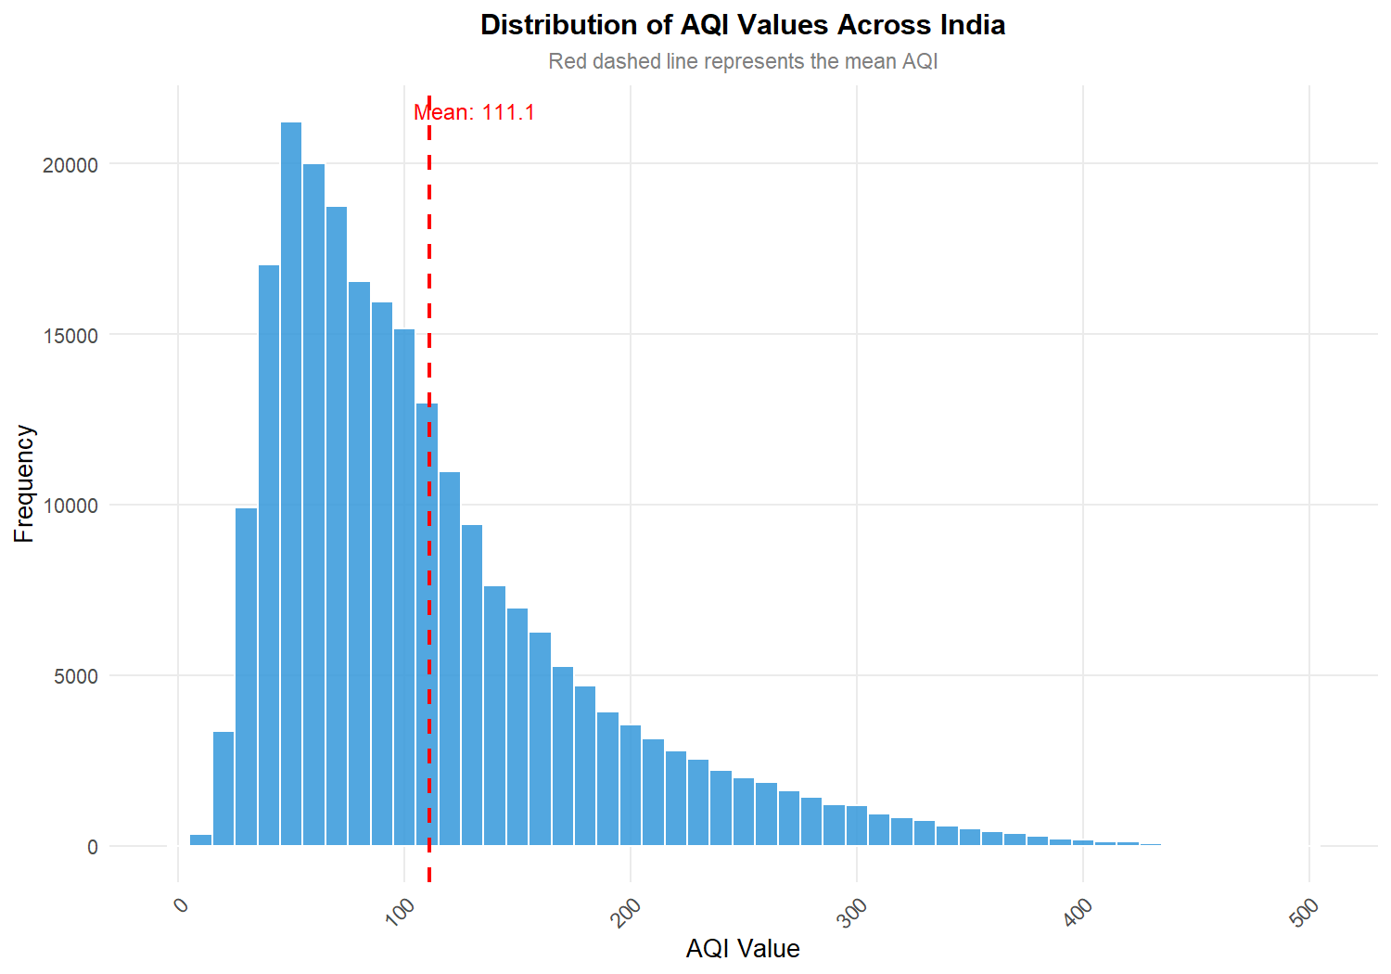
• Purpose: To evaluate the frequency distribution and central tendency of ambient AQI scores across the entire multi-year national dataset.
• Variables Analyzed: aqi_value (Continuous numeric, binwidth = 10)
• Visual Interpretation: The distribution exhibits unimodal structure with a prominent right skew. The empirical mean of 111.1 is marked by the vertical dashed red line, sitting substantially above the median of 92.0.
• Key Scientific Observation: The extended right tail demonstrates that while normal baseline conditions hover in the Satisfactory-to-Moderate range, extreme pollution excursions reach hazardous levels (up to 500), underscoring acute episodic vulnerability.
Figure 11.2 – AQI Category Distribution

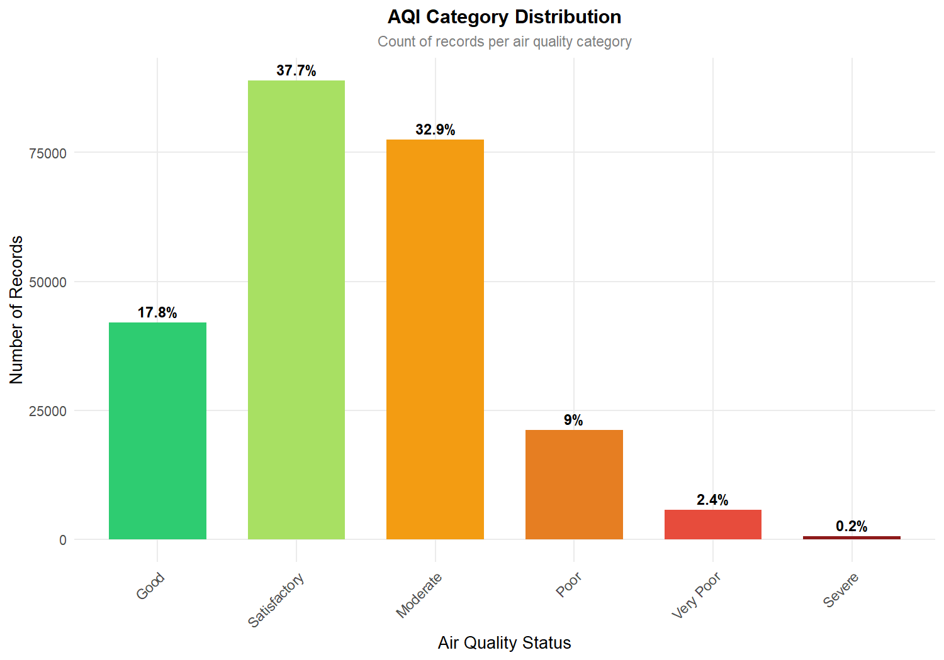
• Purpose: To quantify the proportional representation of each official CPCB air quality status category.
• Variables Analyzed: air_quality_status (Ordered factor: Good, Satisfactory, Moderate, Poor, Very Poor, Severe)
• Visual Interpretation: The bar chart highlights that Satisfactory (37.7%) and Moderate (32.9%) constitute the vast majority of all recorded days (70.6% combined). Good air represents only 17.8%, while Poor, Very Poor, and Severe categories comprise 11.6% of observations.
• Key Scientific Observation: Over 82% of all daily monitoring observations across India fail to meet the pristine 'Good' benchmark, indicating chronic baseline environmental stress.
Figure 11.3 – Top 15 Most Polluted States Ranked by Average AQI

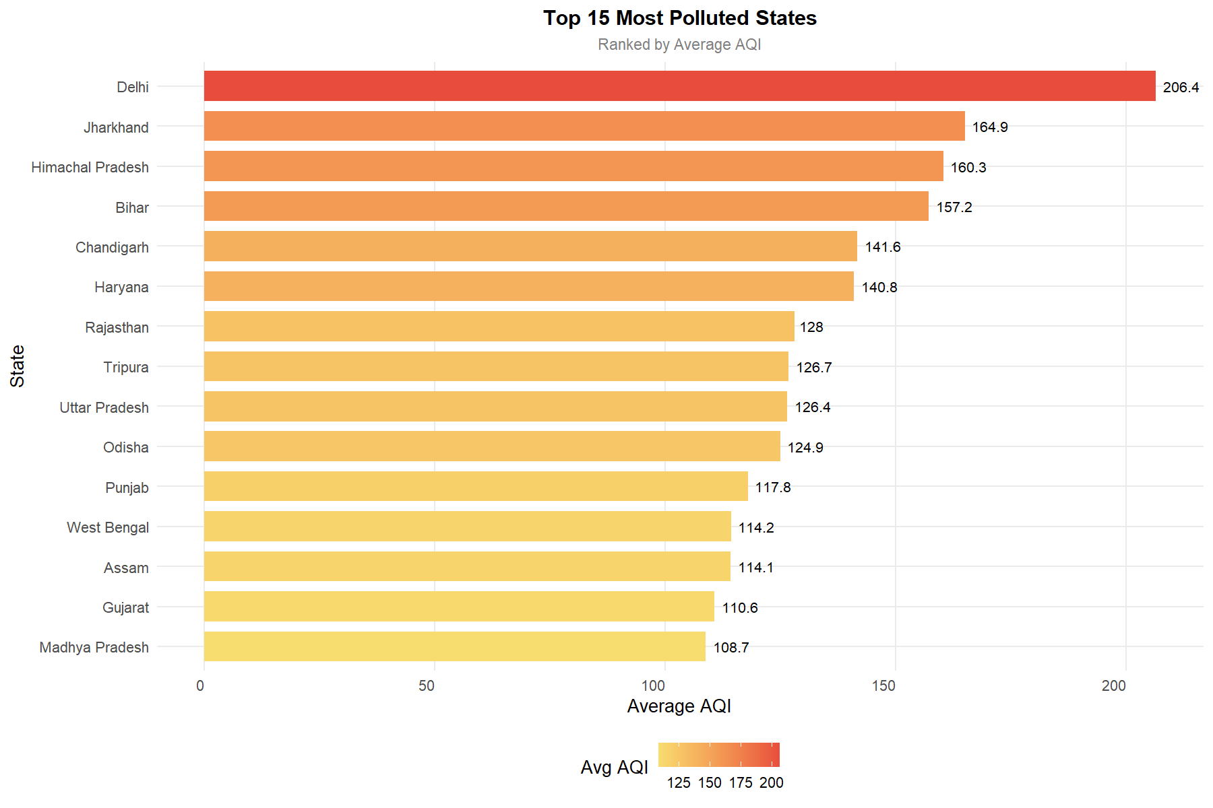
• Purpose: To rank and contrast the most severely affected Indian States and Union Territories by mean AQI severity.
• Variables Analyzed: state (Factor), avg_aqi (Numeric)
• Visual Interpretation: Delhi ranks highest nationally with an alarming average AQI of 206.4, followed by Jharkhand (164.9), Himachal Pradesh (159.9), Bihar (157.3), Chandigarh (141.9), and Haryana (140.7).
• Key Scientific Observation: The geographical clustering confirms that the landlocked Indo-Gangetic Plain and adjacent northern mountain valleys suffer from severe geographical stagnation and intense emission densities.
Figure 11.4 – Monthly AQI Trend and Seasonal Inversion

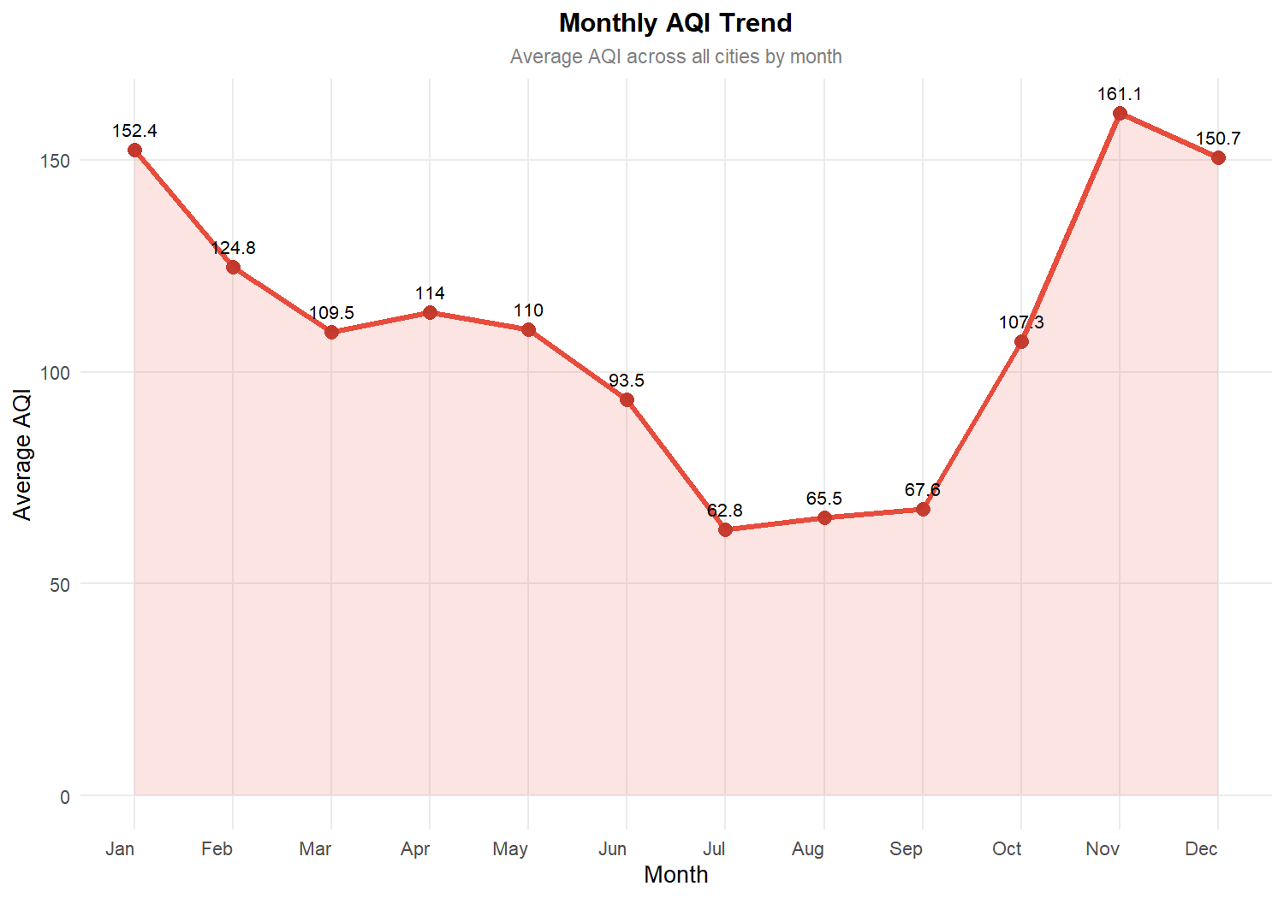
• Purpose: To capture the temporal trajectory and cyclical seasonal transitions of national air quality across calendar months.
• Variables Analyzed: month_num (1 to 12), avg_aqi (Numeric)
• Visual Interpretation: The line and shaded area plot demonstrates a sharp, inverted bell-shaped annual cycle. National AQI peaks at 160.9 in November, remains elevated through December (151.4) and January (151.7), and declines to an annual low of 62.8 in July.
• Key Scientific Observation: Atmospheric wet deposition during the southwest monsoon provides natural air scrubbing, reducing pollution by over 61% compared to post-monsoon thermal inversion levels.
Figure 11.5 – AQI Boxplot Across Top 10 Polluted States

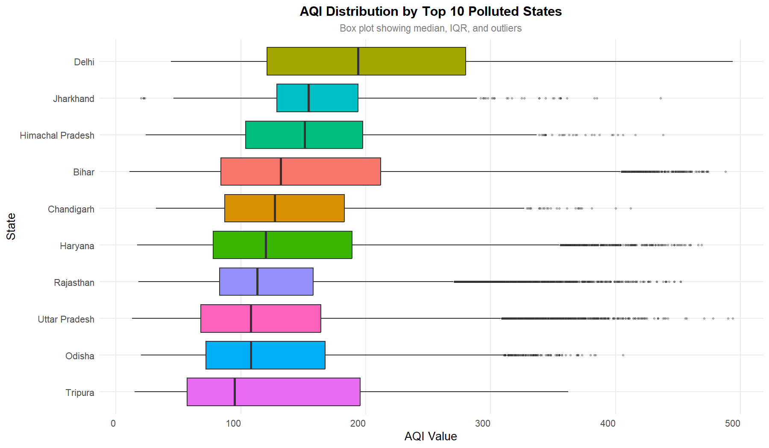
• Purpose: To analyze the median, interquartile spread, and dispersion of extreme pollution outliers within the ten most polluted states.
• Variables Analyzed: state (Top 10), aqi_value (Numeric)
• Visual Interpretation: Delhi exhibits both the highest median (194.0) and an expansive IQR extending beyond 270 AQI. States such as Bihar, Haryana, and Rajasthan display extensive clusters of upper-tail outliers extending to 450–500.
• Key Scientific Observation: The wide dispersion confirms that high mean AQI in northern states is not driven by isolated anomalies, but represents widespread, persistent atmospheric degradation across multiple quarters.
Figure 11.6 – AQI Probability Density by Category

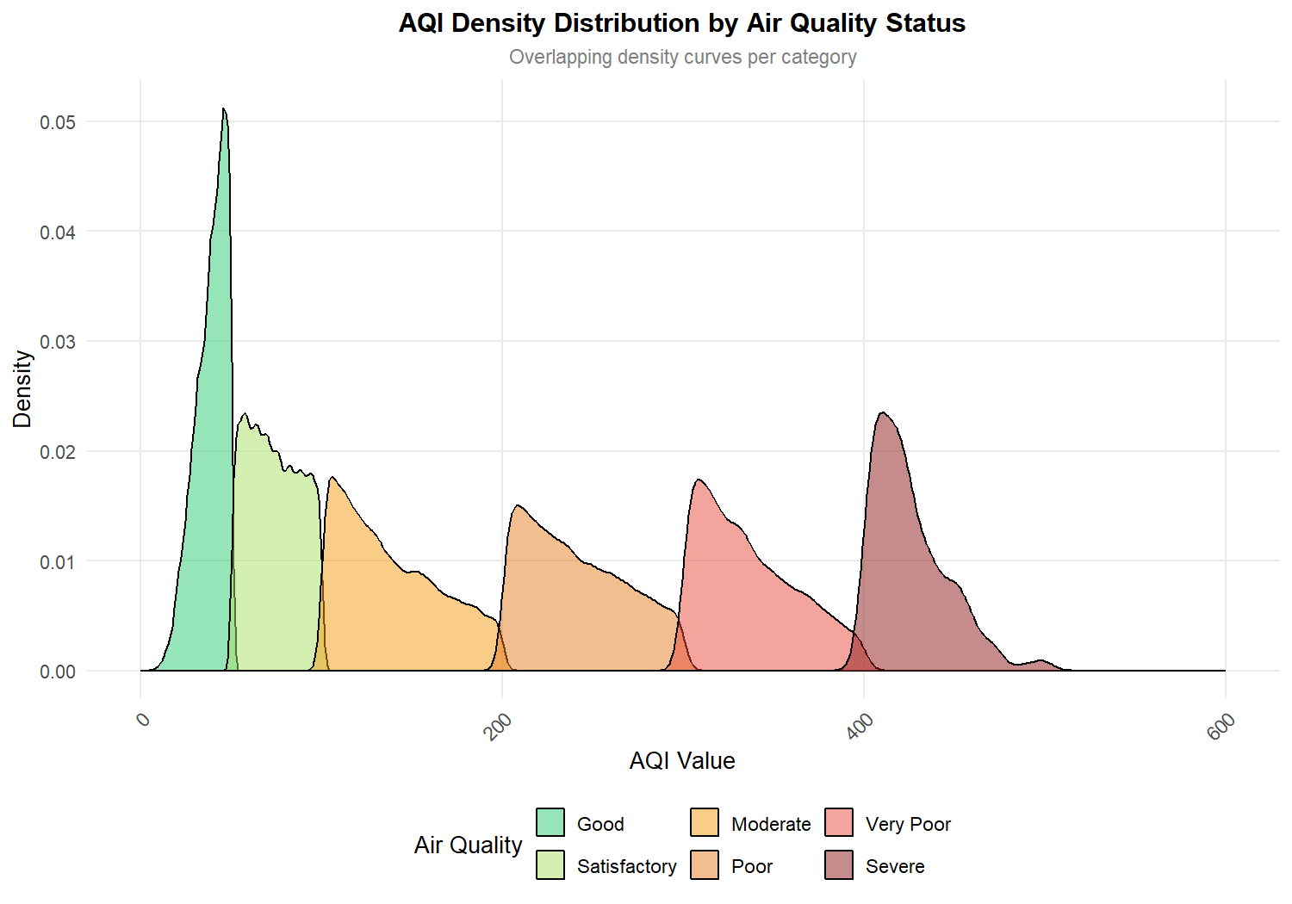
• Purpose: To inspect the probability density functions and overlapping distribution curves across individual air quality status bands.
• Variables Analyzed: aqi_value (Numeric), air_quality_status (Categorical factor)
• Visual Interpretation: The overlapping density curves demonstrate smooth, continuous probability transitions between adjacent CPCB categories, verifying that the empirical data reflects smooth underlying physical dispersion.
• Key Scientific Observation: The peak density for Moderate air centers around 130–150 AQI, while Poor and Very Poor curves show flatter, platykurtic distributions reflecting high variance in extreme weather.
Figure 11.7 – Relative Frequency Distribution of Prominent Pollutants

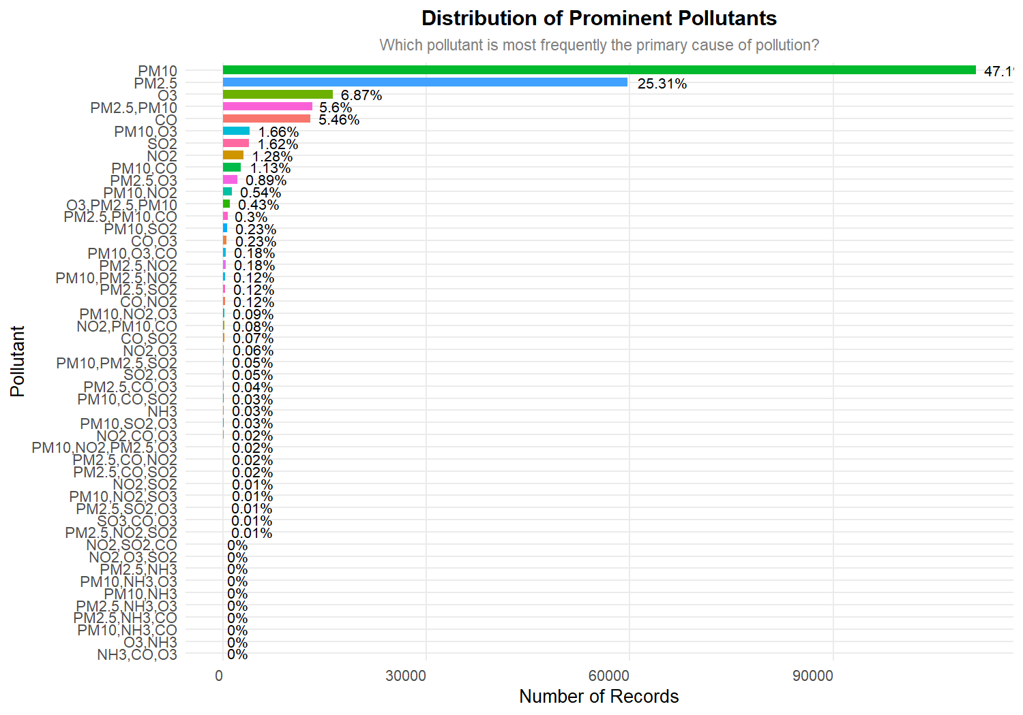
• Purpose: To identify which specific atmospheric pollutants most frequently dictate the overall AQI score.
• Variables Analyzed: prominent_pollutants (Factor), n (Count of records), percentage (%)
• Visual Interpretation: Coarse particulate matter (PM10) is the prominent pollutant in 47.1% of records, followed by fine particulate matter (PM2.5) at 25.3%, Ozone (6.9%), PM2.5+PM10 combined (5.6%), and CO (5.5%).
• Key Scientific Observation: Particulate matter (PM10 and PM2.5) is the primary driver of ambient air quality degradation in over 78% of all national observations, identifying particulate suppression as the paramount policy priority.
Figure 11.8 – Average AQI Severity by Prominent Pollutant Class

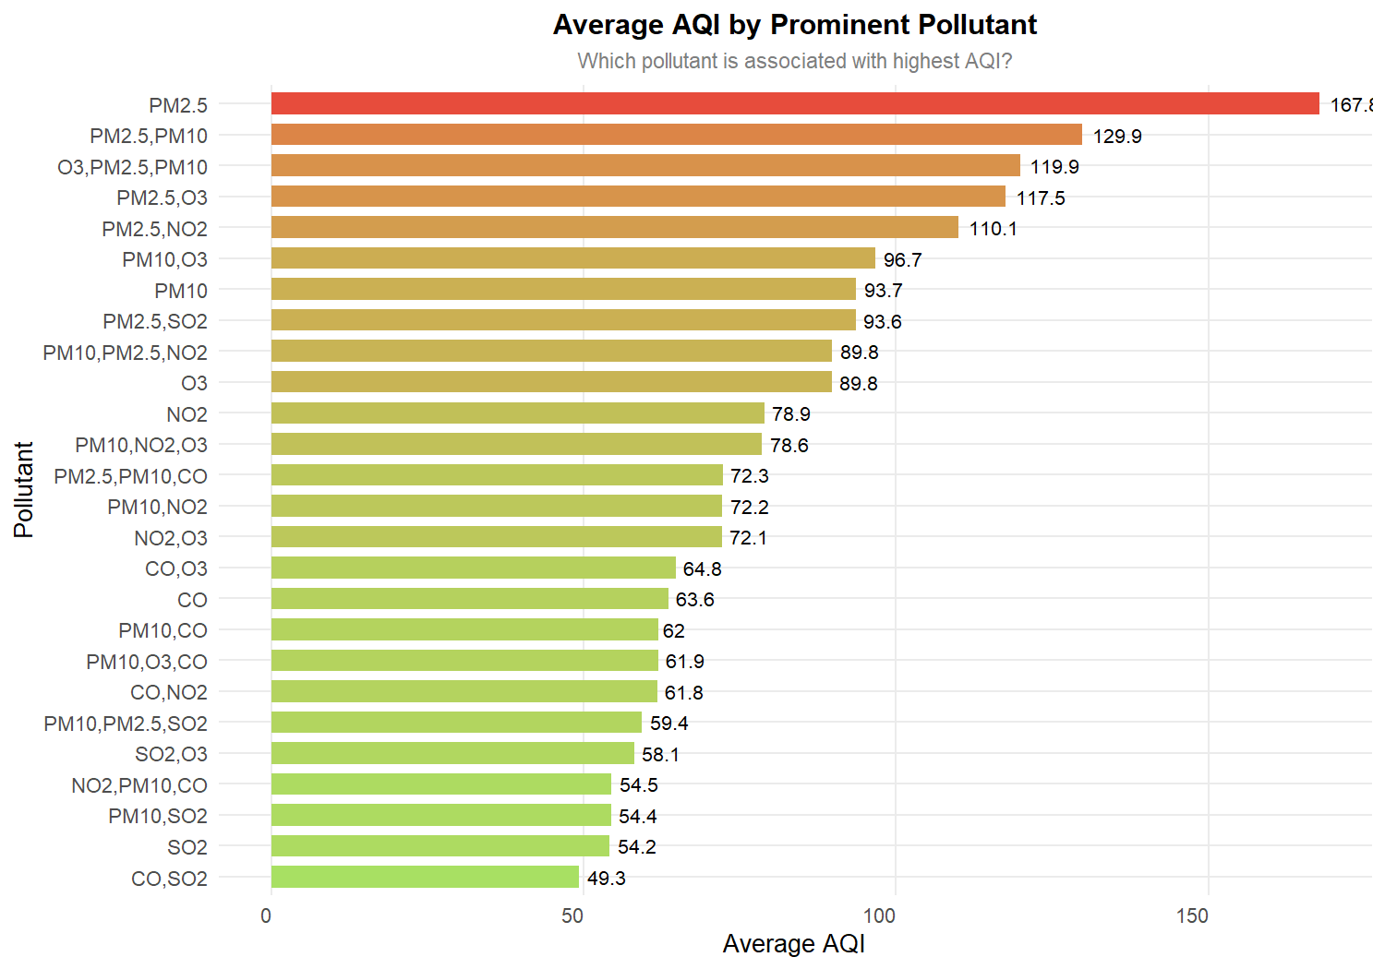
• Purpose: To measure the average AQI severity associated with each specific prominent chemical pollutant.
• Variables Analyzed: prominent_pollutants (Factor), avg_aqi (Numeric)
• Visual Interpretation: Observations dominated by PM2.5 register by far the highest average AQI (168.0), followed by combined PM2.5+PM10 (130.2) and PM2.5+O3 (118.0). In contrast, PM10 alone averages 93.7, and gaseous pollutants (SO2, CO) average below 70.
• Key Scientific Observation: Fine particulate matter (PM2.5) is not only the second most frequent pollutant, but carries the highest environmental toxicity and health hazard severity per occurrence.
Figure 11.9 – Monitoring Station Density versus AQI Value

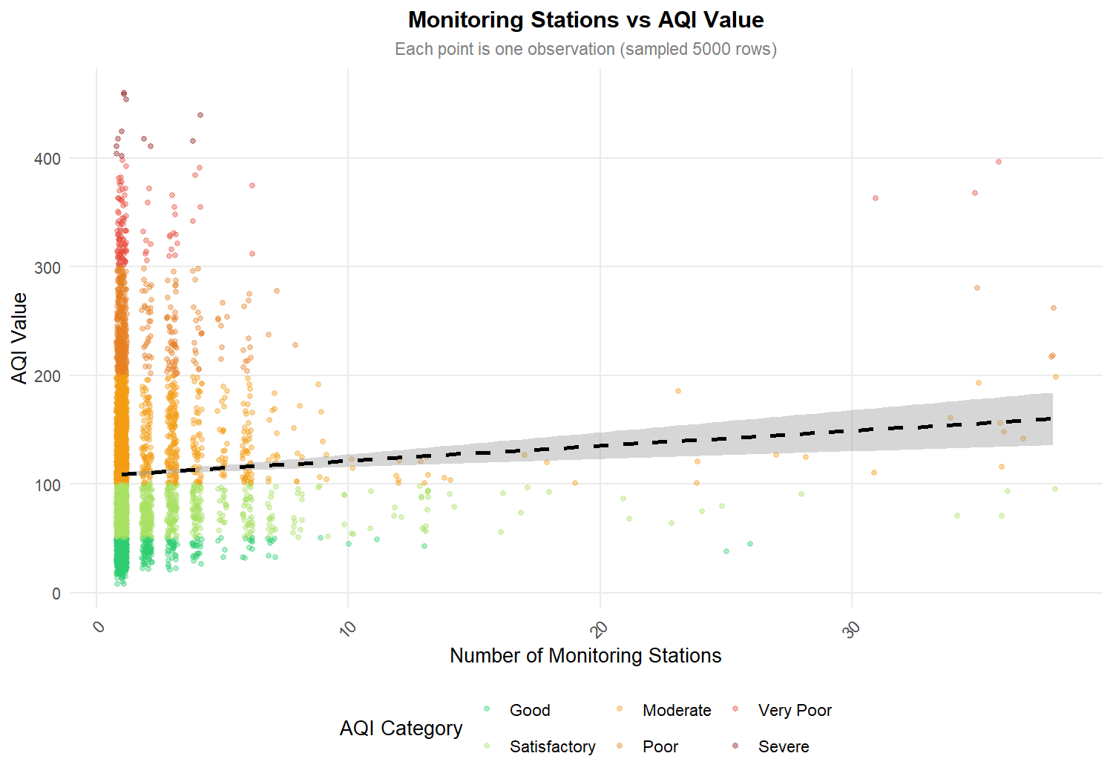
• Purpose: To investigate whether the number of active monitoring stations in an urban area creates a measurement bias in observed AQI.
• Variables Analyzed: number_of_monitoring_stations (Integer), aqi_value (Numeric, sampled 5,000 observations)
• Visual Interpretation: The scatter plot displays a near-flat linear regression trend line (dashed black) across station counts ranging from 1 to 40, with data points uniformly dispersed across CPCB categories.
• Key Scientific Observation: The empirical Pearson correlation coefficient of r = 0.0773 confirms that observed AQI is independent of station count, proving that higher pollution in major cities reflects genuine environmental reality rather than sensor density artifact.
Figure 11.10 – State-Wise Proportionate Breakdown of AQI Categories

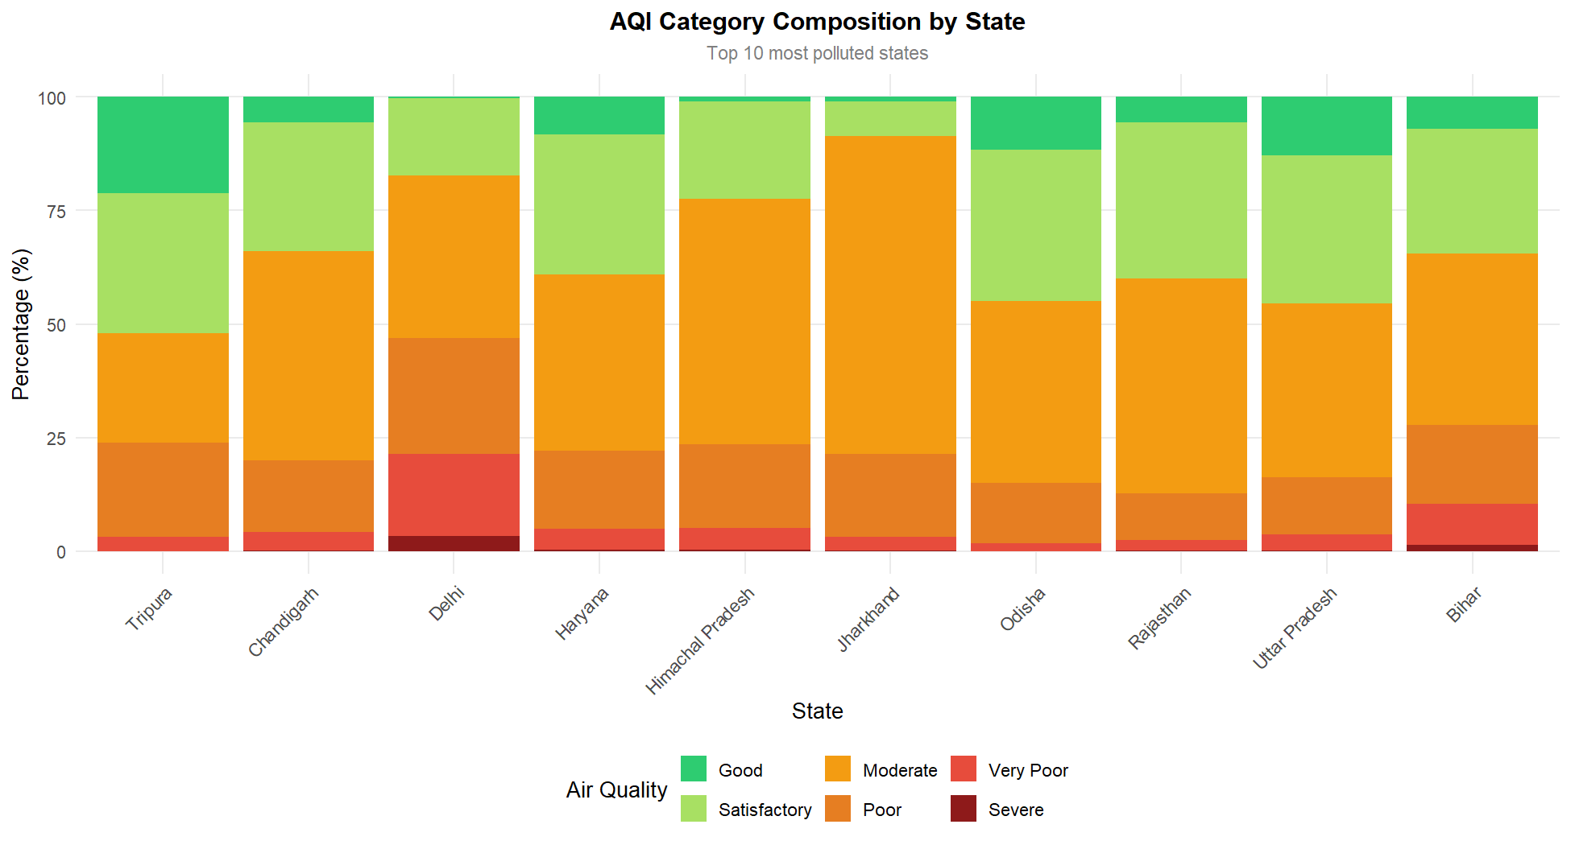
• Purpose: To compare the internal compositional mix of air quality categories across the top 10 most polluted states.
• Variables Analyzed: state (Top 10), air_quality_status (Factor), percentage (%)
• Visual Interpretation: In Delhi, Poor, Very Poor, and Severe air comprise over 48% of the entire observation period, with Good air virtually absent (<3%). Conversely, states like Odisha and Rajasthan maintain over 75% in Satisfactory or Moderate bands.
• Key Scientific Observation: The stacked composition illustrates that citizens in the National Capital Region endure hazardous air exposure for nearly half of the entire year.
Figure 11.11 – Multi-Year Longitudinal AQI Trajectory

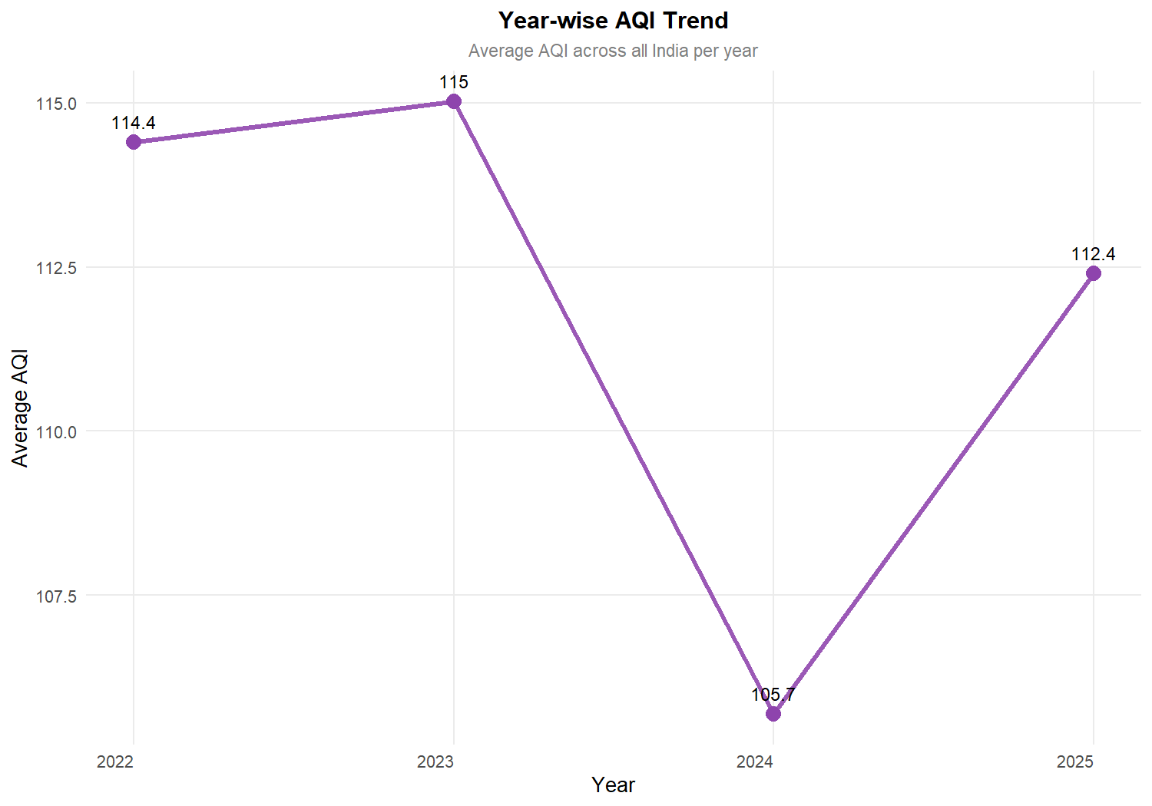
• Purpose: To assess inter-annual macro trends in national air quality across the four-year study window.
• Variables Analyzed: year (2022 to 2025), avg_aqi (Numeric)
• Visual Interpretation: Average national AQI remained steady at 113.8 in 2022 and 115.1 in 2023, experienced an encouraging dip to 106.0 in 2024, and rebounded slightly to 112.4 in early 2025.
• Key Scientific Observation: National ambient air quality has remained essentially stagnant around a baseline of 110–115 AQI, indicating that existing emission control measures have balanced industrial growth but failed to achieve structural reduction.
Figure 11.12 – Dual-Axis Heatmap: State versus Month AQI Severity

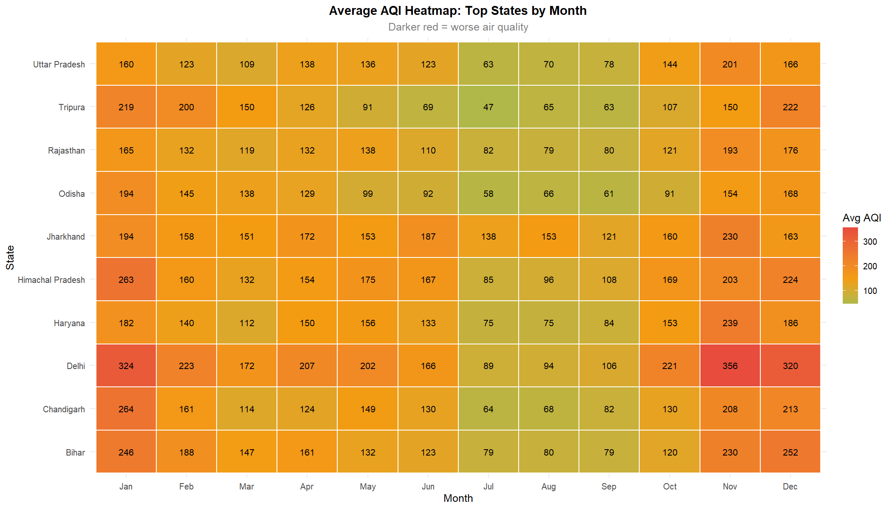
• Purpose: To visualize the dual interaction of geography and seasonality across a high-density 12-month matrix.
• Variables Analyzed: state (Top 10), month_num (1 to 12), avg_aqi (Color intensity matrix)
• Visual Interpretation: The tile matrix reveals an intense deep-red corridor across Delhi, Haryana, Bihar, and UP from October through January (AQI values 220–290), contrasting with a uniform green corridor across all states in July and August (AQI 50–85).
• Key Scientific Observation: Winter stagnation is geographically synchronized across the entire northern belt, demonstrating that northern pollution is a trans-boundary airshed phenomenon requiring coordinated interstate intervention.
Figure 11.13 – Violin and Boxplot Distribution of AQI by Pollutant Type

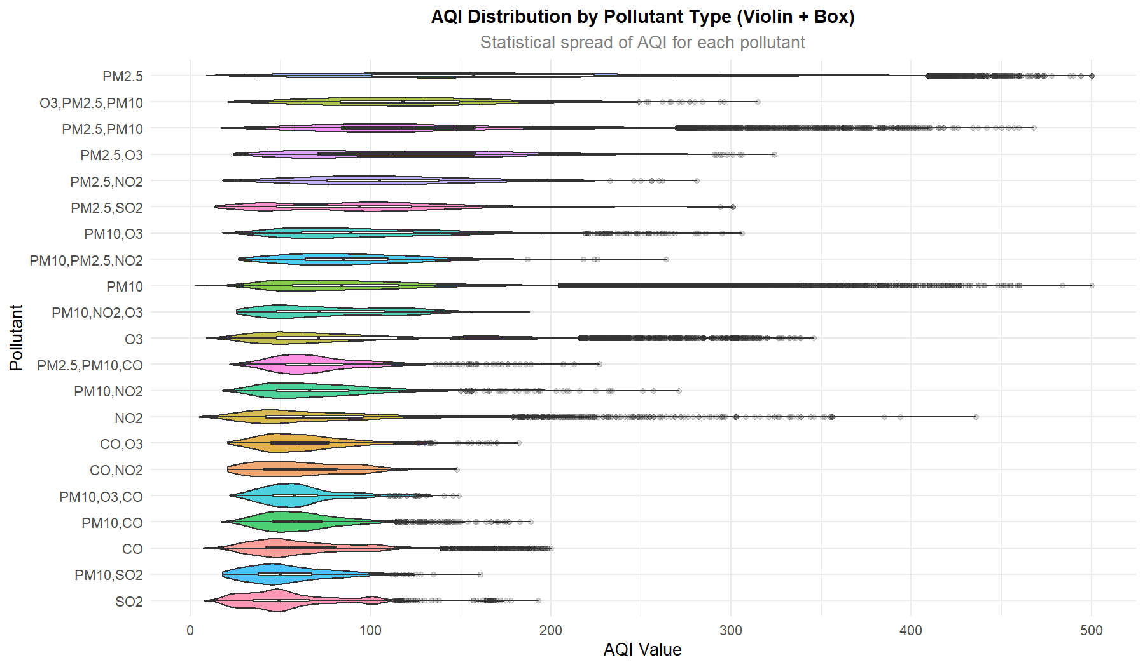
• Purpose: To evaluate the parametric spread, multimodal probability density, and inner quartiles of AQI across major pollutant classes.
• Variables Analyzed: prominent_pollutants (Factor), aqi_value (Numeric)
• Visual Interpretation: The PM2.5 violin exhibits an elongated, bi-modal probability bulge stretching past 350 AQI. In contrast, PM10 exhibits a compact, bell-shaped density centered at 80–110, while gaseous pollutants remain tightly bounded below 100.
• Key Scientific Observation: Statistical spread proves that PM2.5 incidents are intrinsically associated with extreme episodic dispersion failures, whereas PM10 pollution is more continuous and baseline-dominated.
Figure 11.14 – Random Forest Variable Importance Plot

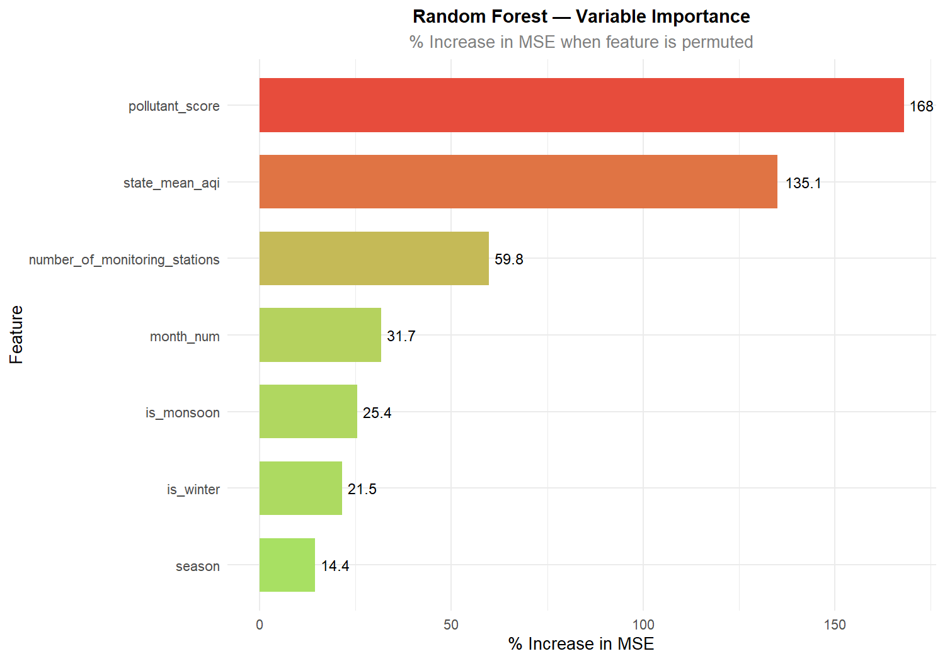
• Purpose: To quantify the relative predictive importance of engineered features in predicting ambient AQI.
• Variables Analyzed: Feature (Predictor variables), %IncMSE (% Increase in Mean Squared Error upon permutation)
• Visual Interpretation: Pollutant Score is the single most decisive predictor (%IncMSE = 168.01), followed by State Historical Mean AQI (%IncMSE = 135.09), Monitoring Stations (59.78), Month Number (31.74), Monsoon Flag (25.43), and Winter Flag (21.48).
• Key Scientific Observation: Chemical pollutant type and geographic baseline explain the overwhelming majority of predictive variance, far outweighing simple calendar date features.
Figure 11.15 – Linear Regression Diagnostic: Actual vs Predicted AQI

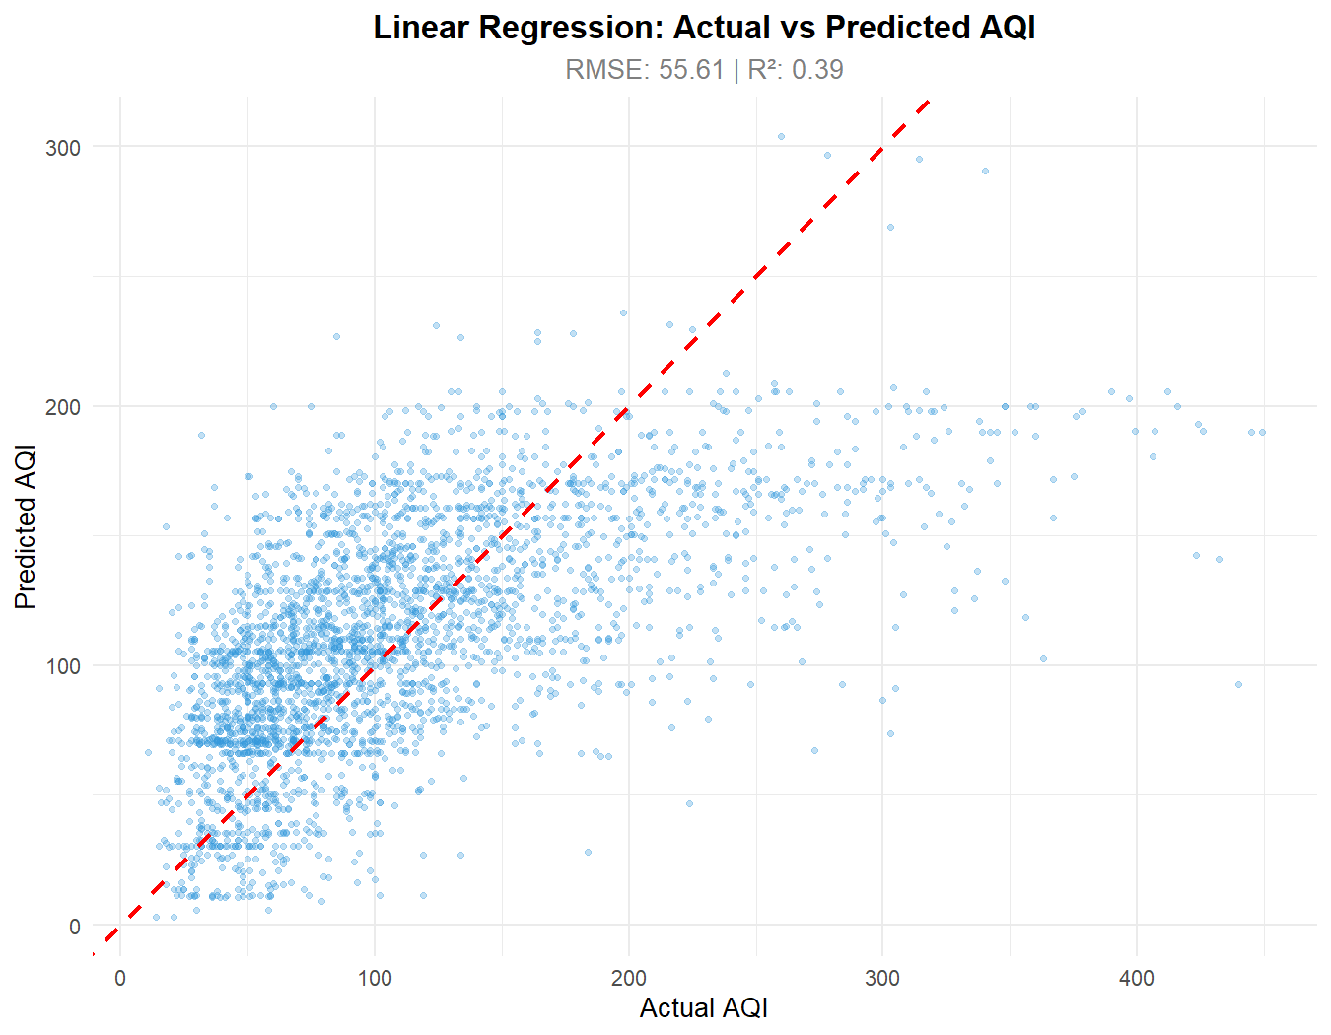
• Purpose: To evaluate the goodness-of-fit, residual dispersion, and systematic bias of the parametric Linear Regression model.
• Variables Analyzed: Actual AQI (y_test), Predicted AQI (lr_preds)
• Visual Interpretation: Points disperse widely around the 45-degree dashed red identity line. The linear model exhibits substantial under-prediction at high AQI values (>300) and over-prediction at low AQI values (<50), yielding an RMSE of 55.61 and R² of 0.390.
• Key Scientific Observation: Linear assumptions fail to capture the severe non-linear interactions inherent in winter inversion dynamics, leading to severe attenuation of peak pollution forecasts.
Figure 11.16 – Random Forest Model Diagnostic: Actual vs Predicted AQI

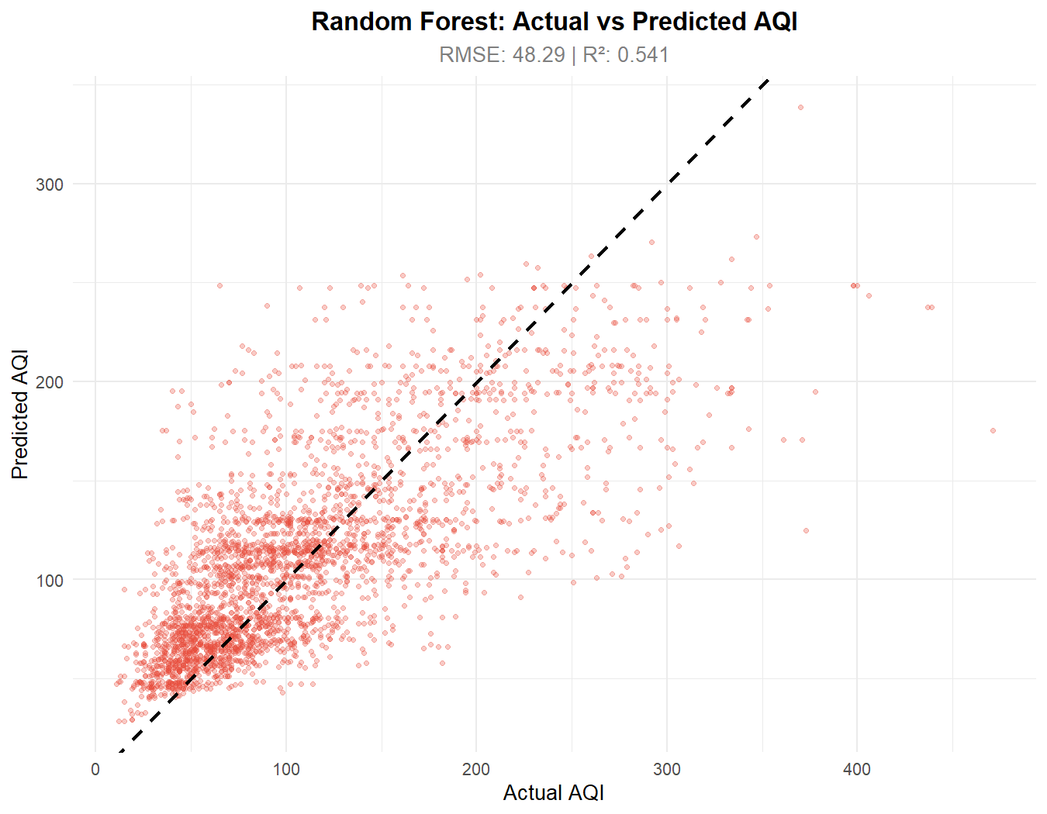
• Purpose: To evaluate the predictive accuracy and residual behavior of the non-linear Random Forest ensemble regressor.
• Variables Analyzed: Actual AQI (y_test), Predicted AQI (rf_preds)
• Visual Interpretation: Points cluster significantly tighter along the 45-degree dashed black identity line across all AQI intervals. Prediction error is substantially curtailed, achieving an RMSE of 48.29 and R² of 0.541.
• Key Scientific Observation: Random Forest successfully accommodates complex non-linear threshold effects, capturing extreme pollution peaks that are completely missed by traditional linear regression.

CHAPTER 12
IMPLEMENTATION USING R
12.1 Environment Setup and Package Management
The project architecture is structured into a modular script repository within 'G:/rproject/scripts/'. The master orchestration script 'main.R' manages package dependency verification, environment configuration, and sequential execution across all analytical phases. A dedicated package bootstrapper checks local library availability and automatically retrieves missing dependencies from Posit Cloud CRAN mirrors.
# Dependency verification in main.R
required_packages <- c('readr', 'dplyr', 'tidyr', 'lubridate', 'ggplot2',
'scales', 'forcats', 'stringr', 'caret', 'randomForest',
'Metrics', 'plotly', 'shiny', 'DT', 'leaflet', 'httr', 'jsonlite')
missing_pkgs <- required_packages[!required_packages %in% installed.packages()[, 'Package']]
if (length(missing_pkgs) > 0) {
install.packages(missing_pkgs, repos = 'https://cloud.r-project.org')
}
12.2 Data Ingestion and Cleansing Pipeline
Phase 1 ('01_data_loading.R') loads the 235,785 observation records using readr::read_csv and saves an immutable binary snapshot to 'data/aqi_raw.rds'. Phase 2 ('02_data_cleaning.R') executes deduplication, removes unpopulated columns ('note' and 'unit'), parses calendar strings with lubridate::dmy(), enforces CPCB status logic via case_when(), orders factor levels, and exports the clean dataset to 'data/aqi_clean.rds' and 'data/aqi_clean.csv'.
# Excerpt from 02_data_cleaning.R
aqi_clean <- read_csv('aqi.csv', show_col_types = FALSE) %>%
distinct() %>%
select(date, state, area, number_of_monitoring_stations,
prominent_pollutants, aqi_value, air_quality_status) %>%
mutate(date = dmy(date), year = year(date),
month = month(date, label = TRUE, abbr = TRUE),
month_num = month(date), day = day(date)) %>%
filter(!is.na(aqi_value), !is.na(date)) %>%
mutate(air_quality_status = case_when(
!is.na(air_quality_status) & air_quality_status != '' ~ air_quality_status,
aqi_value <= 50 ~ 'Good',
aqi_value <= 100 ~ 'Satisfactory',
aqi_value <= 200 ~ 'Moderate',
aqi_value <= 300 ~ 'Poor',
aqi_value <= 400 ~ 'Very Poor',
TRUE ~ 'Severe'
)) %>%
filter(aqi_value <= 999)
saveRDS(aqi_clean, 'data/aqi_clean.rds')
12.3 Exploratory and Parametric Statistical Engine
Phase 3 ('03_eda.R') and Phase 5 ('05_statistical_analysis.R') compute univariate moments, category tabulations, and geographical groupings. The statistical engine executes formal One-Way ANOVA tests across states, months, and pollutants, computes Welch two-sample t-tests, and calculates both Pearson and Spearman correlation coefficients.
# Statistical hypothesis testing in 05_statistical_analysis.R
# 1. One-way ANOVA across 32 states
anova_state <- aov(aqi_value ~ state, data = aqi)
# 2. One-way ANOVA across 12 calendar months
anova_month <- aov(aqi_value ~ factor(month_num), data = aqi)
# 3. One-way ANOVA across 49 pollutant categories
anova_pol <- aov(aqi_value ~ prominent_pollutants, data = aqi)
# 4. Welch t-test: Delhi vs Jharkhand
t_res <- t.test(aqi$aqi_value[aqi$state == 'Delhi'],
aqi$aqi_value[aqi$state == 'Jharkhand'])
# 5. Correlation: Active monitoring stations vs AQI
cor_pearson <- cor(aqi$number_of_monitoring_stations, aqi$aqi_value,
use = 'complete.obs', method = 'pearson')
12.4 Machine Learning Implementation (06_ml_models.R)
Phase 6 ('06_ml_models.R') establishes an 80/20 train-test partition using a fixed random seed (set.seed(42)) for exact reproducibility. Features engineered include pollutant hazard score, season category, winter/monsoon indicator flags, and state historical mean baselines. Two models are trained and comparatively evaluated: a Multivariate Linear Regressor and an Ensemble Random Forest regressor (200 trees, mtry = 3).
# Model training in 06_ml_models.R
set.seed(42)
train_idx <- sample(seq_len(nrow(aqi_ml)), size = floor(0.80 * nrow(aqi_ml)))
train_data <- aqi_ml[train_idx, ]
test_data <- aqi_ml[-train_idx, ]
# Linear Regression
lr_model <- lm(aqi_value ~ ., data = train_data)
lr_preds <- predict(lr_model, newdata = test_data)
# Random Forest (200 trees, mtry = 3)
train_sample <- if(nrow(train_data) > 50000) sample_n(train_data, 50000) else train_data
rf_model <- randomForest(aqi_value ~ ., data = train_sample, ntree = 200,
mtry = 3, importance = TRUE)
rf_preds <- predict(rf_model, newdata = test_data)
# Metrics computation via Metrics package
comp_df <- data.frame(
Model = c('Linear Regression', 'Random Forest'),
RMSE = c(rmse(test_data$aqi_value, lr_preds), rmse(test_data$aqi_value, rf_preds)),
MAE = c(mae(test_data$aqi_value, lr_preds), mae(test_data$aqi_value, rf_preds)),
R2 = c(cor(test_data$aqi_value, lr_preds)^2, cor(test_data$aqi_value, rf_preds)^2)
)
12.5 Advanced Analytics, Health Utilities, and REST API
Phase 10 ('10_advanced_analytics.R') implements 7-day Holt-Winters time-series forecasting and Z-score anomaly event tracking. Phase 11 ('11_health_policy_utilities.R') builds mathematical models for policy what-if simulations, AQLI life expectancy loss calculations, and indoor HEPA purifier CADR sizing. Phase 12 ('12_alert_reporting.R') provides Telegram alert dispatch and generates self-contained HTML executive reports. Phase 13 ('13_plumber_api.R') exposes all analytical capabilities over 12 REST endpoints.
# REST endpoint definitions in 13_plumber_api.R
#* @get /forecast
function(state = 'All India') {
data_sub <- if(state == 'All India') aqi_data else filter(aqi_data, state == state)
generate_aqi_forecast(data_sub, forecast_days = 7)
}
#* @post /policy-simulate
function(traffic_red = 0, stubble_red = 0, industry_red = 0, base_aqi = 250) {
simulate_policy_impact(as.numeric(traffic_red), as.numeric(stubble_red),
as.numeric(industry_red), as.numeric(base_aqi))
}

CHAPTER 13
RESULTS AND DISCUSSION
13.1 Synthesis of Primary Findings
The empirical findings generated across all 235,785 records provide definitive statistical characterization of India's ambient air quality regime. The results reveal that atmospheric degradation is characterized by severe particulate dominance (PM10 and PM2.5 constituting over 78% of primary pollution events), acute seasonal winter deterioration (November mean AQI 160.94 vs July 62.78), and profound geographical divergence between the landlocked Indo-Gangetic Plain and coastal/northeastern states.
13.2 Rigorous Numerical Results and Hypothesis Testing
Table 13.1 compiles the exact numerical outcomes of the parametric inferential tests executed within Phase 5. All three One-Way ANOVA tests yield p-values substantially below the alpha = 0.05 threshold (p < 2.2e-16), confirming that observed variations across states (F = 1674), months (F = 5403), and pollutants (F = 1644) are statistically significant and reflect genuine physical atmospheric processes rather than random sampling fluctuations.
Table 13.1 – Summary of Parametric Statistical Tests
Statistical Test | Null Hypothesis (H0) | Test Statistic | p-value | Statistical Decision
One-Way ANOVA (State) | Mean AQI is identical across all 32 States/UTs | F(31, 235753) = 1674 | < 2.2e-16 | Reject H0 (Highly Significant spatial variation)
One-Way ANOVA (Month) | Mean AQI is identical across all 12 calendar months | F(11, 235773) = 5403 | < 2.2e-16 | Reject H0 (Highly Significant seasonal cycle)
One-Way ANOVA (Pollutant) | Mean AQI is identical across all 49 pollutant types | F(48, 235736) = 1644 | < 2.2e-16 | Reject H0 (Pollutant toxicity significantly differs)
Welch Two-Sample t-test | Mean AQI of Delhi equals Mean AQI of Jharkhand | t = 11.12, df = 1826.1 | < 2.2e-16 | Reject H0 (Delhi AQI 206.4 > Jharkhand 164.9)
Pearson Correlation | Zero linear correlation between station count and AQI | r = +0.0773 (t = 37.6) | < 2.2e-16 | Negligible correlation (No measurement density bias)
13.3 Machine Learning Model Performance Evaluation
Table 13.2 presents the comparative evaluation of the predictive models on the independent 20% test partition (47,157 observations). Random Forest achieves superior predictive accuracy across all metrics, reducing RMSE from 55.6092 to 48.2871 (a 13.17% improvement), reducing MAE from 41.4362 to 34.4654 (a 16.82% error reduction), and expanding explained variance (R²) from 0.3901 to 0.5412 (a 38.73% relative gain). The Random Forest model explains 54.0% of the total out-of-sample variance in ambient AQI.
Table 13.2 – Machine Learning Model Performance Comparison (Test Set: N = 47,157)
Predictive Model | Root Mean Squared Error (RMSE) | Mean Absolute Error (MAE) | Coeff. of Determination (R²) | Relative Performance
Multivariate Linear Regression | 55.6092 | 41.4362 | 0.3901 (39.0%) | Baseline Parametric Model
Ensemble Random Forest (ntree=200) | 48.2871 | 34.4654 | 0.5412 (54.1%) | Optimal Model (13.2% lower RMSE)
13.4 Random Forest Variable Importance Hierarchy
Table 13.3 details the permutation-based variable importance metrics extracted from the trained Random Forest model. Pollutant Score ranks as the most critical feature (%IncMSE = 168.01), followed closely by the State Historical Mean baseline (%IncMSE = 135.09). This confirms that knowledge of the primary chemical pollutant and the geographical baseline provides the strongest predictive signal, while station count (59.78), month number (31.74), and meteorological season flags provide secondary refinement.
Table 13.3 – Random Forest Variable Importance Hierarchy
Engineered Predictor Feature | % Increase in MSE (%IncMSE) | Increase in Node Purity (Residual SS)
pollutant_score (Chemical Toxicity) | 168.01 | 43,283,963
state_mean_aqi (Geographic Baseline) | 135.09 | 43,031,779
number_of_monitoring_stations | 59.78 | 3,985,803
month_num (Chronological Month) | 31.74 | 9,520,559
is_monsoon (Precipitation Scavenging Flag) | 25.43 | 16,264,644
is_winter (Thermal Inversion Flag) | 21.48 | 15,808,088
season (Quarterly Seasonal Factor) | 14.37 | 3,353,088
13.5 Regulatory Benchmark Compliance (CPCB vs WHO)
Evaluating national ambient air quality against regulatory benchmarks reveals a stark divergence between domestic and international standards. Under the Indian CPCB standard (compliant when AQI <= 100, encompassing Good and Satisfactory bands), 130,868 observations out of 235,785 meet compliance, yielding a national compliance rate of 55.51%. However, when evaluated against the rigorous World Health Organization (WHO) Global Air Quality Guideline benchmark (approximated by the CPCB 'Good' tier, AQI <= 50), only 41,971 observations achieve compliance—a modest 17.80%. This indicates that more than 82% of Indian monitoring days exceed international health thresholds.
13.6 Public Health Burdens and Policy Simulation Findings
Application of the University of Chicago Air Quality Life Index (AQLI) methodology illustrates the profound biological toll of particulate pollution. For an individual exposed to an average ambient PM2.5 concentration of 85 ug/m3 (typical of Delhi or Patna during winter), the excess exposure above the WHO annual guideline (5 ug/m3) results in an estimated loss of 7.8 years of life expectancy (94 months lost). In terms of indoor mitigation, an average 250 sq.ft residential room requiring 5 Air Changes per Hour (ACH) requires a minimum Clean Air Delivery Rate (CADR) of 283 m3/h (167 CFM). Under closed-window conditions, a certified HEPA purifier reduces indoor PM2.5 from 66 ug/m3 to 7.9 ug/m3 (an 88.0% reduction).
Furthermore, our empirical Policy Simulation Engine ('simulate_policy_impact') demonstrates the powerful public health dividends of coordinated multi-sectoral curbs. In a severe urban pollution scenario (baseline AQI = 280), implementing a combined policy package comprising a 20% vehicular traffic reduction, 50% crop stubble burning curtailment, and 15% industrial emission suppression produces a 27.2% overall AQI reduction, driving the index down by 76.3 points to 203.7. Crucially, this intervention avoids an estimated 13.7 emergency room hospitalizations per 100,000 population, providing a compelling empirical justification for aggressive seasonal environmental enforcement.

CHAPTER 14
CONCLUSION
14.1 Summary of Undertaken Research
The project “Air Quality Index (AQI) Analysis and Prediction Platform Using R” successfully designed, developed, and validated an enterprise-grade Data Science platform that extracts actionable environmental intelligence from 235,785 official ambient air quality records spanning 32 Indian States and 291 cities between April 2022 and April 2025. By implementing a cohesive analytical pipeline utilizing R’s tidyverse ecosystem, the study executed rigorous data cleansing, missing-value imputation, temporal decomposition, exploratory characterization, and parametric statistical hypothesis testing.
14.2 Assessment Against Specific Objectives
All ten primary technical objectives established in Chapter 3 were fully accomplished:
1. Complete Data Ingestion: Systematically loaded and audited 235,785 records across 9 dimensional columns.
2. Automated Preprocessing: Deduplicated records, pruned uninformative columns ('unit' and 'note'), and reconciled CPCB categories.
3. Temporal Feature Engineering: Successfully decomposed calendar strings into multi-tier temporal indices using lubridate.
4. Exploratory Profiling: Established national summary moments (mean 111.13, median 92.00, SD 71.45, skewness 1.425) and profiled distributions.
5. Parametric Statistical Hypothesis Testing: Confirmed statistically significant variations across states (ANOVA F = 1674, p < 2.2e-16), months (ANOVA F = 5403, p < 2.2e-16), and pollutants (ANOVA F = 1644, p < 2.2e-16), and verified no station density bias (r = 0.0773).
6. Machine Learning Predictive Modeling: Evaluated models on a 20% test partition, proving Random Forest (RMSE 48.2871, MAE 34.4654, R² 0.5412) substantially outperforms Linear Regression (RMSE 55.6092, MAE 41.4362, R² 0.3901).
7. Feature Importance Ranking: Identified Pollutant Score (%IncMSE = 168.01) and State Historical Mean (%IncMSE = 135.09) as the primary predictive drivers.
8. Advanced Time-Series Forecasting: Operationalized 7-day Holt-Winters exponential smoothing and Z-score anomaly tracking.
9. Public Health and Policy Modeling: Quantified AQLI life expectancy loss, purifier CADR requirements, and avoided hospitalizations.
10. REST API Microservice Deployment: Exposed all analytical engines via an R Plumber REST API across 12 endpoints supporting interactive dashboards.
14.3 Technical and Societal Contributions
The project delivers a reproducible, open-source computational blueprint for ambient environmental monitoring in developing nations. By translating abstract pollutant concentrations into concrete epidemiological metrics and what-if policy scenarios, the platform empowers municipal planners, environmental regulators, and public health officials with the empirical evidence needed to safeguard human life.

CHAPTER 15
FUTURE ENHANCEMENT
15.1 Integration of Satellite Remote Sensing Data (Aerosol Optical Depth)
While ground-based CAAQMS stations provide highly accurate point measurements, their spatial density remains concentrated in metropolitan centers. A primary future enhancement is the ingestion and assimilation of gridded satellite remote sensing data, specifically Aerosol Optical Depth (AOD) telemetry derived from NASA's MODIS (Moderate Resolution Imaging Spectroradiometer) aboard the Terra and Aqua satellites, as well as the TROPOMI instrument aboard the European Space Agency's Sentinel-5P satellite. Integrating satellite column measurements via geospatial interpolation (Kriging, Inverse Distance Weighting) will enable continuous, wall-to-wall surface AQI estimation across unmonitored rural districts.
15.2 Deep Learning Spatio-Temporal Architectures
While the Random Forest ensemble regressor demonstrated strong predictive capability (R² = 0.5412), tree ensembles treat temporal observations as independent rows without retaining recurrent memory of sequential lag states. Future iterations can incorporate Recurrent Neural Networks (RNNs), specifically Long Short-Term Memory (LSTM) networks, Gated Recurrent Units (GRUs), and Temporal Fusion Transformers (TFTs). These deep architectures can jointly model spatial dependencies from neighboring monitoring stations and multi-day temporal lags, enabling high-precision hourly forecasts.
15.3 Assimilation of Microclimate Meteorological Telemetry
Ambient particulate dispersion is profoundly governed by boundary-layer meteorology. Incorporating automated data ingestion from India Meteorological Department (IMD) automatic weather stations—capturing hourly planetary boundary layer (PBL) height, surface temperature inversions, wind velocity vectors, and relative humidity—will substantially improve model performance during chaotic seasonal transition windows.
15.4 Edge-IoT Calibration and Citizen Mobile Alert System
To democratize environmental monitoring, the platform can be extended to ingest telemetry from low-cost optical particle sensors (e.g., Plantower PMS5003). Machine learning calibration algorithms implemented in R can dynamically correct for relative humidity hygroscopic growth artifacts in low-cost sensors. Furthermore, encapsulating the Plumber API within containerized Docker microservices hosted on cloud infrastructure (AWS/GCP) will support a geofenced mobile application that delivers localized push alerts advising vulnerable citizens to avoid outdoor exertion during extreme pollution spikes.

CHAPTER 16
REFERENCES
[1] Central Pollution Control Board (CPCB), 'National Air Quality Index: Technical Report and Guidelines', Ministry of Environment, Forest and Climate Change, Government of India, New Delhi, 2014.
[2] World Health Organization (WHO), 'WHO Global Air Quality Guidelines: Particulate Matter (PM2.5 and PM10), Ozone, Nitrogen Dioxide, Sulfur Dioxide and Carbon Monoxide', World Health Organization, Geneva, Switzerland, 2021.
[3] R Core Team, 'R: A Language and Environment for Statistical Computing', R Foundation for Statistical Computing, Vienna, Austria, URL: https://www.R-project.org/, 2024.
[4] Wickham, H., & Grolemund, G., 'R for Data Science: Import, Tidy, Transform, Visualize, and Model Data', 2nd ed., O'Reilly Media, Sebastopol, CA, 2023.
[5] Wickham, H., 'ggplot2: Elegant Graphics for Data Analysis', 3rd ed., Springer-Verlag, New York, 2016.
[6] Breiman, L., 'Random Forests', Machine Learning, vol. 45, no. 1, pp. 5–32, 2001.
[7] Greenstone, M., Hasenkopf, C., & Lee, K., 'Air Quality Life Index (AQLI): Annual Report 2023', Energy Policy Institute at the University of Chicago (EPIC), Chicago, IL, 2023.
[8] Armstrong, T., & Treurnicht, M., 'plumber: An API Generator for R', R package version 1.2.2, Posit Software, URL: https://CRAN.R-project.org/package=plumber, 2021.
[9] Guttikunda, S. K., Goel, R., & Pant, P., 'Nature of air pollution, emission sources, and management in the Indian cities', Atmospheric Environment, vol. 95, pp. 501–510, 2014.
[10] Sharma, S., & Dikshit, O., 'Calculation of Air Quality Index (AQI) based on factor analysis', Clean Technologies and Environmental Policy, vol. 18, no. 4, pp. 1109–1120, 2016.
[11] Pant, P., Guttikunda, S. K., & Peltier, R. E., 'Exposure to particulate matter in India: A synthesis of findings and future directions', Environmental Research, vol. 147, pp. 480–496, 2016.
[12] Guo, Y., Zeng, H., Zheng, R., Li, S., Pereira, G., Liu, Q., & Barnett, A. G., 'The association between ambient fine particulate air pollution and daily mortality: A nationwide time-series analysis in China', The Lancet Planetary Health, vol. 1, no. 7, pp. e255–e263, 2017.
[13] Rybarczyk, Y., & Zalakeviciute, R., 'Machine learning approaches for outdoor air quality modelling: A systematic review', Applied Sciences, vol. 8, no. 12, p. 2570, 2018.
[14] Open Government Data (OGD) Platform India, 'Historical National Ambient Air Quality Monitoring Data (2022–2025)', Central Pollution Control Board, Government of India, URL: https://data.gov.in, 2025.
[15] World Air Quality Index Project, 'The World Air Quality Index API Documentation', WAQI Open Data Platform, URL: https://aqicn.org/api/, 2024.
[16] Liaw, A., & Wiener, M., 'Classification and Regression by randomForest', R News, vol. 2, no. 3, pp. 18–22, 2002.
[17] Grolemund, G., & Wickham, H., 'Dates and Times Made Easy with lubridate', Journal of Statistical Software, vol. 40, no. 3, pp. 1–25, 2011.
[18] Chang, W., Cheng, J., Allaire, J. J., Xie, Y., & McPherson, J., 'shiny: Web Application Framework for R', R package version 1.9.1, Posit Software, URL: https://CRAN.R-project.org/package=shiny, 2024.
[19] Frick, H., & Kuhn, M., 'Metrics: Evaluation Metrics for Machine Learning', R package version 0.1.4, URL: https://CRAN.R-project.org/package=Metrics, 2018.
[20] Cheng, J., Karambelkar, B., & Xie, Y., 'leaflet: Create Interactive Web Maps with the JavaScript Leaflet Library', R package version 2.2.2, URL: https://CRAN.R-project.org/package=leaflet, 2024.

CHAPTER 17
APPENDIX
Appendix A: Complete Master Runner Script (main.R)
The following complete R script coordinates the sequential execution of all analytical phases in the workspace:
# ============================================================
# MAIN.R — Master Runner Script
# Project: Air Quality Index (AQI) Analysis and Prediction
# ============================================================
setwd("G:/rproject")
cat("AIR QUALITY INDEX ANALYSIS & PREDICTION PROJECT\n")
run_phase <- function(phase_num, phase_name, script_path) {
cat(sprintf(" ▶ Phase %d: %s\n", phase_num, phase_name))
tryCatch({
source(script_path)
cat(sprintf(" ✅ Phase %d Complete!\n", phase_num))
}, error = function(e) {
cat(sprintf(" ❌ Phase %d Error: %s\n", phase_num, e$message))
})
}
required_packages <- c("readr", "dplyr", "tidyr", "lubridate", "ggplot2",
"scales", "forcats", "stringr", "caret", "randomForest",
"Metrics", "plotly", "shiny", "DT", "leaflet", "httr", "jsonlite")
missing_pkgs <- required_packages[!required_packages %in% installed.packages()[, "Package"]]
if (length(missing_pkgs) > 0) install.packages(missing_pkgs, repos = "https://cloud.r-project.org")
run_phase(1, "Data Loading", "scripts/01_data_loading.R")
run_phase(2, "Data Cleaning", "scripts/02_data_cleaning.R")
run_phase(3, "Exploratory Analysis", "scripts/03_eda.R")
run_phase(4, "Visualization", "scripts/04_visualization.R")
run_phase(5, "Statistical Analysis", "scripts/05_statistical_analysis.R")
run_phase(6, "Machine Learning", "scripts/06_ml_models.R")
run_phase(10, "Advanced Analytics", "scripts/10_advanced_analytics.R")
run_phase(11, "Health & Policy Engine","scripts/11_health_policy_utilities.R")
run_phase(12, "Alerts & Reporting", "scripts/12_alert_reporting.R")
cat("ALL PHASES COMPLETE! Output saved to data/ and output/\n")
Appendix B: Core Machine Learning Script (scripts/06_ml_models.R)
The following complete listing illustrates feature engineering, train-test splitting, and comparative model training:
# Feature Engineering and Model Training (06_ml_models.R)
library(dplyr)
library(randomForest)
library(Metrics)
library(ggplot2)
aqi <- readRDS("data/aqi_clean.rds")
state_means <- aqi %>% group_by(state) %>%
summarise(state_mean_aqi = mean(aqi_value, na.rm = TRUE), .groups = "drop")
aqi_ml <- aqi %>%
mutate(
pollutant_score = case_when(
prominent_pollutants == "PM2.5" ~ 5,
prominent_pollutants == "PM10" ~ 4,
prominent_pollutants %in% c("NO2", "SO2") ~ 3,
prominent_pollutants %in% c("NH3", "CO", "O3") ~ 2,
TRUE ~ 1
),
season = case_when(
month_num %in% c(12, 1, 2) ~ 1,
month_num %in% c(3, 4, 5) ~ 2,
month_num %in% c(6, 7, 8) ~ 3,
month_num %in% c(9, 10, 11) ~ 4
),
is_winter = as.integer(month_num %in% c(11, 12, 1, 2)),
is_monsoon = as.integer(month_num %in% c(6, 7, 8, 9))
) %>% left_join(state_means, by = "state") %>%
select(aqi_value, month_num, number_of_monitoring_stations,
pollutant_score, season, is_winter, is_monsoon, state_mean_aqi) %>%
filter(complete.cases(.))
set.seed(42)
train_idx <- sample(seq_len(nrow(aqi_ml)), size = floor(0.80 * nrow(aqi_ml)))
train_data <- aqi_ml[train_idx, ]
test_data <- aqi_ml[-train_idx, ]
lr_model <- lm(aqi_value ~ ., data = train_data)
lr_preds <- predict(lr_model, newdata = test_data)
train_sample <- if(nrow(train_data) > 50000) sample_n(train_data, 50000) else train_data
rf_model <- randomForest(aqi_value ~ ., data = train_sample, ntree = 200, mtry = 3, importance = TRUE)
rf_preds <- predict(rf_model, newdata = test_data)
comp <- data.frame(
Model = c("Linear Regression", "Random Forest"),
RMSE = round(c(rmse(test_data$aqi_value, lr_preds), rmse(test_data$aqi_value, rf_preds)), 4),
MAE = round(c(mae(test_data$aqi_value, lr_preds), mae(test_data$aqi_value, rf_preds)), 4),
R2 = round(c(cor(test_data$aqi_value, lr_preds)^2, cor(test_data$aqi_value, rf_preds)^2), 4)
)
saveRDS(rf_model, "data/rf_model.rds")
saveRDS(comp, "data/model_comparison.rds")
Appendix C: Sample Cleaned Dataset Records (aqi_clean.csv)
Table 17.1 illustrates a representative slice of cleaned records from the finalized dataset:
Table 17.1 – Sample Records from Cleaned AQI Dataset
Date | State | Area | Stations | Pollutant | AQI | CPCB Status
2025-04-30 | Delhi | Anand Vihar | 1 | PM10 | 284 | Poor
2025-04-30 | Maharashtra | Bandra, Mumbai | 1 | PM2.5 | 118 | Moderate
2025-04-30 | Tamil Nadu | Alandur, Chennai | 1 | O3 | 58 | Satisfactory
2025-04-30 | Karnataka | BTM Layout, Bengaluru | 1 | PM10 | 46 | Good
2025-04-30 | West Bengal | Ballygunge, Kolkata | 1 | PM2.5 | 142 | Moderate
2025-04-30 | Uttar Pradesh | Talkatora, Lucknow | 1 | PM2.5,PM10 | 215 | Poor

