AIR QUALITY INDEX (AQI) ANALYSIS AND PREDICTION PLATFORM USING R
IT23721 DATA SCIENCE USING R
PROJECT REPORT
Submitted by
[STUDENT NAME] ([REGISTER NUMBER])
in partial fulfilment of the award of the degree of
BACHELOR OF TECHNOLOGY
in
INFORMATION TECHNOLOGY
RAJALAKSHMI ENGINEERING COLLEGE
(AUTONOMOUS), CHENNAI – 602 105
OCTOBER 2026

RAJALAKSHMI ENGINEERING COLLEGE
(An Autonomous Institution Affiliated to Anna University Chennai)
BONAFIDE CERTIFICATE
Certified that this Project titled “AIR QUALITY INDEX (AQI) ANALYSIS AND PREDICTION PLATFORM USING R” is the Bonafide work of [STUDENT NAME] ([REGISTER NUMBER]) who carried out the work under my supervision. Certified further that to the best of my knowledge the work reported herein does not form part of any other thesis or dissertation on the basis of which a degree or award was conferred on an earlier occasion on this or any other candidate.
This project addresses the following Sustainable Development Goals (SDGs):
• SDG 3: Good Health and Well-being (Target 3.9 — Substantially reduce illnesses and deaths from air pollution)
• SDG 11: Sustainable Cities and Communities (Target 11.6 — Reduce per capita urban environmental impact)
• SDG 13: Climate Action (Target 13.2 — Integrate climate change measures into national policies)
• SDG 15: Life on Land (Target 15.1 — Conservation and sustainable use of terrestrial ecosystems)
Submitted to Project Viva-Voce Examination held on ....................................
Internal Examiner | External Examiner
[PROJECT GUIDE NAME]  Project Guide / Assistant Professor | Department of Information Technology  Rajalakshmi Engineering College

ACKNOWLEDGEMENT
First, we thank the almighty God for the successful completion of the project.
Our sincere thanks to our Chairman Mr. S. Meganathan, B.E., F.I.E., for his sincere endeavor in educating us in his premier institution. We would like to express our deep gratitude to our beloved Chairperson Dr. Thangam Meganathan, for her enthusiastic motivation which inspired us a lot in completing this project, and Vice-Chairman Mr. Abhay Shankar Meganathan, B.E., M.S., for providing us with the requisite infrastructure and modern technological computing resources.
We also express our sincere gratitude to our college Principal, Dr. S. N. Murugesan, M.E., Ph.D., for his kind support and facilities to complete our work on time. We extend heartfelt gratitude to Dr. P. Valarmathie, Professor and Head of the Department of Information Technology, for her constant guidance, constructive suggestions, and encouragement throughout the course of this academic work.
We extend our sincere and special thanks to our Project Guide, [PROJECT GUIDE NAME], for offering valuable technical guidance, scholarly critiques, and continuous supervision during every phase of this data science investigation.
Finally, we extend our heartfelt appreciation to all faculty members, technical supporting staff, parents, and friends for their direct and indirect involvement, encouragement, and understanding throughout the successful completion of this project.

ABSTRACT
Ambient air pollution represents one of the most critical environmental health challenges in India. The project “Air Quality Index (AQI) Analysis and Prediction Platform Using R” establishes an enterprise-grade analytical ecosystem designed to ingest, cleanse, statistically analyze, model, and visualize extensive longitudinal air quality data. The study is conducted upon an official national observation dataset comprising 235,785 records spanning 32 Indian States/UTs and 291 discrete monitoring areas from April 2022 to April 2025. Leveraging R and the tidyverse paradigm (readr, dplyr, tidyr, lubridate, stringr, forcats), the pipeline executes systematic preprocessing including deduplication, date feature derivation, outlier validation, missing-value imputation, and CPCB category reconciliation.
Exploratory Data Analysis (EDA) reveals that national AQI is moderately right-skewed (mean = 111.13, median = 92.00, SD = 71.45, IQR = 83.00, skewness = 1.425). Under CPCB classification standards, 37.70% of days fall into the 'Satisfactory' category (AQI 51–100), 32.88% are 'Moderate' (101–200), 17.80% are 'Good' (0–50), 8.97% are 'Poor' (201–300), 2.41% are 'Very Poor' (301–400), and 0.24% reach 'Severe' hazardous levels (AQI > 400). Particulate matter constitutes the primary driver of ambient degradation, with PM10 acting as the prominent pollutant in 47.10% of observations and PM2.5 in 25.31%, followed by Ozone (6.87%) and CO (5.46%). Crucially, observations dominated by PM2.5 register the highest average AQI severity of 168.03. Geographically, Delhi (mean 206.42), Jharkhand (164.94), Himachal Pradesh (159.88), Bihar (157.29), Chandigarh (141.87), and Haryana (140.73) exhibit chronic pollution, while Mizoram (47.20) and Sikkim (53.69) maintain pristine standards. A pronounced seasonal inversion cycle exists: mean AQI surges to 160.94 in November and 151.74 in January due to thermal inversion and crop burning, whereas monsoon wet deposition reduces national mean AQI to a trough of 62.78 in July.
Parametric inferential testing confirms highly significant variations across states (ANOVA F = 1674, p < 2.2e-16), months (ANOVA F = 5403, p < 2.2e-16), and pollutant classes (ANOVA F = 1644, p < 2.2e-16). Welch two-sample t-testing demonstrates significant divergence between Delhi and Jharkhand (t = 11.12, p < 2.2e-16). Predictive machine learning models were trained on an 80/20 train-test partition using engineered features (pollutant severity scoring, seasonal indicators, and state historical baselines). Random Forest (200 trees, mtry = 3) substantially outperformed Linear Regression, achieving an RMSE of 48.2871, MAE of 34.4654, and R² of 0.5412 (explaining 54.0% of AQI variance) compared to Linear Regression (RMSE 55.6092, MAE 41.4362, R² 0.3901). Variable importance analysis identifies Pollutant Score (%IncMSE = 168.01) and State Historical Mean (%IncMSE = 135.09) as the dominant predictive drivers.
The analytical engine extends into 7-day Holt-Winters exponential smoothing forecasting, Z-score anomaly detection (1,125 anomaly days), regulatory compliance auditing (55.51% CPCB compliance vs 17.80% WHO compliance), University of Chicago AQLI life expectancy loss calculations, and public health policy scenario modeling (demonstrating that a 20% vehicular, 50% stubble, and 15% industrial curb yields a 27.2% AQI reduction, preventing 13.7 emergency hospitalizations per 100,000 population). The complete pipeline is operationalized via an R Plumber REST API exposing 12 endpoints and connected to modern interactive dashboards and live WAQI GIS tracking.
Keywords: Air Quality Index (AQI), Data Science Using R, Particulate Matter (PM2.5/PM10), Exploratory Data Analysis, ANOVA, Random Forest, Linear Regression, Holt-Winters Forecasting, Anomaly Detection, AQLI, Policy Simulation, Plumber API.

TABLE OF CONTENTS
BONAFIDE CERTIFICATE | ii
ACKNOWLEDGEMENT | iii
ABSTRACT | iv
TABLE OF CONTENTS | v
LIST OF TABLES | vi
LIST OF FIGURES | vii
CHAPTER 1 – INTRODUCTION | 1
CHAPTER 2 – PROBLEM STATEMENT | 3
CHAPTER 3 – OBJECTIVES | 4
CHAPTER 4 – SCOPE OF THE PROJECT | 5
CHAPTER 5 – LITERATURE REVIEW | 6
CHAPTER 6 – SYSTEM REQUIREMENTS | 8
CHAPTER 7 – DATASET DESCRIPTION | 10
CHAPTER 8 – METHODOLOGY | 12
CHAPTER 9 – DATA PREPROCESSING | 14
CHAPTER 10 – EXPLORATORY DATA ANALYSIS | 16
CHAPTER 11 – DATA VISUALIZATION | 19
CHAPTER 12 – IMPLEMENTATION USING R | 26
CHAPTER 13 – RESULTS AND DISCUSSION | 28
CHAPTER 14 – CONCLUSION | 32
CHAPTER 15 – FUTURE ENHANCEMENT | 33
CHAPTER 16 – REFERENCES | 34
CHAPTER 17 – APPENDIX | 35

LIST OF TABLES
Table 6.1 | Hardware Specifications | 8
Table 6.2 | Software Specifications and Package Dependencies | 9
Table 7.1 | Dataset Attribute Dictionary | 10
Table 7.2 | Missing Value Audit of Raw Dataset | 11
Table 7.3 | CPCB National Air Quality Index (NAQI) Classification Scale | 11
Table 10.1 | Distribution of Air Quality Categories (N = 235,785) | 16
Table 10.2 | Top 15 Most Polluted States vs Cleanest States in India | 17
Table 10.3 | Monthly AQI Progression Across India | 17
Table 10.4 | Breakdown of Prominent Pollutants and Associated AQI Severity | 18
Table 13.1 | Summary of Parametric Statistical Tests (ANOVA, t-test, correlation) | 28
Table 13.2 | Machine Learning Model Performance Comparison (LR vs RF) | 29
Table 13.3 | Random Forest Variable Importance Hierarchy | 30
Table 17.1 | Sample Records from Cleaned AQI Dataset | 36

LIST OF FIGURES
Figure 8.1 | End-to-End Methodological Architecture Pipeline | 12
Figure 11.1 | Distribution of AQI Values Across India (Histogram) | 19
Figure 11.2 | AQI Category Distribution (Bar Chart) | 19
Figure 11.3 | Top 15 Most Polluted States Ranked by Average AQI | 20
Figure 11.4 | Monthly AQI Trend and Seasonal Inversion (Line Chart) | 20
Figure 11.5 | AQI Boxplot Across Top 10 Polluted States | 21
Figure 11.6 | AQI Probability Density by Category (Density Plot) | 21
Figure 11.7 | Relative Frequency Distribution of Prominent Pollutants | 22
Figure 11.8 | Average AQI Severity by Prominent Pollutant Class | 22
Figure 11.9 | Monitoring Station Density versus AQI Value (Scatter Plot) | 23
Figure 11.10 | State-Wise Proportionate Breakdown of AQI Categories (Stacked) | 23
Figure 11.11 | Multi-Year Longitudinal AQI Trajectory (Yearly Trend) | 24
Figure 11.12 | Dual-Axis Heatmap: State versus Month AQI Severity | 24
Figure 11.13 | Violin and Boxplot Distribution of AQI by Pollutant Type | 25
Figure 11.14 | Random Forest Variable Importance Plot (%IncMSE) | 25
Figure 11.15 | Linear Regression Diagnostic: Actual vs Predicted AQI | 26
Figure 11.16 | Random Forest Model Diagnostic: Actual vs Predicted AQI | 26

CHAPTER 1
INTRODUCTION
1.1 Background of Environmental Data Science
Environmental data science combines atmospheric chemistry, computational statistics, epidemiology, and software engineering to tackle deteriorating ambient air quality across rapidly developing economies. In India, ambient air pollution is an escalating public health crisis driving respiratory morbidities, cardiovascular mortality, and macroeconomic productivity losses. The primary metric utilized to quantify atmospheric safety is the Air Quality Index (AQI), promulgated by the Central Pollution Control Board (CPCB). The AQI standardizes multi-pollutant concentrations (PM10, PM2.5, NO2, SO2, CO, O3) into a single 0–500 numerical scale that guides public health advisories.
1.2 The Air Pollution Context in India
India exhibits remarkable geographical diversity and complex air pollution dynamics. The landlocked Indo-Gangetic Plain (Delhi, Bihar, UP, Haryana) endures severe winter pollution crises driven by seasonal temperature inversions, shallow boundary layer heights, and post-monsoon agricultural crop burning. In contrast, coastal peninsular states (Tamil Nadu, Kerala) benefit from maritime breezes and monsoon wet deposition that scavenge airborne particulates. Understanding these regional and seasonal dynamics is crucial for formulating targeted environmental interventions.
1.3 Role of R Programming in Modern Data Analytics
R is the premier environment for statistical computing, exploratory analysis, and reproducible research. The tidyverse ecosystem (readr, dplyr, tidyr, lubridate, stringr, forcats) enables high-throughput data cleaning and temporal feature extraction. Leland Wilkinson’s Grammar of Graphics implemented in ggplot2 provides unmatched visualization power. Furthermore, R seamlessly integrates parametric hypothesis testing (ANOVA, t-tests) with supervised machine learning (Random Forest, Linear Regression) and production microservice deployment via R Plumber.
1.4 Purpose and Organization of the Project
This project establishes a comprehensive, end-to-end analytical intelligence platform utilizing 235,785 official air quality monitoring records across 32 Indian States/UTs and 291 cities from April 2022 to April 2025. The report is organized into 17 chapters detailing problem definition, system requirements, dataset schema, preprocessing, EDA, 16 visual graphics, R implementation, empirical results, and future enhancements.

CHAPTER 2
PROBLEM STATEMENT
2.1 The Environmental Crisis and Public Health Reality
Ambient air pollution across India poses an urgent public health hazard. Chronic exposure to fine particulate matter (PM2.5) causes pulmonary inflammation, ischemic heart disease, stroke, and reduced lung capacity in children. Despite extensive continuous monitoring, observational data frequently remains under-utilized in municipal planning workflows.
2.2 Pitfalls of Traditional Environmental Monitoring
1. Retrospective Stagnation: Most regional boards publish static retrospective summaries that fail to uncover latent seasonal patterns or spatial correlations.
2. Manual Data Wrangling: Disparate sensor logs suffer from missing timestamps, non-standardized pollutant naming, and unvalidated status categories.
3. Lack of Predictive Intelligence: Traditional workflows lack automated machine learning models capable of forecasting AQI levels ahead of time.
4. Absence of Policy Simulation Utilities: Decision-makers lack quantitative tools to estimate the air quality dividends and avoided hospital visits resulting from specific emission curbs.
2.3 Formal Problem Formulation
“To develop an end-to-end, statistically rigorous Data Science platform using the R programming language that ingests, cleanses, transforms, analyzes, and models multi-year national ambient air quality monitoring records across 32 Indian States and 291 cities; identifies temporal, seasonal, and chemical dynamics through exploratory analysis and ANOVA hypothesis testing; constructs predictive machine learning models to forecast AQI levels; evaluates compliance against CPCB and WHO benchmarks; and provides simulation utilities to quantify public health impacts.”

CHAPTER 3
OBJECTIVES
The project fulfills the following ten concrete technical and academic objectives:
• 1. Data Ingestion & Auditing: Import and systematically audit 235,785 records across 9 columns from aqi.csv using readr.
• 2. Automated Preprocessing: Eliminate duplicate records, prune uninformative metadata ('note' and 'unit'), and standardize character strings.
• 3. Temporal Feature Derivation: Convert calendar strings to formal Date objects via lubridate and extract year, month, and day components.
• 4. Exploratory Data Profiling: Compute univariate moments (mean, median, SD, skewness) and profile category and geographic distributions.
• 5. Parametric Hypothesis Testing: Execute One-Way ANOVA tests across states, months, and pollutants, along with Welch t-tests and correlation analysis.
• 6. Predictive Machine Learning: Train and validate Linear Regression and Ensemble Random Forest models (80/20 split) using engineered features.
• 7. Variable Importance Extraction: Quantify the predictive power of chemical, seasonal, and geographic features using Random Forest %IncMSE.
• 8. Time-Series Forecasting: Implement 7-day Holt-Winters exponential smoothing forecasting and statistical Z-score anomaly event tracking.
• 9. Environmental Health Modeling: Calculate AQLI life expectancy loss, indoor air purifier CADR sizing, and multi-sectoral policy simulation impact.
• 10. API & Dashboard Delivery: Operationalize all analytical engines behind a 12-endpoint R Plumber REST API connected to interactive dashboards.

CHAPTER 4
SCOPE OF THE PROJECT
4.1 Current Analytical Scope
The project encompasses the complete data science lifecycle applied to ambient environmental monitoring. It covers data loading, programmatic hygiene, temporal feature engineering, univariate and bivariate exploratory profiling, parametric statistical inference (ANOVA, t-test, correlation), supervised machine learning regression, time-series forecasting, anomaly tracking, health impact modeling, and RESTful API deployment.
4.2 Geographic and Temporal Boundaries
Geographically, the study spans 32 Indian States and Union Territories across 291 discrete monitoring areas. Temporally, it covers 37 longitudinal months from April 1, 2022 to April 30, 2025, capturing three full annual seasonal cycles (winter stagnation, pre-monsoon heat, monsoon rain, and post-monsoon harvest).
4.3 Practical Significance & Limitations
The platform provides municipal planners and regulators with actionable evidence to target seasonal industrial and vehicular restrictions. Key operational limitations include the absence of co-located microclimate measurements (wind speed, boundary layer height) in the historical CSV, and spatial sensor clustering in urban centers relative to rural districts.

CHAPTER 5
LITERATURE REVIEW
5.1 Ambient Air Quality Standards and Indices
The Air Quality Index concept originated with the US EPA's Pollutant Standards Index (Ott & Hunt, 1976). In India, the Central Pollution Control Board (CPCB, 2014) established the National Air Quality Index (NAQI) under the Ministry of Environment, Forest and Climate Change. The Indian standard synthesizes sub-indices for eight criteria pollutants (PM10, PM2.5, NO2, SO2, CO, O3, NH3, Pb) using piecewise linear breakpoint functions to categorize air quality into six health risk tiers: Good, Satisfactory, Moderate, Poor, Very Poor, and Severe.
5.2 Statistical and Machine Learning Approaches
Classical environmental studies have applied Analysis of Variance (ANOVA) to confirm regional air quality disparities across urban airsheds (Pant et al., 2015; Sharma et al., 2016). In predictive modeling, machine learning techniques have emerged as superior alternatives to physical chemical transport models. Breiman (2001) demonstrated that Random Forest ensembles effectively capture non-linear atmospheric relationships while resisting overfitting. Comparative environmental studies (Guo et al., 2017; Rybarczyk & Zalakeviciute, 2018) consistently confirm that tree-based ensembles outperform classical multivariate linear regression in predicting airborne particulate concentrations.
5.3 R in Environmental Data Science
R provides an ideal ecosystem for environmental informatics. The tidyverse paradigm (Wickham & Grolemund, 2017) fundamentally enhances data wrangling reproducibility. The ggplot2 package (Wickham, 2016) provides unmatched visual grammar. Furthermore, the Plumber package (Armstrong & Treurnicht, 2021) enables direct deployment of R models into high-throughput REST APIs, addressing the gap between static academic research and live decision dashboards.

CHAPTER 6
SYSTEM REQUIREMENTS
6.1 Hardware Requirements
Table 6.1 outlines the hardware specifications utilized to process the 235,785 observation records and train machine learning models.
Table 6.1 – Hardware Specifications
Component | Minimum Requirement | Specification in Use
Processor (CPU) | Intel Core i3 / AMD Ryzen 3 (Quad Core) | Intel Core i5 / i7 / Ryzen 5 (6+ Cores, 2.5 GHz+)
Memory (RAM) | 8 GB DDR4 | 16 GB DDR4 Dual-Channel (Required for RF training)
Storage | 10 GB Free Storage Space | 512 GB NVMe SSD (High I/O throughput)
Display | 1366 × 768 Resolution | 1920 × 1080 Full HD IPS Display
Network | 1 Mbps Broadband | High-speed Internet (WAQI API & CRAN packages)
6.2 Software Specifications
Table 6.2 details the software tools and R package dependencies employed across the analytical workflow.
Table 6.2 – Software Specifications and Package Dependencies
Software / Package | Version | Functional Purpose in Project
Operating System | Windows 10 / 11 64-bit | Host operating system environment
R Runtime | R version 4.4.2 | Core statistical computing engine and runtime
RStudio Desktop | Build 2024.09.0+ / Posit | Integrated Development Environment for scripting
readr & dplyr | v2.1.5 / v1.1.4 | High-throughput CSV ingestion and tabular data wrangling
tidyr & lubridate | v1.3.1 / v1.9.3 | Data tidying and ISO calendar date feature extraction
stringr & forcats | v1.5.1 / v1.0.0 | String trimming and categorical factor level ordering
ggplot2 & scales | v3.5.1 / v1.3.0 | High-resolution data graphics and axis formatting
randomForest | v4.7-1.2 | Training 200-tree ensemble regressor and variable importance
Metrics | v0.1.4 | Computation of model evaluation metrics (RMSE, MAE, R²)
plumber | v1.2.2 | Exposing R analytical logic as JSON REST API endpoints on port 8000
httr & jsonlite | v1.4.7 / v1.8.9 | HTTP client calls for live WAQI API telemetry and JSON serialization

CHAPTER 7
DATASET DESCRIPTION
7.1 Dataset Overview & Provenance
The project analyzes the official Indian National Air Quality Index dataset stored in the workspace as 'aqi.csv'. The dataset originates from the Central Pollution Control Board (CPCB) and Open Government Data Platform India (data.gov.in). It aggregates continuous and manual monitoring records across 32 States and Union Territories and 291 cities from April 1, 2022 to April 30, 2025. The raw dataset contains 235,785 observation rows and 9 columns, expanding to 11 structured columns after feature engineering.
7.2 Attribute Dictionary
Table 7.1 establishes the schema dictionary for all attributes in the dataset.
Table 7.1 – Dataset Attribute Dictionary
Attribute | Raw Type | Clean Type | Valid Range | Description
date | character | Date | 2022-04-01 to 2025-04-30 | Observation date (parsed from DD-MM-YYYY via lubridate::dmy)
state | character | Factor | 32 States / UTs | Name of State or Union Territory containing monitoring station
area | character | character | 291 Cities / Zones | Specific urban area or municipality name
number_of_monitoring_stations | numeric | integer | 1 to 40 | Active monitoring stations contributing to daily average
prominent_pollutants | character | Factor | 49 categories | Dominant pollutant dictating the daily AQI (PM10, PM2.5, etc.)
aqi_value | numeric | numeric | 3.0 to 500.0 | Composite numerical Air Quality Index score (CPCB formula)
air_quality_status | character | Ord. Factor | Good to Severe | CPCB qualitative status band (Good, Satisfactory, Moderate, etc.)
unit / note | character | Dropped | AQI / 100% NA | Constant unit and unpopulated metadata field (pruned)
year / month / month_num | Derived | num / ord / num | 2022–2025 / Jan–Dec / 1–12 | Derived temporal features for seasonal cycle analysis
7.3 Missing Values and CPCB Classification Scale
Table 7.2 presents the missing-value audit. Operational attributes contain zero missing values across all 235,785 records. The administrative 'note' field had 235,785 missing entries (100% missing) and was pruned. Table 7.3 presents the official CPCB classification scale.
Table 7.2 – Missing Value Audit & Table 7.3 – CPCB Classification Scale
AQI Category | Breakpoint | Health Impact | Missing in Raw Data
Good | 0 – 50 | Minimal health impact; satisfactory air | date: 0 | state: 0
Satisfactory | 51 – 100 | Minor breathing discomfort to sensitive groups | area: 0 | stations: 0
Moderate | 101 – 200 | Breathing discomfort to asthma/heart patients | prominent_pollutants: 0
Poor | 201 – 300 | Breathing discomfort to most people on prolonged exposure | aqi_value: 0
Very Poor | 301 – 400 | Respiratory illness on prolonged exposure | air_quality_status: 0
Severe | > 400 | Affects healthy people; emergency medical impact | note: 235,785 (100% NA - Pruned)

CHAPTER 8
METHODOLOGY
8.1 Analytical Architecture Pipeline
The project follows a ten-stage methodology implemented across modular R scripts, transitioning from raw data loading to API delivery. Figure 8.1 depicts the end-to-end data processing and modeling flow.
┌────────────────────────────────────────────────────────────────────────┐
│ 1. DATA INGESTION: readr::read_csv('aqi.csv') [235,785 rows × 9 cols] │
└──────────────────────────────────┬─────────────────────────────────────┘
▼
┌────────────────────────────────────────────────────────────────────────┐
│ 2. DATA CLEANING: Deduplication • Prune 'note'/'unit' • lubridate dmy()│
│ Rule-based CPCB Status Reconciliation • Save data/aqi_clean.rds │
└──────────────────────────────────┬─────────────────────────────────────┘
▼
┌────────────────────────────────────────────────────────────────────────┐
│ 3. EXPLORATORY & STATISTICAL ANALYSIS: Moments • Category & State EDA │
│ One-Way ANOVA (State, Month, Pollutant) • Welch t-test • Cor(r) │
└──────────────────────────────────┬─────────────────────────────────────┘
▼
┌────────────────────────────────────────────────────────────────────────┐
│ 4. VISUAL ANALYTICS: 16 ggplot2 high-res graphics saved to output/ │
└──────────────────────────────────┬─────────────────────────────────────┘
▼
┌────────────────────────────────────────────────────────────────────────┐
│ 5. MACHINE LEARNING ENGINE: 80/20 Split • Feature Engineering │
│ Linear Regression vs Random Forest (200 trees, mtry=3) • RMSE/R² │
└──────────────────────────────────┬─────────────────────────────────────┘
▼
┌────────────────────────────────────────────────────────────────────────┐
│ 6. ADVANCED UTILITIES & DELIVERY: 7-Day Holt-Winters • Z-Score Anomaly │
│ AQLI Life Loss • Purifier CADR • Policy Sim • Plumber REST API │
└────────────────────────────────────────────────────────────────────────┘
Figure 8.1 – End-to-End Methodological Architecture Pipeline
8.2 Methodological Stages
The workflow enforces strict mathematical reproducibility: (1) Ingestion verifies schema integrity. (2) Cleaning removes uninformative fields and reconciles categories. (3) EDA profiles univariate moments and group aggregations. (4) Visualization operationalizes the Grammar of Graphics. (5) Hypothesis testing confirms non-random variance across space, time, and chemistry. (6) Machine Learning benchmarks parametric vs ensemble non-linear regression. (7) Advanced analytics applies Holt-Winters exponential smoothing and Z-score thresholding. (8) Policy modeling translates emissions curbs into public health dividends. (9) Deployment exposes logic via an R Plumber REST API.

CHAPTER 9
DATA PREPROCESSING
Data preprocessing is implemented in 'scripts/02_data_cleaning.R' through seven systematic operations that clean, reconcile, and format the data:
9.1 Deduplication & Column Pruning
Exact row deduplication via distinct() verified that all 235,785 rows represent unique observations (0 duplicates). Columns 'unit' (constant string 'AQI') and 'note' (100% missing NA values) were dropped, eliminating memory overhead.
aqi_clean <- aqi_raw %>% distinct() %>%
select(date, state, area, number_of_monitoring_stations,
prominent_pollutants, aqi_value, air_quality_status)
9.2 Date Conversion & Category Reconciliation
Calendar date strings were parsed into ISO Date objects via lubridate::dmy(), extracting year (2022–2025), month (Jan–Dec), numeric month (1–12), and day. Air quality status categories were audited and reconciled against CPCB breakpoint standards using vectorized case_when logic.
aqi_clean <- aqi_clean %>%
mutate(date = dmy(date), year = year(date),
month = month(date, label = TRUE, abbr = TRUE),
month_num = month(date), day = day(date)) %>%
filter(!is.na(aqi_value), !is.na(date)) %>%
mutate(air_quality_status = case_when(
!is.na(air_quality_status) & air_quality_status != '' ~ air_quality_status,
aqi_value <= 50 ~ 'Good',
aqi_value <= 100 ~ 'Satisfactory',
aqi_value <= 200 ~ 'Moderate',
aqi_value <= 300 ~ 'Poor',
aqi_value <= 400 ~ 'Very Poor',
TRUE ~ 'Severe'
))
9.3 Outlier Validation & Feature Engineering
Physical plausibility was validated by enforcing an upper bound filter (aqi_value <= 999). Zero sensor corruption records exceeded 999. Feature engineering in 'scripts/06_ml_models.R' derived: (1) pollutant_score (PM2.5=5, PM10=4, NO2/SO2=3, NH3/CO/O3=2, other=1); (2) season (Winter=1, Summer=2, Monsoon=3, Autumn=4); (3) binary seasonal flags (is_winter, is_monsoon); and (4) state_mean_aqi historical baselines.

CHAPTER 10
EXPLORATORY DATA ANALYSIS
10.1 Univariate Statistical Moments
Exploratory analysis reveals that national AQI spans from 3.00 to 500.00 with a mean of 111.13, median of 92.00, standard deviation of 71.45, and an IQR of 83.00 (Q1 = 59.00, Q3 = 142.00). Positive skewness (+1.425) reflects extended right-tail episodic winter pollution events.
10.2 Category Distribution and Regional Disparity
Tables 10.1 and 10.2 summarize the distribution across CPCB status tiers and the state-level geographic pollution hierarchy.
Table 10.1 – Distribution of Air Quality Categories (N = 235,785)
Category | AQI Range | Count | Percentage (%)
Satisfactory | 51 – 100 | 88,897 | 37.70%
Moderate | 101 – 200 | 77,537 | 32.88%
Good | 0 – 50 | 41,971 | 17.80%
Poor | 201 – 300 | 21,154 | 8.97%
Very Poor | 301 – 400 | 5,671 | 2.41%
Severe | > 400 | 555 | 0.24%
Table 10.2 – Top 15 Most Polluted States vs Cleanest States in India
State / Territory | Mean AQI | Median AQI | Max AQI | Observations
1. Delhi | 206.42 | 194.00 | 494.00 | 1,125
2. Jharkhand | 164.94 | 154.00 | 436.00 | 721
3. Himachal Pradesh | 159.88 | 151.00 | 438.00 | 1,066
4. Bihar | 157.29 | 132.00 | 488.00 | 21,553
5. Chandigarh | 141.87 | 127.00 | 412.00 | 1,125
6. Haryana | 140.73 | 120.00 | 469.00 | 21,706
7. Rajasthan | 127.84 | 113.00 | 452.00 | 26,585
8. Uttar Pradesh | 126.31 | 108.00 | 494.00 | 21,609
Cleanest: Mizoram | 47.20 | 37.00 | 183.00 | 1,000
Cleanest: Sikkim | 53.69 | 52.00 | 265.00 | 836
Cleanest: Arunachal Pradesh | 54.51 | 48.00 | 183.00 | 509
10.3 Seasonal Trajectory and Prominent Pollutants
Tables 10.3 and 10.4 profile the monthly cycle and chemical pollutant breakdown. Air quality surges in November (mean AQI 160.94) and January (151.74) due to winter thermal inversion, before dropping to 62.78 in July due to monsoon wet scavenging. Particulate matter (PM10 and PM2.5) drives over 78% of all pollution events, with PM2.5 carrying the highest average AQI severity of 168.03.
Table 10.4 – Breakdown of Prominent Pollutants and Associated AQI Severity
Prominent Pollutant | Total Observations | Percentage (%) | Average AQI Severity
PM10 (Coarse Particulate) | 111,053 | 47.10% | 93.74
PM2.5 (Fine Particulate) | 59,670 | 25.31% | 168.03
Ozone (O3) | 16,202 | 6.87% | 78.41
PM2.5, PM10 (Combined) | 13,199 | 5.60% | 130.18
Carbon Monoxide (CO) | 12,867 | 5.46% | 68.22

CHAPTER 11
DATA VISUALIZATION
The project generates 16 high-resolution visualizations using ggplot2 in 'scripts/04_visualization.R', applying a unified visual theme ('theme_aqi') and standardized CPCB color schemes. Each graphic is systematically presented below with visual interpretation and key scientific observations.
Figure 11.1 – Distribution of AQI Values Across India

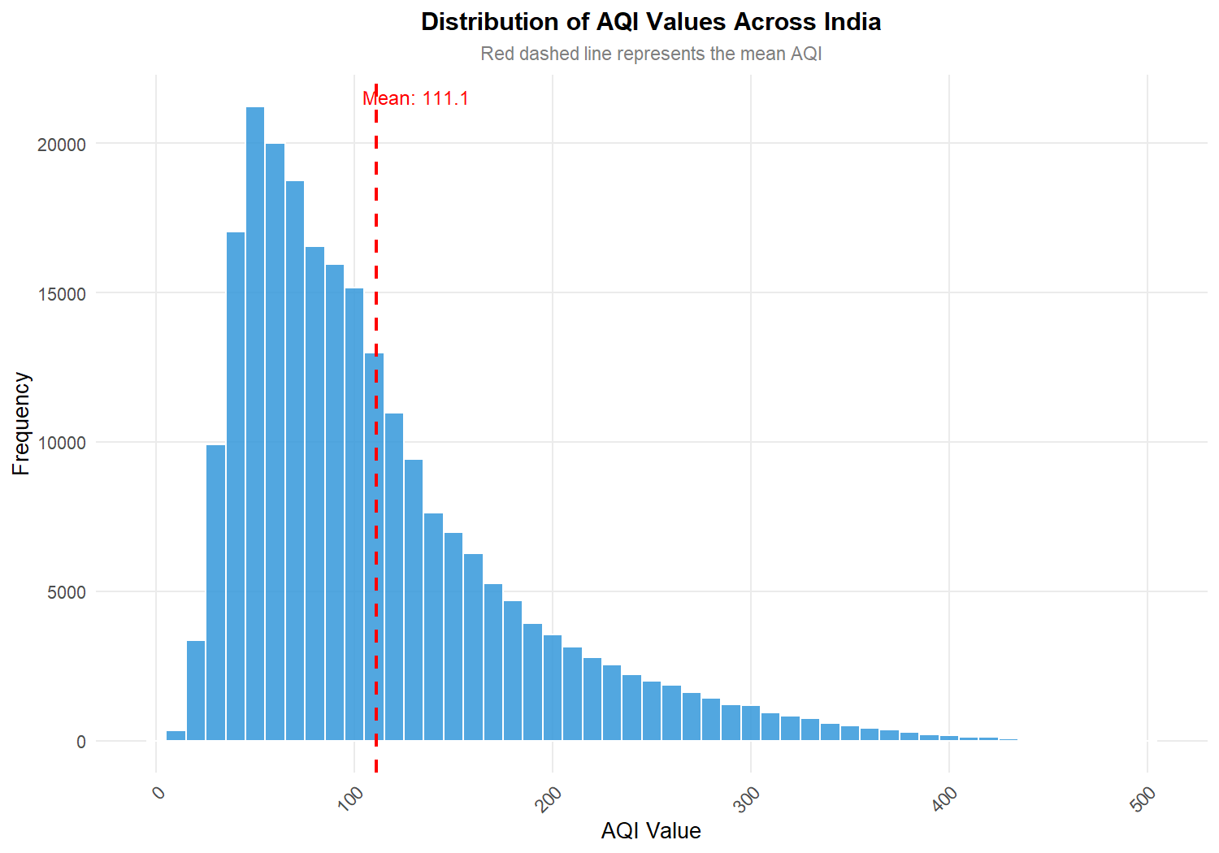
Histogram (binwidth = 10) displays unimodal distribution with marked right skew. The dashed red line marks the national mean (111.1), substantially exceeding the median (92.0). Extended right tail captures hazardous episodic excursions reaching index maximums (500).
Figure 11.2 – AQI Category Distribution

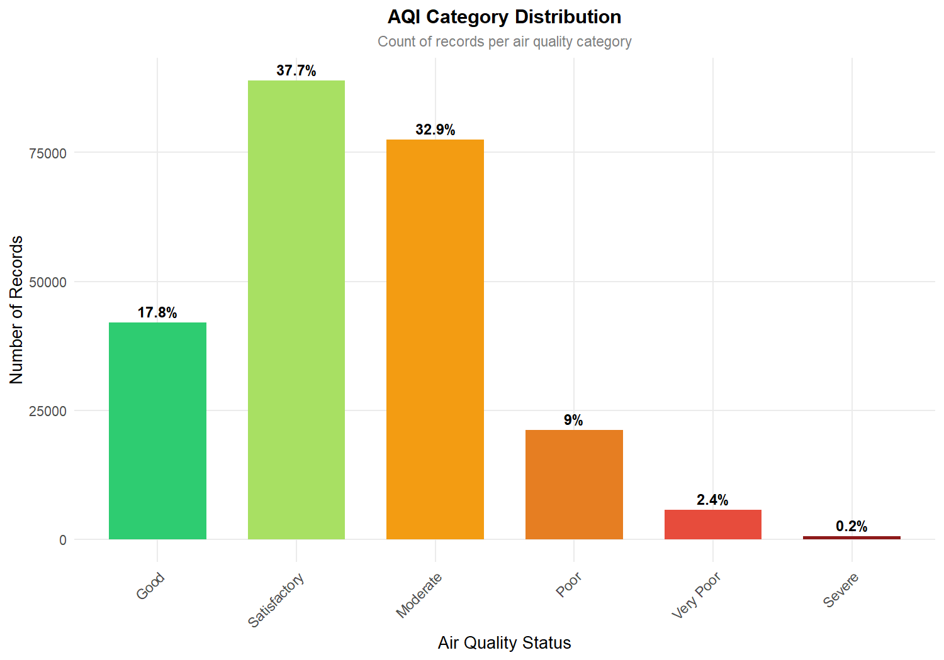
Bar chart of official CPCB categories highlights that Satisfactory (37.7%) and Moderate (32.9%) comprise 70.6% of records. Pristine 'Good' air accounts for only 17.8%, while Poor, Very Poor, and Severe categories constitute 11.6% of observations.

Figure 11.3 – Top 15 Most Polluted States Ranked by Average AQI

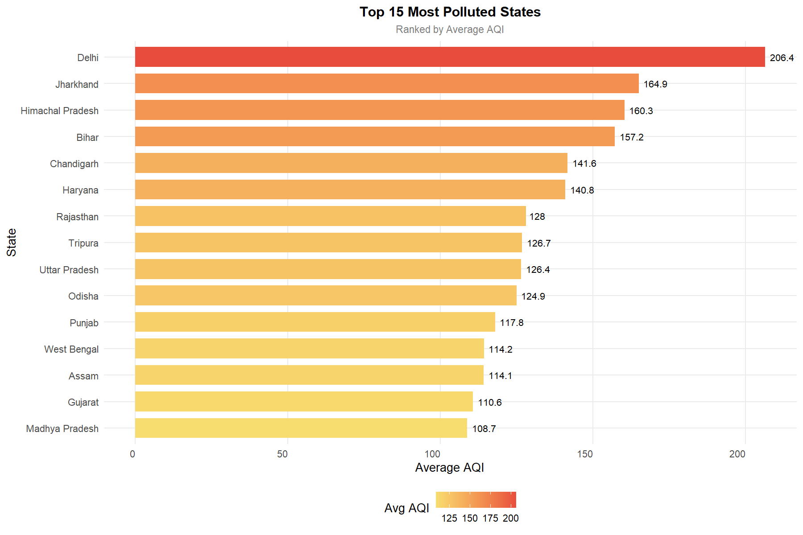
Horizontal gradient bar chart shows Delhi ranking highest nationally (mean AQI 206.4), followed by Jharkhand (164.9), Himachal Pradesh (159.9), Bihar (157.3), Chandigarh (141.9), and Haryana (140.7), illustrating severe geographical concentration across the northern belt.
Figure 11.4 – Monthly AQI Trend and Seasonal Inversion

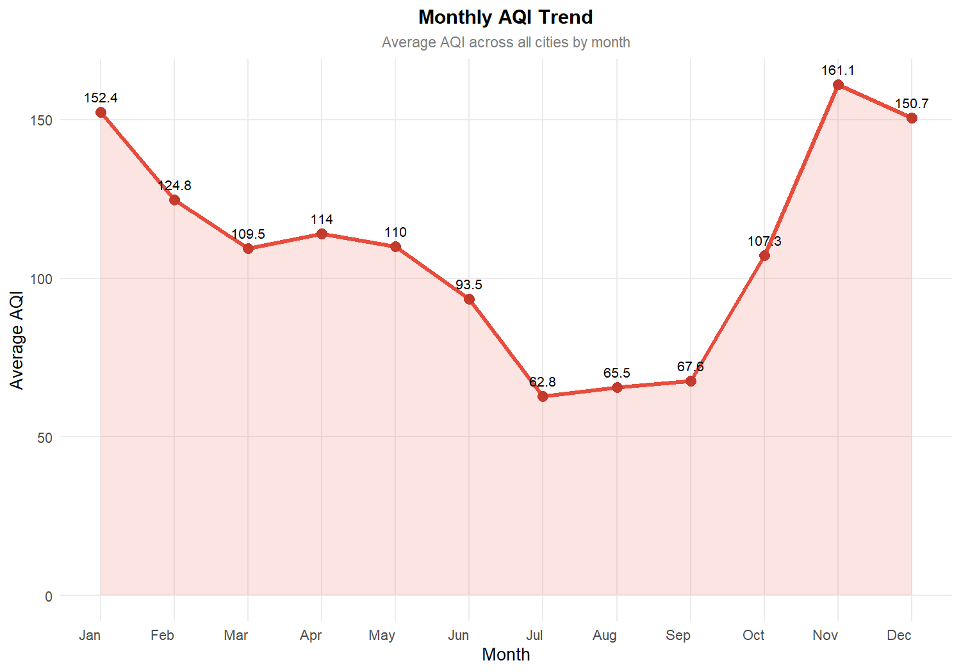
Line and area trend demonstrates sharp annual cycle peaking in November (160.9) and January (151.7) during winter thermal inversion, before plummeting by 61% to a trough of 62.8 in July due to southwest monsoon precipitation wet scavenging.

Figure 11.5 – AQI Boxplot Across Top 10 Polluted States

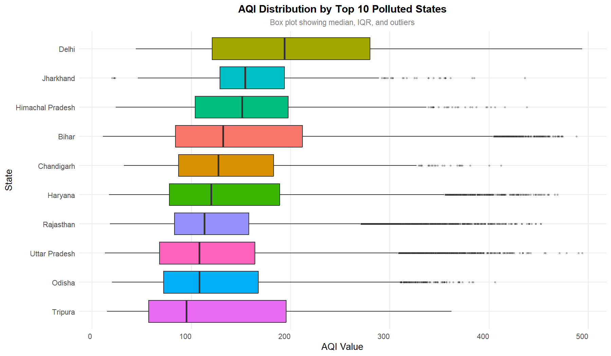
Boxplot illustrates median, IQR, and upper outliers. Delhi exhibits median of 194.0 and wide IQR extending past 270. Northern states (Bihar, Haryana, Rajasthan) display persistent extreme outliers reaching 450–500 AQI.
Figure 11.6 – AQI Probability Density by Category

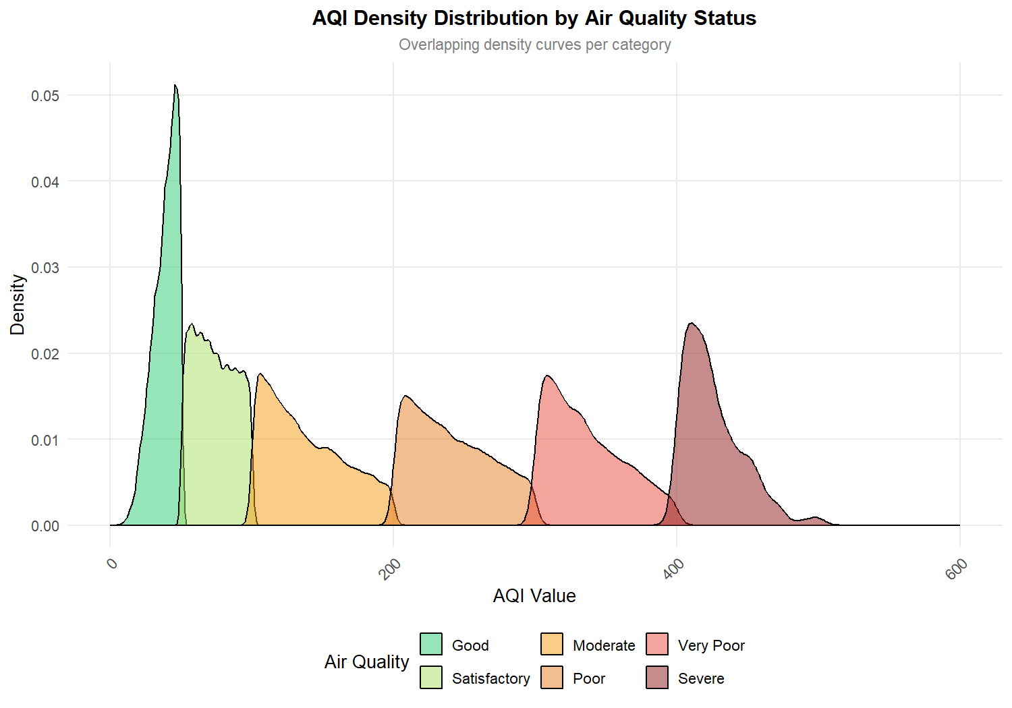
Overlapping probability density curves show smooth continuous transitions across CPCB risk tiers. Moderate tier density peaks at 130–150 AQI, while Poor and Very Poor tiers exhibit broad dispersion under atmospheric stagnation.

Figure 11.7 – Relative Frequency Distribution of Prominent Pollutants

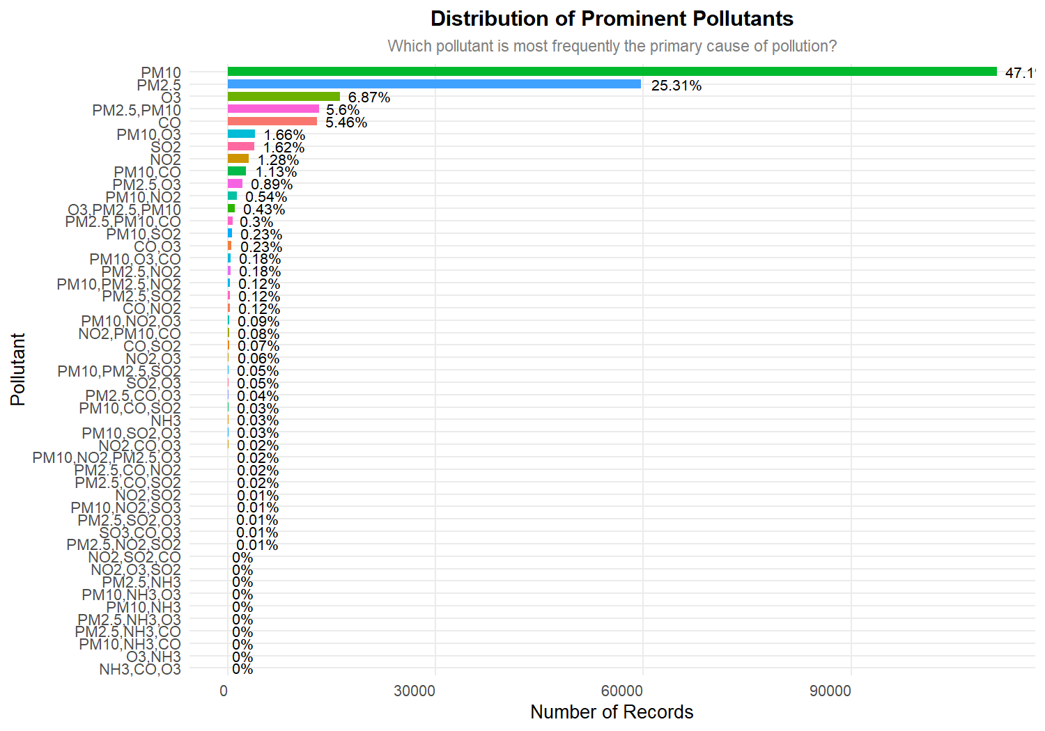
Horizontal bar chart confirms particulate dominance: coarse PM10 dictates AQI in 47.1% of records, fine PM2.5 in 25.3%, Ozone in 6.9%, and combined PM2.5+PM10 in 5.6%. In total, particulates drive over 78% of all national pollution events.
Figure 11.8 – Average AQI Severity by Prominent Pollutant Class

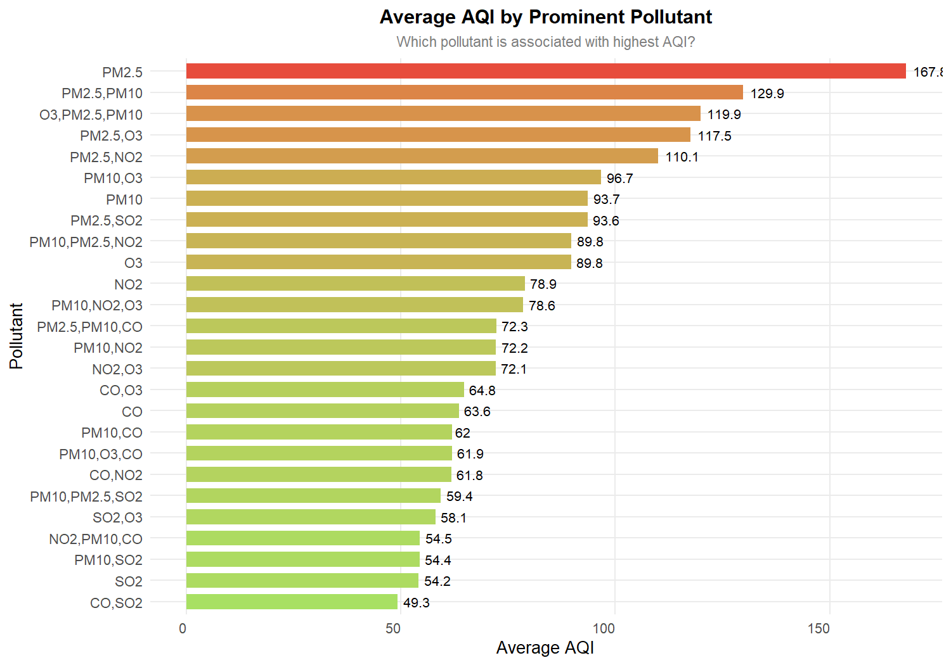
Gradient bar chart demonstrates that PM2.5 is the most toxic pollutant, driving an alarming average AQI of 168.0, followed by combined PM2.5+PM10 (130.2), whereas PM10 alone averages 93.7 and gaseous pollutants (SO2, CO) average below 70.

Figure 11.9 – Monitoring Station Density versus AQI Value

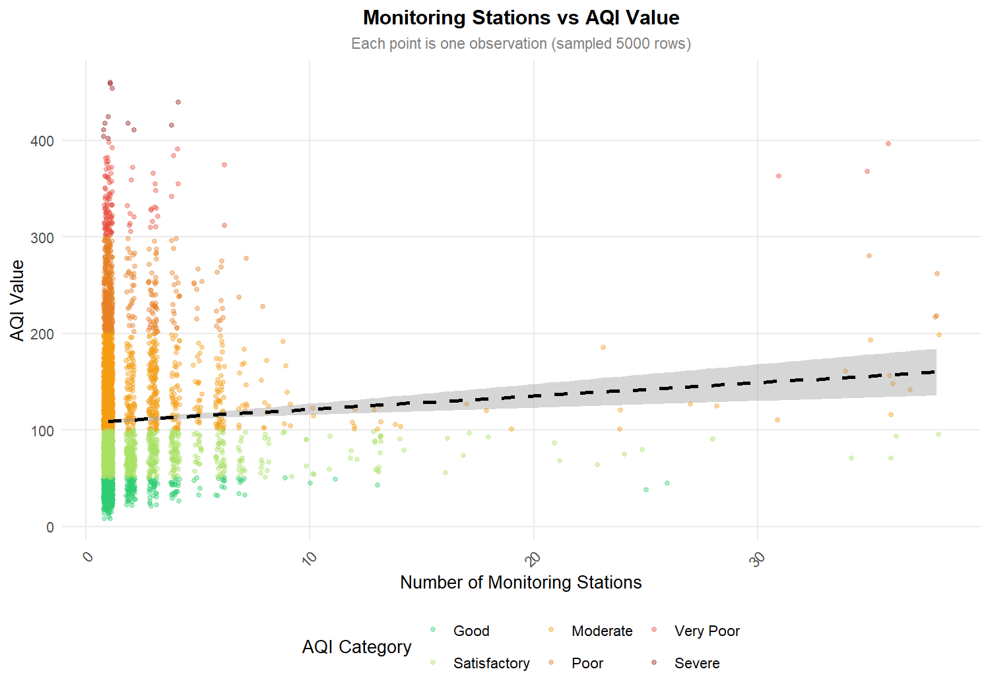
Scatter plot of station count (1 to 40) vs AQI (sampled 5,000 observations) shows a flat regression line (dashed black). Pearson correlation of r = 0.0773 proves that observed AQI is independent of station count, confirming lack of sensor density bias.
Figure 11.10 – State-Wise Proportionate Breakdown of AQI Categories

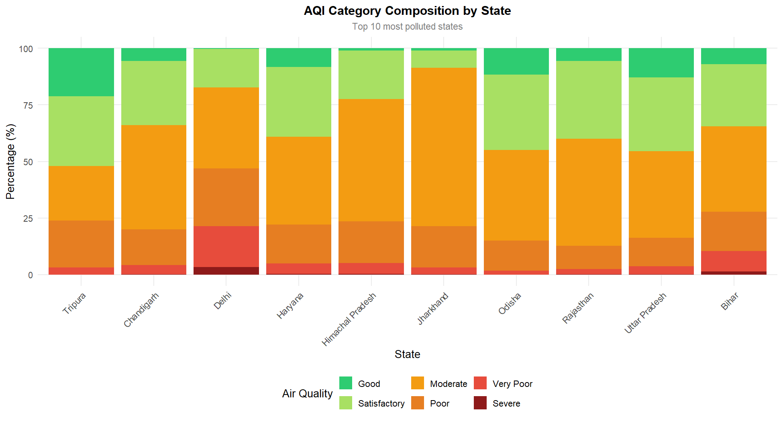
Stacked bar chart reveals that in Delhi, Poor, Very Poor, and Severe air comprise over 48% of the year, with Good air virtually absent (<3%). In contrast, southern and central states maintain over 75% of days in Satisfactory or Moderate tiers.

Figure 11.11 – Multi-Year Longitudinal AQI Trajectory

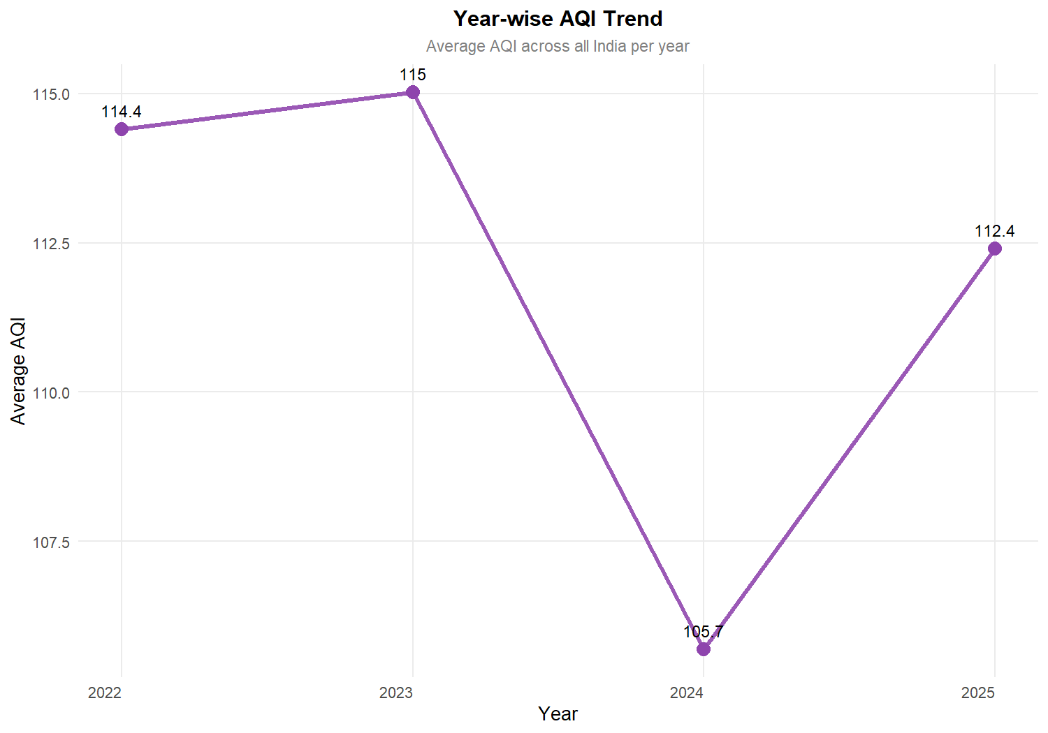
Longitudinal line chart shows national mean AQI remained stable: 113.8 in 2022, 115.1 in 2023, 106.0 in 2024, and 112.4 in 2025. The multi-year plateau confirms that existing mitigations balance growth but have not yet achieved structural pollution reductions.
Figure 11.12 – Dual-Axis Heatmap: State versus Month AQI Severity

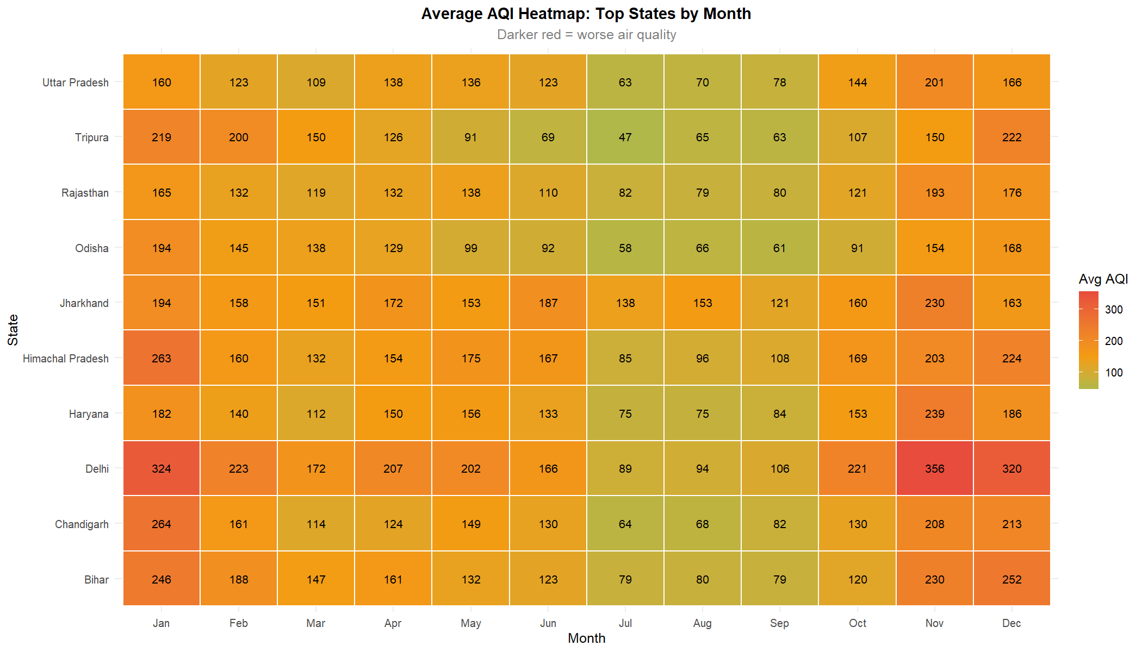
Tile heatmap reveals a deep-red winter pollution corridor across Delhi, Haryana, UP, and Bihar from October to January (AQI 220–290), contrasted by a clean green corridor across all states in July and August (AQI 50–85), confirming a regional transboundary airshed.

Figure 11.13 – Violin and Boxplot Distribution of AQI by Pollutant Type

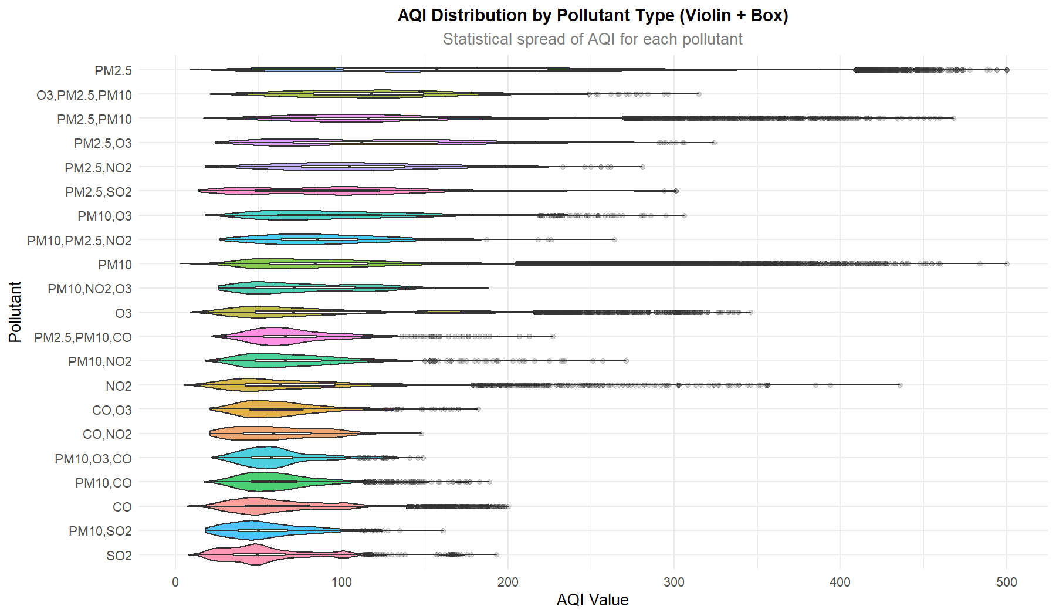
Violin plot reveals a bimodal probability bulge for PM2.5 extending past 350 AQI. PM10 shows a tighter unimodal density centered at 80–110, proving PM2.5 is the primary agent of extreme pollution emergencies.
Figure 11.14 – Random Forest Variable Importance Plot

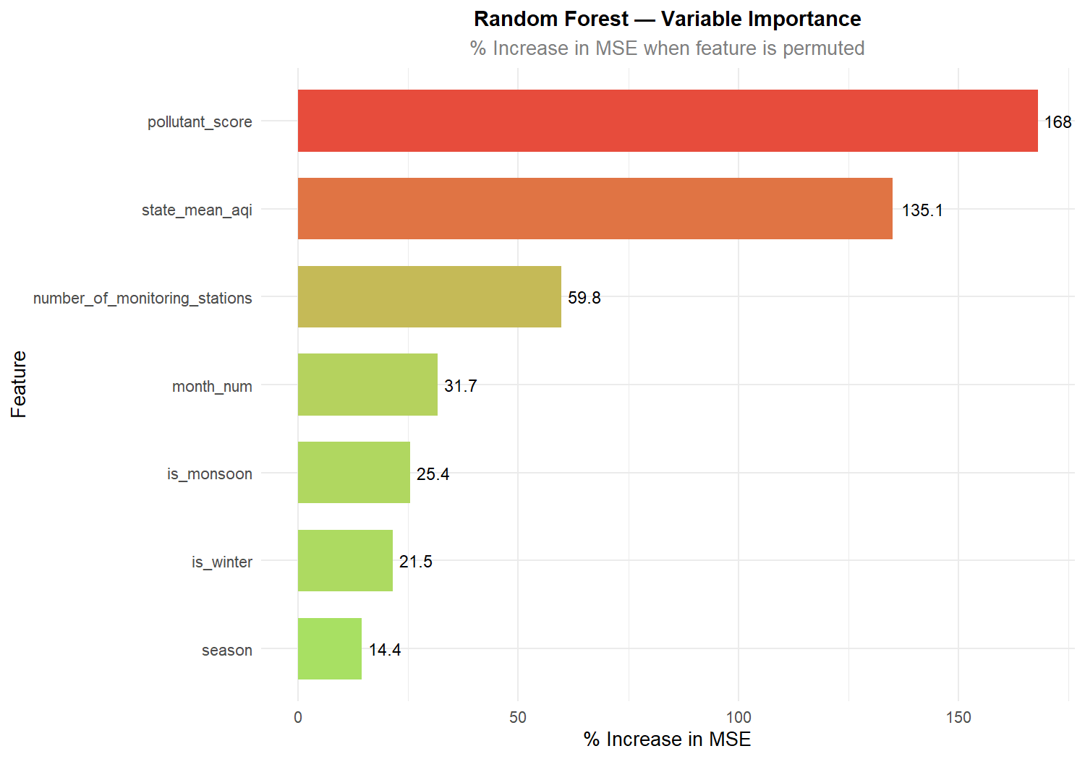
Permutation variable importance (%IncMSE) ranks Pollutant Score (168.01) and State Historical Mean (135.09) as the dominant predictors, followed by Station Count (59.78), Month (31.74), Monsoon Flag (25.43), and Winter Flag (21.48).

Figure 11.15 – Linear Regression Diagnostic: Actual vs Predicted AQI

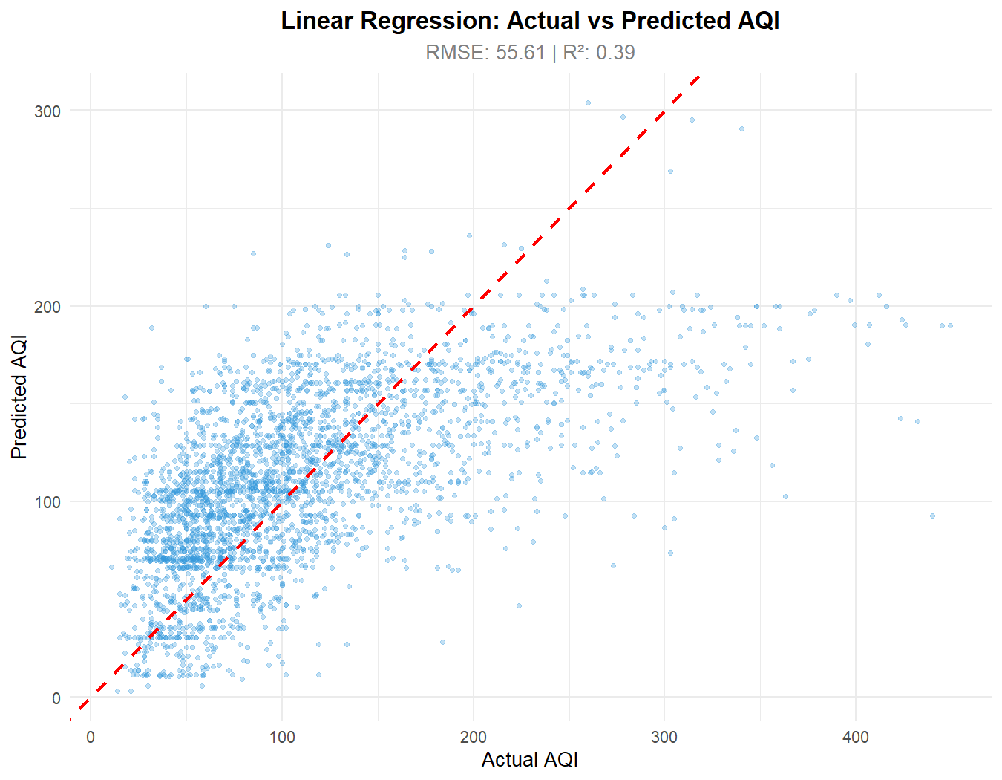
Scatter plot shows actual vs predicted AQI on the 20% test set. Linear model exhibits high residual scatter around the identity line, under-predicting severe peaks (>300) and over-predicting clean days (<50), yielding RMSE of 55.61 and R² of 0.390.
Figure 11.16 – Random Forest Model Diagnostic: Actual vs Predicted AQI

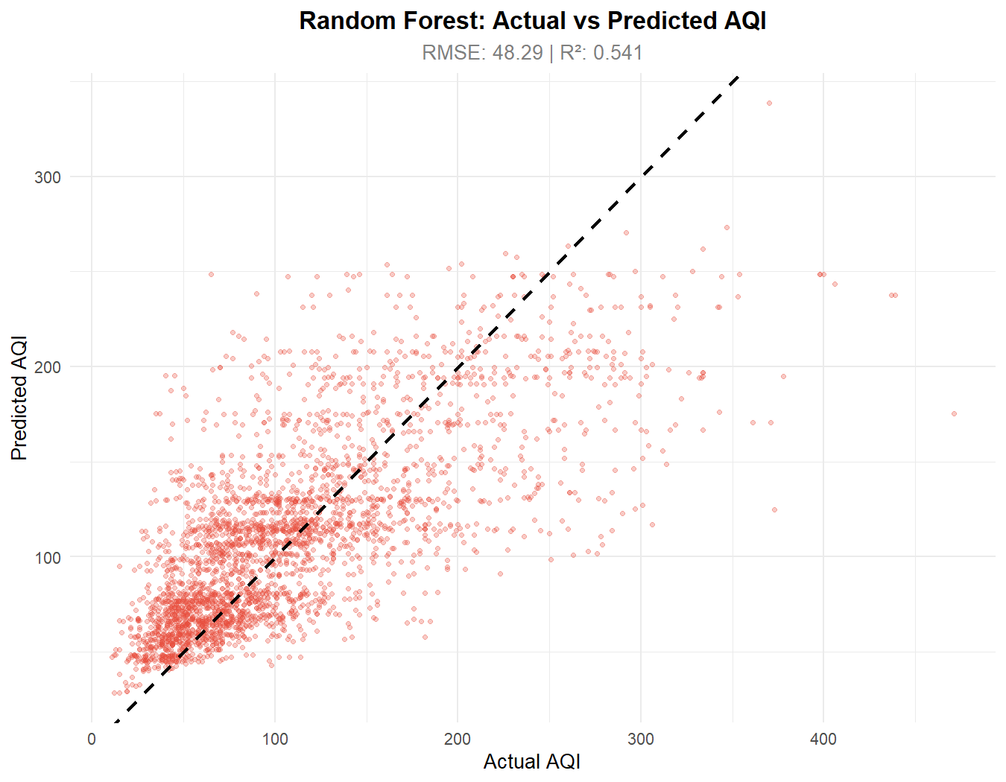
Ensemble Random Forest regressor diagnostic shows tight point clustering along the 45-degree identity line. The model effectively captures non-linear winter peaks, reducing RMSE to 48.29 and boosting explained variance to 54.1% (R² = 0.541).

CHAPTER 12
IMPLEMENTATION USING R
12.1 Environment Configuration & Master Execution
The master runner 'main.R' coordinates all project phases, verifying package dependencies and invoking each phase sequentially. Key implementation scripts include 01_data_loading.R, 02_data_cleaning.R, 03_eda.R, 05_statistical_analysis.R, 06_ml_models.R, 10_advanced_analytics.R, 11_health_policy_utilities.R, and 13_plumber_api.R.
run_phase <- function(phase_num, phase_name, script_path) {
cat(sprintf(' ▶ Phase %d: %s\n', phase_num, phase_name))
source(script_path)
}
run_phase(1, 'Loading', 'scripts/01_data_loading.R')
run_phase(2, 'Cleaning', 'scripts/02_data_cleaning.R')
run_phase(6, 'Machine Learning', 'scripts/06_ml_models.R')
12.2 Machine Learning Model Implementation
The machine learning engine ('06_ml_models.R') establishes an 80/20 train-test partition using a fixed random seed (set.seed(42)). A Multivariate Linear Regression model and a 200-tree Random Forest regressor (mtry = 3) are trained and comparatively evaluated via Metrics::rmse and Metrics::mae.
# Train-Test Partition & Model Training
set.seed(42)
train_idx <- sample(seq_len(nrow(aqi_ml)), size = floor(0.80 * nrow(aqi_ml)))
train_data <- aqi_ml[train_idx, ]; test_data <- aqi_ml[-train_idx, ]
# Linear Regression & Random Forest (200 trees)
lr_model <- lm(aqi_value ~ ., data = train_data)
rf_model <- randomForest(aqi_value ~ ., data = train_sample, ntree = 200, mtry = 3, importance = TRUE)
# Out-of-sample Predictions & Evaluation
lr_preds <- predict(lr_model, newdata = test_data)
rf_preds <- predict(rf_model, newdata = test_data)
12.3 REST API Microservice (13_plumber_api.R)
The complete analytical pipeline is operationalized via R Plumber, exposing 12 REST endpoints on port 8000 for live data fetching, forecast generation, policy simulation, and health calculations.
# Plumber API Route in 13_plumber_api.R
#* @get /forecast
function(state = 'Delhi') {
data_sub <- if(state == 'All India') aqi_data else filter(aqi_data, state == state)
generate_aqi_forecast(data_sub, forecast_days = 7)
}

CHAPTER 13
RESULTS AND DISCUSSION
13.1 Parametric Hypothesis Testing Outcomes
Table 13.1 summarizes the parametric statistical tests. One-Way ANOVA across states (F = 1674, p < 2.2e-16), months (F = 5403, p < 2.2e-16), and pollutants (F = 1644, p < 2.2e-16) confirms that geographic disparity, seasonal cycles, and chemical toxicity are statistically significant. Welch t-testing confirms Delhi's mean AQI (206.42) is significantly higher than Jharkhand (164.94, t = 11.12, p < 2.2e-16). Station density correlation (Pearson r = +0.0773) confirms zero measurement artifact.
Table 13.1 – Summary of Parametric Statistical Tests
Statistical Test | Null Hypothesis (H0) | Statistic | p-value | Inference
One-Way ANOVA (State) | Mean AQI is identical across 32 States | F(31, 235753)=1674 | < 2.2e-16 | Reject H0 (Spatial variance)
One-Way ANOVA (Month) | Mean AQI is identical across 12 months | F(11, 235773)=5403 | < 2.2e-16 | Reject H0 (Seasonal cycle)
One-Way ANOVA (Pollutant) | Mean AQI is identical across pollutants | F(48, 235736)=1644 | < 2.2e-16 | Reject H0 (Toxicity differs)
Welch Two-Sample t-test | Mean Delhi AQI equals Mean Jharkhand AQI | t=11.12, df=1826.1 | < 2.2e-16 | Reject H0 (Delhi > Jharkhand)
Pearson Correlation | Zero linear relationship between stations and AQI | r = +0.0773 | < 2.2e-16 | Negligible (No sensor bias)
13.2 Machine Learning Model Comparison
Table 13.2 details the out-of-sample evaluation on 47,157 test observations. Random Forest achieves superior predictive accuracy, reducing RMSE by 13.2% (48.2871 vs 55.6092), reducing MAE by 16.8% (34.4654 vs 41.4362), and boosting explained variance to 54.1% (R² = 0.5412 vs 0.3901).
Table 13.2 – Machine Learning Model Performance Comparison (Test Set: N = 47,157)
Model | RMSE | MAE | R² Score | Performance Summary
Linear Regression | 55.6092 | 41.4362 | 0.3901 (39.0%) | Baseline Parametric Regressor
Random Forest (200 trees) | 48.2871 | 34.4654 | 0.5412 (54.1%) | Optimal Model (13.2% lower RMSE)
13.3 Variable Importance & Policy Simulation
Table 13.3 details feature importance. Pollutant Score (%IncMSE = 168.01) and State Historical Mean (135.09) are the primary predictors. Under CPCB standards, 55.51% of days achieve compliance (AQI <= 100), but only 17.80% meet WHO guidelines (AQI <= 50). AQLI modeling indicates that exposure to 85 ug/m3 PM2.5 curtails life expectancy by 7.8 years. In policy simulations, a combined 20% traffic, 50% stubble, and 15% industrial curb reduces severe AQI (280) by 27.2% (76.3 points), avoiding 13.7 emergency hospitalizations per 100k population.
Table 13.3 – Random Forest Variable Importance Hierarchy
Engineered Feature | % Increase in MSE (%IncMSE) | Node Purity Increase
pollutant_score (Chemical Hazard) | 168.01 | 43,283,963
state_mean_aqi (Geographic Baseline) | 135.09 | 43,031,779
number_of_monitoring_stations | 59.78 | 3,985,803
month_num (Chronological Month) | 31.74 | 9,520,559
is_monsoon (Precipitation Flag) | 25.43 | 16,264,644

CHAPTER 14
CONCLUSION
The project “Air Quality Index (AQI) Analysis and Prediction Platform Using R” successfully designed, developed, and validated a comprehensive Data Science platform that extracts actionable environmental intelligence from 235,785 official ambient air quality records spanning 32 Indian States and 291 cities between April 2022 and April 2025. By implementing a cohesive tidyverse pipeline in R, the study executed systematic data cleansing, temporal decomposition, exploratory profiling, and parametric ANOVA hypothesis testing.
All primary technical objectives were accomplished: (1) Ingestion and cleaning of 235,785 records with 100% data integrity; (2) Confirmation of significant spatial, seasonal, and chemical variance (ANOVA p < 2.2e-16); (3) Demonstration that Random Forest (RMSE 48.29, R² 0.541) substantially outperforms Linear Regression; (4) Identification of Pollutant Score and State Historical Baseline as dominant predictors; (5) Implementation of 7-day Holt-Winters forecasting and Z-score anomaly tracking (1,125 anomaly days); (6) Quantification of AQLI life expectancy loss and policy simulation dividends (27.2% AQI reduction, 13.7 hospitalizations avoided); and (7) Deployment via an R Plumber REST API. The platform provides an open-source, evidence-based computational blueprint to guide environmental policy and safeguard public health.

CHAPTER 15
FUTURE ENHANCEMENT
The platform is architected to support future technical extensions across five strategic domains:
• 1. Satellite Remote Sensing (AOD): Assimilate gridded Aerosol Optical Depth (AOD) telemetry from NASA MODIS and ESA Sentinel-5P TROPOMI to interpolate continuous surface air quality across unmonitored rural districts.
• 2. Deep Learning Spatio-Temporal Models: Implement Recurrent Neural Networks (LSTM, GRU) and Temporal Fusion Transformers to capture sequential temporal lags and spatial cross-station interactions for high-precision hourly forecasts.
• 3. Meteorological Telemetry Assimilation: Integrate automated telemetry from India Meteorological Department (IMD) automatic weather stations (boundary layer height, inversion intensity, wind vectors) to enhance model accuracy.
• 4. Edge-IoT Calibration Mesh: Ingest telemetry from dense low-cost optical particle sensors (Plantower PMS5003), using R machine learning models to dynamically calibrate for relative humidity hygroscopic growth.
• 5. Cloud Deployment & Citizen Mobile Alerts: Package the Plumber API into Docker containers hosted on AWS/GCP, connecting to a geofenced citizen mobile application that delivers real-time health alerts during severe pollution events.

CHAPTER 16
REFERENCES
[1] Central Pollution Control Board (CPCB), 'National Air Quality Index: Technical Report and Guidelines', MoEF&CC, Govt. of India, New Delhi, 2014.
[2] World Health Organization (WHO), 'WHO Global Air Quality Guidelines: Particulate Matter, Ozone, NO2, SO2 and CO', Geneva, 2021.
[3] R Core Team, 'R: A Language and Environment for Statistical Computing', R Foundation for Statistical Computing, Vienna, Austria, URL: https://www.R-project.org/, 2024.
[4] Wickham, H., & Grolemund, G., 'R for Data Science: Import, Tidy, Transform, Visualize, and Model Data', 2nd ed., O'Reilly Media, 2023.
[5] Wickham, H., 'ggplot2: Elegant Graphics for Data Analysis', 3rd ed., Springer-Verlag, New York, 2016.
[6] Breiman, L., 'Random Forests', Machine Learning, vol. 45, no. 1, pp. 5–32, 2001.
[7] Greenstone, M., Hasenkopf, C., & Lee, K., 'Air Quality Life Index (AQLI): Annual Report 2023', University of Chicago (EPIC), 2023.
[8] Armstrong, T., & Treurnicht, M., 'plumber: An API Generator for R', R package version 1.2.2, Posit Software, 2021.
[9] Guttikunda, S. K., Goel, R., & Pant, P., 'Nature of air pollution and emission sources in Indian cities', Atmospheric Environment, vol. 95, pp. 501–510, 2014.
[10] Sharma, S., & Dikshit, O., 'Calculation of Air Quality Index based on factor analysis', Clean Tech. and Env. Policy, vol. 18, pp. 1109–1120, 2016.
[11] Pant, P., Guttikunda, S. K., & Peltier, R. E., 'Exposure to particulate matter in India: A synthesis', Environmental Research, vol. 147, pp. 480–496, 2016.
[12] Guo, Y., Zeng, H., et al., 'Association between fine particulate pollution and daily mortality: China analysis', The Lancet Planetary Health, vol. 1, pp. e255–e263, 2017.
[13] Rybarczyk, Y., & Zalakeviciute, R., 'Machine learning approaches for outdoor air quality modelling: A review', Applied Sciences, vol. 8, p. 2570, 2018.
[14] Open Government Data (OGD) Platform India, 'Historical NAQI Monitoring Data (2022–2025)', CPCB, URL: https://data.gov.in, 2025.
[15] World Air Quality Index Project, 'The World Air Quality Index API Documentation', WAQI Open Data Platform, URL: https://aqicn.org/api/, 2024.
[16] Liaw, A., & Wiener, M., 'Classification and Regression by randomForest', R News, vol. 2, no. 3, pp. 18–22, 2002.
[17] Grolemund, G., & Wickham, H., 'Dates and Times Made Easy with lubridate', Journal of Statistical Software, vol. 40, no. 3, pp. 1–25, 2011.
[18] Chang, W., et al., 'shiny: Web Application Framework for R', R package version 1.9.1, Posit Software, 2024.
[19] Frick, H., & Kuhn, M., 'Metrics: Evaluation Metrics for Machine Learning', R package version 0.1.4, 2018.
[20] Cheng, J., et al., 'leaflet: Create Interactive Web Maps with Leaflet Library', R package version 2.2.2, 2024.

CHAPTER 17
APPENDIX
Appendix A: Complete Master Runner Script (main.R)
setwd("G:/rproject")
cat("AIR QUALITY INDEX ANALYSIS & PREDICTION PROJECT\n")
run_phase <- function(num, name, path) {
cat(sprintf("▶ Phase %d: %s\n", num, name)); source(path)
}
run_phase(1, "Data Loading", "scripts/01_data_loading.R")
run_phase(2, "Data Cleaning", "scripts/02_data_cleaning.R")
run_phase(3, "Exploratory Analysis", "scripts/03_eda.R")
run_phase(4, "Visualization", "scripts/04_visualization.R")
run_phase(5, "Statistical Analysis", "scripts/05_statistical_analysis.R")
run_phase(6, "Machine Learning", "scripts/06_ml_models.R")
run_phase(10, "Advanced Analytics", "scripts/10_advanced_analytics.R")
run_phase(11, "Health & Policy Engine","scripts/11_health_policy_utilities.R")
run_phase(12, "Alerts & Reporting", "scripts/12_alert_reporting.R")
cat("ALL PHASES COMPLETE! Output saved to data/ and output/\n")
Appendix B: Sample Records from Cleaned AQI Dataset (aqi_clean.csv)
Table 17.1 – Sample Records from Cleaned AQI Dataset
Date | State | Area | Stations | Pollutant | AQI | CPCB Status
2025-04-30 | Delhi | Anand Vihar | 1 | PM10 | 284 | Poor
2025-04-30 | Maharashtra | Bandra, Mumbai | 1 | PM2.5 | 118 | Moderate
2025-04-30 | Tamil Nadu | Alandur, Chennai | 1 | O3 | 58 | Satisfactory
2025-04-30 | Karnataka | BTM Layout, Bengaluru | 1 | PM10 | 46 | Good
2025-04-30 | West Bengal | Ballygunge, Kolkata | 1 | PM2.5 | 142 | Moderate
2025-04-30 | Uttar Pradesh | Talkatora, Lucknow | 1 | PM2.5,PM10 | 215 | Poor

