- Open the project folder click the address bar type cmd
- Type pip install django
- Type pip install pillow
- Type pip install mysqlclient
- Open the project folder open the folder Gokulnath. Now next open the file settings.py scroll down till you find database function in the settings.py. The name database can be at the line 81
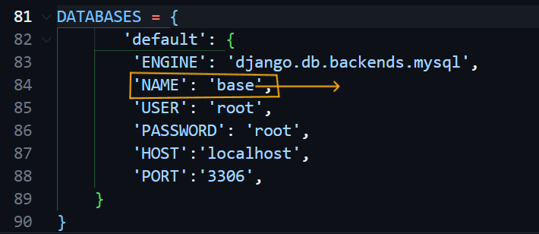
Change only this name
- Change the NAME inside the default function. Change the NAME as your wise.
- Now create same database name in your MySQL command line what you have given in the settings.py file.

- Now open the same cmd file how you opened in above line
- Type python manage.py makemigrations
- Type python manage.py migrate
- This is the last step how to run the project file. Follow the command in below
- In same cmd file type python manage.py runserver
- The above command by running will give the demo URL you can copy the URL from the cmd and past it in the web browser or after running the server copy this URL and past it in the web browser http://127.0.0.1:8000/
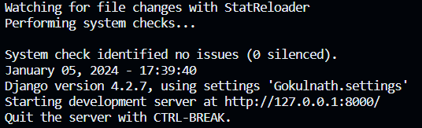

Demo URL

