Ethernet Shield :

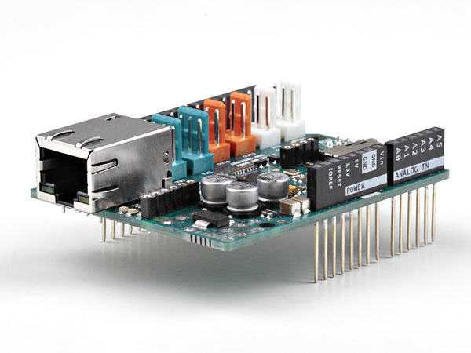
The Ethernet Shield is a retired product. The Arduino Ethernet Shield 2 is available to buy .

Connection to Ethernet Shield:
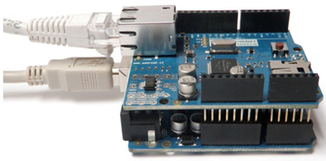

Description:
The Arduino Ethernet Shield 2 allows an Arduino board to connect to the internet using the Ethernet library and to read and write an SD card using the SD library. This shield is fully compatible with the former version but relies on the newer W5500 chip.
To use the shield, mount it on top of an Arduino board (e.g. the Uno). To upload sketches to the board, connect it to your computer with a USB cable as you normally would. Once the sketch has been uploaded, you can disconnect the board from your computer and power it with an external power supply.
Connect the shield to your computer or a network hub or router using a standard ethernet cable (CAT5 or CAT6 with RJ45 connectors). Connecting to a computer may require the use of a cross-over cable (although many computers, including all recent Macs can do the cross-over internally).

Cross-Over Vs Straight Forward Cables :
|-->T568A And T568B Wiring Standard Basis :
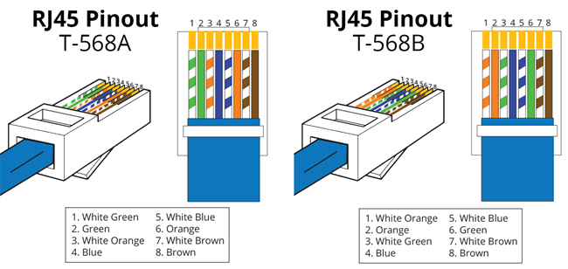
A RJ45 connector is a modular 8 position, 8 pin connector used for terminating Cat5e patch cable or Cat6 cable. A pinout is a specific arrangement of wires that dictate how the connector is terminated. There are two standards recognized by ANSI, TIA and EIA for wiring Ethernet cables. The first is the T568A wiring standard and the second is T568B. T568B has surpassed 568A and is seen as the default wiring scheme for twisted pair structured cabling. If you are unsure of which to use, choose 568B.
|--> What Is Straight Through Cable?
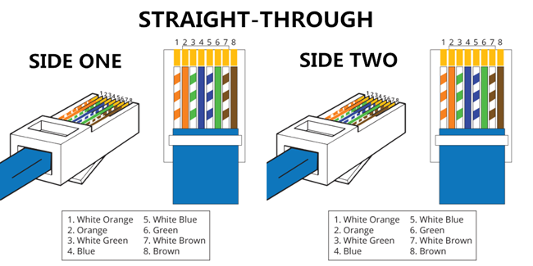
A straight through cable is a type of twisted pair cable that is used in local area networks to connect a computer to a network hub such as a router. This type of cable is also sometimes called a patch cable and is an alternative to wireless connections where one or more computers access a router through a wireless signal. On a straight through cable, the wired pins match. Straight through cable use one wiring standard: both ends use T568A wiring standard or both ends use T568B wiring standard. The following figure shows a straight through cable of which both ends are wired as the T568B standard.

|-->What Is Crossover Cable?
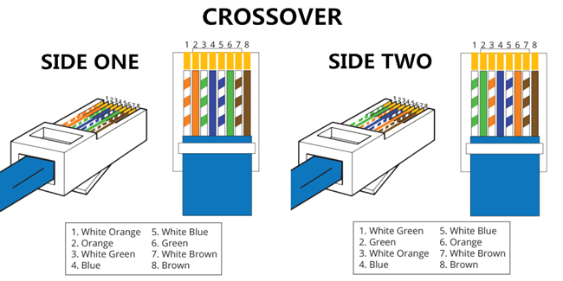
A crossover Ethernet cable is a type of Ethernet cable used to connect computing devices together directly. Unlike straight through cable, the RJ45 crossover cable uses two different wiring standards: one end uses the T568A wiring standard, and the other end uses the T568B wiring standard. The internal wiring of Ethernet crossover cables reverses the transmit and receive signals. It is most often used to connect two devices of the same type: e.g. two computers (via network interface controller) or two switches to each other.

Network Settings
The shield must be assigned a MAC address and a fixed IP address using the Ethernet.begin() function. A MAC address is a globally unique identifier for a particular device. Current Ethernet shields come with a sticker indicating the MAC address you should use with them. For older shields without a dedicated MAC address, inventing a random one should work, but don't use the same one for multiple boards. Valid IP addresses depend on the configuration of your network. It is possible to use DHCP to dynamically assign an IP to the shield. Optionally, you can also specify a network gateway and subnet.

SD Card
The latest revision of the Ethernet Shield includes a micro-SD card slot, which can be interfaced with using the SD library.
The text of the Arduino getting started guide is licensed under a Creative Commons Attribution-ShareAlike 3.0 License. Code samples in the guide are released into the public domain.

|-->SD Library

The SD library allows for reading from and writing to SD cards, e.g. on the Arduino Ethernet Shield. It is built on sdfatlib by William Greiman. The library supports FAT16 and FAT32 file systems on standard SD cards and SDHC cards. It uses short 8.3 names for files. The file names passed to the SD library functions can include paths separated by forward-slashes, /, e.g. "directory/filename.txt". Because the working directory is always the root of the SD card, a name refers to the same file whether or not it includes a leading slash (e.g. "/file.txt" is equivalent to "file.txt"). As of version 1.0, the library supports opening multiple files.
The communication between the microcontroller and the SD card uses SPI, which takes place on digital pins 11, 12, and 13 (on most Arduino boards) or 50, 51, and 52 (Arduino Mega). Additionally, another pin must be used to select the SD card. This can be the hardware SS pin - pin 10 (on most Arduino boards) or pin 53 (on the Mega) - or another pin specified in the call to SD.begin(). ote that even if you don't use the hardware SS pin, it must be left as an output or the SD library won't work.
To use this library
#include <SPI.h>
#include <SD.h>

The SD library allows for reading from and writing to SD cards, e.g. on the Arduino Ethernet Shield. It is built on sdfatlib by William Greiman. The library supports FAT16 and FAT32 file systems on standard SD cards and SDHC cards. It uses short 8.3 names for files. The file names passed to the SD library functions can include paths separated by forward-slashes, /, e.g. "directory/filename.txt". Because the working directory is always the root of the SD card, a name refers to the same file whether or not it includes a leading slash (e.g. "/file.txt" is equivalent to "file.txt"). As of version 1.0, the library supports opening multiple files.
The communication between the microcontroller and the SD card uses SPI, which takes place on digital pins 11, 12, and 13 (on most Arduino boards) or 50, 51, and 52 (Arduino Mega). Additionally, another pin must be used to select the SD card. This can be the hardware SS pin - pin 10 (on most Arduino boards) or pin 53 (on the Mega) - or another pin specified in the call to SD.begin(). Note that even if you don't use the hardware SS pin, it

Examples
- Card Info: Get info about your SD card.
- Datalogger: Log data from three analog sensors to an SD card.
- Dump File: Read a file from the SD card.
- Files: Create and destroy an SD card file.
- List Files: Print out the files in a directory on a SD card.
- Read Write: Read and write data to and from an SD card.

Using the SD library to log data

|--> Reading SD Card Information :
For the Ethernet shield, put your formatted SD card into the SD card slot (top side up, don't force it, gentle). Put your shield on your Arduino-compatible board. Power the boards with a suitable power supply recommended for the Arduino. Connect the microcontroller board to your computer with a suitable USB cable. For the Feathers, place the formatted micro-SD card into the micro-SD card slot in the Adalogger Feather. Plug the board into a USB port on your computer. Using the Arduino IDE software and select the correct type of Arduino-compatible board and the serial port for the board in the Tools menu. You may have to push the reset button for the operating system to see the serial port. Load the following sketch, compile, and run.

Using the SD library to read and write to a file on a SD card:
The code below is configured for use with an Ethernet shield, which has an onboard SD slot. In the setup(), we call SD.begin(), naming pin 4 as the CS pin. This pin varies depending on the make of shield or board you are using.
In setup(), create a new file with SD.open() named "test.txt". FILE_WRITE enables read and write access to the file, starting at the end. If a file "test.txt" was already on the card, that file would be opened.
Name the instance of the opened file "myFile".
Once opened, use myFile.println() to write a string to the card, followed by a carriage return. Once the content is written, close the file.
Again, open the file with SD.open(). Once opened, ask the Arduino to read the contents of the file with SD.read() and send them over the serial port. After all the contents of the file are read, close the file with SD.close().

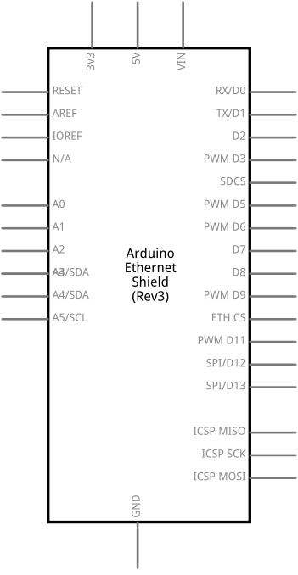

ReadWrite using SD Library
/*
SD card read/write

This example shows how to read and write data to and from an SD card file
The circuit:
* SD card attached to SPI bus as follows:
** MOSI - pin 11
** MISO - pin 12
** CLK - pin 13
** CS - pin 4

created Nov 2010
by David A. Mellis
modified 9 Apr 2012
by Tom Igoe

This example code is in the public domain.

*/

#include <SPI.h>
#include <SD.h>

File myFile;

void setup()
{
// Open serial communications and wait for port to open:
Serial.begin(9600);
while (!Serial) {
; // wait for serial port to connect. Needed for Leonardo only
}

Serial.print("Initializing SD card...");
// On the Ethernet Shield, CS is pin 4. It's set as an output by default.
// Note that even if it's not used as the CS pin, the hardware SS pin
// (10 on most Arduino boards, 53 on the Mega) must be left as an output
// or the SD library functions will not work.
pinMode(10, OUTPUT);

if (!SD.begin(4)) {
Serial.println("initialization failed!");
return;
}
Serial.println("initialization done.");

// open the file. note that only one file can be open at a time,
// so you have to close this one before opening another.
myFile = SD.open("test.txt", FILE_WRITE);

// if the file opened okay, write to it:
if (myFile) {
Serial.print("Writing to test.txt...");
myFile.println("testing 1, 2, 3.");
// close the file:
myFile.close();
Serial.println("done.");
} else {
// if the file didn't open, print an error:
Serial.println("error opening test.txt");
}

// re-open the file for reading:
myFile = SD.open("test.txt");
if (myFile) {
Serial.println("test.txt:");

// read from the file until there's nothing else in it:
while (myFile.available()) {
Serial.write(myFile.read());
}
// close the file:
myFile.close();
} else {
// if the file didn't open, print an error:
Serial.println("error opening test.txt");
}
}

void loop()
{
// nothing happens after setup
}

--> Use Our code for log data from 2 Arduino’s.

GUI – Graphical User Interface :
The graphical user interface, developed in the late 1970s by the Xerox Palo Alto research laboratory and deployed commercially in Apple’s Macintosh and Microsoft’s Windows operating systems, was designed as a response to the problem of inefficient usability in early, text-based command-line interfaces for the average user.
Graphical user interfaces would become the standard of user-centered design in software application programming, providing users the capability to intuitively operate computers and other electronic devices through the direct manipulation of graphical icons such as buttons, scroll bars, windows, tabs, menus, cursors, and the mouse pointing device. Many modern graphical user interfaces feature touchscreen and voice-command interaction capabilities.

How Does a Graphical User Interface Work?
Graphical user interface design principles conform to the model–view–controller software pattern, which separates internal representations of information from the manner in which information is presented to the user, resulting in a platform where users are shown which functions are possible rather than requiring the input of command codes. Users interact with information by manipulating visual widgets, which are designed to respond in accordance with the type of data they hold and support the actions necessary to complete the user’s task.
The appearance, or “skin,” of an operating system or application software may be redesigned at will due to the nature of graphical user interfaces being independent from application functions. Applications typically implement their own unique graphical user interface display elements in addition to graphical user interface elements already present on the existing operating system. A typical graphical user interface also includes standard formats for representing graphics and text, making it possible to share data between applications running under common graphical user interface design software.
Graphical user interface testing refers to the systematic process of generating test cases in order to evaluate the functionality of the system and its design elements. Graphical user interface testing tools, which are either manual or automated and typically implemented by third-party operators, are available under a variety of licenses and are supported by a variety of platforms. Popular examples include: Tricentis Tosca, Squish GUI Tester, Unified Functional Testing (UFT), Maveryx, Appium, and eggPlant Functional.

Graphical User Interface Examples
Sketchpad, believed to be the first graphical computer-aided design program, was developed in 1962 by Ivan Sutherland while he was at MIT, and consisted of a light pen that enabled users to create and manipulate objects in engineering drawings in real time with coordinated graphics.
Modern operating systems and graphical user interfaces are incorporated into nearly every interactive application, such as ATMs, self-service checkouts, airline self-ticketing and check-in, video games, smartphones, and desktops. Some popular, modern graphical user interface examples include Microsoft Windows, macOS, Ubuntu Unity, and GNOME Shell for desktop environments, and Android, Apple's iOS, BlackBerry OS, Windows 10 Mobile, Palm OS-WebOS, and Firefox OS for smartphones.
Advantages of Graphical User Interfaces
The advantage of a graphical user interface is a stark improvement in useability for the average person. The features of a graphical user interface leverage familiar metaphors, such as drag-and-drop for transferring files, and use familiar icons, such as a trash bin for deleted files, creating an environment in which computer operations are intuitive and easily mastered without any prior practice or knowledge of computing machinery or languages. Graphical user interface applications are self descriptive, feedback is typically immediate, and visual cues encourage and steer discoverability.
Best Programming Language for Graphical User Interfaces
While there are several different visual programming languages with their own unique advantages for the development of a graphical user interface design, C# or Java may be considered preferable options due to their ability to run GUIs simultaneously in a browser and as a desktop application. Other options include Python, HTML5/Javascript, and C/C++.

Difference Between Character User Interface and Graphical User Interface

Character user interface, also known as command-line user interface or non graphical user interface, refers to the use of text commands, managed by a command-line interpreter, in order to communicate with a computer program. Typically software developers and system administrators rely on command-line interfaces to configure machines, manage computer files, and access program features that are otherwise unavailable on a graphical user interface.
Character user interfaces support automation and scripting and tend to provide greater granular control and a higher level of functionality than graphical user interfaces. While the character user interface was the primary method of operating computers through the 1980s, most modern electronic devices are equipped with intuitive graphical user interfaces and the average user will rarely if ever have cause to access a computer terminal.
Difference Between Web User Interface and Graphical User Interface
A web user interface, or web-based graphical user interface, refers to the interaction between a user and software running on a web server wherein the user interface is the web browser and the web page it downloaded and rendered. Technologies such as Flash, Java, JavaScript, and Silverlight enable interactions such as drag-and-drop, playing audio, drawing on the screen, and access to the keyboard and mouse.
Web graphical user interfaces are platform independent, require no installation or separate software development, easy to update and monitor due to the nature of not being dependent upon the user to deploy updates, provides a vibrant UI experience, and are low cost, requiring only Ethernet or WiFi interface connectivity.

How Does GUI Work?
The uses of a pointer that serves as navigation to interact with different visually appealing Graphical icons. Abstraction is a major concept that has been used in a GUI operating system. Users can use the pointer to click on the icon which initiates a series of actions. Normally an application or functionality will get started. Then the user will have to provide input or tasks to generate the desired action from the machine. The GUI actually translates user language which comprises simple one-line commands, single click and double clicks to machine language or assembly language. Machine language is understood by the machine and hence the machine responds to the task initiated which is translated to use language and communicated to the user via GUI.

How Does the User Interact with GUI?
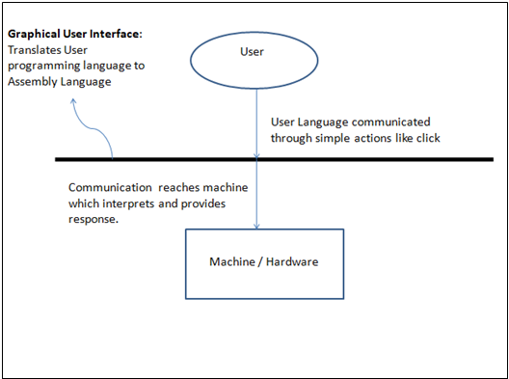

Why Do We Need GUI?
1. One could practically start using a computer using GUI.
2. But, one could actually start to learn and unravel several kinds of options present in the computer.
3. Also, one could also start understanding the computer and its language and get interested in it so much that the person himself could learn or even create a programming language that makes computers and its products even simpler to work within the future.

Advantages and Disadvantages
Advantages :
- Simplicity.
- It is visually appealing and makes anyone to get involved in working with the machine.
- Even a guy with no computer knowledge can use the computer and perform basic functions. GUI is responsible for that.
- Searching becomes very easy as GUI provides a visual representation of files present and provides details about it.
- Each and every response from the computer is visually communicated through GUI.
- A user with no computer knowledge can literally start learning about the machine because of GUI as it provides scope for users to explore and provides discoverability.

Disadvantages :
- One can only do what is already pre-programmed by some other developer.
- You cannot change the basic functionality of a system.
- It takes more power for the system to function.
- It is slow compared to simple command-based Interfaces.

TKINTER:
Tkinter is Python's de-facto standard GUI (Graphical User Interface) package. It is a thin object-oriented layer on top of Tcl/Tk.
Tkinter is not the only GuiProgramming toolkit for Python. It is however the most commonly used one. CameronLaird calls the yearly decision to keep TkInter "one of the minor traditions of the Python world."

The foundational element of a Tkinter GUI is the window. Windows are the containers in which all other GUI elements live. These other GUI elements, such as text boxes, labels, and buttons, are known as widgets. Widgets are contained inside of windows.
Tkinter Programming :
Tkinter is the standard GUI library for Python. Python when combined with Tkinter provides a fast and easy way to create GUI applications. Tkinter provides a powerful object-oriented interface to the Tk GUI toolkit.
Creating a GUI application using Tkinter is an easy task. All you need to do is perform the following steps −
1. Import the Tkinter module.
2. Create the GUI application main window.
3. Add one or more of the above-mentioned widgets to the GUI application.
4. Enter the main event loop to take action against each event triggered by the user.

Example
#!/usr/bin/python

import Tkinter
top = Tkinter.Tk()
# Code to add widgets will go here...
top.mainloop()
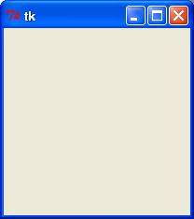

Tkinter Widgets:
Tkinter provides various controls, such as buttons, labels and text boxes used in a GUI application. These controls are commonly called widgets.
There are currently 15 types of widgets in Tkinter. We present these widgets as well as a brief description in the following table −

- Button
- Canvas
- CheckButton
- Entry
- Frame
- Label
- Listbox
- MenuButton
- Menu
- Message
- RadioButton
- Scale
- Scrollbar
- Text
- Scrollbar
- Text
- Toplevel
- PanedWindow
- LabelFrame
- tkMessageBox

Standard attributes:
1. Dimension
2. Colors
3. Fonts
4. Anchors
5. Relief Styles
6. BitMaps
7. Cursor

File Explorer in Python using Tkinter:
The following steps are involved in creating a tkinter application:
- Importing the tkinter module.
- Creation of the main window (container).
- Addition of widgets to the main window
- Applying the event Trigger on widgets like buttons, etc.

Creating the File Explorer:
In order to do so, we have to import the filedialog module from Tkinter. The Filedialog module will help you open, save files or directories.
In order to open a file explorer, we have to use the method, askopenfilename(). This function creates a file dialog object.
Syntax: tkFileDialog.askopenfilename(initialdir = “/”,title = “Select file”,filetypes = ((“file_type”,”*.extension”),(“all files”,”*.*”)))

Parameters:

1. initialdir: We have to specify the path of the folder that is to be opened when the file explorer pops up.
2. title: The title of file explorer opened.
3. filetypes: Here we can specify different kinds of file extensions so that the user can filter based on different file types

Read Files Using Python TkInter :
You can open up text files quite easily in Python. Just use the inbuilt open function. In between round brackets, you type the name and path of the file you want to open:
fileToOpen = "C:\Users\Ken\Documents\test.txt"
openFileFromPath = open( fileToOpen )
Once you have a file and a path, place it between the round brackets of open. Because it's on the right of an equals sign, a file object will be created in our variable called openFileFromPath.

Creating a file object allows you to call the file functions:
read
readline
readlines
write
close
So you would do this:
openFileFromPath.read()
openFileFromPath.write("Some text")
openFileFromPath.close()

One important parameter that's used with the open function is mode. Files can be opened in read mode (r), write mode (w), append mode (a), and read and write mode (r+). Each mode is shortened to a single letter and goes as a parameter to open:

open( fileToOpen, ‘r')
open( fileToOpen, 'w')
open( fileToOpen, ‘a')
open( fileToOpen, 'r+')

The default is read mode. So if you only want to read the file into a text area then you can miss out the 'r' for the first one.
open( fileToOpen)

The Code For Opening the file From Desired Path :

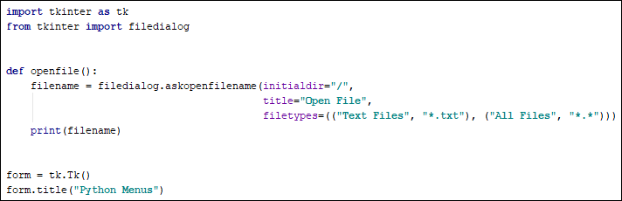
Code For FileRead Line by Line and if error Occur’s:
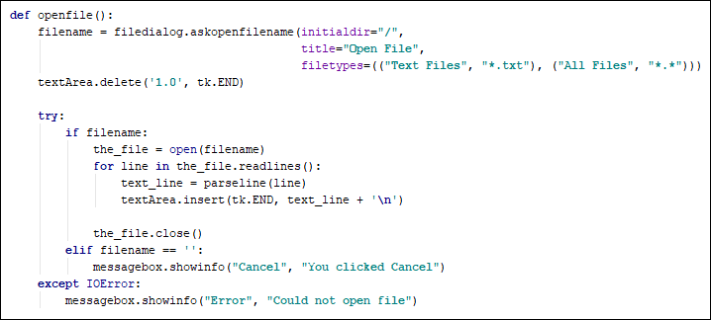
Output by Reading the File:
|--> Insert Our Output tk dialogbox by reading the data from SD card.

