RBE 595 - Haptic and Robotic Interact
Project Report

Topic: Bounding Volume Hierarchy based Collision detection in two dimensions.

Description:
The project aims to find if two polygons are colliding with each other using Bounding Volume Hierarchy. The polygons are two dimensional and the entire calculation is done on x and y axes.

Following Assumptions are considered:
- The bounding volumes are hard coded.
- The vertices of the polygons are also hard coded.

Description of the objects, data structures, and algorithms used.
Polygon Generation:
The vertices of the polygons are user provided. These coordinates are then used by pygame to draw the polygons. This is done in an infinite loop block, that keeps constantly checking for a keyboard input. When the keyboard inputs UP,DOWN, LEFT and RIGHT happen, the calls are used to store the changes in coordinates of the second polygon. These change in coordinate list then used to update the coordinates in the root of the second polygon’s binary tree.

Bounding Volume Hierarchy:
Since the bounding volumes are hard coded, the bounding volume hierarchy is manually created with the top left and bottom right coordinates of individual bounding volumes. A 3 level bounding volume hierarchy was created for the blue polygon and a two level bounding volume hierarchy was created for the red polygon.

Bounding Volume Test Tree:
Running time simultaneous recursive traversal of the two BVHs results in a bounding volume test tree. The tree obtained is as follows. The tree is then traversed in a Depth First Search method to find the colliding leaf nodes.

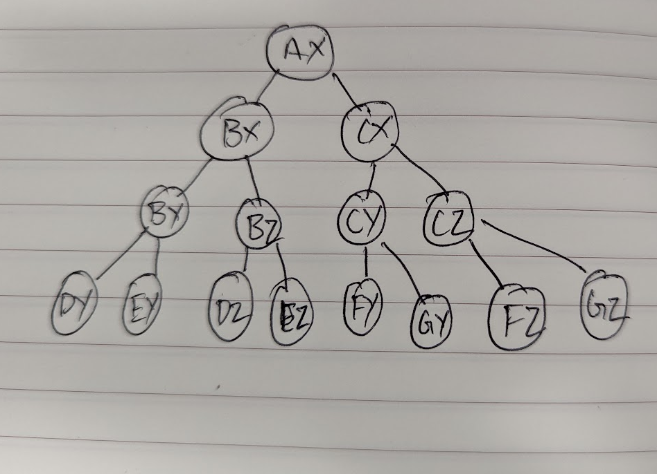

Collision Check:
A simple function that checks if two rectangles are overlapping each other. If they are then it will return True. Else False. Here the two rectangles are the bounding boxes of the polygons, say D and Y.

Simulation Setup:
Python3 is used for the processes.
Pygame is used for the visualization.

How to run the program:
Using Terminal: Execute the following command. ~$ python3 Gsrinivasan.py
Using VSCode: Open the code and hit F5.
(The program requires Pygame to be installed)
Once the program is started the following image gets displayed. The red polygons can be moved using the arrow key. The bounding boxes of the objects can be displayed by hitting the Right_Control_Key. The bounding boxes can be removed by hitting the Right_Shift_Key. When in collision the nodes at collision will be displayed in the terminal.

-Description of experiments/simulation; display of examples (with input) and results; discussion of results.
The polygons used for the experiment:

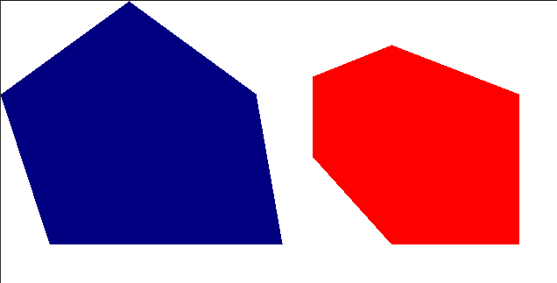
The bounding boxes of the objects are generated as follows:

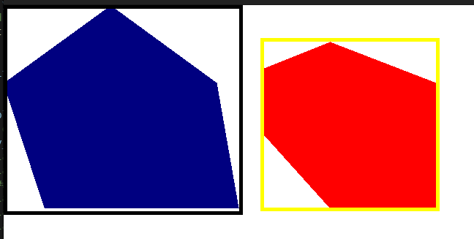
The above image shows the 1st level of the bounding boxes and shows the nodes A (bounding box over blue) and node X (bounding box over red).

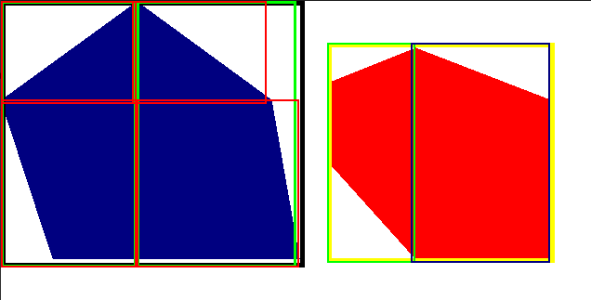
The left part of the blue polygon is the B node, and the right part the C node. These two can be further divided into nodes D(top left), E (bottom left), F (top right) and G (bottom right).

For the red polygon, the bounding box X is divided into Y (left portion) and Z (right portion).

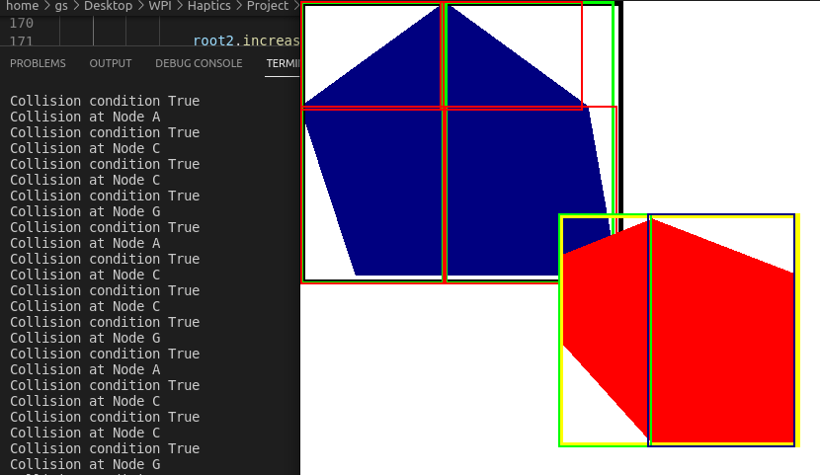

The above image gives the output of all the nodes that are in collision with the red polygon. From the figure we can see that the red polygon is in collision with the G node of the blue polygon. This G node is a child node of Node C, which is in turn a child node of Node A. The same is displayed on the terminal.

Since this collision check is done for every simulation step, the output is repeated until the program is closed or the red polygon is moved away.

Discussion of problems/limitations and future improvement:
- The program utilized hard coded values to plot the polygons. The polygons could have been generated randomly.
- The algorithm was developed around simple polygons. This could be extended to more complex polygons as well as in 3D.
- The bounding volumes used for the calculation are also hard coded. This could be automated.

References:

“Wang, X., Tang, M., Manocha, D., & Tong, R. (2018, May). Efficient BVH‐based collision detection scheme with ordering and restructuring. In Computer Graphics Forum (Vol. 37, No. 2, pp. 227-237).”

