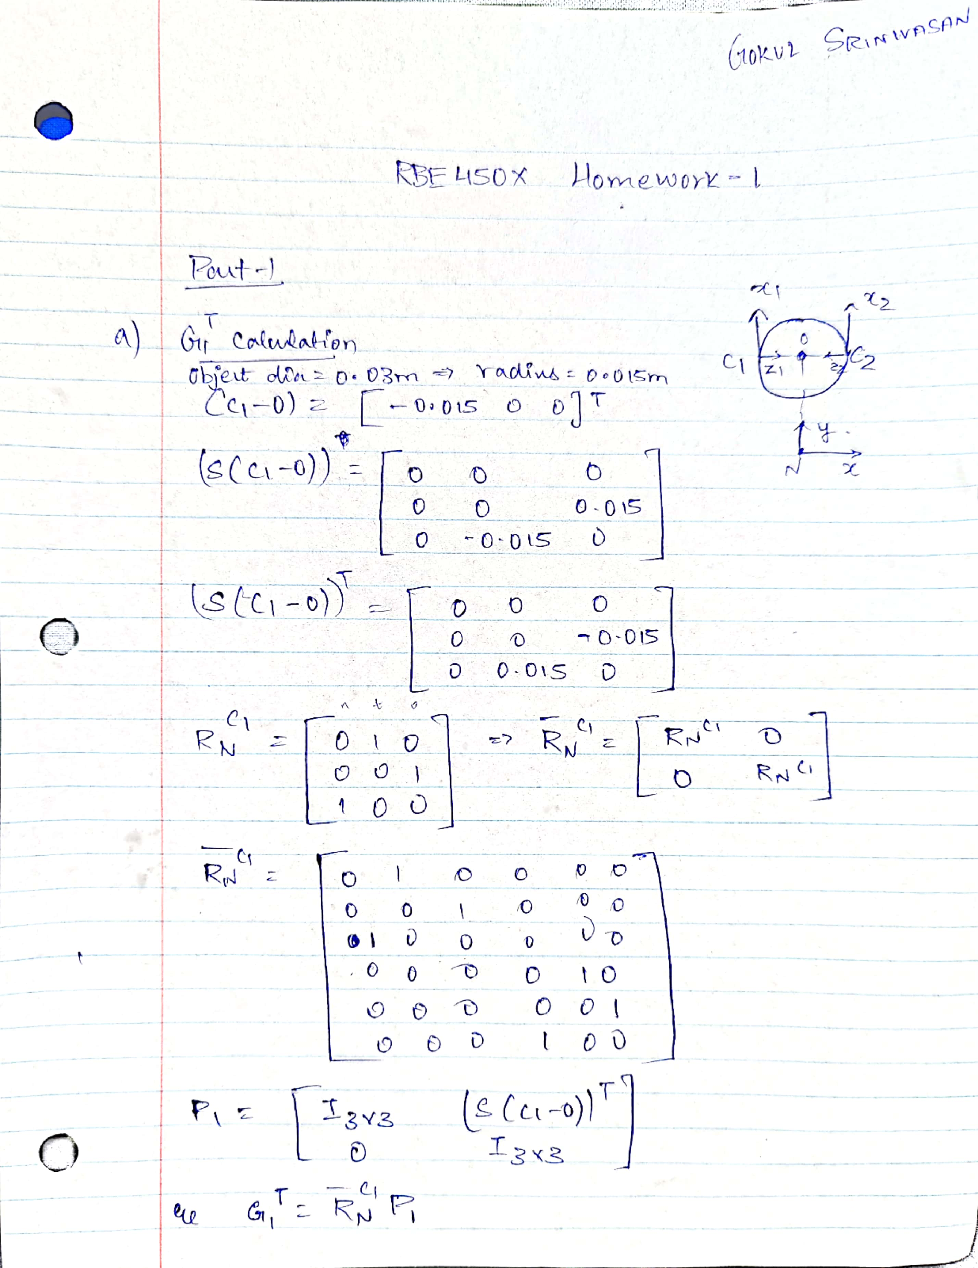

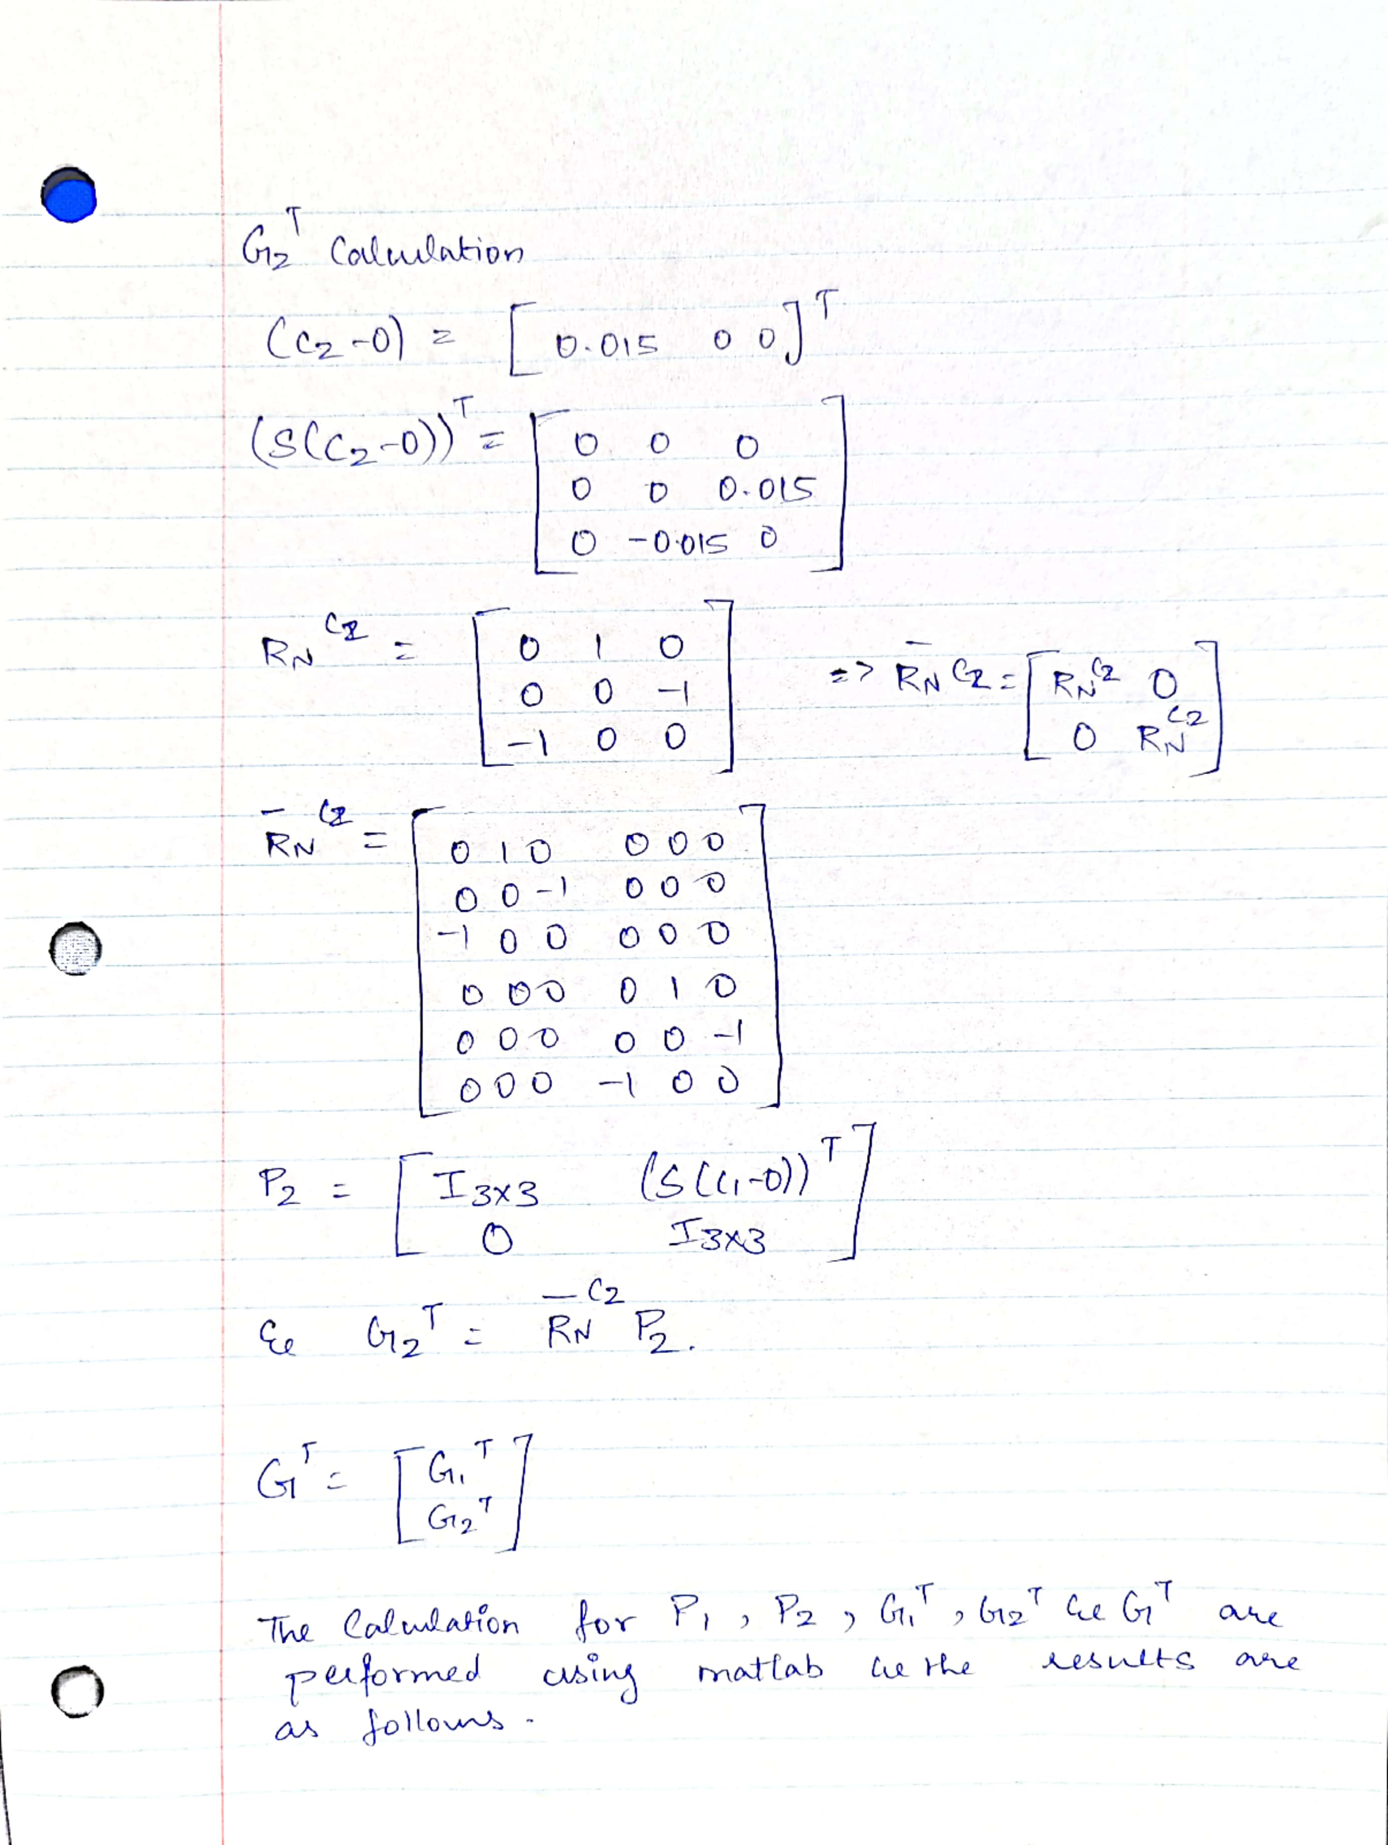 >> skew1 = [0 0 0; 0 0 -0.015; 0 0.015 0]

skew1 =

0 0 0

0 0 -0.0150

0 0.0150 0

>> rnc1 = [0 1 0; 0 0 1; 1 0 0]

rnc1 =

0 1 0

0 0 1

1 0 0

>> rnc1bar = [rnc1 zeros(3); zeros(3) rnc1]

rnc1bar =

0 1 0 0 0 0

0 0 1 0 0 0

1 0 0 0 0 0

0 0 0 0 1 0

0 0 0 0 0 1

0 0 0 1 0 0

>> P1 = [eye(3) skew1; zeros(3) eye(3)]

P1 =

1.0000 0 0 0 0 0

0 1.0000 0 0 0 -0.0150

0 0 1.0000 0 0.0150 0

0 0 0 1.0000 0 0

0 0 0 0 1.0000 0

0 0 0 0 0 1.0000

>> G1 = rnc1bar*P1

**G1 =**

**0 1.0000 0 0 0 -0.0150**

**0 0 1.0000 0 0.0150 0**

**1.0000 0 0 0 0 0**

**0 0 0 0 1.0000 0**

**0 0 0 0 0 1.0000**

**0 0 0 1.0000 0 0**

>> skew2 = [0 0 0; 0 0 0.015; 0 -0.015 0]

skew2 =

0 0 0

0 0 0.0150

0 -0.0150 0

>> rnc2 = [0 1 0; 0 0 -1; -1 0 0]

rnc2 =

0 1 0

0 0 -1

-1 0 0

>> rnc2bar = [rnc2 zeros(3); zeros(3) rnc2]

rnc2bar =

0 1 0 0 0 0

0 0 -1 0 0 0

-1 0 0 0 0 0

0 0 0 0 1 0

0 0 0 0 0 -1

0 0 0 -1 0 0

>> P2 = [eye(3) skew2; zeros(3) eye(3)]

P2 =

1.0000 0 0 0 0 0

0 1.0000 0 0 0 0.0150

0 0 1.0000 0 -0.0150 0

0 0 0 1.0000 0 0

0 0 0 0 1.0000 0

0 0 0 0 0 1.0000

>> G2 = rnc2bar*P2

**G2 =**

**0 1.0000 0 0 0 0.0150**

**0 0 -1.0000 0 0.0150 0**

**-1.0000 0 0 0 0 0**

**0 0 0 0 1.0000 0**

**0 0 0 0 0 -1.0000**

**0 0 0 -1.0000 0 0**

>> G = [G1;G2]

**G =**

**0 1.0000 0 0 0 -0.0150**

**0 0 1.0000 0 0.0150 0**

**1.0000 0 0 0 0 0**

**0 0 0 0 1.0000 0**

**0 0 0 0 0 1.0000**

**0 0 0 1.0000 0 0**

**0 1.0000 0 0 0 0.0150**

**0 0 -1.0000 0 0.0150 0**

**-1.0000 0 0 0 0 0**

**0 0 0 0 1.0000 0**

**0 0 0 0 0 -1.0000**

**0 0 0 -1.0000 0 0**

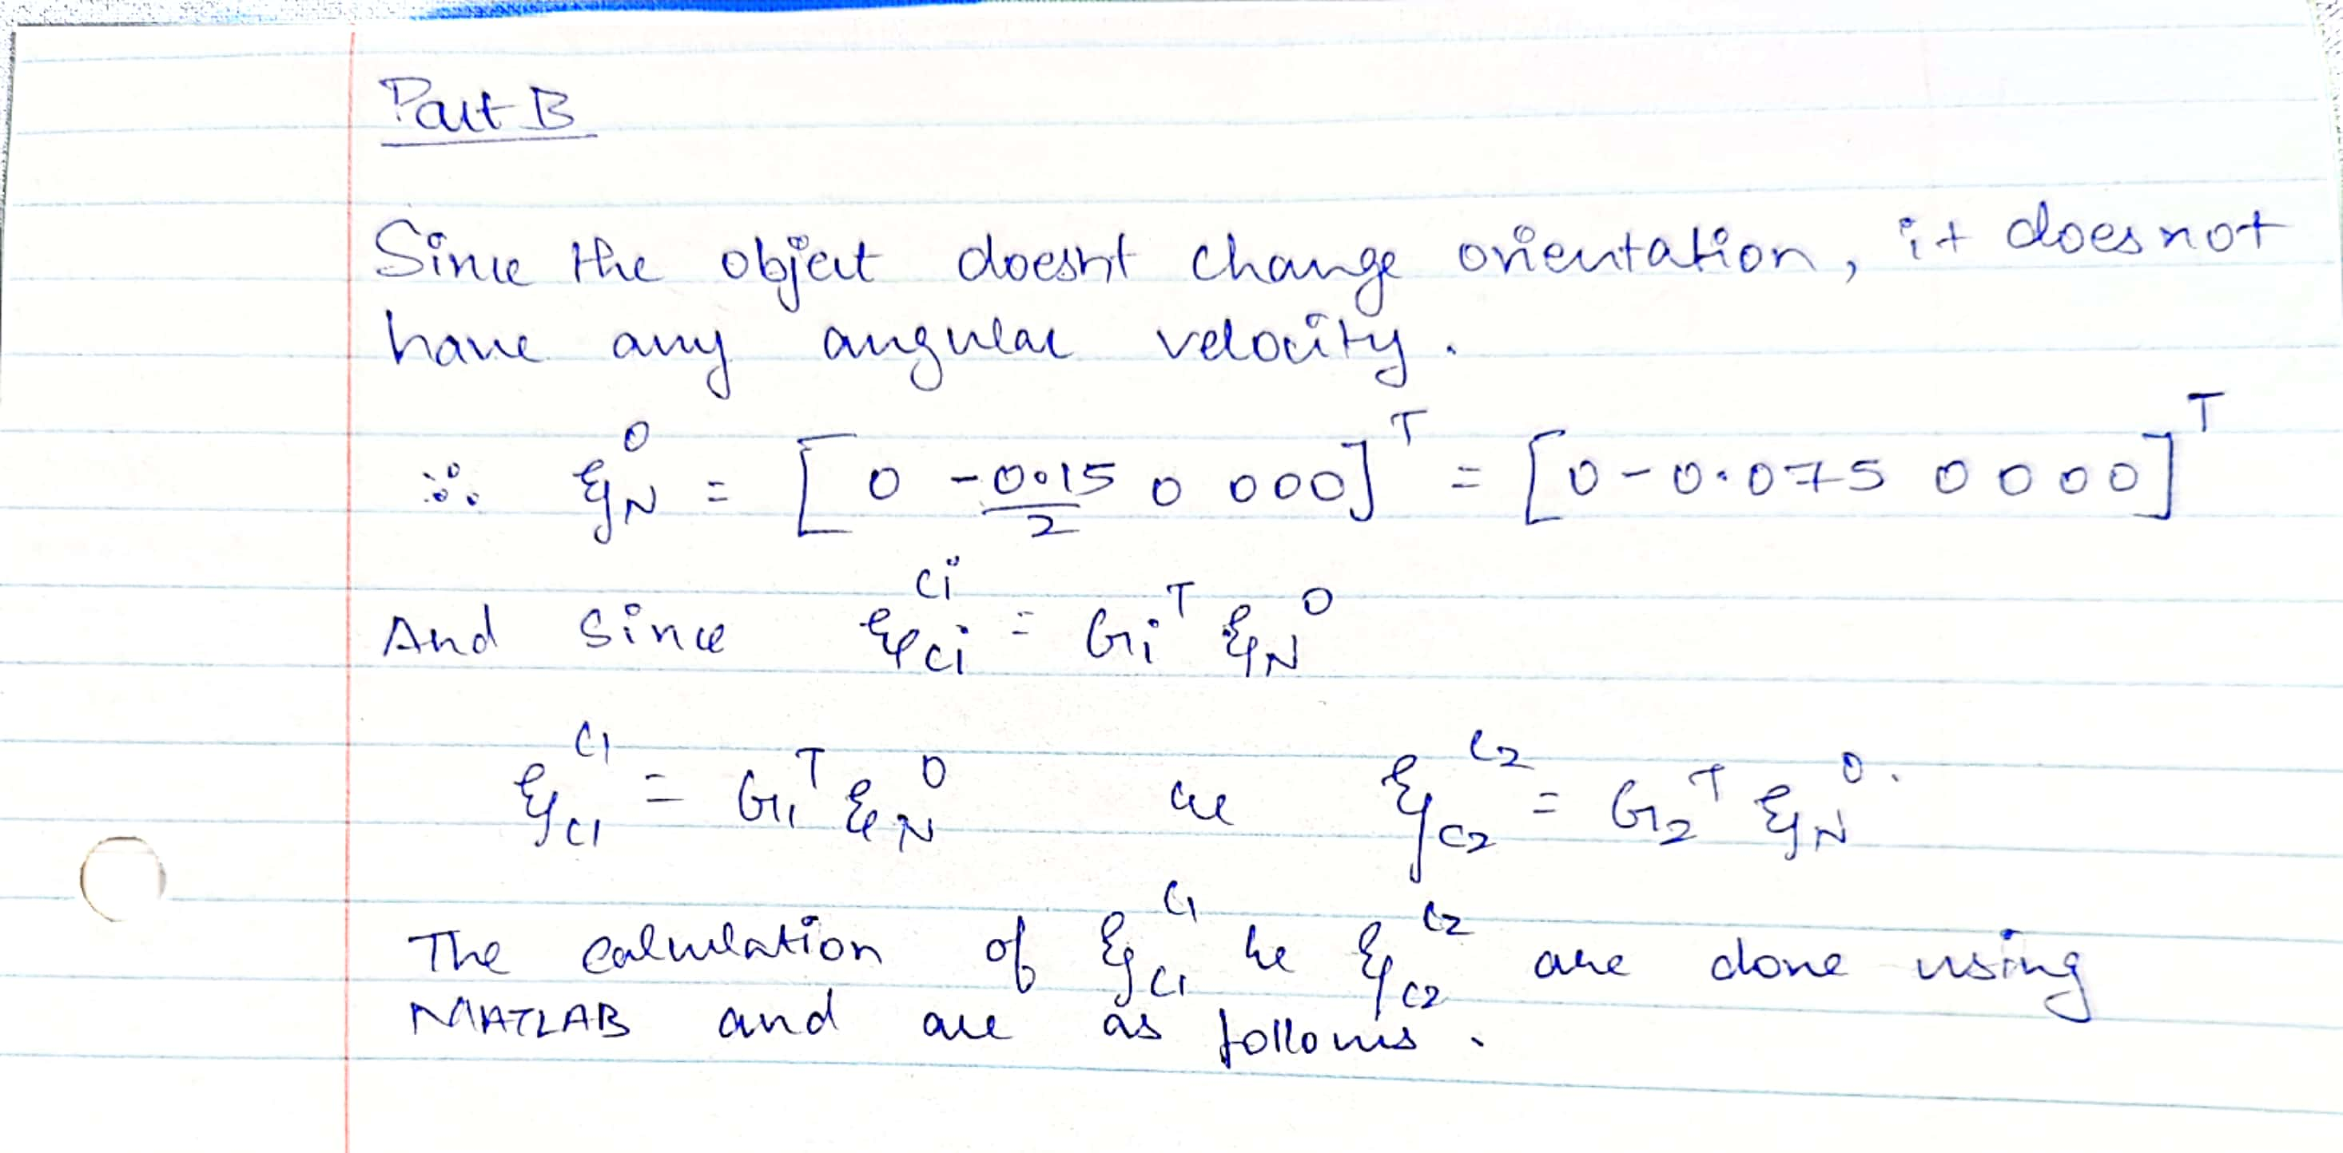

>> newtwist = transpose([0 -0.075 0 0 0 0])

newtwist =

0

-0.0750

0

0

0

0

>> twistc1toc1 = G1*newtwist

twistc1toc1 =

-0.0750

0

0

0

0

0

>> twistc2toc2 = G2*newtwist

twistc2toc2 =

-0.0750

0

0

0

0

0

**PART - B**

