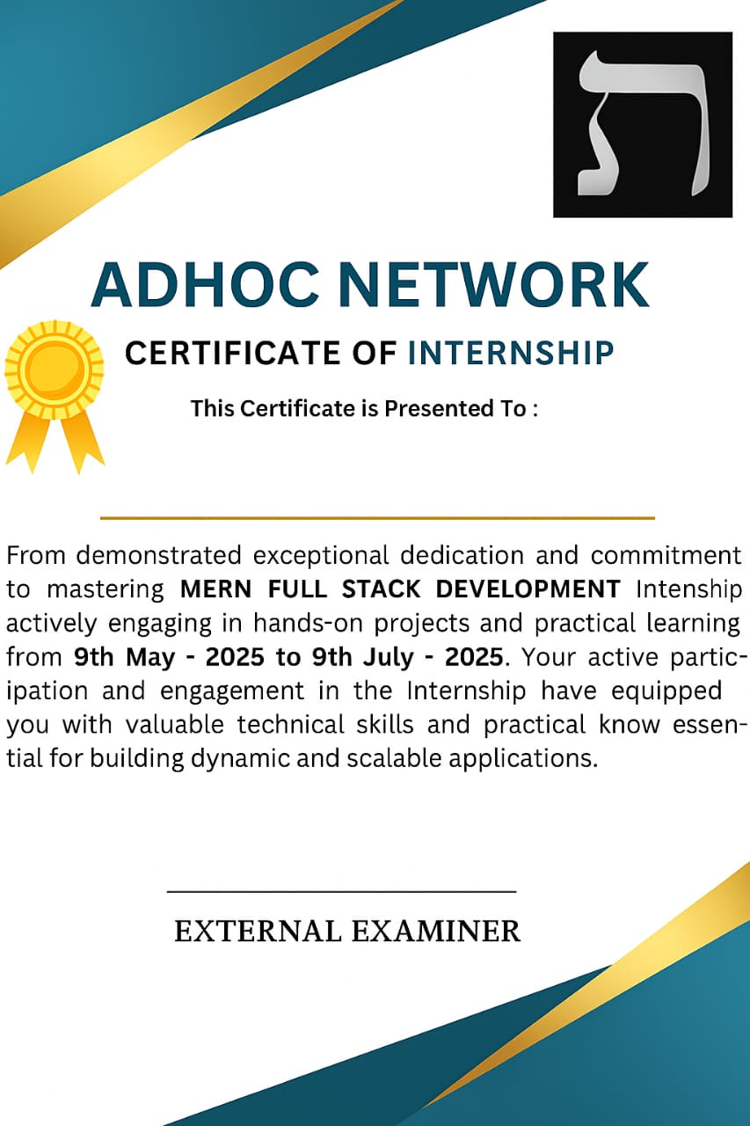

From demonstrated exceptional dedication and commitment to mastering **MERN FULL STACK DEVELOPMENT** Internship actively engaging in hands-on projects and practical learning from **9th May 2025** to **9th July 2025**. Your active participation and engagement in the Internship have equipped you with valuable technical skills and practical know essentials for building dynamic and scalable applications.

**PANDRANKI THARUN**