Insert your name, centre number and candidate number into the header above.
Save this evidence document as evidence_ followed by your centre number_ candidate number. For example: evidence_ zz999_9999.doc
Screenshots or program listings must be copied into appropriate cells in the following tables.
Examiners must be able to read the contents including any screenshots without the use of a magnifying glass. Answers that are not readable or missing will not be awarded any marks.
Save this evidence document at regular intervals, for example, every 10 minutes.
Question 1
Part 1(a)
DataStored = []
NumberItems = 0

Part 1(b)
def Initialise():
global DataStored
global NumberItems
valid = False
while (valid == False):
NumberItems = int(input("How many items would u like to enter (1-20): "))
if NumberItems >= 1 and NumberItems <= 20:
valid = True
else:
print("invalid number, must be between 1 and 20")
for i in range(0, NumberItems):
DataStored.append(int(input("Enter Number: ")))

Part 1(c)(i)
NumberItems = 0
Initialise()
print(DataStored)

Part 1(c)(ii)
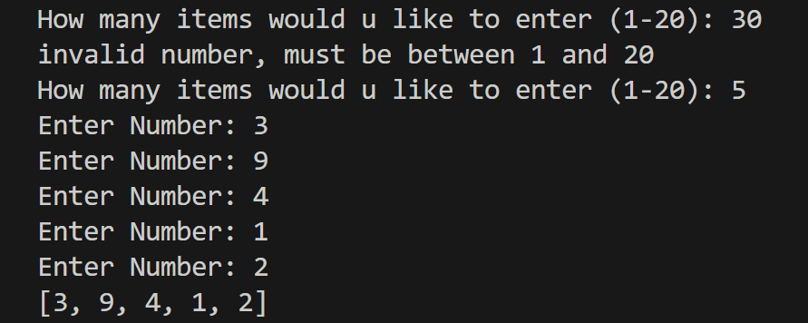

Part 1(d)(i)
def BubbleSort():
global DataStored
global NumberItems
temp = 0
for x in range(0, NumberItems):
for y in range(0, NumberItems - 1 - x):
if DataStored[y] > DataStored[y+1]:
temp = DataStored[y+1]
DataStored[y+1] = DataStored[y]
DataStored[y] = temp

Part 1(d)(ii)
BubbleSort()
print(DataStored)

Part 1(d)(iii)
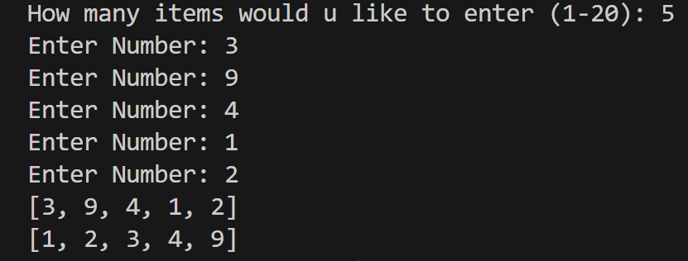

Part 1(e)(i)
def BinarySearch(DataToFind):
global DataStored
global NumberItems
First = 0
Last = NumberItems
while First <= Last:
mid = (First + Last) // 2
if DataStored[mid] == DataToFind:
return mid
else:
if DataStored[mid] < DataToFind:
First = mid + 1
elif DataStored[mid] > DataToFind:
Last = mid - 1
return - 1

Part 1(e)(ii)
Data = int(input("What number do u wish to find?: "))
print(BinarySearch(Data))

Part 1(e)(iii)
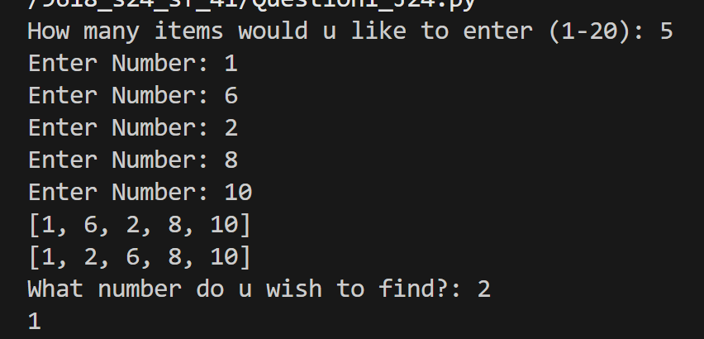

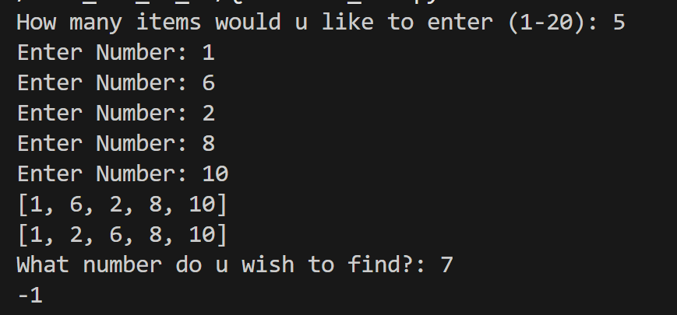

Question 2
Part 2(a)(i)
{Copy and paste program code listing for question 2(a)(i) here}
class Tree:
def __init__(self, aname, agrowth, aheight, awidth, aevergreen):
self.__TreeName = aname #string
self.__HeightGrowth = agrowth #integer
self.__MaxHeight = aheight #integer
self.__MaxWidth = awidth #integer
self.__Evergreen = aevergreen #string

Part 2(a)(ii)
{Copy and paste program code listing for question 2(a)(ii) here}
def GetTreeName(self):
return self.__TreeName
def GetGrowth(self):
return self.__HeightGrowth
def GetMaxHeight(self):
return self.__MaxHeight
def GetMaxWidth(self):
return self.__MaxWidth
def GetEverGreen(self):
return self.__Evergreen

Part 2(b)
{Copy and paste program code listing for question 2(b) here}
def ReadData():
TreeObjects=[]
try:
File = open("Trees.txt")
TreeData = []
TreeData = File.read().split("\n")
SplitTrees = []
for Item in TreeData:
SplitTrees.append(Item.split(","))
File.close()
for Item in SplitTrees:
TreeObjects.append(Tree(Item[0],int(Item[1]),int(Item[2]),int(Item[3]),Item[4]))
except IOError:
print ("invalid file")
return TreeObjects

Part 2(c)
{Copy and paste program code listing for question 2(c) here}
def PrintTrees(Tree):
if Tree.GetEverGreen() == "No":
output = "It loses its leaves each year"
print(f"{Tree.GetTreeName()} has a maximum height {Tree.GetMaxHeight()} a maximum width {Tree.GetMaxWidth()} and grows {Tree.GetGrowth()} cm a year. {output}")
else:
output = "It does not lose its leaves"
print(f"{Tree.GetTreeName()} has a maximum height {Tree.GetMaxHeight()} a maximum width {Tree.GetMaxWidth()} and grows {Tree.GetGrowth()} cm a year. {output}")

Part 2(d)(i)
{Copy and paste program code listing for question 2(d)(i) here}
returned = ReadData()
for i in returned:
PrintTrees(i)

Part 2(d)(ii)
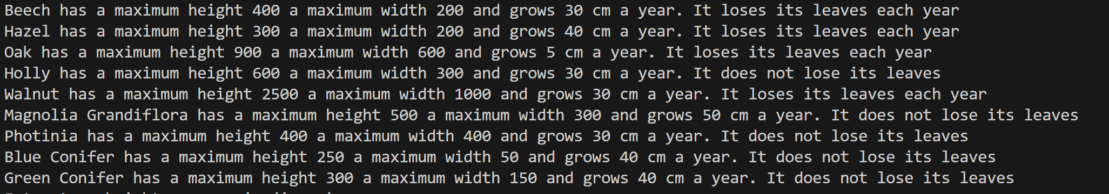

Part 2(e)(i)
{Copy and paste program code listing for question 2(e)(i) here}
def ChooseTrees(Trees):
Height = int(input("Enter tree height you require(in cm): "))
Width = int(input("Enter tree width you require(in cm): "))
Evergreen = input("Yes for evergreen/No for not evergreen: ")

if Evergreen.lower() == "yes":
Keep = "Yes"
else:
Keep = "No"
options = []
for items in Trees:
if items.GetMaxHeight() <= Height and items.GetMaxWidth() <= Width and items.GetEverGreen() == Keep:
options.append(items)
PrintTrees(items)
if len(options) == 0:
print("No suitable tree available")

Part 2(e)(ii)
{Copy and paste program code listing for question 2(e)(ii) here}
Valid = False
while Valid == False:
Choice = input("Enter the name of the tree you want: ")
for Item in options:
if Item.GetTreeName() == Choice:
Valid = True
Selected = Item
Start = int(input("Enter the height of the tree you would like to start with in cm: "))
Years = (Selected.GetMaxHeight() - Start)/Selected.GetGrowth()
print("Your tree should be full height in approximately", Years,"years")

Part 2(e)(iii)
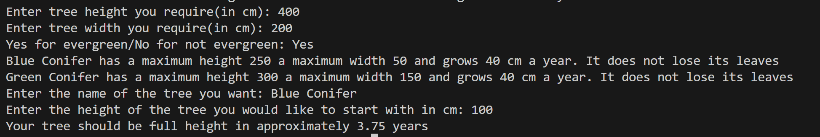

Question 3
Part 3(a)
{Copy and paste program code listing for question 3(a) here}
QueueData = []
for x in range(0,20):
QueueData.append("")
QueueHead = -1
QueueTail = -1

Part 3(b)
{Copy and paste program code listing for question 3(b) here}
def Enqueue(Data):
global QueueData
global QueueHead
global QueueTail
if QueueTail >=19:
return False
else:
if QueueHead == -1:
QueueHead = 0
QueueTail += 1
QueueData[QueueTail] = Data
return True

Part 3(c)
{Copy and paste program code listing for question 3(c) here}

def Dequeue():
global QueueData
global QueueHead
global QueueTail
if QueueHead == -1 or QueueHead > QueueTail:
return False
else:
QueueHead += 1
return (QueueData[QueueHead-1])

Part 3(d)(i)
{Copy and paste program code listing for question 3(d)(i) here}
def StoreItems():
invalid = 0
for i in range(0, 10):
values = input("Enter a 7 character string: ")

sum_1 = (int(values[0]) * 1) + (int(values[2]) * 1) + (int(values[4]) * 1)
sum_3 = (int(values[1]) * 3) + (int(values[3]) * 3) + (int(values[5]) * 3)

sums = sum_1 + sum_3
calc_digit = sums // 10

if calc_digit == 10:
final_check = "X"
else:
final_check = str(calc_digit)
if values[6] == final_check:
if Enqueue(values[0:6]):
print("Item inserted")
else:
print("Queue is already full")
else:
print("Invalid check digit")
invalid += 1

print(f"There were {invalid} invalid items")

Part 3(d)(ii)
{Copy and paste program code listing for question 3(d)(ii) here}
StoreItems()
result = Dequeue()
if result == False:
print("Queue is Empty")
else:
print(result)

Part 3(d)(iii)
{Copy and paste screenshot for question 3(d)(iii) here}
