Insert your name, centre number and candidate number into the header above.
Save this evidence document as evidence_ followed by your centre number_ candidate number. For example: evidence_ zz999_9999.doc
Screenshots or program listings must be copied into appropriate cells in the following tables.
Examiners must be able to read the contents including any screenshots without the use of a magnifying glass. Answers that are not readable or missing will not be awarded any marks.
Save this evidence document at regular intervals, for example, every 10 minutes.
Question 1
Part 1(a)
def ReadData():
data = []
try:
file = open('Data.txt', 'r')
for line in file:
value = line.strip()
data.append(value)
file.close()
return data
except:
print("file not found")

Part 1(b)(i)
def FormatArray(array):
result = ""
for i in range(len(array)):
result += " " + array[i]
return result

Part 1(b)(ii)
stored_array = ReadData()
result = FormatArray(stored_array)
print(result)

Part 1(b)(iii)

Part 1(c)
def CompareStrings(val1, val2):
count = 0
found = False
while not found:
if val1[count] == val2[count]:
count += 1
else:
found = True
if val1[count] > val2[count]:
return 1
else:
return 2

Part 1(d)(i)
def Bubble(array):
for x in range(0, len(array)):
for y in range(0, len(array)-1-x):
result = CompareStrings(array[y], array[y+1])
if result == 1:
array[y], array[y+1] = array[y+1], array[y]
return array

Part 1(d)(ii)
sorted = Bubble(stored_array)
sorted_format = FormatArray(sorted)
print(sorted_format)

Part 1(d)(iii)

Question 2
Part 2(a)(i)
class Horse:
def __init__(self, aname, amaxfenceheight, apercentage):
self.__Name = aname #string
self.__MaxFenceHeight = amaxfenceheight #integer
self.__PercentageSuccess = apercentage #integer

Part 2(a)(ii)
def GetName(self):
return self.__Name
def GetMaxFenceHeight(self):
return self.__MaxFenceHeight

Part 2(b)(i)
Horses = []

Horses.append(Horse("Beauty", 150, 72))
Horses.append(Horse("Jet", 160, 65))

print(Horses[0].GetName())
print(Horses[1].GetName())

Part 2(b)(ii)
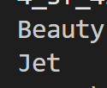

Part 2(c)(i)
class Fence:
def __init__(self, aheight, arisk):
self.__Height = aheight #integer
self.__Risk = arisk #integer

def GetHeight(self):
return self.__Height
def GetRisk(self):
return self.__Risk

Part 2(c)(ii)
Course = []
for x in range(0, 4):
valid = False
while not valid:
value1 = int(input("Enter height between 70 and 180: "))
if value1 >= 70 and value1 <= 180:
valid = True
valid = False
while not valid:
value2 = int(input("Enter risk between 1 and 5: "))
if value2 >= 1 and value2 <= 5:
valid = True
Course.append(Fence(value1, value2))

Part 2(d)
def Success(self, height, risk):
if height > self.__MaxFenceHeight:
success = self.__PercentageSuccess * 0.20
else:
if risk == 5:
success = self.__PercentageSuccess * 0.6
elif risk == 4:
success = self.__PercentageSuccess * 0.7
elif risk == 3:
success = self.__PercentageSuccess * 0.8
elif risk == 2:
success = self.__PercentageSuccess * 0.9
elif risk == 1:
success = self.__PercentageSuccess * 1
return success

Part 2(e)(i)
for y in range(0,2):
for x in range(0, 4):
chance = Horses[y].Success(Course[x].GetHeight(), Course[x].GetRisk())
print(f"The horse {Horses[y].GetName()} at fence {x} has a {chance}% chance of success")

Part 2(e)(ii)
Averagesuccess = []
for y in range(0,2):
total = 0
for x in range(0,4):
chance = Horses[y].Success(Course[x].GetHeight(), Course[x].GetRisk())
total += chance
average = total / 4
Averagesuccess.append(average)
print(f"{Horses[y].GetName()} has a average success chance of {average}%")
Highest = Averagesuccess[0]
winner = -1
for i in range(1,2):
if Highest < Averagesuccess[i]:
winner = i
Highest = Averagesuccess[i]
print(f"{Horses[winner].GetName()} has the highest average chance of success with {Highest}%")

Part 2(e)(iii)
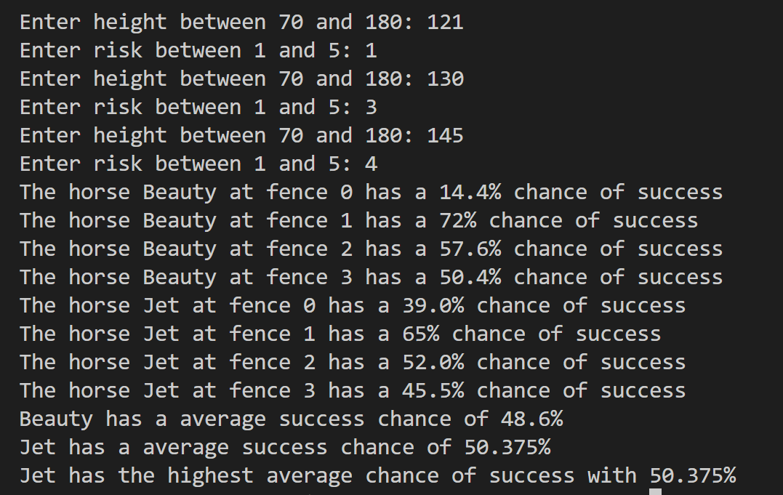

Question 3
Part 3(a)
{Copy and paste program code listing for question 3(a) here}

Part 3(b)
{Copy and paste program code listing for question 3(b) here}

Part 3(c)(i)
{Copy and paste program code listing for question 3(c)(i) here}

Part 3(c)(ii)
{Copy and paste program code listing for question 3(c)(ii) here}

Part 3(c)(iii)
{Copy and paste the screenshot for question 3(c)(iii) here}

Part 3(d)(i)
{Copy and paste program code listing for question 3(d)(i) here}

Part 3(d)(ii)
{Copy and paste program code listing for question 3(d)(ii) here}

Part 3(d)(iii)
{Copy and paste the screenshot(s) for question 3(d)(iii) here}

