**Scenario1:**

SELECT * FROM Customers;

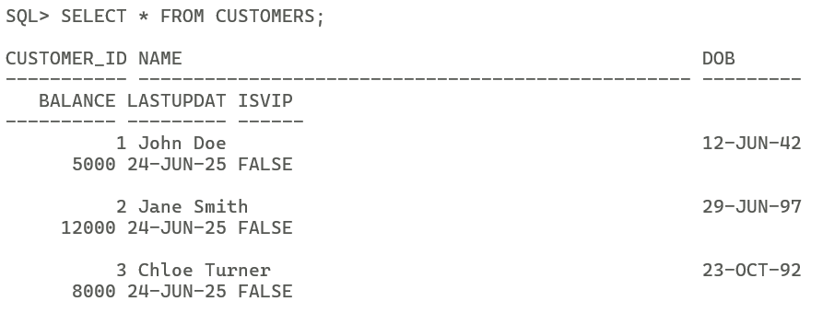

SELECT * FROM Loans;

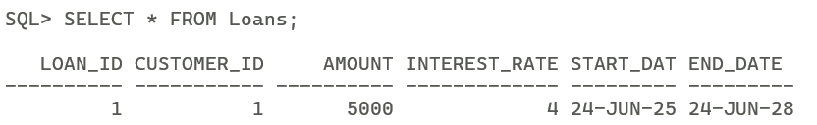

SET SERVEROUTPUT ON;  
DECLARE  
CURSOR C IS  
SELECT Customer_Id, EXTRACT(YEAR FROM SYSDATE) – EXTRACT(YEAR FROM DOB) AS AGE FROM Customers;  
C_Id Customers.Customer_Id%TYPE;  
C_Age NUMBER;  
BEGIN  
FOR CUSTOMER IN C LOOP  
C_Id := CUSTOMER.Customer_Id;  
C_Age := CUSTOMER.AGE;  
IF C_Age > 60 THEN  
UPDATE Loans SET Interest_Rate = Interest_Rate - 1  
WHERE Customer_Id = C_Id;  
DBMS_OUTPUT.PUT_LINE(‘Interest rate reduced for customer ‘ || C_Id);  
ELSE  
DBMS_OUTPUT.PUT_LINE(‘No change for customer’ || C_Id);  
END IF;  
END LOOP;  
END;  
/

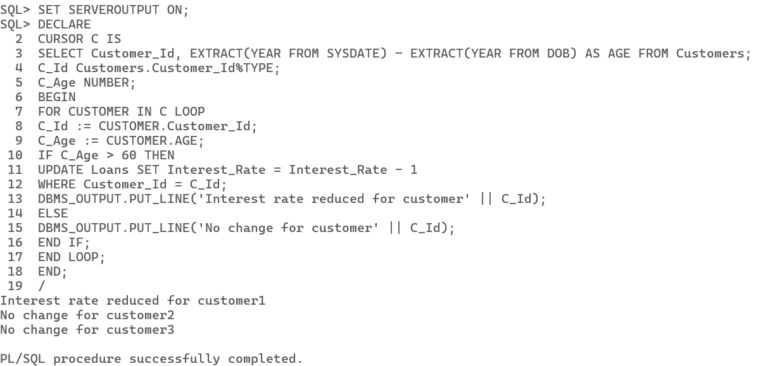

SELECT * FROM Loans;

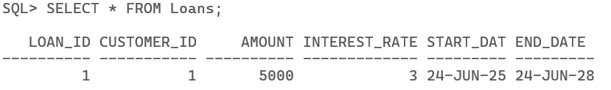

**Scenario2:**

SELECT * FROM Customers;

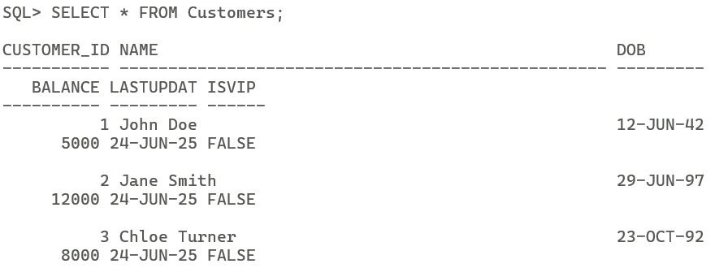

SET SERVEROUTPUT ON;  
DECLARE  
CURSOR C IS  
SELECT Customer_Id, Balance FROM Customers;  
C_Id Customers.Customer_Id%TYPE;  
Bal Customers.Balance%TYPE;  
BEGIN  
FOR CUSTOMER IN C LOOP  
C_Id := CUSTOMER.Customer_Id;  
Bal := CUSTOMER.Balance;  
IF Bal > 10000 THEN  
DBMS_OUTPUT.PUT_LINE(‘Customer ‘ || C_Id || ‘ is VIP’);  
UPDATE Customers SET IsVIP = ‘TRUE’  
WHERE Customer_Id = C_Id;  
ELSE  
DBMS_OUTPUT.PUT_LINE(‘Customer ’ || C_Id || ‘ is not VIP’);  
END IF;  
END LOOP;  
END;  
/

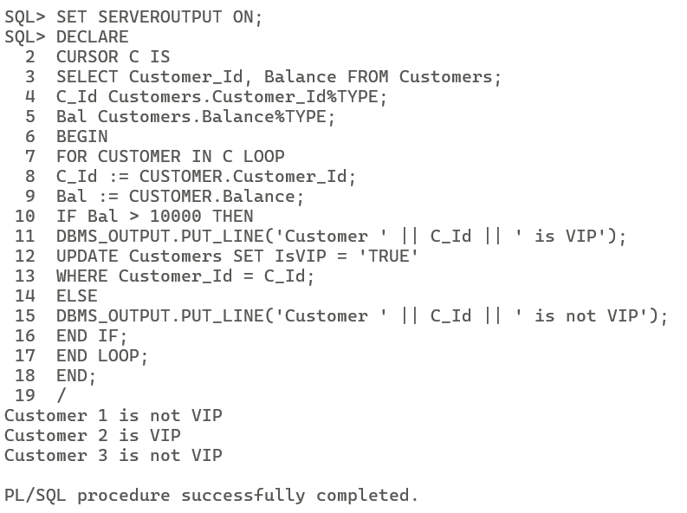

SELECT * FROM Customers;

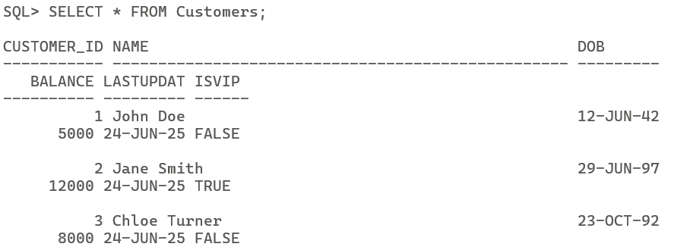

**Scenario3:**

SELECT * FROM Loans;

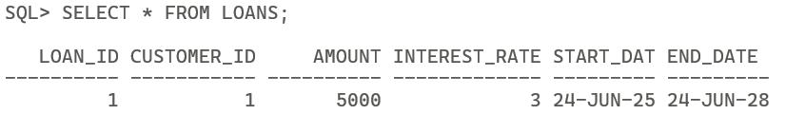

SET SERVEROUTPUT ON;  
DECLARE  
CURSOR C IS  
SELECT Loan_Id, Customer_Id, End_Date FROM Loans  
WHERE End_Date BETWEEN SYSDATE AND SYSDATE+30;  
L_Id Loans.Loan_Id%TYPE;  
C_Id Loans.Customer_Id%TYPE;  
ED Loans.End_Date%TYPE;  
FLAG BOOLEAN := FALSE;  
BEGIN  
OPEN C;  
LOOP  
FETCH C INTO L_Id, C_Id, ED;  
EXIT WHEN C%NOTFOUND;  
FLAG := TRUE;  
DBMS_OUTPUT.PUT_LINE(‘REMINDER: Loan ‘ || L_Id || ‘ for customer ‘ || C_Id || ‘ is due on ‘ || TO_CHAR(ED,’YYYY-MM-DD’));  
END LOOP;  
CLOSE C;  
IF NOT FLAG THEN  
DBMS_OUTPUT.PUT_LINE(‘No loans are due within the next 30 days’);  
END IF;  
END;  
/

