**Scenario1:**

SELECT * FROM Accounts;

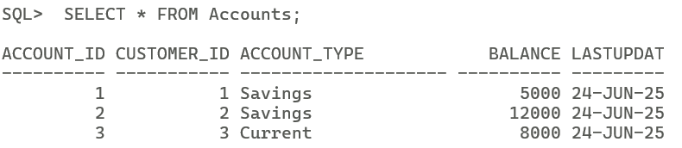

SET SERVEROUTPUT ON;  
CREATE OR REPLACE PROCEDURE ProcessMonthlyInterest AS  
BEGIN  
UPDATE Accounts SET Balance = Balance * 1.01, LastUpdated = SYSDATE  
WHERE Account_Type = ‘Savings’;  
DBMS_OUTPUT.PUT_LINE(‘Monthly interest processed for all savings accounts’);  
EXCEPTION  
WHEN OTHERS THEN   
ROLLBACK;  
DBMS_OUTPUT.PUT_LINE(‘Error: ‘ || SQLERRM);  
END ProcessMonthlyInterest;  
/

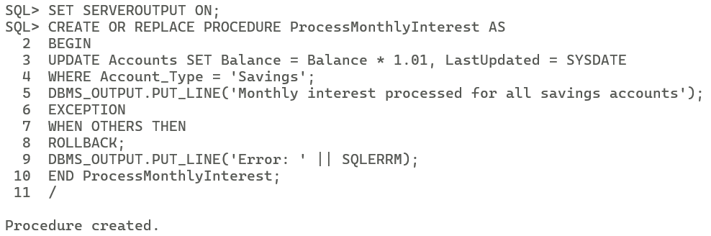

BEGIN  
ProcessMonthlyInterest;  
END;  
/

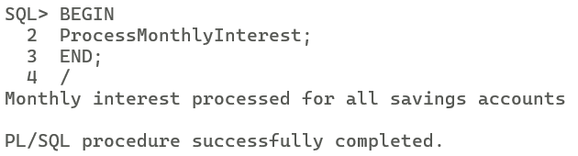

SELECT * FROM Accounts;

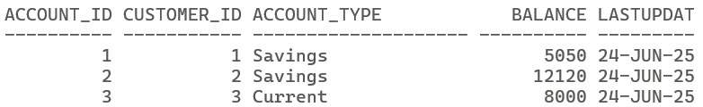

**Scenario2:**

SELECT * FROM Employees;

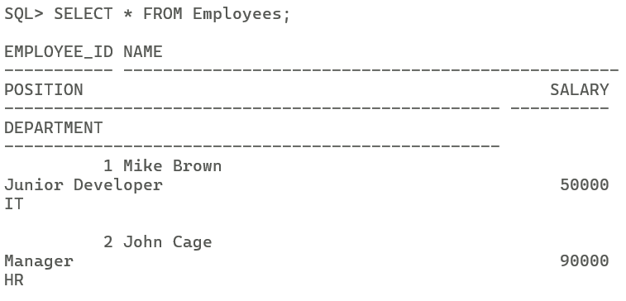

SET SERVEROUTPUT ON;  
CREATE OR REPLACE PROCEDURE UpdateEmployeeBonus(  
DEPT IN Employees.Department%TYPE, Bonus IN NUMBER) AS  
BEGIN  
UPDATE Employees SET Salary = Salary * (1 + Bonus/100)  
WHERE Department = DEPT;  
DBMS_OUTPUT.PUT_LINE(‘Bonus applied to employees in the ‘ || DEPT || ‘ department’);  
EXCEPTION  
WHEN OTHERS THEN  
ROLLBACK;  
DBMS_OUTPUT.PUT_LINE(‘Error: ‘ || SQLERRM);  
END UpdateEmployeeBonus;  
/

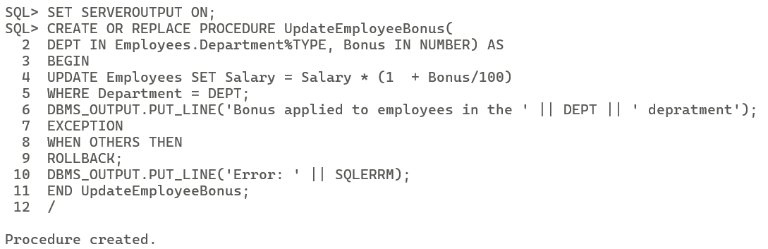

BEGIN  
UpdateEmployeeBonus(‘IT’,5);  
END;  
/

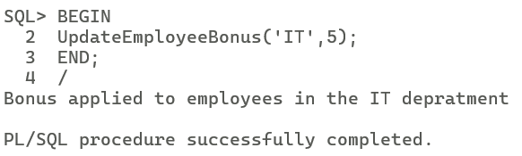

SELECT * FROM Employees;

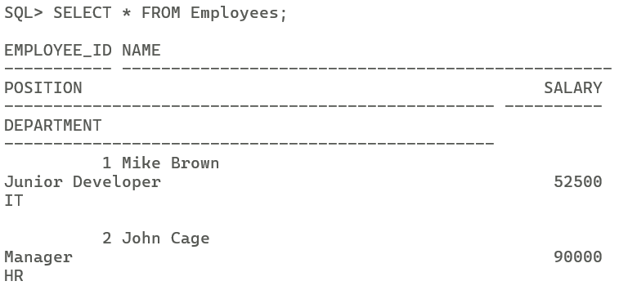

**Scenario3:**

SELECT * FROM Accounts;

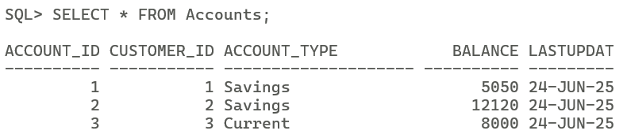

SET SERVEROUTPUT ON;  
CREATE OR REPLACE PROCEDURE TransferFunds(  
Acc_From IN Accounts.Account_Id%TYPE,  
Acc_To IN Accounts.Account_Id%TYPE,  
Amt IN NUMBER) AS  
Bal_From Accounts.Balance%TYPE;  
BEGIN  
SELECT BALANCE INTO Bal_From FROM Accounts  
WHERE Account_Id = Acc_From  
FOR UPDATE;  
IF Bal_From < Amt THEN  
RAISE_APPLICATION_ERROR(-20001,’Insufficient funds’);  
END IF;  
UPDATE Accounts SET Balance = Balance – Amt, LastUpdated = SYSDATE  
WHERE Account_Id = Acc_From;  
UPDATE Accounts SET Balance = Balance + Amt, LastUpdated = SYSDATE  
WHERE Account_Id = Acc_To;  
DBMS_OUTPUT.PUT_LINE(‘Transfer of ‘ || Amt || ‘ from account ‘ || Acc_From || ‘ to account ‘ || Acc_To);  
EXCEPTION  
WHEN OTHERS THEN  
ROLLBACK;  
DBMS_OUTPUT.PUT_LINE(‘Transfer failed’);  
END TransferFunds;  
/

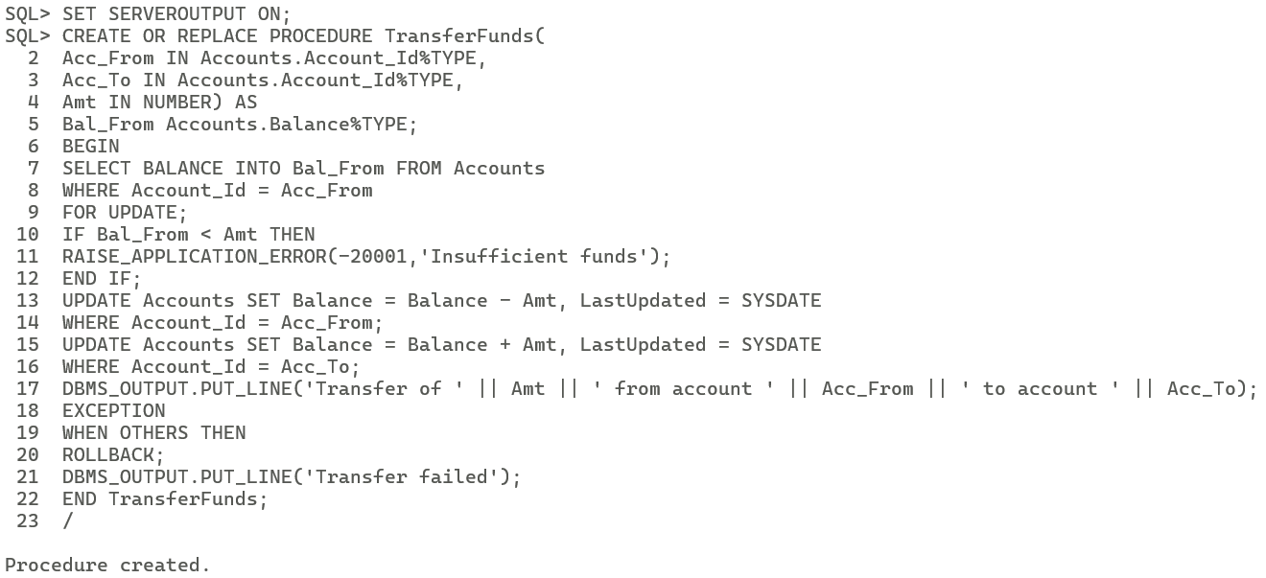

BEGIN  
TransferFunds(2,1,5000);  
END;  
/

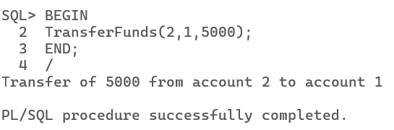

SELECT * FROM Accounts;

