**Final Report for Software Engineering**

Car Park Management System

Professor: Mohammad Reza Ghaeli

Group 5

Winter 2021

Jacky Lam (300307441)

Soheila Hosseini (300311938)

Golazin Abolfathi (300324007)

York Bosco Li (300271244)

Table of Contents

System Components………...…………………………….1

Use Case Diagram…………………………………………2

Database……………………………………………………3

Planning……………………………………………………..4

User Story………………………………..…………………4

Acceptance Tests…………………………………………..5

**Components of the system:**

* **Car driver**
* **Member**
* **Database**
* **Parking**

Controller:

Calculator

Controller_Class

IdGenerator

IParkingCintroller

ParkingSystemController

Service:

NewUserService

NewUserServiceImp

DAO:

DatabaseManager

IDatabaseManager

NewUserRepository

TempDatabasemanager

UserDatabase

View

ParkingDisplay

SignInDisplay

SignUpDisplay

Webapps

Index

**Use Case Diagram of the Program**

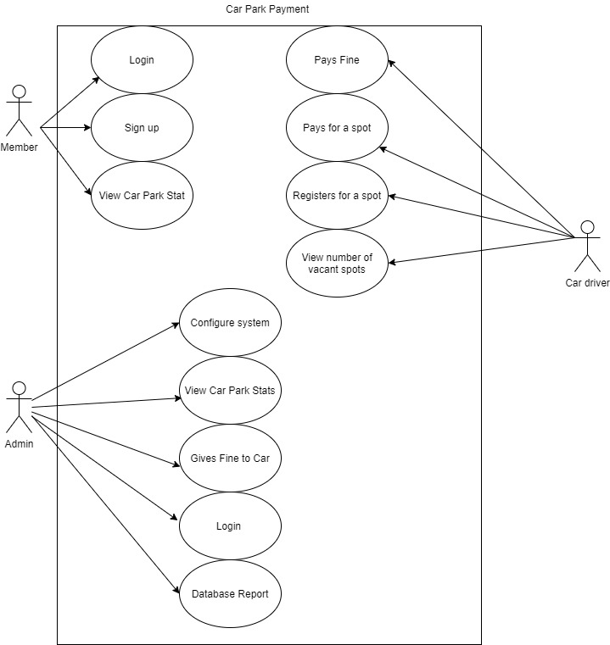

**Defining the database and schemas**

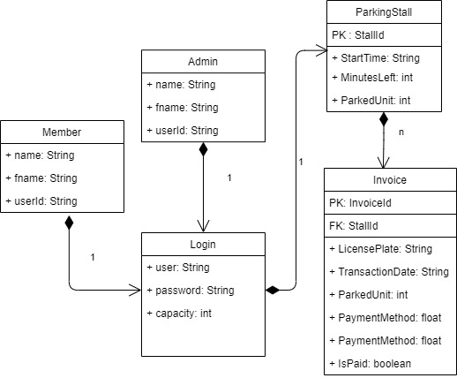

**Our database will contain three tables.**

* ParkingStall**:** keep information related to parking stalls.
* Invoice: contain the payment info for each record. In ParkingStall, StartTime tracks the time that the driver first bought the ticket while minutes left records the amount of time left including extensions bought. In Invoice, PaymentMethod records the type of payment(cash, visa, mastercard, debit) used, PaymentType is the type of payment it’s for(parking or fine)
* Member: employee who reserved a stalls.

**Description of the system architecture**

Our project is a multi layered application:

* **API layer**: connect with user, web page
* **Service layer**: manage application and connect with different layer
* **Database Access layer**: connect with database

**Project plan:**

**1. Login/Logout**

This feature will allow a member to be able to log into the Car Parking Lot system, if a profile has been created before for a member, he/she can login by using user and password and observe parking stalls and times that are reserved.

If the user is new, an error message shows and a sign-up page opens.

**2. Sign up**

This feature will allow a new member to register for a stall. The member should enter personal information such as first name, last name, employee id, email id, address and contact number.

**3. Filter parking stalls, empty/full**

This feature will allow logged in admin and members to view a list of parking stalls, and also apply a custom filter on them.

**4. Invoice**

This feature shows the information related to the invoice for each parking stall such as payment method (cash/visa card) , amount, parking stall number, license plate.

**User Story**

“As a car park owner, I want to check how long each car parks for and the busiest times so that I can track my profits”

**Acceptance test:**

* Cars can be
  + Each car spot displays plate no, time arrived, departure time and payment
* Admin overview of lot can be seen
  + Admin overview displays number of spots filled
* Payment can be made
  + Drivers can pay for parking fees and fines
* Fines can be assessed
  + Admins can levy fines against cars in violation of rules
* Profiits displayed
  + Admin overview displays total profit and a breakdown of profit