Week 6 — 16S Microbiome Analysis Report
罗涵 SUAT24000110
2026-09-23

1. Data & Design
Input: tests/16S_level-7.csv (species-level) + 16S_mapping.csv. 132 sample columns → 2 ungrouped K_XYL samples dropped → 130 grouped samples across 66 patients in a paired longitudinal design (each patient has a _01 before and _02 after sample). Groups: IBS_before 36, IBS_after 36, UC_before 29, UC_after 29. Collapsed to 137 genera.
Workflow: import (tax, Species) → prepare taxonomy → Genus → alpha → beta (Bray–Curtis PCoA/PCA/NMDS) → visualize → differential (wilcox) → interpret. Executed via the EMP-web backend engine; 'interpret' statistics use paired Wilcoxon, PERMANOVA and effect sizes.

2. Alpha Diversity (Shannon, paired Wilcoxon signed-rank)
Disease | before (mean) | after (mean) | median Δ | p
IBS | 1.664 | 1.589 | -0.079 | 0.177
UC | 1.616 | 1.468 | -0.121 | 0.023*
UC shows a significant Shannon-diversity loss after treatment (p=0.023); IBS no change (p=0.18). Observed-species paired p=0.98 (UC) → the change is evenness, not species richness.
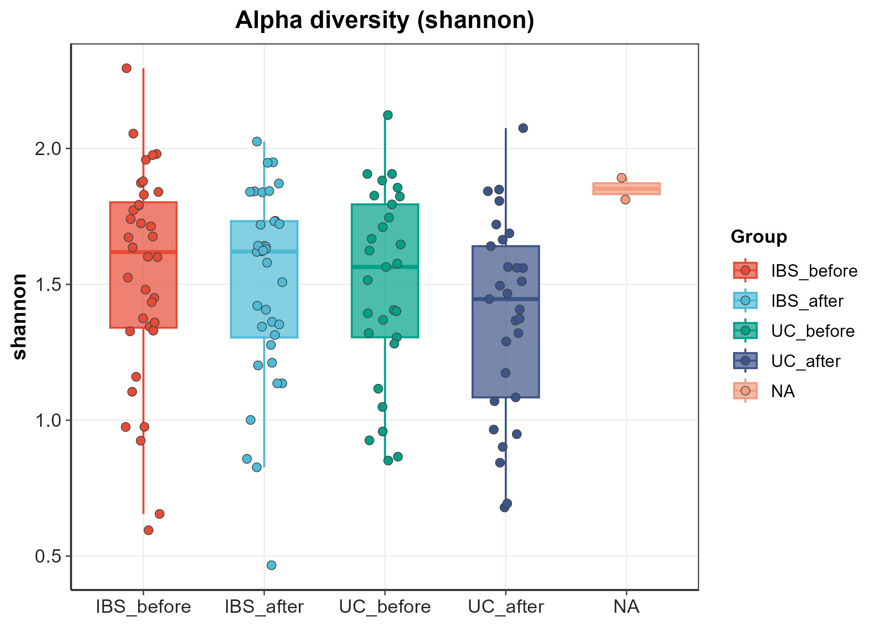

3. Beta Diversity (Bray–Curtis)
Model | R² | F | p
Group | 0.0319 | 1.385 | 0.149
Group | 0.9681 | - | -
Group | 1.0000 | - | -
Disease | 0.0238 | 3.123 | 0.008
Disease | 0.9762 | - | -
Disease | 1.0000 | - | -
Time | 0.0053 | 0.686 | 0.671
Time | 0.9947 | - | -
Time | 1.0000 | - | -
Disease*Time | 0.0319 | 1.385 | 0.144
Disease*Time | 0.9681 | - | -
Disease*Time | 1.0000 | - | -
Time (before vs after) R²=0.005, p=0.67 → no community restructuring. Dispersion homogeneous (betadisper p=0.93) → PERMANOVA valid. Within-patient Bray=0.345 ≈ 0.75× population spread → patients stay more similar to themselves than to others. Disease baseline differs (p=0.008).
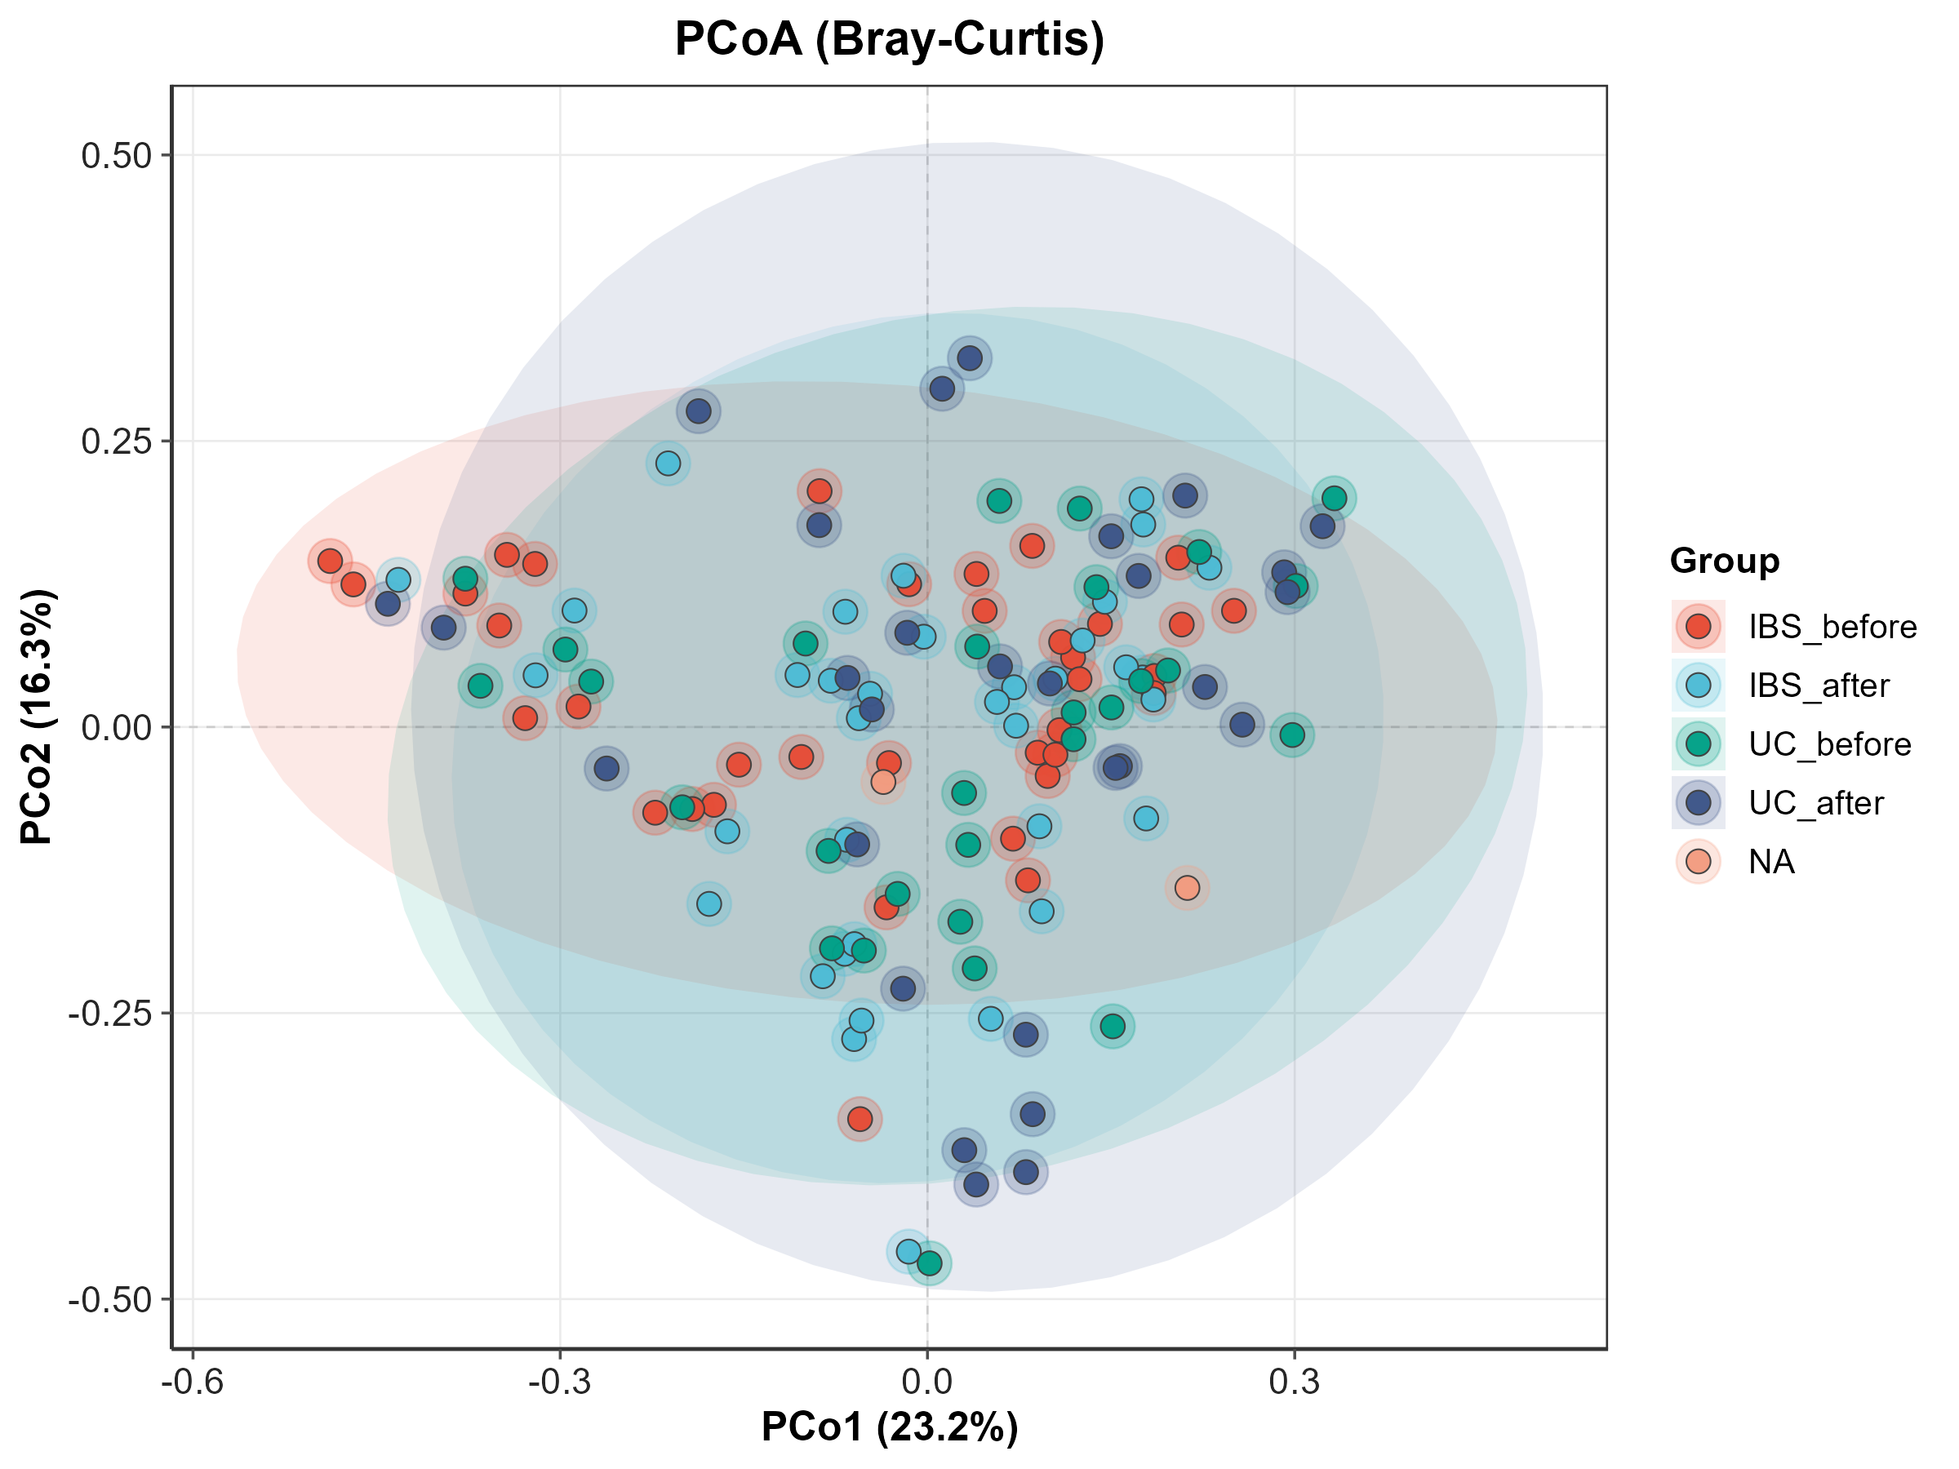

4. Differential Abundant Genera (paired Wilcoxon, BH-corrected)
FDR-significant genera: 0 in both diseases → no keystone replacement. Nominal candidates (p<0.05):
IBS:
genus | before rel | after rel | log2FC / p
s__animalis | 0.0000 | 0.0008 | +5.22 (p=0.00915)
s__reuteri | 0.0001 | 0.0022 | +4.27 (p=0.00915)
s__muciniphila | 0.0103 | 0.0388 | +1.92 (p=0.0132)
s__uniformis | 0.0091 | 0.0046 | -1.00 (p=0.0168)
s__fragi | 0.0000 | 0.0006 | +9.24 (p=0.036)
s__callidus | 0.0017 | 0.0006 | -1.38 (p=0.0367)
UC:
genus | before rel | after rel | log2FC / p
s__parvula | 0.0021 | 0.0004 | -2.35 (p=0.0191)
s__caccae | 0.0023 | 0.0003 | -2.81 (p=0.0244)
s__mucilaginosa | 0.0059 | 0.0026 | -1.19 (p=0.0254)
s__fragilis | 0.0043 | 0.0013 | -1.73 (p=0.0464)
s__uniformis | 0.0084 | 0.0046 | -0.86 (p=0.05)
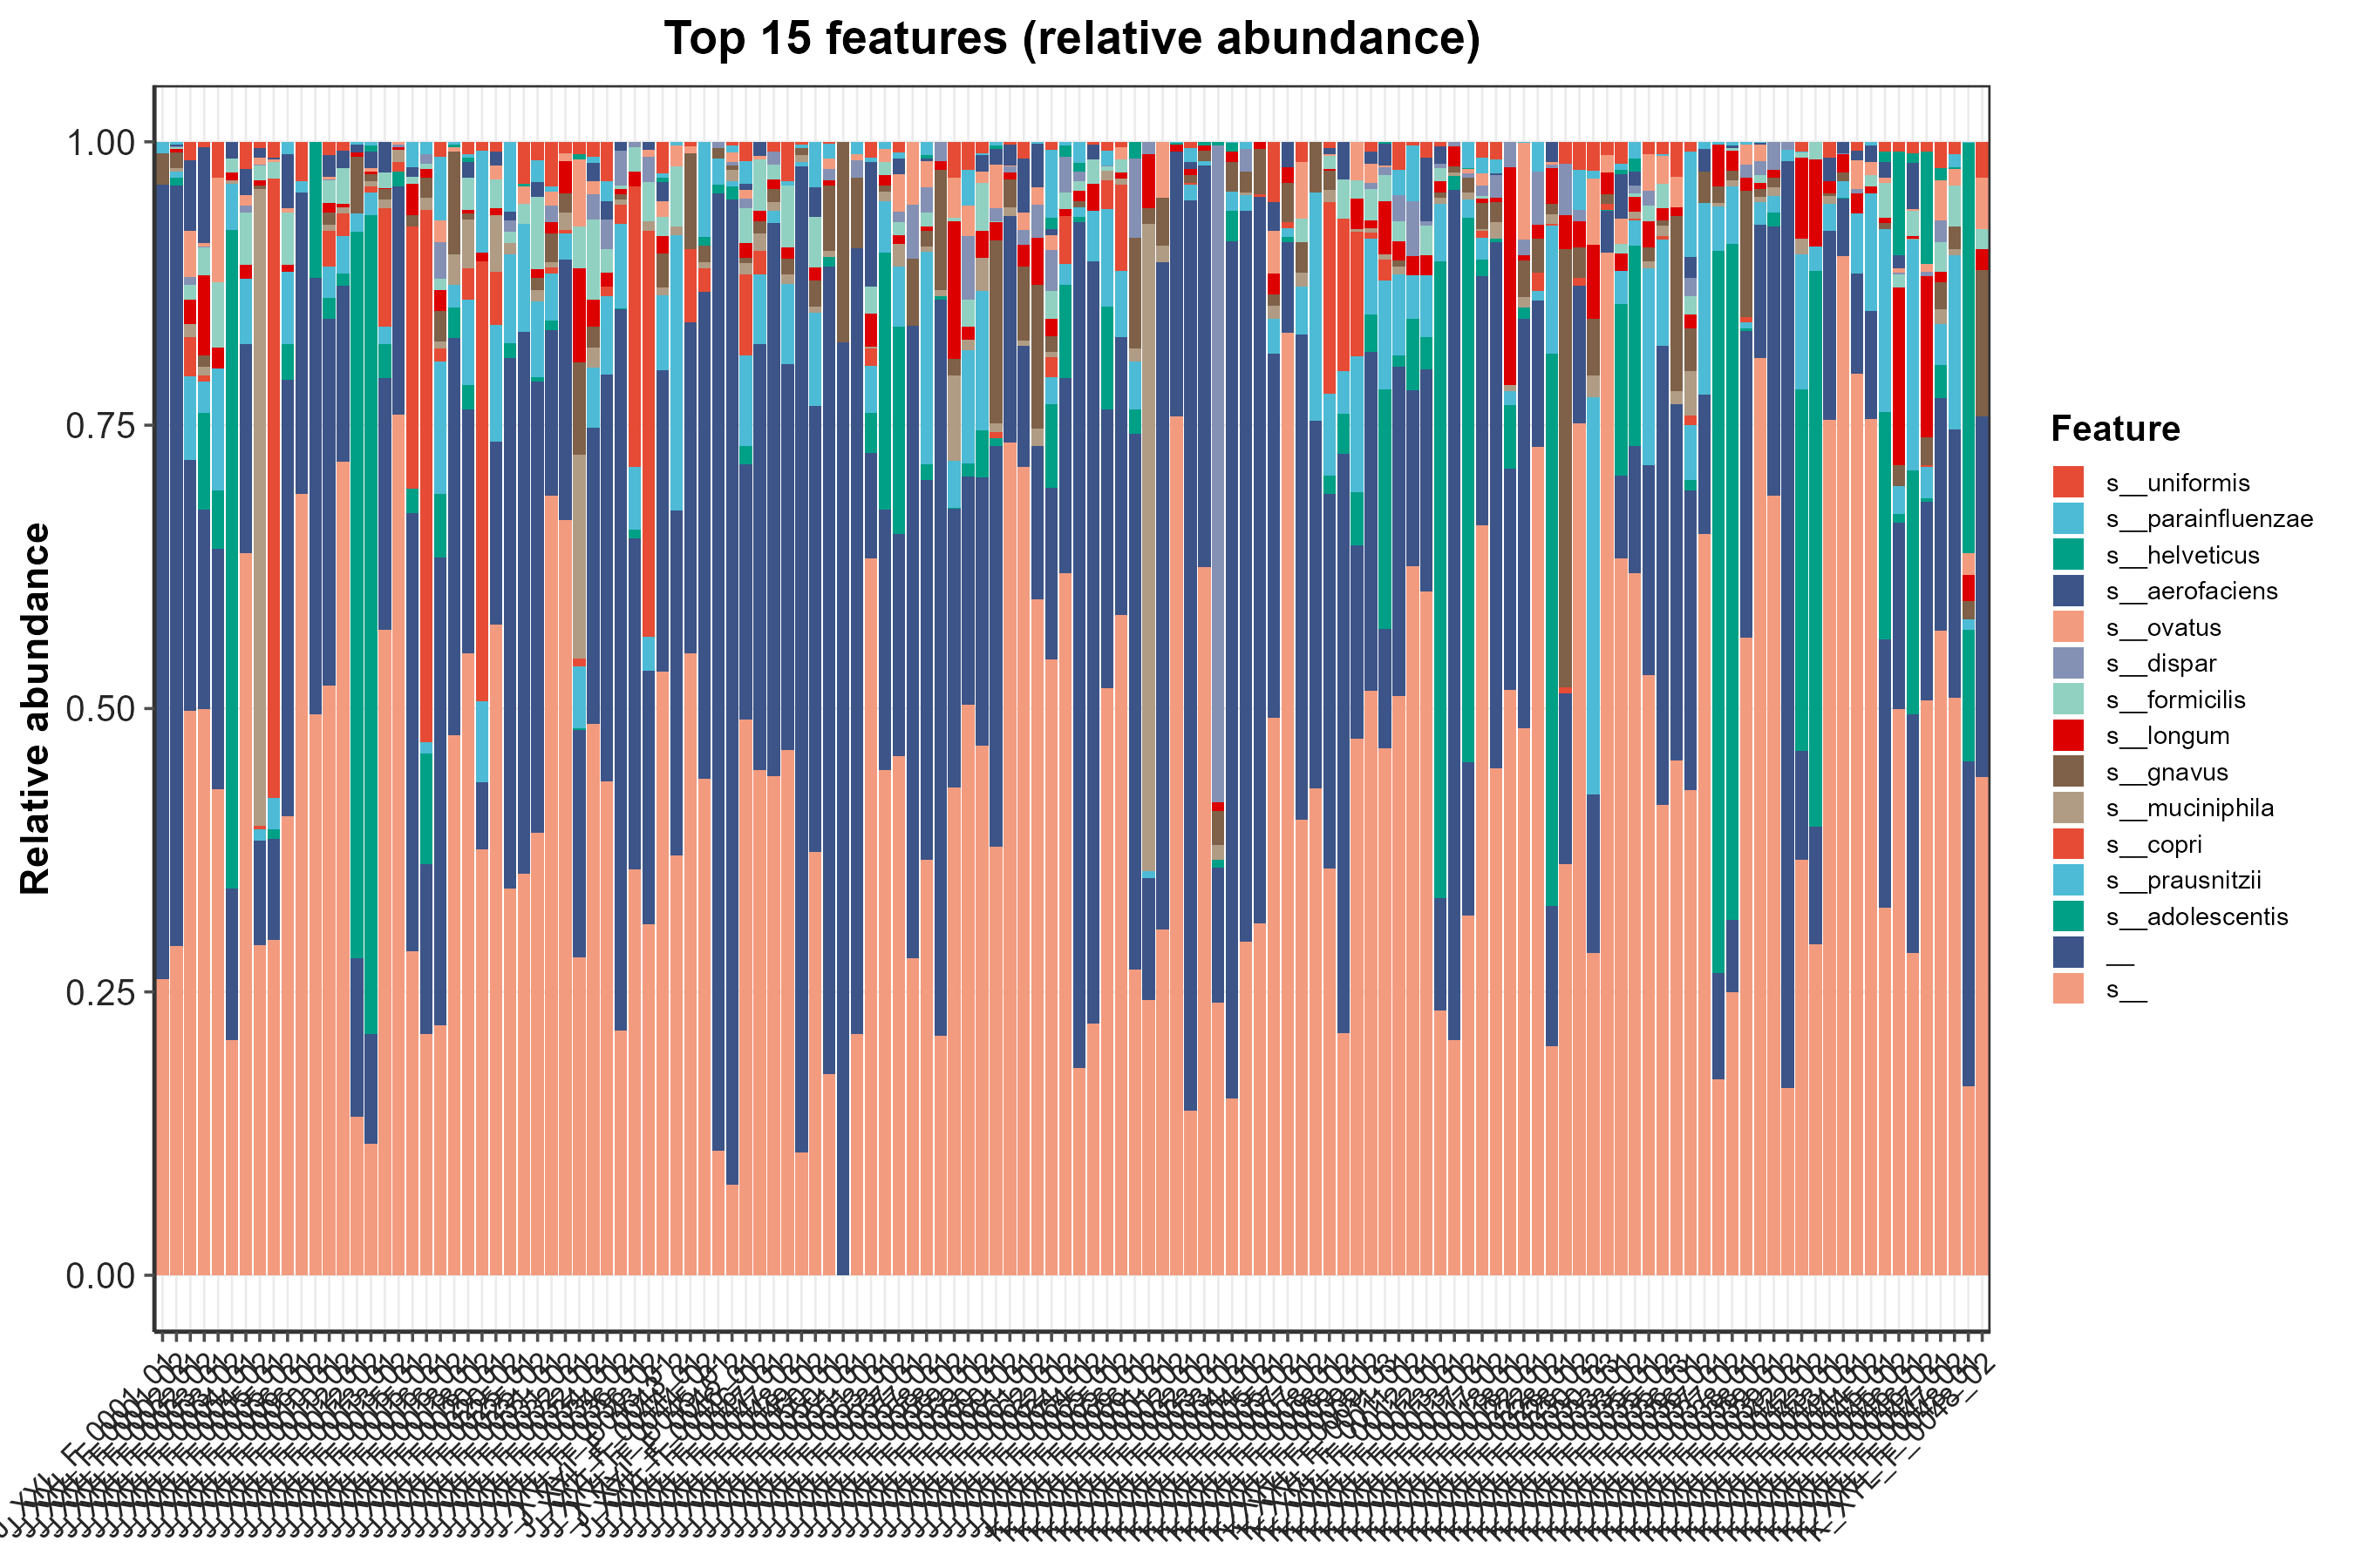
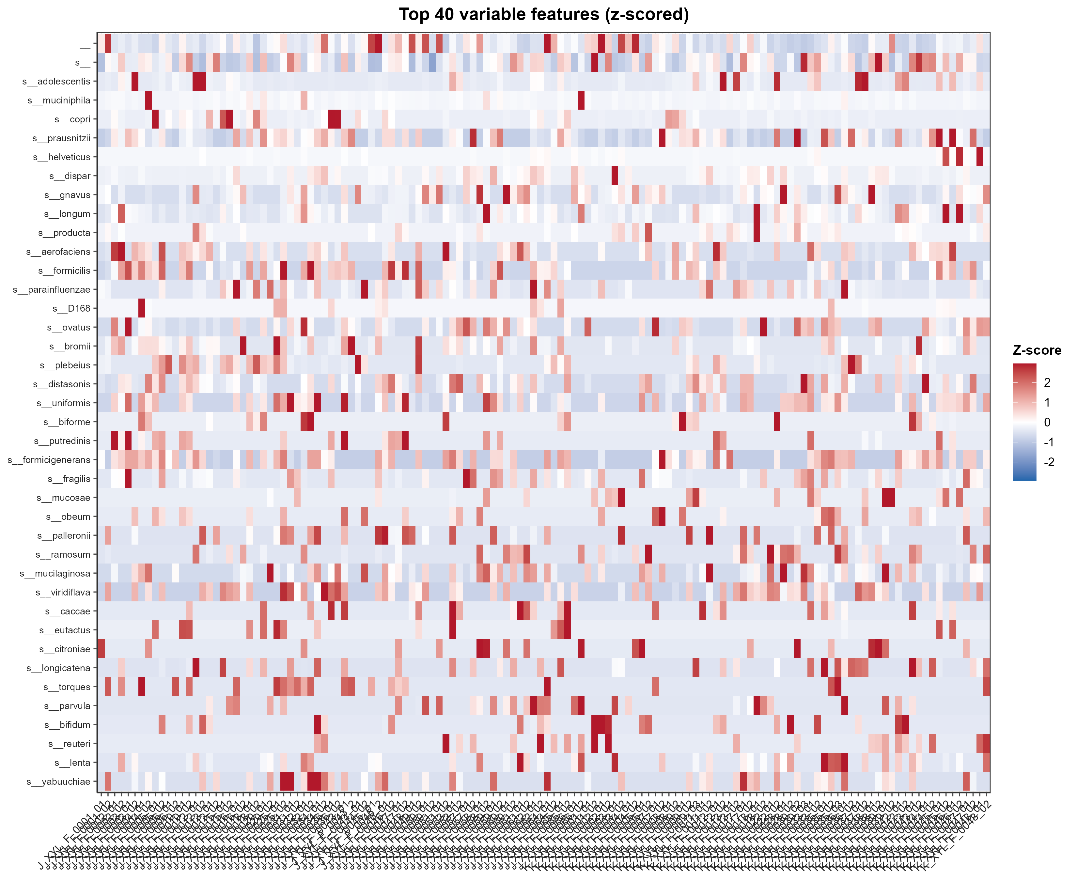

5. Scientific Hypothesis
In UC (but not IBS), the intervention reduces gut-microbiome alpha diversity (Shannon) without detectably reshaping community structure at genus resolution — it acts as an evenness eroder, not a community replacer: diversity falls via distributed erosion of moderate-abundance taxa, not replacement of a dominant genus.
Parameters supporting the hypothesis:
- Alpha: paired Wilcoxon on Shannon — UC p=0.023 (Δ=−0.12, significant ↓), IBS p=0.18; observed-species p=0.98 → evenness, not richness.
- Beta: Bray–Curtis PCoA + PERMANOVA Time R²=0.005 (p=0.67), dispersion homogeneous (p=0.93) → no restructuring.
- Differential: paired Wilcoxon, BH q<0.05 = 0 genera → distributed, not keystone, effect.
- Stratification: Disease PERMANOVA p=0.008 → disease-stratified analysis is required.
Follow-up prediction: species/ASV or metagenomic-functional resolution will localize eroded taxa to butyrate producers / mucus-associated commensals, and the UC diversity loss will correlate with clinical response (Group_sub poor/great) in a larger paired cohort.

6. Limitations
- Compositional (relative-abundance) data → PERMANOVA on proportions can be compositionality-biased.
- No taxon survives FDR → candidate genera are exploratory.
- Power: 35/29 pairs; subtle effects may be underpowered.
- No site/batch variable in metadata → residual confounding cannot be fully excluded.
- Genus resolution only; mechanism needs species/ASV or functional profiling.

