UNIVERSITY OF ENGINEERING AND TECHNOLOGY

MACHINE LEARNING

CLASS COURSE: INT 3405 20

FINAL PROJECT REPORT

Team members:

* Nguyen Dinh Minh
  + Student ID: 17021297
  + Class: K62-CA-CLC3
* Nguyen Tuan Anh
  + Student ID: 17021207
  + Class: K62-CA-CLC2

1. Goal of the Project

Project’s name: Winter/Summer Converter and Detector

Goal: The project is made to let the computer have the ability to detect if the input image is taken in summer or winter as well as to convert it to the opposite season – From Winter to Summer and from Summer to Winter

1. Use Cases and Features Installed
   1. Use Cases:

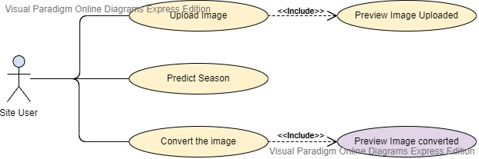

* 1. Features:
     + Upload Image and preview
     + Predict the season in the image uploaded
     + Convert the image uploaded to the opposite season – Winter to Summer or Summer to Winter

1. Implemented Technologies
   1. Tensorflow
   2. Flask
2. Difficulties and Solutions
   1. The quality of the image after converted is not as good as the one before conversion.
   2. Saving process is not fully optimized
3. Models’s Grading

* Easy to use, Image quality is low

1. Team members’ task
   1. Nguyen Dinh Minh: Training models, Combining models with the webpage
   2. Nguyen Tuan Anh: Creating webpage

Mục tiêu

Use Cases + tính năng đã cài đặt

Công Nghệ, kỹ thuật đã sử dụng

Các khó khăn + cách khắc phục

Đánh giá hiệu suất của mô hình

Công sức của các thành viên