Set up Cassandra to run integration tests:

Open a WinScp session, or use the tool of your choice to copy data to the VM

Copy the following from the test asset library to the /home/devuser/test data folder. Create the testdata folder if it doesn’t exist with mkdir command

foodmart_table_Creation.txt from the test asset library 9.0.0.0/resources

sales_fact_1998.csv and time_by_day.csv from 9.0.0.0/data

SSH to 172.16.10.61 (or node 1 for any cluster) as devuser

Create the foodmart keyspace and tables if it doesn’t exist:

Open the foodmart_table_Creation.txt using the editor of your choice and copy the CREATE KEYSPACE, CREATE TABLE sales_fact_1998 and CREATE TABLE time_by_day commands

CREATE KEYSPACE <name of the keyspace, i.e. foodmart> with REPLICATION = { 'class' : 'SimpleStrategy' , 'replication_factor' : 1 };

CREATE TABLE sales_fact_1998 (uid uuid primary key, product_id int, time_id int, customer_id int, promotion_id int, store_id int, store_sales float, store_cost float, unit_sales float);

CREATE TABLE time_by_day (uid uuid primary key, time_id int, the_date timestamp, the_day varchar, the_month varchar, the_year int, day_of_month int, week_of_year int, month_of_year int, quarter varchar, fiscal_period varchar);

Start a cqlsh session at /home/devuser

cqlsh 172.16.10.61 -u cassandra -p pentaho06

Paste the commands in the cqlsh command line, the commands should automatically be executed

Check that the tables where added.; cqlsh:foodmart> describe tables;

Load the foodmart data for each table using the cqlsh copy command:

COPY keyspace.tableName (col1,col2,col3.....) FROM 'file/file.csv' WITH DELIMITER=',' AND HEADER=TRUE;

Example:

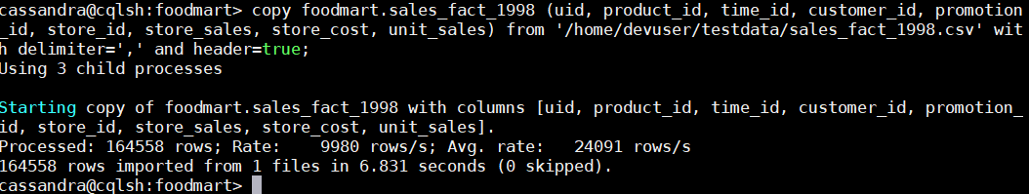

To Add Any New Foodmart Tables:

1. Read the table using the table Input step and output the results to a text file output step
2. Check the number of rows produced
3. Create UIDs (Cassandra requires a primary key) using a row generator set the limit to the number to equal the number of rows in the output.
4. Add the Random generator step, set name to UID and type to UUID
5. Set the results to a text file output
6. Open the text file output, copy the UID column. Open the text file output for the table that you want to add and insert the UID column. Save the updates.
7. The .csv / .txt file should reside in the 9.0.0.0/data folder in the test asset library
8. Create the CREATE TABLE statement for the table in the foodmart_table_Creation.txt file.
9. Update this document