Oracle Create a Database

1. You will need an ssh tool that has XServer capability, such as MobaXterm
2. Start an SSH session to the VM and login with the orauser credentials. If there you are not able to login as orauser, login as devuser and do the following:
   1. Sudo su - (to get to root user)
   2. Type passwd orauser and enter
   3. The system will prompt you for the password, use the same password as devuser
3. End the session
4. Create a new ssh session using the orauser account
5. Deploy the x11 forwarding package
   1. yum install xorg-x11-server-Xorg xorg-x11-xauth xorg-x11-apps -y
   2. <https://www.osradar.com/configure-x11-forwarding-in-centos-rhel-6-7-8-and-fedora-28-29/>
   3. Follow the instructions on the page to test that Xserver is working.
6. Install xMing on your windows laptop to install the X Server
   1. <https://sourceforge.net/projects/xming/>
7. Find the oracle home path, it should be something like /home/orauser/app/orauser/product/<product version: ex: 12.1.0>/dbhome_1
8. Edit the .bash_profile using vi and set $ORACLE_HOME and add it to PATH
   1. vi ~/.bash_profile
   2. type a to put vi into insert mode
   3. when you made the changes hit the esc key to put vi back to command mode and type :wq! to save changes and exit
9. type source ~/.bash_profile to reload the file
10. type echo $ORACLE_HOME to confirm the changes?

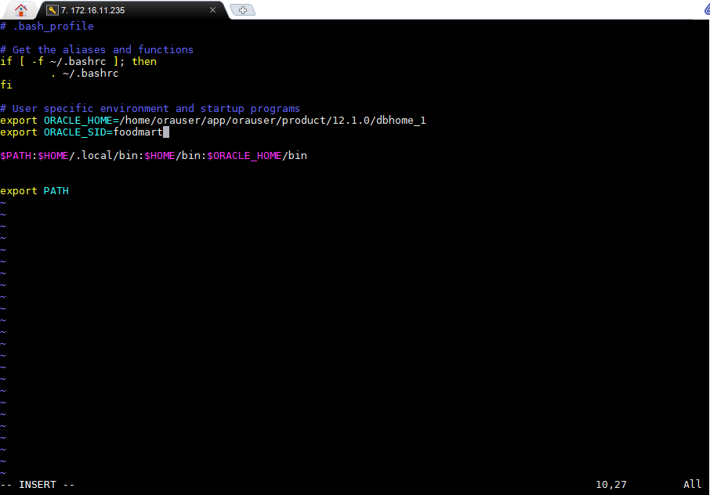

1. test the path by typing sqlplus /nolog on the command line. It should open SQL>
2. type exit on SQL> to run to return command line mode.
3. If SQLPLUS doesn’t open then the ORACLE_HOME path is not set correctly.
4. Open an ssh session as devuser and sudo su – to become root
5. We will need to increase the system memory size for shmall
6. vi etc/sysctl.conf
7. update the kernel.shmall=125828120
8. review the following page and validate the other parameters to make sure they meet or exceed the guidelines: <https://docs.oracle.com/database/121/LTDQ1/toc.htm#BHCCADGD>
9. While you can create a database manually, the easiest way and least likely to have issues is to use the Oracle Database Configuration Assistance.
   1. Manual reference: <https://docs.oracle.com/cd/B28359_01/server.111/b28310/create003.htm#ADMIN11074>
10. To launch type dbca on the command line: (This is a bit slow, so be patient)
    1. Enter the database name (foodmart or other)
    2. For Administrative Password, keep as Pentaho11 (what ever password given to sys by engOps

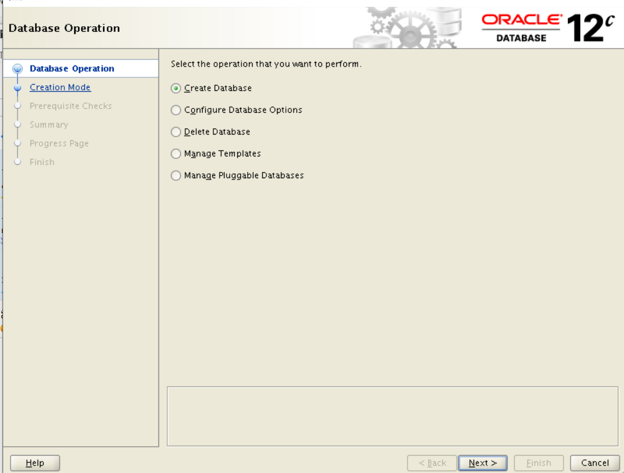

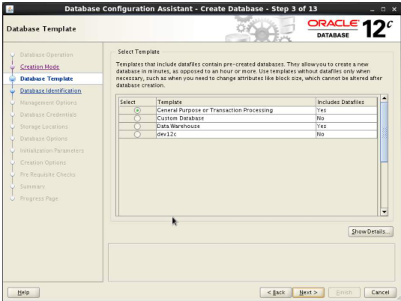

1. After the database creation is successful, you’ll be presented with a user screen, update sys and system with the same password given to sys by engOps (Pentaho11)
2. <https://www.dummies.com/programming/databases/how-to-use-the-database-configuration-assistant-dbca-to-create-databases-in-oracle-12c/>

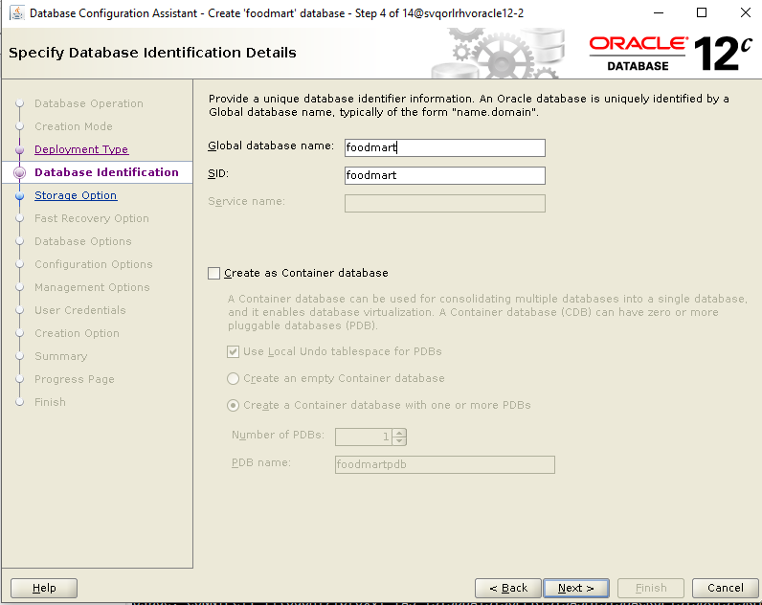

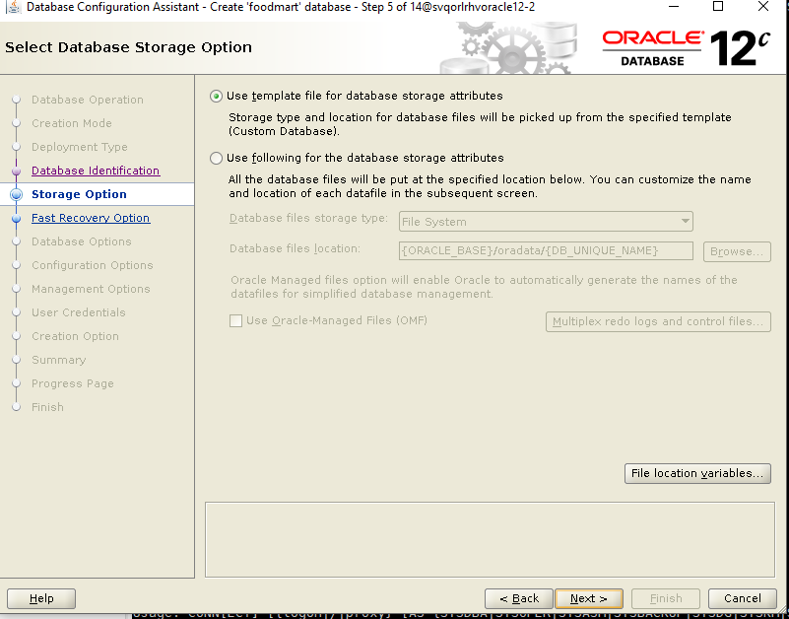

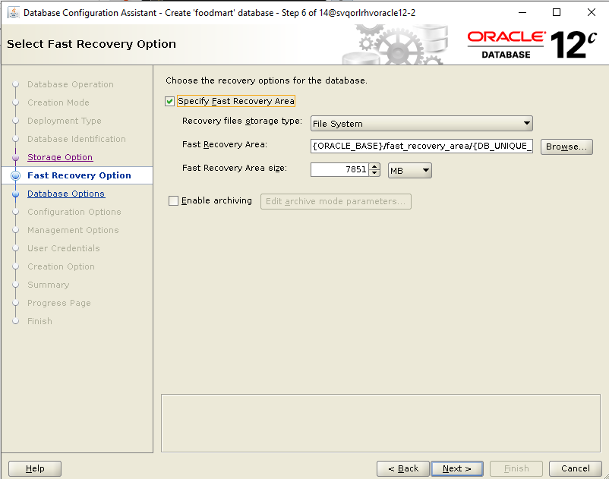

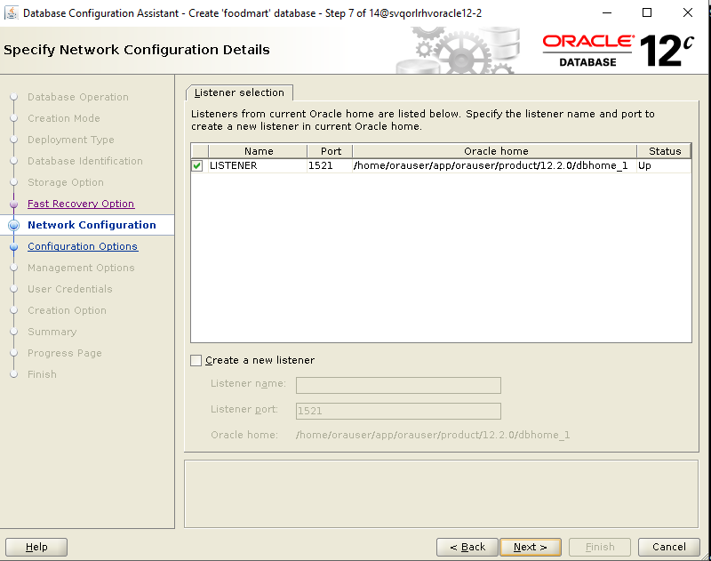

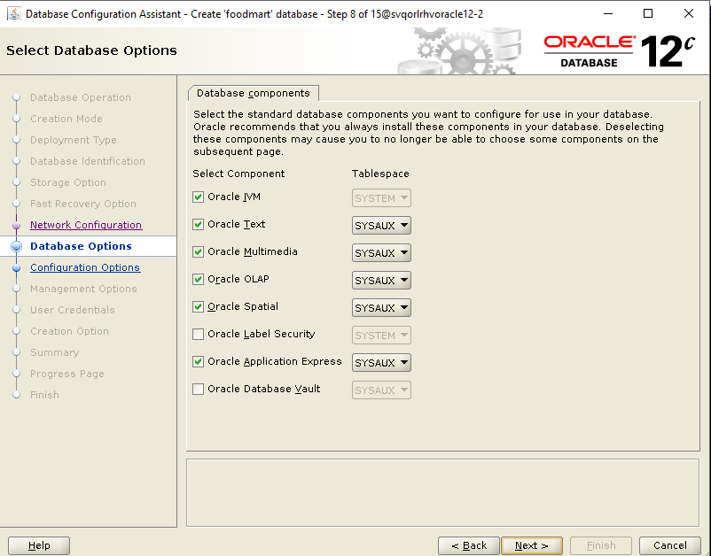

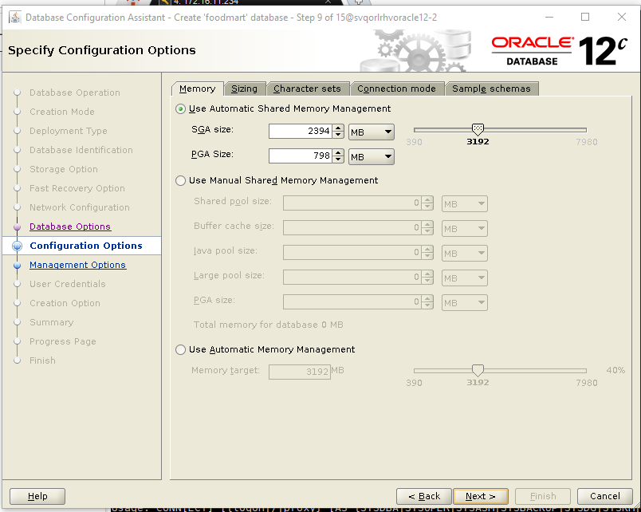

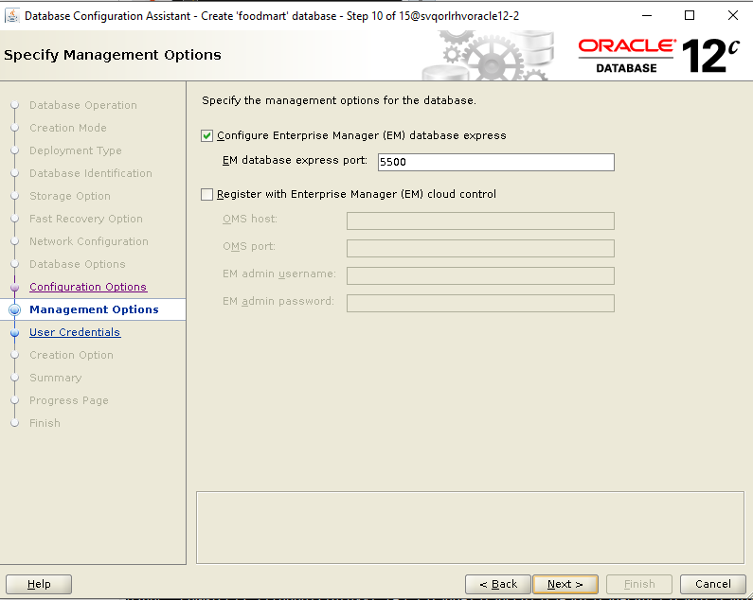

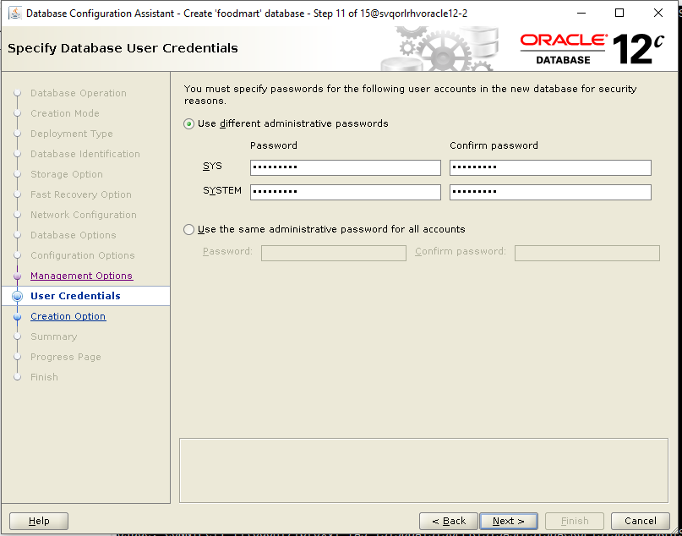

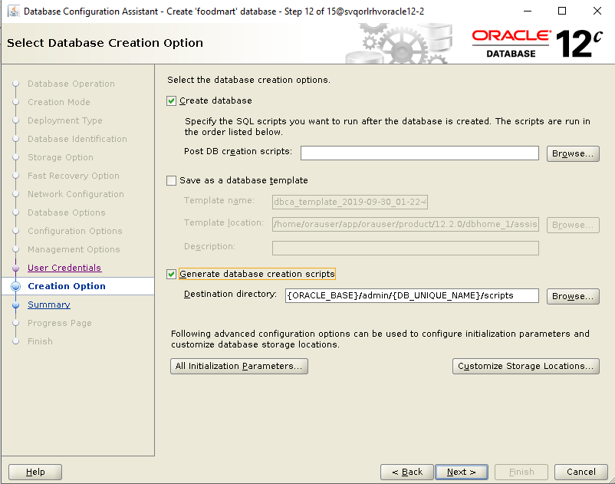

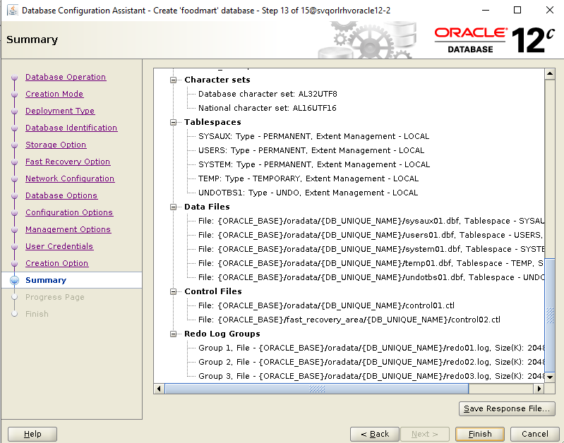

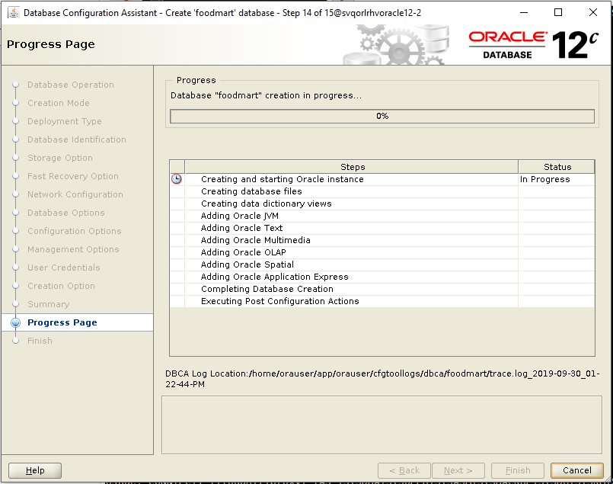

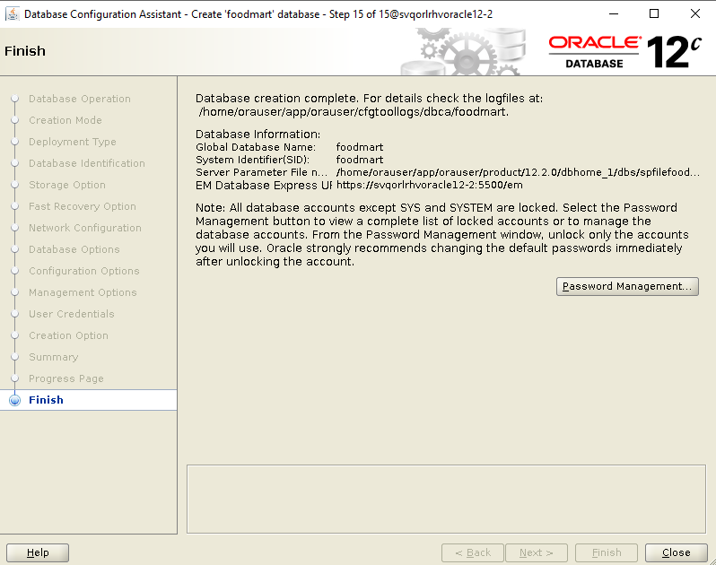

Check to see if database is up and running

Ps -ef | grep pmon

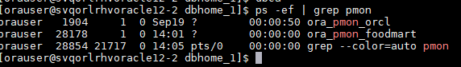

Check the status of the listener:

You should see that the service running includes foodmart.

Lsnrctl status

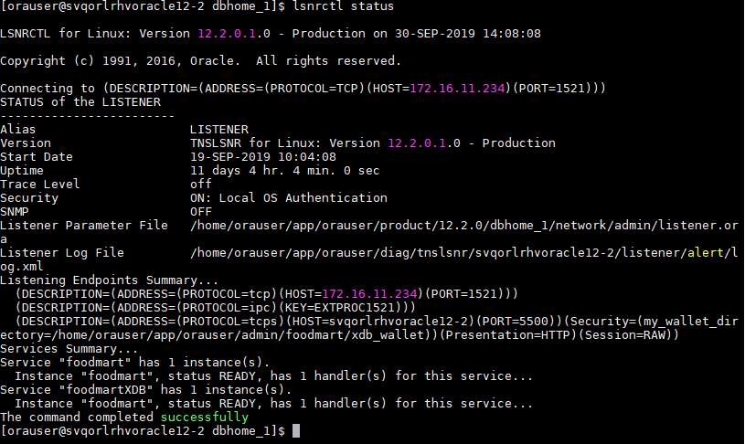

Start sqlplus and add a new user and grant permissions. This is the user that will be used with Pentaho products.

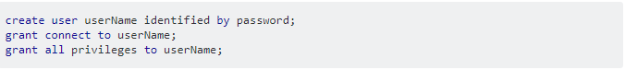

Shutdown the database and restart it for the user.

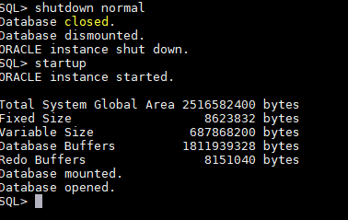ex

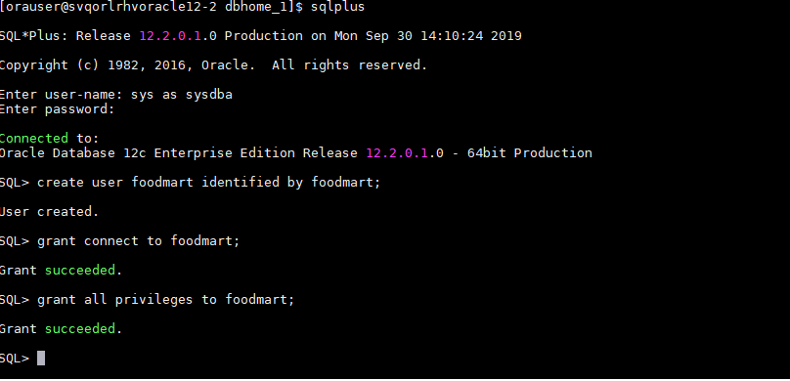

Add a database to the listener:

f you're pretty sure that your database instance is up and running, please check the parameter of local listener.

SQL> show parameter local_listener  
  
NAME                                 TYPE        VALUE  
------------------------------------ ----------- ------------------------------  
local_listener                       string       (ADDRESS=(PROTOCOL=TCP)(HOST=  
                                                 192.168.0.111)(PORT=1521))

Normally, we don't have to [set LOCAL_LISTENER parameter](https://docs.oracle.com/en/database/oracle/oracle-database/18/refrn/LOCAL_LISTENER.html) explicitly, because the database instance will look for an existing and appropriate local listener to register its services after startup. Once the listener accepts dynamic service registration, it facilitates connections to get database service subsequently.

Let's continue reading this post to see how we register the service in the listener.

**Solution**

In our case, we want it go to port 1522. Apparently, it went to the wrong port. Therefore, we corrected the setting by this:

SQL> alter system set local_listener='(ADDRESS=(PROTOCOL=TCP)(HOST=192.168.0.111)(PORT=1522))';  
  
System altered.  
  
SQL> show parameter local_listener  
  
NAME                                 TYPE        VALUE  
------------------------------------ ----------- ------------------------------  
local_listener                       string      (ADDRESS=(PROTOCOL=TCP)(HOST=1  
                                                 92.168.0.111)(PORT=1522))

Please note that, if the instance was startup with a SPFILE, it implied SCOPE=BOTH in the above statement. Otherwise, it implied SCOPE=MEMORY.

After setting the parameter, a background process called [listener registration (LREG) will discover the target listener in 60 seconds](https://docs.oracle.com/en/database/oracle/oracle-database/18/rilin/about-service-registration-for-an-oracle-rac-database.html) and send information such as the service name, instance names, and workload information to the listeners. Therefore, you don't have to register it by yourself.

Of course, you can override the 60-second delay of LREG by this SQL statement below:

SQL> ALTER SYSTEM REGISTER;

The above statement forces LREG to register with the listener in order to support the database service immediately.

Sqlplus / as sysdba

SQL>shutdown immediate

SQL>startup

Will it show **The listener supports no services** this time? Let's check the listener again.

[oracle@primary01 admin]$ lsnrctl status listener2  
...  
Listener Parameter File   /u01/app/oracle/product/12.1.0/db_1/network/admin/listener.ora  
Listener Log File         /u01/app/oracle/diag/tnslsnr/primary01/listener2/alert/log.xml  
Listening Endpoints Summary...  
  (DESCRIPTION=(ADDRESS=(PROTOCOL=tcp)(HOST=primary01)(PORT=1522)))  
  (DESCRIPTION=(ADDRESS=(PROTOCOL=ipc)(KEY=EXTPROC1522)))  
Services Summary...  
Service "SMALLDB" has 1 instance(s).  
  Instance "SMALLDB", status READY, has 1 handler(s) for this service...  
Service "SMALLDBXDB" has 1 instance(s).  
  Instance "SMALLDB", status READY, has 1 handler(s) for this service...  
The command completed successfully

AGG_L_05_SALES_FACT_1997

AGG_LC_06_SALES_FACT_1997

INVENTORY_FACT_1997

INVENTORY_FACT_1998

AGG_C_SPECIAL_SALES_FACT_1997

DAYS

SALES_FACT_1998

SALES_FACT_1997

AGG_C_10_SALES_FACT_1997

STORE_RAGGED

POSITION

ACCOUNT

EMPLOYEE_CLOSURE

AGG_L_03_SALES_FACT_1997

SALARY

WAREHOUSE_CLASS

CATEGORY

PRODUCT

AGG_LL_01_SALES_FACT_1997

AGG_G_MS_PCAT_SALES_FACT_1997

CUSTOMER

CURRENCY

SALES_FACT_DEC_1998

TIME_BY_DAY

WAREHOUSE

EMPLOYEE

CUSTOMER_BY_COUNTRY

DEPARTMENT

EXPENSE_FACT

AGG_L_04_SALES_FACT_1997

REGION

AGG_C_14_SALES_FACT_1997

PROMOTION

AGG_PL_01_SALES_FACT_1997

STORE

PRODUCT_CLASS

AGG_LC_100_SALES_FACT_1997

RESERVE_EMPLOYEE

Check the status of a Database Instance:

1. Run the **sqlplus "/as sysdba"** command to connect to the database.
2. Run the **select INSTANCE_NAME, STATUS from v$instance;** command to check the status of database instances.

Information similar to the following is displayed:

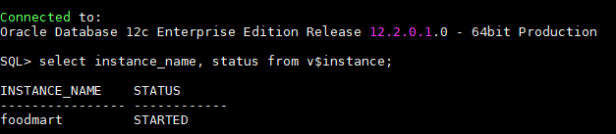

Restart the instance. The value of **audit_trail** takes effect only after the instance is restarted.

* Single-node system:

SQL>**shutdown immediate;**

SQL>**startup;**