<https://www.vertica.com/download/vertica/community-edition/>

You may need to create an account in order to download the file

Download the Vertica file.

Example: vertica-9.2.1-0.x86_64.RHEL6.rpm

Download the Management Console listed in the additional download section.

Example: vertica-console-9.2.1-0.x86_64.RHEL6.rpm

Move both the .rpm and console files to the VM under /home/devuser

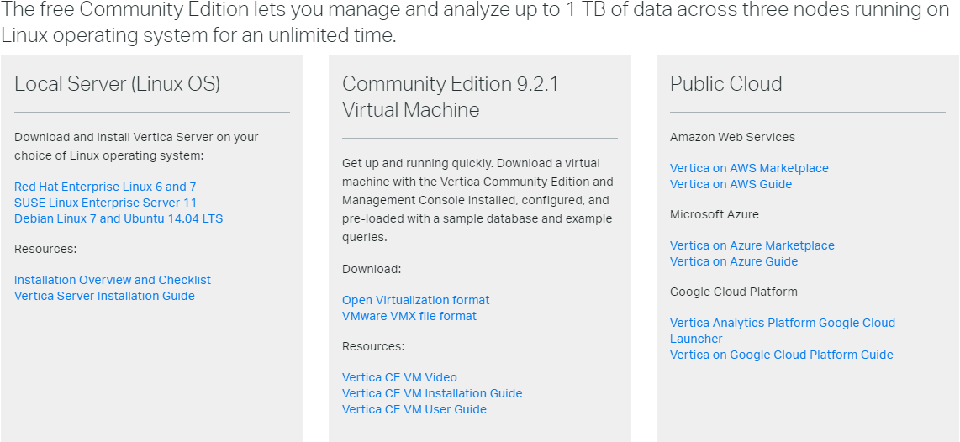

On the VM validate that Perl is installed by default (should be with RHEL)

perl -v

Run chmod 777 * to update permissions on /home/devuser

Run sudo yum install dialog

Run sudo rpm -Uvh <vertica-9.2.1-0.x86_64.RHEL6.rpm> or whatever package you are installing

If on RHEL, Run sudo setenforce PERMISSIVE

Update the vm.swappiness to 1 , sudo sysctl vm.swappiness=1

Run sudo systemctl mask firewalld

Run sudo systemctl disable firewalld

Run sudo systemctl stop firewalld

Run sudo /opt/vertica/sbin/install_vertica --hosts <hostname of VM> \

--rpm /tmp/vertica-9.2.1-0.x86_64.RHEL6.rpm \

Pentaho06

Run sudo rpm -Uvh vertica-console-*current-version*.x86_64.RHEL6.rpm

Open a browser https://<host name of VM>:5450

Complete the set up

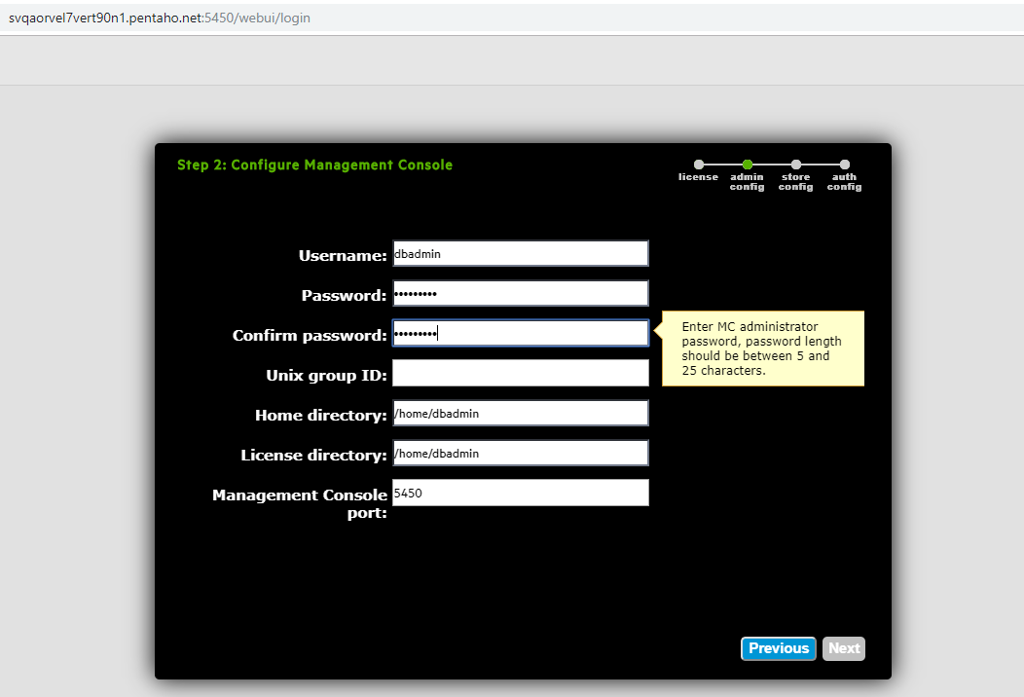

SSH into VM using dbadmin/<password> =password entered on installation for dbadmin

/opt/vertica/bin/adminTools

Click Ok on the license screen (we don’t need one with CE)

Select accept on Review and accept the EULA screen

At the main menu screen select 6 Configuration Menu

At the configuration menu screen select 1 Create Database

Enter a password for the db, use the same one as dbadmin

Select host for db this will be only the VM ip that is set up for Vertica

Leave the Catalog and Data pathname /home/dbadmin

Accept the risk of data loss with only 1 node

Stop/Start a Vertica DB

Stop:

[*dbadmin***@***bih001* **~**]$ *admintools* **-***t* *stop_db* **-***F* **-***d* *test* **-***p* *test*

*Issuing* *shutdown* *command* **to** **database**

**Database** *test* *stopped* *successfully*

Where the -t option is pointing to the tool is about to be used the -F it forces the stop in case any session are still running, -d it point to the database name, -p is the password.

Start:

[*dbadmin***@***bih001* **~**]$ *admintools* **-***t* *start_db* **-***F* **-***d* *test* **-***p* *test*

*Starting* *nodes*:

*v_test_node0001* (127.0.0.1)

*Starting* *Vertica* **on** **all** *nodes*. *Please* *wait*, *databases* **with** **large** *catalogs* *may* *take* *a* *while* **to** **initialize**.

*Node* *Status*: *v_test_node0001*: (*INITIALIZING*)

*Node* *Status*: *v_test_node0001*: (*INITIALIZING*)

*Node* *Status*: *v_test_node0001*: (*UP*)

*Running* *upgrade* *hooks*

**Database** *test* *started* *successfully*

Where the -t option is pointing to the tool is about to be used the -F it forces the start, -d it point to the database name, -p is the password.

Check Status:

$ /opt/vertica/bin/admintools -t view_cluster

DB | Host | State

---------+--------------+------------

<data_base> | 112.17.31.10 | RECOVERING

<data_base> | 112.17.31.11 | UP

<data_base> | 112.17.31.12 | UP

<data_base> | 112.17.31.17 | UP