

**E-commerce Website**

**Software Requirement Specification**

– Hanoi, September 2021–

**Table of Contents**

I. Overview

1. Introduction

2. System Functions

3. Common Requirements

II. Functional Requirements

# I. Overview

## 1. Introduction

*An E-commerce system is a new software system that draws on technologies such as mobile commerce, electronic funds transfer, supply chain management, Internet marketing, online transaction processing, electronic data interchange (EDI), inventory management systems, and automated data collection systems. E-commerce typically uses the web for at least a part of a transaction's life cycle although it may also use other technologies such as e-mail. Typical e-commerce transactions include the purchase of products (such as books from Amazon) or services (such as music downloads in the form of digital distribution such as iTunes Store). The system is expected to grow over several releases, eventually connecting to the service to become a place to trade items on the internet.*

*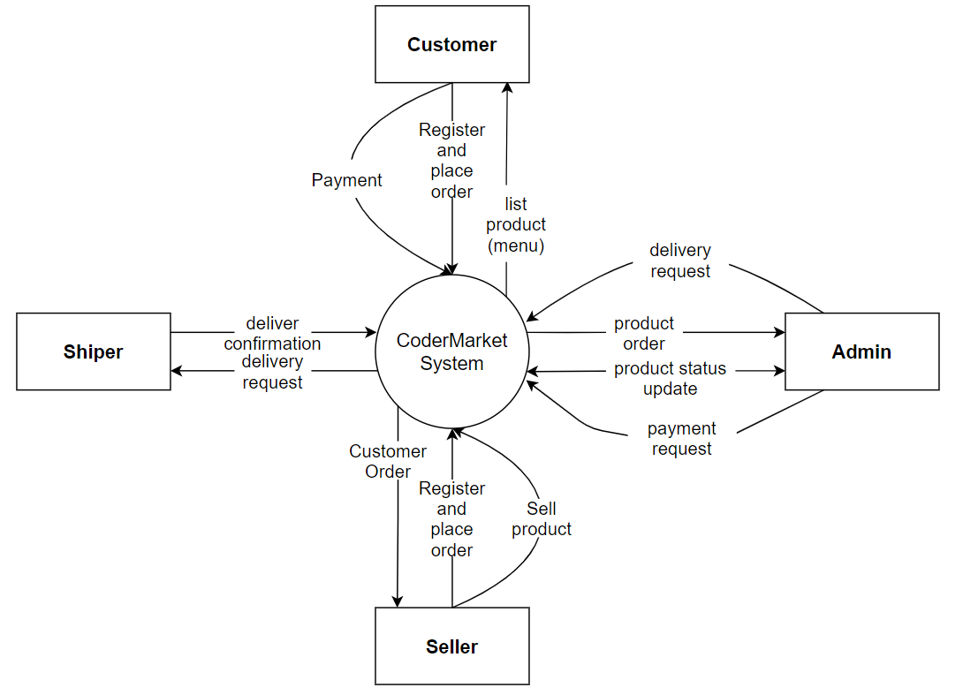*

## 2. System Functions

#### *a. Screen Flow* IMG_258

#### *b. Screen Details*

|  |  |  |  |
| --- | --- | --- | --- |
| **#** | **Function/Screen** | **Feature** | **Function/Screen Details** |
| 1 | Home Page | Public | Show brand slider, hot sales, latest product + the left sider ( Category List ) with the menu classify all the product with Category ( Laptop, PC components, Gear, ..), specify by Genre ( Office, Gaming, ...)  - Slider information: image, title of the brands.  - Left sider information: title, category (genre inside category title); the user is redirected to the page that corresponding to user's clicking. |
| 2 | Category List | Public | Display at the left sider (include thumbnail, title, brief-info), the user is redirected to the product list filtered by chosen category on his/her clicking. |
| 3 | Category Detail | Public | Display when hover category's info, classify category more specify by genre, the user is redirected to the product list filtered by chosen genre on his/her clicking. |
| 4 | User Login | Common | Allows the user to enter username & password to login ( or login with social account ); on this page, there are also links for user to register new information or reset the password for the case user forget it |
| 5 | User Register | Common | Allows the user to register to the system by input following information: full name, user title (Mr, Mrs, Ms,..), email, mobile, address; |
| 6 | Reset Password | Common | The user to input his/her email and phone. If it correct with the info of the account:  - On clicking the link, the user will be able to input new password (twice) |
| 7 | Change Password | Common | This is a pop-up screen which allows the user to change his/her password by inputting his current password as well as new password (twice) |
| 8 | User Profile | Common | This is a pop-up screen which allows the user to update his/her profile information, including the registered ones & the avatar image. |
| 9 | User Authorization | Common | Implementation of authorization mechanism in the system, including the specify the role of logged-in user, his/her authorized page links (building the displayed menu items (in the front end) and preventing unauthorized access via enter the links directly) |
| 10 | Blogs List | Public | Show the posts paginatedly (sorted by updated date, paginated) + the sider with the post search box, the latest posts, and static contacts/links; Shown post information includes its thumbnail, title, brief-info; the user is redirected to the post's details on his/her clicking |
| 11 | Blogs Detail | Public | Show post details (including title, author, updated date and post details) + the sider with the post search box, post categories, static contacts/links |
| 12 | Cart Details | Public | User need to log in to use Cart. Show list of the user's chosen products (including Id, title, price, quantity, total cost) and the total order price. The user can:  - Change the quantity of each product: the total cost is automatically adjusted.  - Choose to delete/remove product by clicking on the deleting icon.  - User can click the Back to Homepage button  - Click the Check Out button to go to the Payment page. |
| 13 | Payment | Public | Show the list of user chosen product (including id, title, price, quantity, total cost), the total order price, the receiver information would be filled with the user's information, user can choose payment method and delivery method (different shipping fees ).  - The user can back to Cart for changing the choosing products, click the Submit button to submit the order before redirecting user to the Card Completion or Error page (due to technical error or any out-of-stock product) |
| 14 | Cart Completion | Public | This page show the cart completion notes. Before this page is shown:  - The Order status changed to wait for shipping.  - The product's available quantities are updated accordingly.  - The submitted order is assigned automatically to the active sellers rotatedly.  - The customer/user would be receive a confirmation of order received. The information of order and payment is shown on the page also. The payment and order information are taken from the system configuration file. |
| 15 | Feedback | Public | On receiving the bought products successfully, the user/receive could also give the feedback on specific product via the website.  The feedback information includes: contents, rated star. |
| 16 | Products List | Public | Show the products paginatedly (sorted by updated date) + the sider with product categories, category genres:  - Shown product information includes its thumbnail, title, brief information, original price, and sale price.  - The user is redirected to the product's details on his/her clicking on the product. |
| 17 | Product Details | Public | Show product details (including title, category, images, original price, sale price, and product details).  - The user can choose to add the product to the cart or view feedback and rated star by the previous buyer. |
| 16 | Suggests (By Category) | Public | Show the products corresponding to categories, category genres with the product displaying:  - Shown product information includes its thumbnail, title, brief information, original price, and sale price.  - The user is redirected to the product's details on his/her clicking on the product. |
| 17 | Product Seller List ( same Seller ) | Public | Show the products are in same seller ( shop ) with the product displaying:  - Shown product information includes its thumbnail, title, brief information, original price, and sale price.  - The user is redirected to the product's details on his/her clicking on the product. |
| 20 | My Orders | Customer | Show the list of user's orders paginatedly + the Product List at the left sider  - Each order include below information: id, ordered date, product (first product name & number of other products if any), total cost, status;  - On clicking the link under the order id, user would be redirected to the Order Information page. |
| 21 | Order Information | Customer | Show the order details, including the information as below + the sider with the product search box, product categories, the latest products, and static contacts/links  - The order id, order date, total cost, status  - The receiver information: full name, gendar, email, mobile  - This list of ordered products, each product include following information & the links/buttons that allow the user to re-buy or feedback: thumbnail, name, category, unit price, quantity, total cost  For the wait for shipping orders, the user can choose to update (redirect the user to the Cart Details page for that) or cancel the order. Cannot update or cancel if the order in shipping status. |
| 22 | Products List ( seller ) | Marketing | Show the paginated list of products (include products' id, thumbnail, title, category, list price, sale price, featured, and status information):  - The user can filter the product by category, status or search by title, brief info  - Sortable by title, category, list price, sale price, featured, or status  - From each product, the user can choose to hide, show, view, edit it  - The page also have the button/link that allows the user to add new product |
| 23 | Product Details ( seller ) | Marketing | Show detailed product information (thumbnail, category, title, brief information, attached images, description, quantity, list price, sale price, flag to turn the featuring on/off, status), from that allow the user to input, view or edit them |
| 24 | Customers List ( seller ) | Marketing | Show the list of customers / contacts paginatedly (include contacts' id, full name, gender, email, mobile, status):  - The user can filter the customers by status + search by full name, email, mobile  - Sortable by full name, email, mobile, status  - From each customer, the user can choose to add new, view or edit it |
| 25 | Customer Details ( seller ) | Marketing | Show detailed customer/contact information (full name, gender, email, mobile, address, status), from that allow the user to input, view or edit them (except for the status which is generated automatically - contact, potential or customer)  Besides, the screen also shows the list of customer/contact changes history in the form of a table which includes following columns: email, full-name, gender, mobile, address, updated by, updated date |
| 26 | Feedbacks List | Marketing | Show the list of feedbacks paginatedly (include feedbacks' contact full name, product name, rated star, status):  - The user can filter the feedbacks by status, product, rated star + search by full name, feedback content  - Sortable by full name, product name, rated star, status  - From each feedback, the user can choose to view or change it's status |
| 27 | Feedback Details ( seller ) | Marketing | Show the feedback details of all user's product (contact full name, email, mobile, product, rated star, feedback, images status) from that allow the user to change its status |
| 28 | Seller Dashboard | Sale | Show the trend of success/total orders, and the revenues trends by day for the last 7 days for all or a specific sale person (the start date, end date, sale, order status can be adjustable) |
| 29 | Orders List ( seller ) | Sale | Show the list of orders paginatedly  - The list can be shorted by the order date, customer name, total cost, status  - Each order include below information: id, ordered date, customer name, product (first product name & number of other products if any), total cost, status;  - Allow the users to filter the order by the order date (from, to), sale name, status  - Allow the user to search the orders by order id, customer name  - On clicking the link under the order id, user would be redirected to the Order Details page |
| 30 | Order Details ( seller ) | Sale | Show the order details, including the following information:  - Basic order information: order id, customer full name, email, mobile, order date, total cost, sale name, status  - The receiver information: full name, gender, email, mobile, address  - This list of ordered products, each product include following information: thumbnail, name, category, unit price, quantity, total cost  Sale Manager & the assigned Sale can change the order status & the sale notes  Sale Manager can assign the order to other sale |
| 31 | Admin Dashboard | Admin | Show statistics of new orders (success, cancelled, submitted), revenues (total, by product categories), customers (newly registered, newly bought), feedbacks (average star: total, by product categories) & the trend of order counts (success, all) by day for the last 7 days (the start date & end date can be adjustable) |
| 32 | Users List ( admin ) | Admin | Show the paginated list of registered users (include users' id, full name, gender, email, mobile, role, status):  - The admin can filter the users by gender, role, status  - Allow the admin to search users by full name, email, mobile  - The list is sortable by id, full name, gender, email, mobile, role, status  - From each user, the admin can choose to view or edit it  - The page also have the button/link that allows the admin to add new user |
| 33 | User Details ( admin ) | Admin | Show detailed user information (avatar, full name, gender, email, mobile, role, address, status), from that allow the user to add new, view or edit user information  - After adding, new generated login password would be email to the new user  - The admin can only edit/update the role and status of the user |
| 34 | Settings List | Admin | Show the paginated list of settings (include settings' id, type, value, order, status):  - The admin can filter the setting by type, status  - Allow the admin to search settings by value  - The list is sortable by id, type, value, order, status  - From each setting, the admin can choose to view, activate/deactivate, or edit it  - The page also have the button/link that allows the admin to add new setting |
| 35 | Setting Details | Admin | Show detailed user information (type, value, order, description, status), from that allow the user to add new, view or edit setting information |

***c. User Authorization***

|  |  |  |  |  |
| --- | --- | --- | --- | --- |
| **Screen** | **Guest** | **Customer** | **Seller** | **Admin** |
| Login | x | x | x | x |
| Login | x | x | x | x |
| Forgot Password | x | x | x | x |
| Register | x | x | x | x |
| Home Page | x | x | x | x |
| Query All Product | x | x | x | x |
| Cart |  | x | x | x |
| Sales Management |  |  | x |  |
| Product Detail | x | x | x | x |
| Product Detail | x | x | x | x |
| Query Product | x | x | x | x |
| Add To Cart |  | x | x | x |
| Comment |  | x | x | x |
| Rating |  | x | x | x |
| Cart |  | x | x | x |
| Create Order |  | x | x | x |
| Order Management |  | x | x |  |
| Query Own Order |  | x | x |  |
| User Management |  |  |  | x |
| Query All User |  |  |  | x |
| Add New User |  |  |  | x |
| Update User |  |  |  | x |
| Delete User |  |  |  | x |
| Genre Management |  |  |  | x |
| Query All Category |  |  |  | x |
| Add New Category |  |  |  | x |
| Update All Category |  |  |  | x |
| Delete Category |  |  |  | x |
| Category Management |  |  |  | x |
| Query All Genre |  |  |  | x |
| Add New Genre |  |  |  | x |
| Update All Genre |  |  |  | x |
| Delete Genre |  |  |  | x |
| User Profile |  | x | x | x |
| View Own Profile |  | x | x | x |
| Update Own Profile |  | x | x | x |
| Change Password |  | x | x | x |
| Sales Management |  |  | x |  |
| Query Own Product |  |  | x |  |
| Add New Product |  |  | x |  |
| Update Own Product |  |  | x |  |
| Delete Own Product |  |  | x |  |
| Revenue |  |  | x |  |
| Ship Management |  |  |  | x |
| Query All Ship Company |  |  |  | x |
| Update Ship Company |  |  |  | x |
| Add New Ship Company |  |  |  | x |
| Delete Ship Company |  |  |  | x |
| Warehouse Management |  |  |  | x |
| Query All Warehouse |  |  |  | x |
| Update Warehouse |  |  |  | x |
| Add New Warehouse |  |  |  | x |
| Delete Warehouse |  |  |  | x |

#### *d. Non-Screen Functions*

|  |  |  |  |
| --- | --- | --- | --- |
| **#** | **Feature** | **System Function** | **Description** |
| 1 | Shipping Cost | Google API | Use Google Maps to calculate the shipping cost based on distance. |
| 2 | Storage | Google API | Find the nearest storage to the user in order to shorten delivery time and to save cost. |

## 3. Common Requirements

+ **Guest:**Login, Register, Shopping, Search Product.

+ **Customer:** Login, Logout, Forgot password, Register, Change password, Update Profile, Shopping, Search Products, Recharge, Top up, View products detail, Cart Management, Comment, Rating

+ **Seller:** Login, Logout, Forgot password, Register, Change password, Update Profile, Shopping, Search Products, Recharge, View products detail, Cart Management, Sell products,  Products management, Sales, Orders management, Revenue, Comment, Rating,

+ **Admin:**  Login, Logout, Forgot password, Register, Change password, Update Profile, Accounts Management, Genre management, Category management, Shipping Management, Storage management, List all products by category,…

# II. Functional Requirements

|  |  |
| --- | --- |
| **Function Requirement No.** | **Function Requirement Description** |
| 1. User Login | + Enter the correct username and password to access the website  + Passwords should be hashcode for security  + *The user clicks the Remember me button to automatically save the account password*  + If the user forgot the password, it should be reset thanks to gmail and phone number |
| 1. User Register | + Do not duplicate username, phone number, and gmail |
| 1. Home Page | + List all products, by category, by genre, etc… |
|  |  |
|  |  |