“数据库系统原理”练习题

姓名 学号 专业

**Major**

**Book**

**Category**

**Student**

**Borrow**

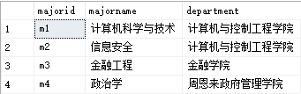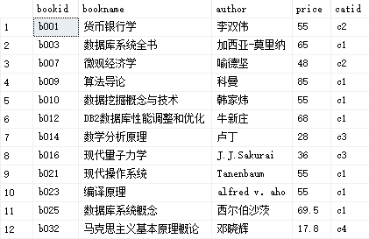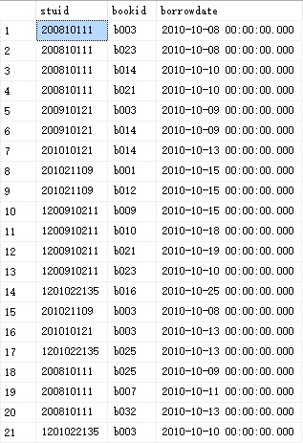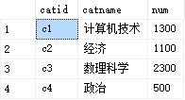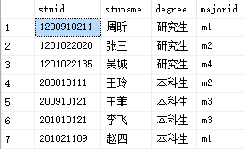

答案以Word文件的方式提交，文件名为“学号_姓名.docx”。每个题目的SQL语句都必须在查询分析器中调试，运行无误后提交查询的SQL语句（文字）和查询结果（截图），注意：查询结果集中的列名必须采用查询需求中给出的列名。

数据库模式如下：

图书类别（类别编号，类别名， 藏书数目）

图书（图书编号，书名，作者，价格，类别编号）

学生（学号，姓名， 学生类别）

借书情况（学号，图书编号，借书日期）

专业（专业编号，专业名称，学院名称）

注：上面数据仅供参考，具体的SQL语句不应该和具体的数据有关

1、给出"DB2数据库性能调整和优化"这本书的图书编号和价格(图书编号,价格)

select bookid as '图书编号',catid as'价格'

from book

where bookname='DB2数据库性能调整和优化'

2、给出图书类别编号为"c1"且图书价格最贵的**两**本书(bookid,bookname,author,price)

select top (2) bookid,bookname,author,price

from book

where catid='c1'

order by price desc **(sql默认升序，desc降序,asc升序)**

3、哪个学院的人数最多，共有多少人？（学院，人数）

select top (1) department as'学院',count(*)as '学院人数'

from major left join student on major.majorid=student.majorid

group by department

order by count(*) desc

4、请列出在2010年10月9日和13日之间与数据库有关的图书（书名包含“数据库”的图书）的借阅信息，并且按照借书时间从小到大排列(stuid, bookid, bookname，borrowdate)

select stuid,borrow.bookid,bookname,borrowdate

from borrow,book

where borrowdate between '2010-10-09' and '2010-10-13' and borrow.bookid=book.bookid

and bookname like '%数据库%'

order by borrowdate asc

5、在2010-10-10以后（包括2010-10-10），谁借的书最多（stuid，stuname，borrownum）

select borrow.stuid,student.stuname, count(borrow.stuid)'borrownum'

from borrow left join student on student.stuid=borrow.stuid

where borrowdate>='2010-10-10'

group by borrow.stuid,student.stuname

having count(borrow.stuid)=

(select max(borrownum)

from(select count(stuid) as 'borrownum'

from borrow

where borrowdate>='2010-10-10'

group by stuid) as A)

6、哪些书没有被“计算机与控制工程学院”的本科生借阅过（bookid，bookname，author）

select bookid,bookname,author from book

where bookid not in

(select bookid from

(select stuid

from student left join major on student.majorid=major.majorid

where department='计算机与控制工程学院' and degree='本科生') A

left join borrow on A.stuid=borrow.stuid)

7、给出每个专业借阅的“c2”类的图书总数，没有借阅的次数显示为0（majorid，majorname，borrowcount）

select majorid,majorname,count(borrow.bookid)'borrowcount' from

(select major.majorid,majorname,stuid

from major left join student on major.majorid=student.majorid) A

left join borrow on A.stuid=borrow.stuid and bookid in (select bookid from book where catid='c2')

group by majorid,majorname

8、给出被所有本科生都借阅过的图书(bookname,author)

select bookname,author

from

(

select bookid,count(stuid) as 'cishu'

from

(

select A.stuid,stuname,degree,majorid,bookid,borrowdate from

(select *

from student

where degree='本科生') A

left join borrow on A.stuid=borrow.stuid) B

group by bookid

having count(stuid)=(select count(*)

from student

where degree='本科生')

) C left join book on C.bookid=book.bookid

9、已知每本图书最多可借阅30天，“计算机技术”类图书每超出一天需交费0.8元，其它类图书每超出一天需交费0.5元，假设王玲在2010-10-11后（包括2010-10-11）所借的书都未归还，问王玲在2010-11-20那天需向图书馆交纳多少钱？从1月1号到1月2号视为借阅了1天）。（stuname, priceSum）

declare @now datetime;

set @now='2010-11-20'

select stuid,sum(priceSum) as 'priceSum'

from

(

select stuid,A.bookid,borrowdate,subdate,bookname,book.catid,catname,case when catname='计算机技术' then subdate*0.8 else subdate*0.5 end as 'priceSum'

from

(

select stuid,bookid,borrowdate,convert(int,datediff(day,borrowdate,@now)) as 'subdate'--,case convert(int,datediff(day,borrowdate,@now))>40 then 'bad'else 'ok' end

from borrow) A left join book on A.bookid=book.bookid

left join category on book.catid=category.catid

) B

where stuid = (select stuid from student where stuname='王玲')

group by stuid

10、给出被学号为'200910121'的学生借阅次数最多的图书类别（catid, catname, borrowcount）

select book.catid,catname,count(*) as 'borrowcount'

from

(select *

from borrow

where stuid='200910121') A

left join book on A.bookid=book.bookid

left join category on book.catid=category.catid

group by stuid,book.catid,catname