Name:...........................................

Class:...........................................



**Mathematics for Engineering**

Exercise Book

Trần Thanh Hiệp - 2021

**CALCULUS**

**Chapter 1: Function and Limit**

1. Find the domain of each function:

a.  b.  c. 

2. Find the range of each function:

a.  b.  c. 

3. Determine whether is even, odd, or neither

a.  b.  c. 

4. Explain how the following graphs are obtained from the graph of *f(x)*

a.  b.  c.  d. 

5. Suppose that the graph of  is given. Describe how the graph of the function  can be obtained from the graph of .

6. Let  and  . Find each function

a.  b.  c.  d. 

7. Let  . Find

a.  b. 

|  |  |  |  |  |  |  |
| --- | --- | --- | --- | --- | --- | --- |
| *x* | 1 | 2 | 3 | 4 | 5 | 6 |
| *f(x)* | 3 | 1 | 4 | 2 | 2 | 5 |
| *g(x)* | 6 | 3 | 2 | 1 | 2 | 3 |

8. Use the table to evaluate each expression

a. f(g(1)) b. g(f(1)) c. f(f(1)) d. g(g(1))

e.  f. 

9. Evaluate the following limits

a.  b.  c.  d. 

e.  f.  g.  h. 

10. Determine whether each curve is the graph of a function of *x*. If it is, state the domain and range of the function.

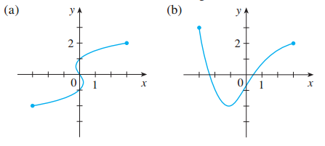

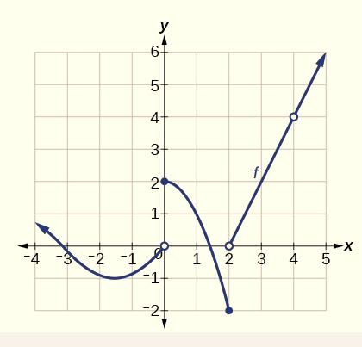11. The graph of *f* is given.

a. Find each limit, or explain why it does not exist.

i.  ,  and 

iii.  and 

b. At what numbers is discontinuous?

12. Determine where the function  is continuous

a.  b.  c. 

13. Find the constant *m* that makes *f* continuous on R

a.  b. 

c.  d. 

14. Find the numbers at which the function  is discontinuous.

**Chapter 2: Derivatives**

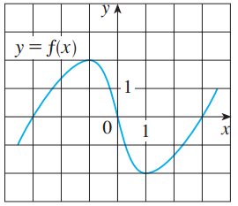1. Use the given graph to estimate the value of each derivative

a.  b. 

c.  d. 

2. Find an equation of the tangent line to the curve at the given point:

a.  b. 

c.  d. 

3. Find 

a.  b.  c. 

d.  e.  f. 

4. Find 

a.  b.  c. 

5. Find  for:

a.  and  b.  and 

c.  and  d.  and 

6. Find  for:

a.  b.  c.  ,  and 

7. The graph of is given. State the numbers at which is not differentiable

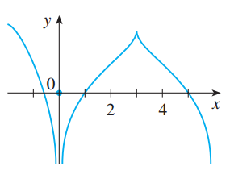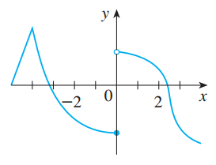a. b.

8. A table of values for  is given

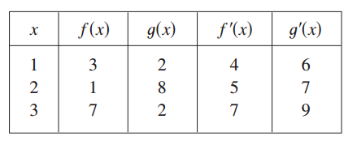

a. If  , find  b. If  , find 

c. If , find  d. If , find 

9. If  , where  , find .

10. For the circle: .

a. Find 

b. Find an equation of the tangent to the circle at the point (3, 4).

11. Let 

a. Find 

b. Find an equation of tangent to the curve (L) at the point (3, 3)

12. Find y' by implicit differentiation

a.  b.  c. 

13. Find  in terms of

a.  b. 

14. Each side of a square is increasing at a rate of 6 cm/s. At what rate is the area of the square increasing when the area of the square is 16 cm2 ?

15. If  and , find  when y = 4 and x > 0.

16. If , find  when 

17. Find the linearization L(x) of the function at a.

a.  b. 

18. The equation of motion is for a particle, where s is in meters and t is in seconds. Find the acceleration (in m/s2) after 3 seconds. **Chapter 3: Applications of Differentiation**

1. Find the absolute maximum and absolute minimum values of the function on the given interval

a.  b. 

c.  d. 

2. Find the critical numbers of the function

a.  b.  c. 

3. Find all numbers that satisfy the conclusion of the Rolle's Theorem

a.  b. 

4. Find all numbers that satisfy the conclusion of the Mean Value Theorem

a.  b. 

5. If  and , how small can  possibly be?

6. Find where the function  is increasing and where it is decreasing.

7. Find the inflection points for the function

a.  b.  c. 

8. Find  for  and .

9. Find the point on the parabola  that is closest to the point 

10. Find two numbers whose difference is 100 and whose product is a minimum.

11. Find two positive numbers whose product is 100 and whose sum is a minimum.

12. Use Newton’s method with the specified initial approximation to find 

a.  b. 

c.  d. 

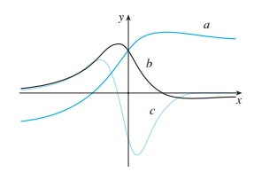13. The figure shows the graphs of  and  . Identify each curve, and explain your choices

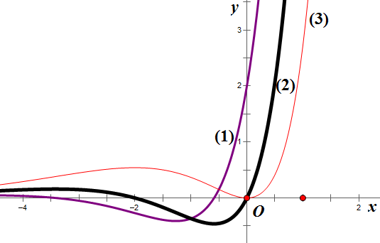a. b.

14. Find the most general anti-derivative of the function.

a.  b. 

c.  d. 

15. Find the anti-derivative of that satisfies the given condition

a.  b. 

16. A particle is moving with the given data. Find the position of the particle

a. 

b. 

c. 

**Chapter 4 - 6: Integration**

1. Estimate the area under the graph of  using 6 rectangles and left endpoints

a.  ,  b.  , 

c. A table of values for *f* is given

|  |  |  |  |  |  |  |  |
| --- | --- | --- | --- | --- | --- | --- | --- |
| *x* | 1 | 2 | 3 | 4 | 5 | 6 | 7 |
| *f(x)* | 5 | 6 | 3 | 2 | 7 | 1 | 2 |

3. Repeat part (1) using right endpoints

4. For the function . Estimate the area under the graph of using four approximating rectangles and taking the sample points to be

a. Right endpoints

b. Left endpoints

c. Midpoints

5. Use (a) the Trapezoidal Rule, (b) the Midpoint Rule, and (c) Simpson’s Rule to approximate the given integral with the specified value of *n.*

a.  b. 

6. Let . Find the approximations , ,, and  for .

7. Find the derivative of the function 

8. Find 

a.  b. 

c.  d. 

9. Find the average value of the function on the given interval

a.  b. 

c.  d. 

10. A particle moves along a line so that its velocity at time t is v(t) = t2 – t – 6 (m/s)

a. Find the displacement of the particle during the time period 1 ≤ t ≤ 4

b. Find the distance traveled during this time period

11. Suppose the acceleration function and initial velocity are a(t)= t + 3 (m/s2), v(0)=5 (m/s). Find the velocity at time t and the distance traveled when 0 ≤ t ≤ 5.

12. A particle moves along a line with velocity function  , where is measured in meters per second. Find the displacement and the distance traveled by the particle during the time interval  .

13. Evaluate the integral

a.  b.  c. 

d.  e.  f. 

14. Evaluate the integral

a.  b.  c. 

d.  e.  f. 

15. Suppose f(x) is differentiable, f(1) = 4 and . Find 

16. Suppose *f(x)* is differentiable, *f(1) = 3, f(3) = 1* and . What is the average value of *f* on the interval *[1,3]*?

17. Let  . Evaluate 

18. Find  for

a.  b. 

19. Determine whether each integral is convergent or divergent. Evaluate those that are convergent.

a.  b.  c.  d. 

e.  f.  g.  h. 

i.  j.  k.  l. 

20. Use the Comparison Theorem to determine whether the integral is convergent or divergent

a.  b.  c. 

d.  e.  f. 

**LINEAR ALGEBRA**

**Chapter 1: Systems of Linear Equations**

1. Write the augmented matrix for each of the following systems of linear equations and then solve them.

a.  b. 

c.  d. 

2. Compute the rank of each of the following matrices.

a.  b. 

c.  d. 

3. Find all values of k for which the system has nontrivial solutions and determine all solutions in each case.

a.  b. 

c.  d. 

4. Determine the values of m such that the system of linear equations has exactly one solution.

a.  b. 

c.  d. 

5. Determine the values of m such that the system of linear equations is inconsistent.

a.  b. 

6. Find a, b and c so that the system  has the solution 

7. Consider the matrix 

a. If  is the augmented matrix of a system of linear equations, determine the number of equations and the number of variables.

b. If  is the augmented matrix of a system of linear equations, find the value(s) of k such that the system is consistent.

8. Find all values of k so that the system of equations has no solution.

a.  b. 

9. Find all values of a and b for which the system of equations  is inconsistent.

10. Solve the system of linear equation corresponding to the given augmented matrix

a.  b. 

11. Determine the values of m such that the rank of the matrix is 2

A.  b.  c. 

12. Solve the system 

**Chapter 2:** **Matrix Algebra**

1. Let  and  . Compute the matrix

a.  b.  c.  d. 

e.  f.  g.  h. 

2. Suppose that A and B are nxn matrices. Simplify the expression

a.  b. 

3. Let  and  .

a. Compute 

b. Compute  if 

4. Find the inverse of each of the following matrices.

a.  b.  c.  d. 

5. Given  . Find a matrix X such that

a.  b.  c. 

6. Find  when

a.  b.  c. 

7. Write the system of linear equations in matrix form and then solve them.

a.  b.  c. 

8. Find  if

a.  b.  c. 

9. Solve for X

a.  b.  c. 

(where A, B and C are nxn invertible matrices)

10. Compute 

11. Let  be a linear transformation, and assume that  and 

a. Compute  b. Compute 

c. Find the matrix of T d. Compute 

12. Let  be a linear transformation such that the matrix of is.

Find 

13. The (2;1)-entry of the product 

**Chapter 3:** **Determinants and** **Diagonalization**

1. Evaluate the determinant

a.  b.  c.  d. 

e.  f. 

2. Find the minors and the cofactors of the matrix

a.  b.  c. 

3. Find the adjugate and the inverse of the matrix 

4. Let  . Find

a.  b.  c. 

d.  e.  f. 

5. Let A and B be square matrices of order 4 such that  and . Find

a.  b.  c.  d. 

6. Find all values of m for which the matrix is not invertible

a.  b.  c. 

7. Find the characteristic polynomial of the matrix

a.  b. 

c.  d. 

8. Find the eigenvalues and corresponding eigenvectors of the matrix

a.  b. 

c.  d. 

9. Find the determinant of the matrix 

10. Find the (1, 2)-cofactor and (3,1) - cofactor of the matrix 

11. Let  . For which values of  is  invertible ?

**Chapter 4: Vector Geometry**

1. Find the equations of the line through the points P0(2, 0, 1) and P1(4, − 1, 1).

2. Find the equations of the line through P0(3, − 1, 2) parallel to the line with equations:



d=(2,1,4)

3. Determine whether the following lines intersect and, if so, find the point of intersection.



4. Compute ||v|| if v equals:

a. (2,-1,2) b. 2(1,1,-1) c. -3(1,1,2) d. (1,2,3) - (4,1,2)

5. Find a unit vector in the direction from A(3,-1,4) to B(1,3,5).

@ a unit vector in the direction of vector v is 

@ e = =….

6. Find ||v − 3w|| when ||v|| = 2, ||w|| = 1, and v · w = 2

7. Compute the angle between u = (-1,1,2) and v = (-1,2,1).

8. Show that the points P(3, − 1, 1), Q(4, 1, 4), and R(6, 0, 4) are the vertices of a right triangle.

9. Suppose a ten-kilogram block is placed on a flat surface inclined 30◦ to the horizontal as in the diagram. Neglecting friction, how much force is required to keep the block from sliding down the surface? W1= w.sin30

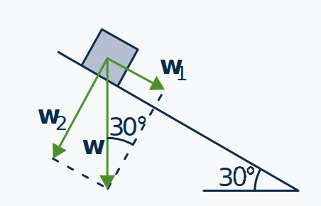

10. Find the projection of u = (2,-3,1) on d = (-1,1,3) and express u = u1 + u2 where u1 is parallel to d and u2 is orthogonal to d.

11. Find an equation of the plane through P0(1, − 1, 3) with n = (-3,-1,2) as normal.

12. Find an equation of the plane through P0(3, − 1, 2) that is parallel to the plane with equation 2x − 3y − z = 6.

13. Find the shortest distance from the point M(2, -1, − 3) to the plane with equation (P): 3x − y + 4z = 1. Also find the point Q on this plane closest to P.



Let 

14. Find the equation of the plane through P(1, 3, − 2), Q(1, 1, 5), and R(2, − 2, 3).



15. Find the shortest distance between the nonparallel lines

(a):

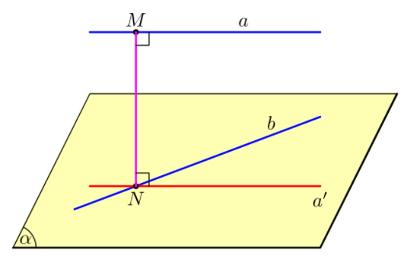





16. Compute u · v where:

a. u = (2,-1,3), v = (-1,1,1) b. u = (-2,1,4), v = (-1,5,1)

17. Find all real numbers x such that:

a. (3,-1,2) and (3,-2,x) are orthogonal.

b. (2,-1,1) and (1,x,2) are at an angle of π/3 .

18. Find the three internal angles of the triangle with vertices:

a. A(3, 1, − 2), B(3, 0, − 1), and C(5, 2, − 1)

b. A(3, 1, − 2), B(5, 2, − 1), and C(4, 3, − 3)

19. Find the equations of the line of intersection of the following planes.

a. 2x − 3y + 2z = 5 and x + 2y − z = 4.

b. 3x + y − 2z = 1 and x + y + z = 5.

20. Find the area of the triangle with vertices P(2, 1, 0), Q(3, − 1, 1), and R(1, 0, 1)

21. Find the volume of the parallelepiped determined by the vectors u = (1,2,-1), v = (3,4,5) and w = (-1,2,4).

22. In each case show that that T is either projection on a line, reflection in a line, or rotation through an angle, and find the line or angle

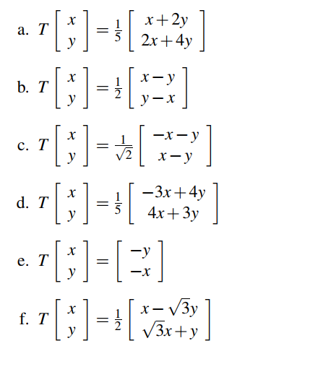

23. Determine the effect of the following transformations.

a. Rotation through π/2 , followed by projection on the y axis, followed by reflection in the line y = x.

b. Projection on the line y = x followed by projection on the line y = −x.

c. Projection on the x axis followed by reflection in the line y = x.

24. Find the reflection of the point P in the line y = 1 + 2x in R2 if:

a. P = P(1, 1)

b. P = P(1, 4)

25. Find the angle between the following pairs of vectors.

a. u = (1,-1,4), v = (5,2,-1)

b. u = (2,1,5), v = (0,3,1)

26. In each case, compute the projection of u on v.

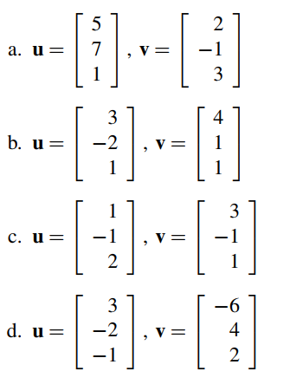

27. Find the shortest distance between the following pairs of nonparallel lines and find the points on the lines that are closest together.

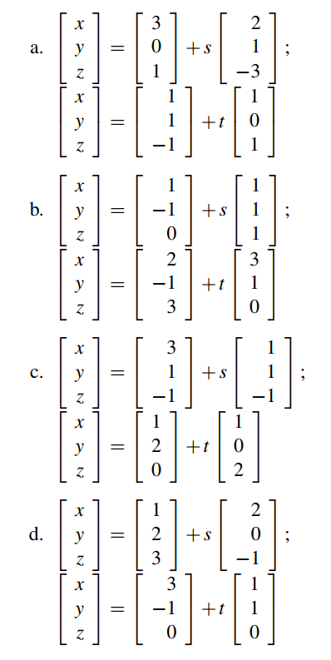

**Chapter 5: The Vector Space **

1. Let  and  in . Find scalars a, b and c such that 

2. Write v as a linear combination of u and w, if possible, where 

a.  b.  c.  d. 

3. Determine whether the set S is linearly independent or linearly dependent

a. b. 

c.  d. 

e. 

4. For which values of k is each set linearly independent?

a.  b. 

c.  d. 

5. Find all values of m such that the set S is a basis of 

a.  b. 

6. Find a basis for and the dimension of the subspace U

a.  b. 

c.  d. 

e.  f. 

g.  h. 

7. Find a basis for and the dimension of the solution space of the homogeneous system of linear equations.

a.  b.  c. 

8. Find all values of m for which  lies in the subspace spanned by S

a.  and 

b.  and 

c.  and 

d.  and 

9. Find the dimension of the subspace 

10. Let  . Find  and 

11. Which of the following are subspaces of R3?



12. Let  and . Compute 

13. Let  such that  and . Find

a.  b.  c. ||2u - v||