## CS 3340 Computer Architecture

## Homework 8: MMIO with MARS

**This homework is worth 200 points**

Objective: To gain experience working with memory-mapped I/O.

Tutorial: Read the MMIO tutorial first, <https://github.com/kjmazidi/CS3340/tree/master/MMIO%20Tutorial>

and make sure you understand the bitmap example programs.

### Instructions

1. Write and test a function to draw a box on the bitmap display. The box should be roughly in the center of the screen. Draw the box one pixel at a time. Use 4 loops, one for the top, one for the right side, one for the bottom, one for the left side. Each loop writes 7 pixels per side. To make debugging easier, make the box a solid color first, then go on to step 2. Make sure that your code uses these settings:

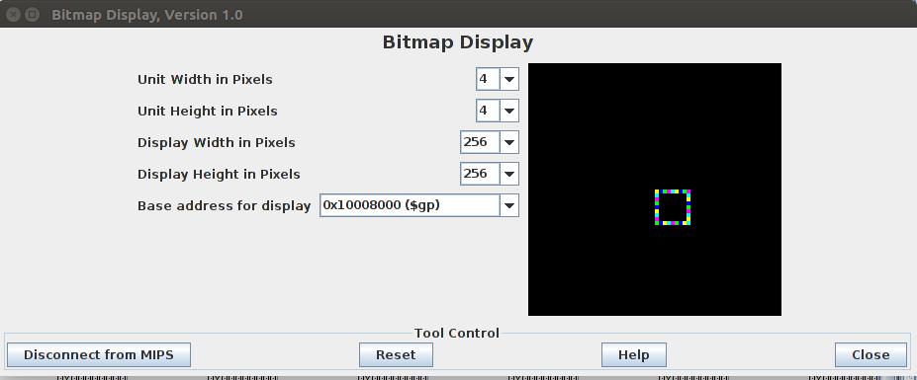

1. Modify the draw box function to have the marquee effect by drawing each pixel in a color from an array of colors. You can use colors similar to the following:

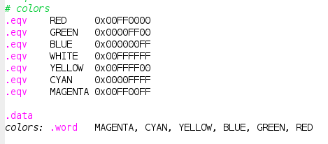

1. Slow the marqee appearance down by adding a pause function between pixel writes, using syscall 32. Make the delay 5 ms.
2. Add keyboard functionality. You can see similar code in the bitmap sample program 2 in the GitHub. The w, a, s, and d keys should move the box up, left, right, or down one pixel. The space key should terminate the program.

Grading Rubric:

200 points

100 points – draw a box near the center of the screen; use a loop for each side

40 points – use rotating colors so that the box has a “marquee” appearance

10 points – use a pause function between pixel writes

30 points – keyboard functionality to move the box with wasd, or space to end

20 points – comments in the code, plus comments on how to run;

and good use of white space

***Upload your .asm file to eLearning***