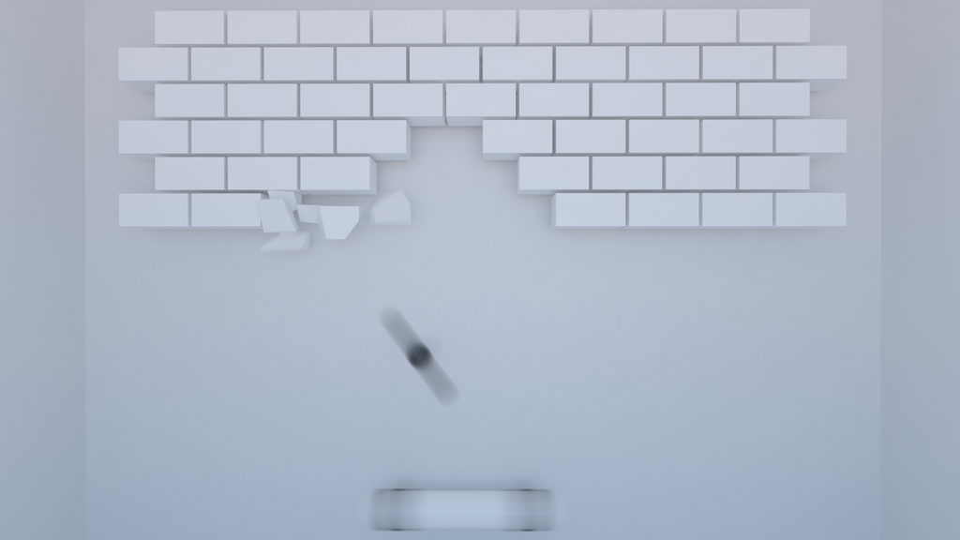

Game Design Documentation

**Game title:** Brick breaker V1.10

**Genre:** Breakout clone

**Platform(s):** [PC, Mobile, laptop, etc.]

**Game Summary:**

Brick breaker V1.10 is a modern revival of the classic Brick Breaker game that was popular on Blackberry cell phones. The game challenges players to knock down all the bricks by deflecting a bouncing ball with a moving platform. The platform can be controlled using arrow keys on a PC or laptop, or via touch controls on mobile devices. In this updated version, players can enjoy a multiplayer mode and a variety of new power-ups for an enhanced gaming experience.

**Game Mechanics**

**Core Systems:**

* Level progression System
* Bricdk (colours + strength) system
* Power-ups system
* Lives System
* Time-Based Mechanics

**Objective:**

The objective of our Brick Breaker game is to break as many bricks as possible within a selected time while collecting power-ups, progressing through different levels, and building up a high score. Players must avoid losing lives to continue advancing through the game.

**Design Elements:**

Levelling System:

* Players start at level 1 and can progress through multiple levels. Each level presents bricks arranged in various patterns and shapes, with the difficulty increasing as levels progress.
* The number of breakable bricks decreases in higher level, making it more challenging for players to break all breaks without losing lives.
* As players advance, the speed of the ball may increase, new obstacles or patterns can appear.

Brick System:

* Bricks are colour-coded based on their strength and the power-ups they provide. For example:
  + - Red Bricks (with a few cracks): Easier to break.
    - Dark Red Bricks (without cracks): Harder to break than the red brick.
    - Silver Brick: Very hard to break and require multiple hits.
* Additional colours and brick types may be added for originality and to introduce new gameplay elements or challenges.

Power-ups System:

* Players can collect various power-ups by breaking certain bricks. These power-ups can include:
  + - Extra lives: Grants an additional life, allowing players to continue the game even if they lose the ball.
    - Increased paddle size: Expands the paddle, making it easier to hit the ball and preventing it from falling.
    - Multi-ball: Splits the ball into the multiple balls, allowing players to break more bricks simultaneously.
    - Magnetic paddle: Temporarily attracts the ball to the paddle, giving players more control over where to aim the ball.

Lives System:

* Players start with a set number of lives. A life is lost when the ball falls below the paddle and out of play.
* The game ends when all lives are lost, but players can earn extra through specific power-ups or reaching certain score milestones.
* Score Milestones: Players receive additional lives at designated score thresholds, encouraging high scores and careful play to prolong the game.

Time-Based Mechanics:

* Time-limits: Each level or game mode can have a different time limit, requiring players to adapt their strategies accordingly. For example, higher levels might have shorter time limits, increasing the challenge.
* Countdown Timer: A visible countdown timer adds urgency to the gameplay, constantly reminding players of the time remaining.
* Bonus Time: Completing levels quicker can award the players bonus time for the next level, rewarding fast and efficient play.
* Time-based scoring: In addition to points for breaking bricks, players can earn bonus points based on how much time is left when the complete a level.

To make our gamemore original and stand out from other breakout clones, we can consider adding the following features:

### **1. Unique Brick Types and Effects:**

* **Explosive Bricks:** When hit, these bricks explode and destroy surrounding bricks, adding a strategic element to gameplay.
* **Teleportation Bricks:** Hitting these bricks teleports the ball to another location on the screen, adding unpredictability.
* **Switch Bricks:** Hitting these changes the layout of the remaining bricks or activates/deactivates barriers on the screen.
* **Invisible Bricks:** These bricks become visible only when the ball or paddle is near, increasing the challenge.

### **2. Dynamic Level Design:**

* **Moving Bricks:** Introduce bricks that move horizontally or vertically, requiring precise timing and skill to hit.
* **Obstacle Courses:** Create levels with obstacles that the ball must navigate around, like rotating barriers or narrow passages.
* **Multi-Layered Bricks:** Some bricks may have layers, requiring multiple hits or the use of specific power-ups to destroy.

### **3. Advanced Power-ups:**

* **Time Freeze:** Temporarily stops all bricks and balls, giving the player a breather or a chance to aim.
* **Gravity Change:** Alters the gravity for the ball, making it move faster or slower depending on the direction.
* **Paddle Weapons:** Equip the paddle with temporary weapons, like a laser that can shoot bricks or a magnet that attracts certain bricks.

### **4. Player Abilities and Upgrades:**

* **Skill Tree:** Allow players to earn points and upgrade abilities, like increasing the paddle size, speed, or the effect duration of power-ups.
* **Character Abilities:** If your game includes multiple paddle characters, each could have unique abilities (e.g., faster speed, double ball damage, etc.).

### **5. Story Mode with Boss Battles:**

* Introduce a narrative or story mode where players progress through levels with themed environments and encounter boss battles at the end of each world. Bosses could have unique abilities or require specific strategies to defeat.

### **6. Environmental Hazards and Effects:**

* **Wind or Water Currents:** These could affect the ball’s movement, requiring players to adjust their strategies.
* **Darkness:** Introduce levels where visibility is limited, and players need to light up parts of the screen by hitting special bricks.

### **7. Custom Level Editor:**

* Allow players to create and share their own levels with friends or the community, fostering a creative and engaged player base.

### **8. Themed Levels and Seasonal Updates:**

* Regularly introduce new themes (like space, underwater, medieval, etc.) and seasonal updates (like Halloween or Christmas) with unique graphics, bricks, and power-ups that reflect the theme.

### **9. Interactive Music and Sound Effects:**

* Develop a dynamic music system where the soundtrack changes based on the player's actions, intensity of the game, or the remaining time, enhancing the overall experience.

**Multiplayer Mode:**

* Cooperative mode: Two players work together on the same screen or over the same network to clear bricks and archive high scores.
* Competitive mode: Players compete against each other to clear bricks the fastest or score the highest within a set time limit. This mode may include power-ups that affect both players, adding a layer of strategy.