# Exercises: Asynchronous Programming

This document defines the **exercise assignments** for the ["CSharp Advanced" course @ Software University](https://softuni.bg/trainings/1361/advanced-c-sharp-may-2016). Please submit your solutions (source code) of all below described problems in [Judge](https://judge.softuni.bg/).

## Responsive GUI

You are given a project skeleton of a GUI application that looks something like this:

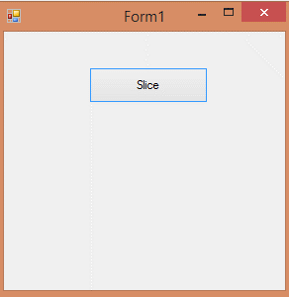

This program slices a single file into multiple files. The problem is that if too big of a file is selected the GUI will freeze while slicing the individual bits. Modify the code of the application so that the GUI stays responsive after you press the "Start" button with at least 500mb file. **Bonus:** Also make a "Stop" button to stop the slicing process.