**Training List:**

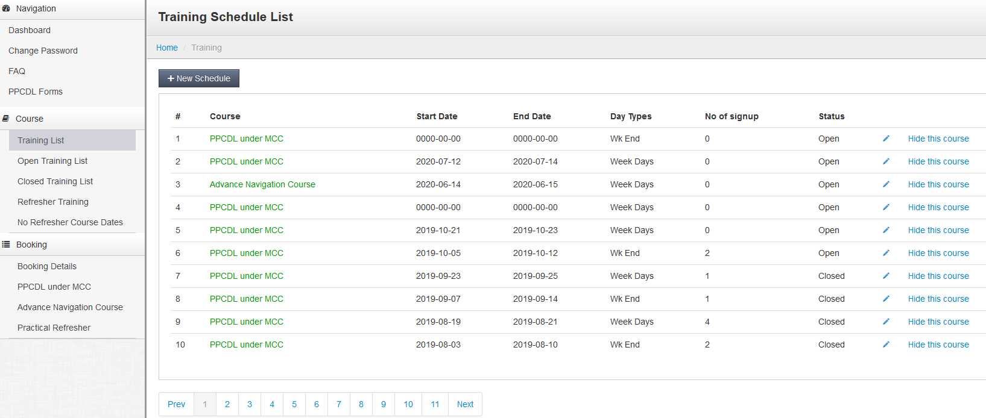

# On ‘click on New Schedule’ button, -> Add Training Schedules

On **‘ Course ‘ Box** select course

When mouse-over **‘Start Date’ Box , ‘date –calendar ‘ would pop-up (*1)**

So, return value: ‘Date-calendar’ value = Start Date value

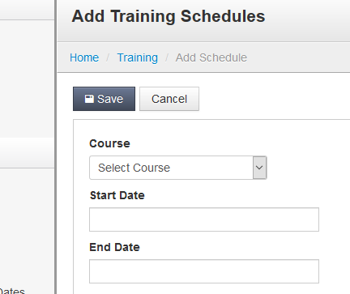

**When mouse-over ‘End Date’ Box , date –calendar would pop-up (*2)**

So, return value: ‘Date-calendar’ value = End Date value

**Refresher Training**

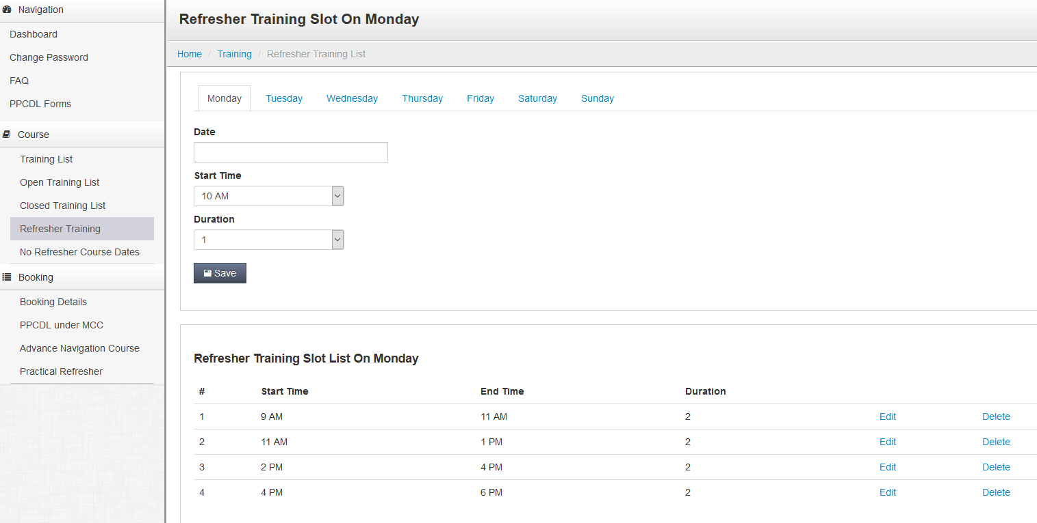

You have added the Date Box. This is good.

When we ‘save’ this date and related ‘Refresher Training for the Day, would be listed, as:

**Refresher Training Slot List On Monday (*3)**

| **#** | **Date Start Time** | **End Time** | **Duration** |  |  |
| --- | --- | --- | --- | --- | --- |
| 1 | dd mm yy 9 AM | 11 AM | 2 | [Edit](https://mets1.sg/admin/home.php?mode=training&pg=edit_refresher_training_list&training_day=1&refresher_training_id=85&start=0) | [Delete](https://mets1.sg/admin/home.php?mode=training&pg=refresher_training_list&training_day=1&refresher_training_id=85&del=true&start=0) |
| 2 | dd mm yy 11 AM | 1 PM | 2 | [Edit](https://mets1.sg/admin/home.php?mode=training&pg=edit_refresher_training_list&training_day=1&refresher_training_id=91&start=0) | [Delete](https://mets1.sg/admin/home.php?mode=training&pg=refresher_training_list&training_day=1&refresher_training_id=91&del=true&start=0) |
| 3 | dd mm yy 2 PM | 4 PM | 2 | [Edit](https://mets1.sg/admin/home.php?mode=training&pg=edit_refresher_training_list&training_day=1&refresher_training_id=92&start=0) | [Delete](https://mets1.sg/admin/home.php?mode=training&pg=refresher_training_list&training_day=1&refresher_training_id=92&del=true&start=0) |
| 4 | dd mm yy 4 PM | 6 PM | 2 | [Edit](https://mets1.sg/admin/home.php?mode=training&pg=edit_refresher_training_list&training_day=1&refresher_training_id=93&start=0) | [Delete](https://mets1.sg/admin/home.php?mode=training&pg=refresher_training_list&training_day=1&refresher_training_id=93&del=true&start=0) |
|  |  |  |  |  |  |

The Date field is required in the **Refresher Training Slot List by Day**, as above. The list may sorted by ‘Date’ order (selectable or please propose).

# No Practical Refresher Course Dates

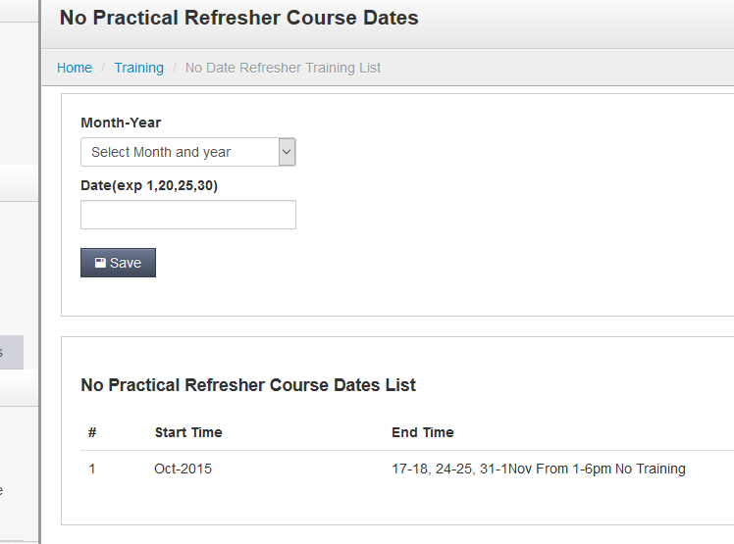

This function is to give the list of **‘No Practical Refresher Course Dates List’.**

I suggest, i) when mouse-over the Month-Year field, Please provide ‘Month-Year’ pop-up only. So, admin user can select ‘month-year’ **(*4)**

As per the “**Date(exp 1,20,25,30)” Box, we would propose to simplify this entry. We would do this by manual entry. Do not require ‘Date-Calendar’ pop here.**

### As per, ‘No Practical Refresher Course Dates List’ need no changes.

**Summary:**

**\***1 : Date-calendar on Training Schedule => Training Schedule List => + New Schedule,

When mouseover ‘**Start Date’ box.**

**\*2 : Same action,** when mouseover ‘ **End Date ’ box.**

**\*3 :** Refresher Training Slot List by Day, also include the Date

*4 : On ‘No Practical Refresher Course Dates’, ‘Date-Calendar’ just ‘Month-Year’.

On ‘**Date(exp 1,20,25,30)’ no ‘date-calendar’ popup required.**

Thanks