# How to go from the picture on the left to the picture on the right for facial experiments

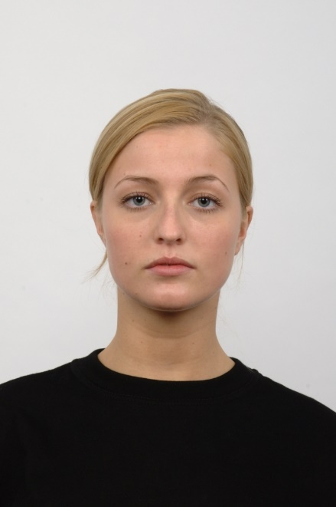

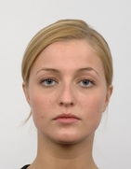

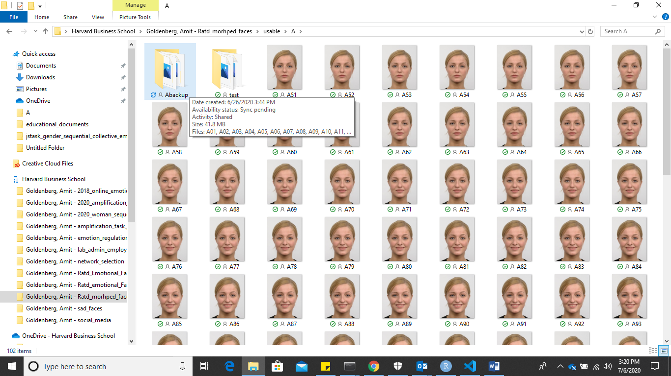

1. **Make a backup folder** – in case you mess up you don’t want to restore everything from scratch
2. Open **picture_format.ipynb.** There you will see a step by step breakdown
3. Loop 1 renames all files
4. Loop 2 crops all files
5. Loop 3 reformats all files – make sure “quality” is set to 100 in the file.save() line, otherwise you will end up with low-qual images.