Abstract
Objective: To determine how seizure-detector sensitivity and false alarm rate affect observed regression to the mean and apparent placebo response in simulated epilepsy randomized controlled trials.
Methods: Using a validated seizure-diary simulator, we generated 100,000 potential participants per device-performance condition with a two-month baseline and three-month test period. Sensitivity ranged from 10% to 100%, and false alarm rate ranged from zero to one alarm/day. Expected false alarms were subtracted from monthly counts. Primary eligibility used monthly count thresholds and omitted a prior 25-day seizure-free-interval rule, which was evaluated in a sensitivity analysis.
Results: At full sensitivity and no false alarms, 37.2% of eligible participants met the observed regression-to-the-mean definition and median placebo change was 13.5% (95% confidence interval 13.1%–14.3%). At 10% sensitivity, these values were 63.0% and 46.7% (44.4%–48.7%); at one false alarm/day, they were 52.8% and 31.2% (30.2%–33.3%). Retaining the 25-day rule did not change the overall trends.
Significance: Lower sensitivity and higher false alarm rate changed trial selection, the frequency of the observed regression-to-the-mean pattern, and apparent placebo response despite aggregate false-alarm correction. Detector performance and correction rules should be modeled when device-derived counts determine trial eligibility or outcomes.
Keywords: seizure detection; regression to the mean; clinical trials; false alarms; simulation

Introduction
Current automated seizure detection devices are evaluated primarily by sensitivity, false alarm rate (FAR), detection latency, and usability. Recent guidelines and meta-analytic studies emphasize that performance varies across seizure types and recording settings.^{1–3} These metrics are usually interpreted for patient safety, caregiver notification, or diary accuracy. Their consequences for randomized controlled trial (RCT) design are underdeveloped.
Epilepsy trials are particularly vulnerable to apparent placebo response for several reasons. First, seizure frequency is highly variable over time, impacting outcomes.^{4–10} Second, placebo response includes regression-to-the-mean (RTM)^{8,11}. Prior work has shown that RTM can be manipulated to materially affect placebo response.⁴ Indeed, natural seizure-frequency variability can reproduce many features of placebo response even without a psychobiological “placebo effect”.^{5–8,12}
Seizure detection devices change the measured seizure time series before trial eligibility and outcomes are calculated. We investigated to what extent sensitivity and false alarm rate (FAR) alter the frequency of a study-specific observed regression-to-the-mean (RTM) pattern and apparent placebo response in simulated epilepsy randomized controlled trials.

Methods
Simulations used Python 3.12.13 and CHOCOLATES, an open-source realistic seizure-diary simulator that recapitulates observed diary properties, including heterogeneous long-term seizure rates, the relationship between mean seizure frequency and variability, seizure clustering, cycles, and inter-seizure constraints.¹²
Each simulated placebo-arm participant had a two-month baseline and three-month test period. No active treatment effect was added, consistent with our prior studies^{4,12,13}. Eligibility was assessed during baseline. The primary rule required a mean baseline frequency of at least four seizures/month and at least three seizures in each baseline month. The prior requirement of no seizure-free interval longer than 25 days was omitted from the primary analysis and retained as a sensitivity analysis in the Appendix. These thresholds were modeled after focal-seizure trial eligibility rules used in cenobamate studies.^{14,15}
Device sensitivity was implemented probabilistically at the daily seizure-count level: each true seizure had the specified probability of detection. FAR was implemented as Poisson-distributed false alarms added to each day. For false-alarm conditions, the expected number of false alarms was subtracted from each 30-day count, and negative corrected counts were set to zero³. This idealized aggregate correction assumes that the condition-specific FAR is known but does not identify individual false alarms. Formal equations and alternative correction rules are reported in the Appendix.
Two device-performance sweeps were conducted. First, FAR was fixed at zero while sensitivity varied from 10% to 100% in 10% increments. Second, sensitivity was fixed at 100% while FAR varied from zero to one alarm/day in 0.1-alarm/day increments. A common cohort of 100,000 latent participants was reused across conditions, with nested detection and false-alarm realizations. The base random seed was 20260813; separate deterministic streams were used for sensitivity and false alarms. For each participant, a separate 36-month diary was generated from the same sampled latent seizure rate, and its mean monthly count was defined as the effective long-term frequency. This empirical long-horizon reference incorporates simulated clustering, cycles, and finite-history variability; for detector-specific comparisons it was scaled by sensitivity. Among eligible participants, an observed-RTM indicator was recorded when measured baseline frequency exceeded the detector-scale effective long-term frequency and the test-period frequency was closer to that reference. This operational indicator describes the observed trajectory and is not a causal decomposition of overall RTM. Apparent placebo response was summarized as the median relative reduction from baseline to the test period. Figure 1 shows nonparametric 95% confidence intervals for the estimated median, calculated from binomial order statistics; these are not intervals for individual responses. No hypothesis tests were performed because the analysis was a descriptive simulation sweep rather than a comparison of randomized groups.
No human participants, identifiable private information, or animals were used. The canonical script, fixed seeds, executed Appendix, aggregate outputs, run metadata, and validation checks are available in the open-source GitHub repository.

Results
When FAR was zero, lower sensitivity increased both the observed-RTM fraction and placebo median percentage change (Figure 1A,C). At 100% sensitivity, 35,744 of 100,000 potential participants were eligible, 37.2% of eligible participants met the observed-RTM definition, and median placebo change was 13.5% (95% CI 13.1%–14.3%). At 50% sensitivity, 18,054 participants were eligible, observed RTM was 43.6%, and median placebo change was 25.0% (95% CI 23.8%–25.3%). At 10% sensitivity, 2,151 participants were eligible, observed RTM was 63.0%, and median placebo change was 46.7% (95% CI 44.4%–48.7%).
When sensitivity was 100%, increasing FAR also increased observed RTM and placebo median percentage change after correction for expected monthly false alarms (Figure 1B,D). At FAR 0.1 alarm/day, 35,752 participants were eligible, observed RTM was 40.3%, and median placebo change was 17.9% (95% CI 17.4%–18.5%). At FAR 0.5 alarms/day, 35,906 participants were eligible, observed RTM was 48.4%, and median placebo change was 26.7% (95% CI 25.9%–27.3%). At FAR one alarm/day, 35,476 participants were eligible, observed RTM was 52.8%, and median placebo change was 31.2% (95% CI 30.2%–33.3%).
Retaining the original 25-day seizure-free-interval criterion in a sensitivity analysis did not change the overall trends (Appendix). Across all 21 device conditions, it changed eligibility by at most 2.49 percentage points, observed RTM by at most 2.67 percentage points, and median placebo change by at most 2.36 percentage points. Thus, lower sensitivity and higher FAR consistently increased the observed-RTM fraction and apparent placebo response under the prespecified correction.

Discussion
This simulation suggests that device performance characteristics should be treated as trial-design parameters, not merely as validation metrics. In a conventional baseline-versus-treatment design, the measured baseline seizure rate determines eligibility and also serves as the denominator for percentage-change outcomes⁴. Imperfect detection changes both. Lower sensitivity enriched the eligible cohort for unusually high measured baseline periods relative to detector-scale effective long-term frequency, producing larger subsequent apparent improvement. FAR had a similar selection effect under expected monthly count correction. Because the primary analysis omitted the day-level interval rule, this result arose through corrected monthly eligibility and outcome counts rather than daily eligibility behavior.
These findings extend prior RTM work in epilepsy randomized controlled trials.⁴ The earlier analysis showed that eligibility criteria can increase or decrease observed RTM and placebo response. The present analysis adds that the measurement system can alter the same pathway. Two trials with identical biological treatment effects and nominal eligibility thresholds could therefore have different apparent placebo responses when devices, algorithms, or correction rules differ.
A historical framework described RTM type 1 as return after a temporary unusual circumstance and RTM type 2 as return associated with ordinary natural variability⁸. Measurement error can be considered a third contributor to observed trajectories, but the present simulation does not identify an isolated participant-level “RTM Type 3” category. Rather, detector error changes cohort selection and the frequency of the overall observed-RTM indicator. We therefore interpret the results as a measurement-related contribution to observed RTM and apparent placebo response, not as proof that RTM Type 3 alone was directly observed.
Objective seizure detection could reduce under-reporting and may improve statistical power when more complete seizure counts are available.^{3,16} Device operating characteristics should be incorporated into trial simulations before randomized controlled trial designs are finalized. Before trial initiation, investigators should specify how sensitivity, FAR, correction, device non-wear, and missing data enter eligibility, baseline counts, and outcome counts. Device validation should also report performance in seizure types and settings that match the planned trial population.^{1,2}
Published device results anchor clinically plausible points in the simulated grid. A multimodal wrist detector reported 94.6% sensitivity with 0.20 false alarms/day; an Apple Watch algorithm reported 100% sensitivity with 0.05/day in epilepsy monitoring units and 0.13/day in ambulatory monitoring; and a connected shirt reported 84.8% sensitivity with a median 0.55/day. These estimates span central portions of our grid, although devices, seizure types, and validation settings differed. ^{17–19}
Several limitations should be considered. First, CHOCOLATES is a simulator and simplifies real-world measurement.¹² Second, sensitivity and FAR were modeled as uniform across participants and time; real detectors may have patient-specific and seizure-type-specific performance, state dependence, correlated false alarms, device non-wear, or signal deficiency. Third, expected-count FAR correction is not event-level correction. The Appendix shows that the magnitude of the FAR association depends on correction, zero-flooring, and day-level interval handling; exact oracle removal eliminated the FAR effect by construction. Fourth, the effective long-term frequency is itself a finite 36-month simulation estimate. Fifth, Figure 1 confidence intervals quantify uncertainty in the estimated median placebo change, not dispersion of individual responses.
Seizure detection devices may make epilepsy trials more objective, but they also make trial statistics depend nonlinearly on detector performance, correction, and eligibility. Observed RTM and apparent placebo response should therefore be evaluated jointly with sensitivity and FAR whenever device-derived counts are used for epilepsy trial eligibility or endpoints.

Acknowledgments and funding
Daniel M. Goldenholz (DMG) was funded by the National Institutes of Health (NIH) K23NS124656, 1R21NS142800 and the American Board of Psychiatry and Neurology (ABPN). SRG, TJK report no funding. RB reports funding from NIH K23NS124656. OpenAI Codex was used to assist with coding and portions of manuscript preparation; however the authors take full responsibility for the entire project including code, images, and manuscript.

Disclosure of conflicts of interest
DMG has been provided speaker fees from Harvard Medical School, the American Academy of Neurology, the American Epilepsy Society, the American Clinical Neurophysiology Society, the National Neurotrauma Society, AI in Epilepsy and Neurology, Florida Epilepsy Alliance, and the University of Texas at Austin. He also previously has been a paid consultant for Neuro Event Labs, IDR, LivaNova, Health Advances, Duke University, Bloom Insights, and Wiley. He has received grants from NIH, ABPN, Beth Israel Deaconess Medical Center, and the Lions Club. Rohan Bhansali and Brandon Westover have no relevant conflicts of interest to disclose.

Ethical publication statement
We confirm that we have read the Journal's position on issues involved in ethical publication and affirm that this report is consistent with those guidelines.

Data and code availability
The open-source code, canonical reproduction script, fixed seeds, executed Appendix notebook, aggregate results, and validation metadata are available at https://github.com/GoldenholzLab/RTM3.git.

Author contributions
DMG conceived the analysis, wrote and revised analysis code, interpreted results, and drafted the manuscript. RB, SRG, TJK and MBW contributed to interpretation and manuscript revision.

References
1. Beniczky S, Wiebe S, Jeppesen J, Tatum WO, Brazdil M, Wang Y, et al. Automated seizure detection using wearable devices: A clinical practice guideline of the International League Against Epilepsy and the International Federation of Clinical Neurophysiology. Clin Neurophysiol Off J Int Fed Clin Neurophysiol. 2021; 132(5):1173–84.
2. Naganur V, Sivathamboo S, Chen Z, Kusmakar S, Antonic-Baker A, O’Brien TJ, et al. Automated seizure detection with noninvasive wearable devices: A systematic review and meta-analysis. Epilepsia. 2022; 63(8):1930–41.
3. Goldenholz DM, Karoly PJ, Viana PF, Nurse E, Loddenkemper T, Schulze-Bonhage A, et al. Minimum clinical utility standards for wearable seizure detectors: A simulation study. Epilepsia. 2024; 65(4):1017–28.
4. Goldenholz DM, Goldenholz EB, Kaptchuk TJ. Quantifying and controlling the impact of regression to the mean on randomized controlled trials in epilepsy. Epilepsia. 2023; 64(10):2635–43.
5. Goldenholz DM, Moss R, Scott J, Auh S, Theodore WH. Confusing placebo effect with natural history in epilepsy: A big data approach. Ann Neurol. 2015; 78(3):329–36.
6. Goldenholz DM, Strashny A, Cook M, Moss R, Theodore WH. A multi-dataset time-reversal approach to clinical trial placebo response and the relationship to natural variability in epilepsy. Seizure. 2017; 53:31–6.
7. Romero J, Larimer P, Chang B, Goldenholz SR, Goldenholz DM. Natural variability in seizure frequency: Implications for trials and placebo. Epilepsy Res. 2020; 162:106306.
8. Klodowski DA, Goldenholz SR, Goldenholz DM. Epilepsy and Placebo: A Literature Review. Neurol Clin. 2026; 44(1):77–89.
9. Zaccara G, Giovannelli F, Schmidt D. Placebo and nocebo responses in drug trials of epilepsy. Epilepsy Behav. 2015; 43:128–34.
10. Rheims S, Perucca E, Cucherat M, Ryvlin P. Factors determining response to antiepileptic drugs in randomized controlled trials. A systematic review and meta-analysis. Epilepsia. 2011; 52(2):219–33.
11. McDonald CJ, Mazzuca SA, McCabe GP. How much of the placebo “effect” is really statistical regression? Stat Med. 1983; 2(4):417–27.
12. Goldenholz DM, Westover MB. Flexible realistic simulation of seizure occurrence recapitulating statistical properties of seizure diaries. Epilepsia. 2023; 64(2):396–405.
13. Morton V, Torgerson DJ. Regression to the mean: treatment effect without the intervention. J Eval Clin Pract. 2005; 11(1):59–65.
14. Chung SS, French JA, Kowalski J, Krauss GL, Lee SK, Maciejowski M, et al. Randomized phase 2 study of adjunctive cenobamate in patients with uncontrolled focal seizures. Neurology. 2020; 94(22):e2311–22.
15. Krauss GL, Klein P, Brandt C, Lee SK, Milanov I, Milovanovic M, et al. Safety and efficacy of adjunctive cenobamate (YKP3089) in patients with uncontrolled focal seizures: a multicentre, double-blind, randomised, placebo-controlled, dose-response trial. Lancet Neurol. 2020; 19(1):38–48.
16. Goldenholz DM, Tharayil JJ, Kuzniecky R, Karoly P, Theodore WH, Cook MJ. Simulating Clinical Trials With and Without Intracranial EEG Data. Epilepsia Open. 2017; 2(2):156–61.
17. Onorati F, Regalia G, Caborni C, Migliorini M, Bender D, Poh M-Z, et al. Multicenter clinical assessment of improved wearable multimodal convulsive seizure detectors. Epilepsia. 2017; 58(11):1870–9.
18. Shah S, Gonzalez Gutierrez E, Hopp JL, Wheless J, Gil-Nagel A, Krauss GL, et al. Prospective multicenter study of continuous tonic-clonic seizure monitoring on Apple Watch in epilepsy monitoring units and ambulatory environments. Epilepsy Behav EB. 2024; 158:109908.
19. Gharbi O, Lamrani Y, St-Jean J, Jahani A, Toffa DH, Tran TPY, et al. Detection of focal to bilateral tonic-clonic seizures using a connected shirt. Epilepsia. 2024; 65(8):2280–94.

Figure 1. Device sensitivity, false alarm rate (FAR), observed regression to the mean (RTM), and placebo median percentage change (MPC). Simulations used a common cohort of 100,000 potential participants and primary baseline eligibility based only on monthly seizure-count thresholds. Panels A and C vary sensitivity with FAR fixed at zero. Panels B and D vary FAR with sensitivity fixed at 100%, with expected monthly false alarms subtracted. Error bars show nonparametric 95% confidence intervals for the estimated median MPC; the dashed line is the perfect-detector MPC.

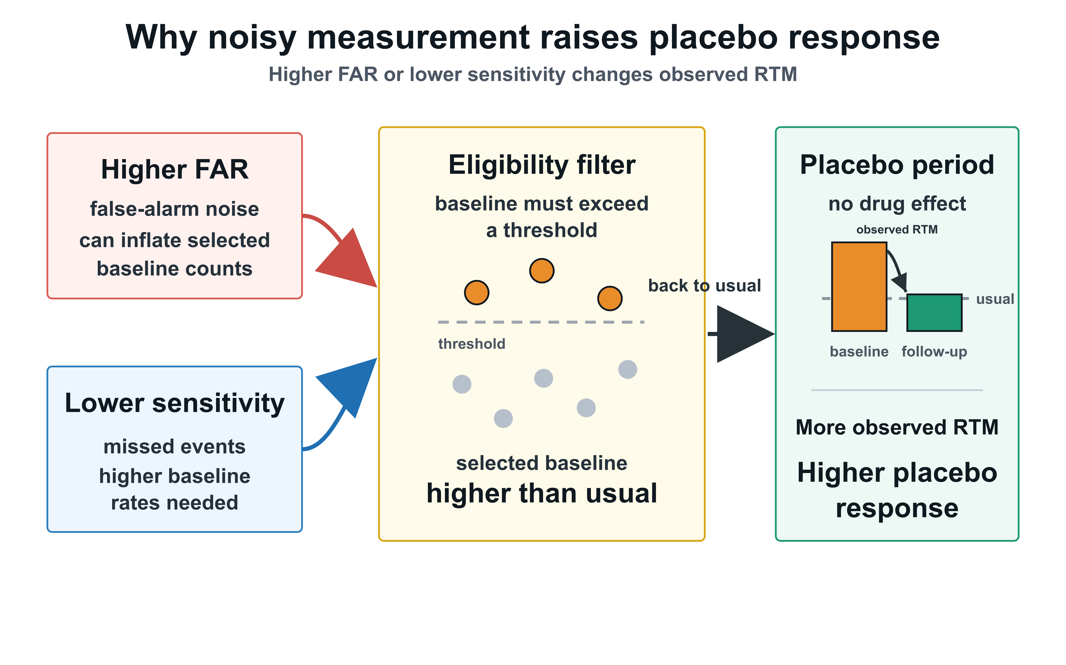
Figure 2. Conceptual mechanism linking detector error to apparent placebo response. Lower sensitivity and residual false-alarm noise change the measured series used for trial eligibility and baseline comparison. Because eligibility selects higher measured baseline counts, detector error can enrich for participants whose later measured counts move closer to their effective long-term frequency, increasing the frequency of the observed RTM pattern and apparent placebo response.

